**Exercise :** 3

**Date :** 10/10/2020

**Aim :**

To create a Python program to remove and print every second number from list until the list becomes empty.

**Program :**

def removeThirdNumber(int_list):

list1=[]

pos=1

st=0

for i in range(0,len(int_list)):

st=(pos+st)%len(int_list)

en=int_list.pop(st)

list1.append(en)

return list1

list1=[]

n=int(input())

for i in range(0,n):

en=int(input())

list1.append(en)

r=removeThirdNumber(list1)

print(r)

**Link :**

<http://103.53.53.18/mod/vpl/forms/submissionview.php?id=231&userid=1663>

**Output :**

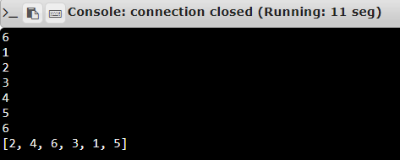

**Result :**

Thus, the program is executed and the required output is displayed.