**Exercise :** 4

**Date :** 15/10/2020

**Aim :**

To create a Python program to print a single string from two set of strings received from user and swap the first two characters of each string.

**Program :**

def chars_mix_up(a, b):

c = b[:2] + a[2:]

d = a[:2] + b[2:]

return c + ' ' + d

e=str(input()).strip()

f=str(input()).strip()

if(len(e)<2 or len(f)<2):

print("Invalid")

else:

g = chars_mix_up(e,f)

print(g)

**Link :**

<http://103.53.53.18/mod/vpl/forms/submissionview.php?id=234&userid=1663>

**Output :**

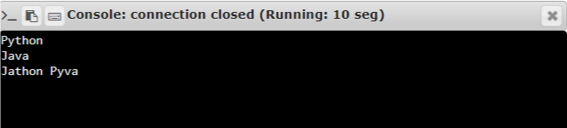

**Result :**

Thus, the program is executed and the required output is displayed.