**Exercise :** 5

**Date :** 15/10/2020

**Aim :**

To create a Python program to print missing characters to make string pangram.

**Program :**

def pangram(s):

a2z="abcdefghijklmnopqrstuvwxyz"

a=[pan for pan in a2z if pan in s]

b=[npan for npan in a2z if npan not in s]

if(len(a)==26):

l2s="".join([str(i) for i in a])

return l2s

else:

l2s="".join([str(i) for i in b])

return l2s

st=str(input())

st=st.lower()

p=pangram(st)

print(p)

**Link :**

<http://103.53.53.18/mod/vpl/forms/submissionview.php?id=235&userid=1663>

**Output :**

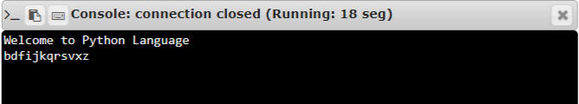

**Result :**

Thus, the program is executed and the required output is displayed.