**Exercise :** 8

**Date :** 23/11/2020

**Aim :**

To create a Python program to get list of numbers of list and create a list of tuples having first as number and second as cube of that number and list of tuples should be sorted by the last element in each tuple from a given list of non-empty tuples.

**Program :**

def last(n):

return n[-1]

def sort_list_last(tuples):

return sorted(tuples, key=last)

n=int(input())

list1=[]

cube=[]

for i in range(n):

a=int(input())

list1.append(a)

b=a**3

cube.append(b)

tuples=list(zip(list1,cube))

print(tuples)

print(sort_list_last(tuples))

**Link :**

<http://103.53.53.18/mod/vpl/forms/submissionview.php?id=317&userid=1663>

**Output :**

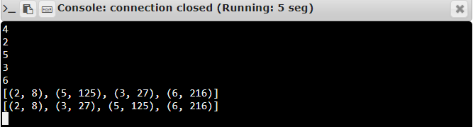

**Result :**

Thus, the program is executed and the required output is displayed.