**NAAN MUDHALVAN**

**DIGITAL MARKETING PROJECT**

**1. INTRODUCTION**

1.1 OVERVIEW

Blogging is a versatile and accessible medium that provides a platform for people toshare their thoughts, expertise, and passions with a global audience. Whether you'rean aspiring writer, an expert in a specific field, or a business looking to connect withcustomers, blogging can be a valuable tool in your online presence and contentmarketing strategy.

Blog Name: Football Pechu

1.2 PURPOSE

Blogging serves a variety of purposes, and the specific purpose of a blog can varydepending on the individual or organization behind it. Here are some common purposes for blogging:

* Sharing Knowledge and Expertise
* Business and Marketing
* Community Building
* Networking and Collaboration
* Documenting Life Events
* Entertainment and Information

**2. PRODUCT DEFINITION & DESIGN THINKING**

2.1 EMPATHY MAP

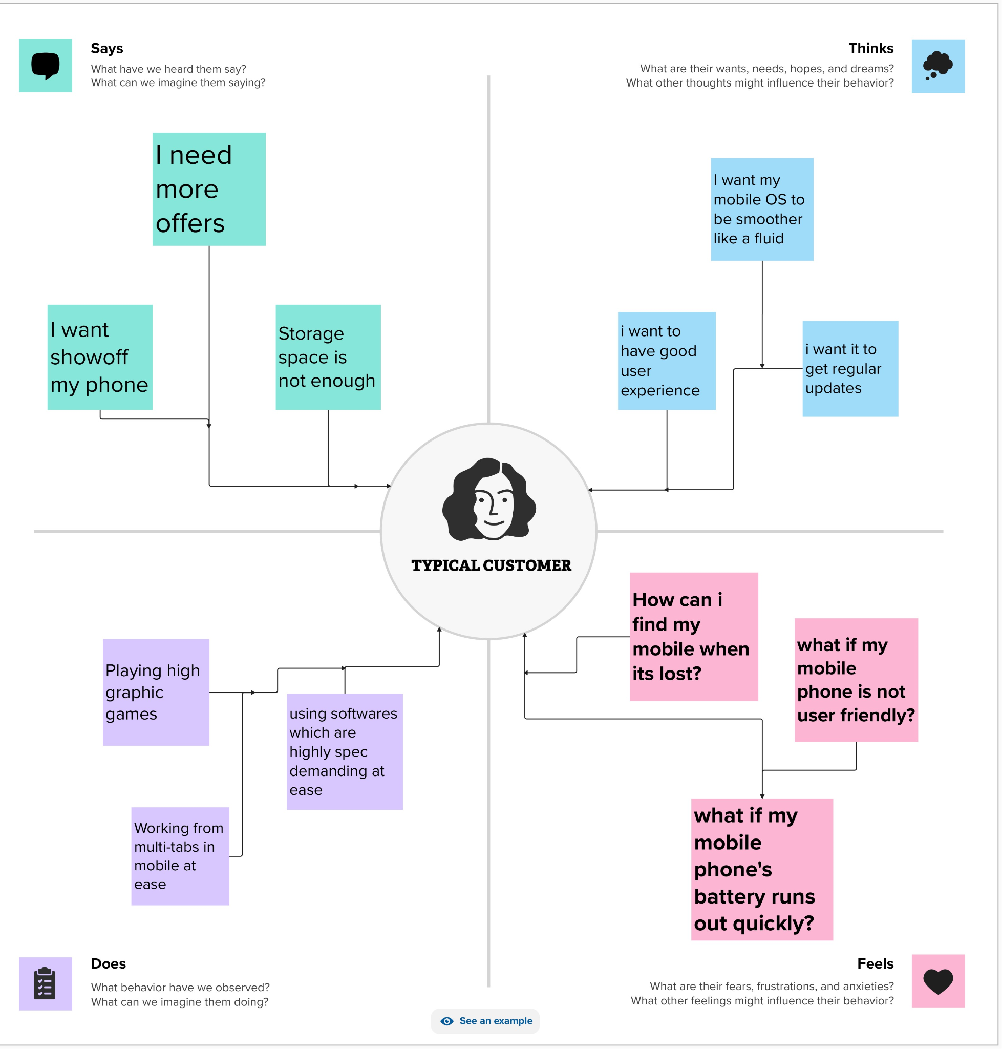

2.2 IDEATION & BRAINSTORMING MAP

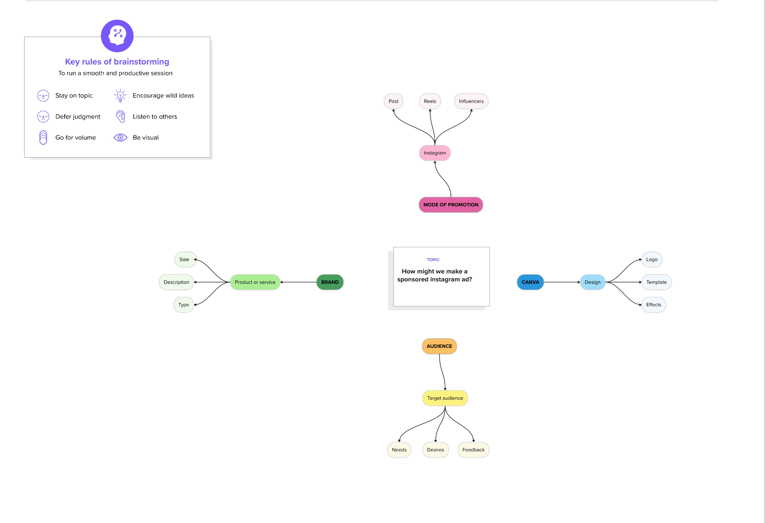

**3. RESULT:**

Hence, the project on Creating Blog using Wordpress Platform has been created by posting about the football match result with our blog named Footaball Pechu.

**4.ADVANTAGES AND DISADVANTAGES:**

Some of the advantages of blogging are,

1. Expressing Creativity: Blogging allows individuals to express themselves creatively, whether through writing, photography, artwork, or other forms of content creation.

2. Sharing Knowledge and Expertise: Bloggers can share their expertise and knowledge on specific topics, establishing themselves as authorities in their respective fields.

3. Building an Online Presence: Blogging is an effective way to establish and maintain an online presence, which can be valuable for personal branding and professional opportunities.

4. Content Marketing: For businesses, blogging is a fundamental component of content marketing. It can help attract and engage customers, build brand awareness, and drive website traffic.

5. Engaging with an Audience: Blogs enable direct interaction with readers through comments, social media, and email. This engagement can help build a loyal readership and a sense of community.

These are also some disadvantages of blogging are,

1. Time-Consuming: Creating high-quality blog content can be time-consuming,especially if you aim to publish regularly. Research, writing, editing, and a promoting content all require substantial time investments

2.Consistency Pressure: Maintaining a consistent posting schedule can be challenging, and irregular updates can lead to a loss of readership.

3.Competitive Landscape: The blogosphere is highly competitive, with millions of blogs covering a wide range of topics. It can be difficult to stand out and attract an audience.

Monetization Challenges: While blogging can be monetized, it often takes time to generate significant income. Many bloggers may struggle to make a sustainable living solely from their blogs

5.Content Quality Expectations: Readers expect high-quality, well-researched, and error-free content. Meeting these expectations can be demanding, especially for beginners

6. Technical Skills: Setting up and maintaining a blog may require technical skills,such as website management, search engine optimization, and basic coding knowledge.

**5. APPLICATION:**

The following are some of the applications of blogging

1.Personal Blogs: Individuals use personal blogs to share their experiences, and stories with a personal touch. These blogs often serve as onlinethoughts,diaries and creative outlets.

2.Professional Branding: Professionals, such as freelancers, consultants, and jobseekers, create blogs to showcase their expertise, work portfolio, and industry in sights. Blogging can enhance personal branding and career opportunities.

3.Educational Resources: Educational institutions, teachers, and educators maintain blogs to share educational content, resources, lesson plans, and updates with students and the broader educational community

4.Content Marketing: Businesses use blogs as a core component of their content a marketing strategy. Blogs help attract and engage customers, promote products or services, and establish industry authority.

5.Corporate Blogs: Companies maintain corporate blogs to communicate with customers, employees, and stakeholders. These blogs can provide updates, share industry insights, and offer a humanized look at the company

6.News and Journalism: Many news organizations and journalists maintain blog so complement their traditional reporting. Blogs allow for more informal and personalized storytelling.

7.Photoblogs: Photographers use photoblogs to showcase their work and tell visual stories. They often provide insight into their creative process and share photography tips.

**6.CONCLUSION:**

In this project, we focused on creating a visually captivating blog for marketing our

page, ‘Football Pechu’ on Wordpress. Through striking design and compelling visuals, we

aimed to enhance brand recognition and engagement. This project exemplifies the

power ofa well-crafted poster in making a strong visual impact on Instagram,

showcasing the brand's identity and products effectively.