**Question 1: Crate a table Empl to store the below data’s**

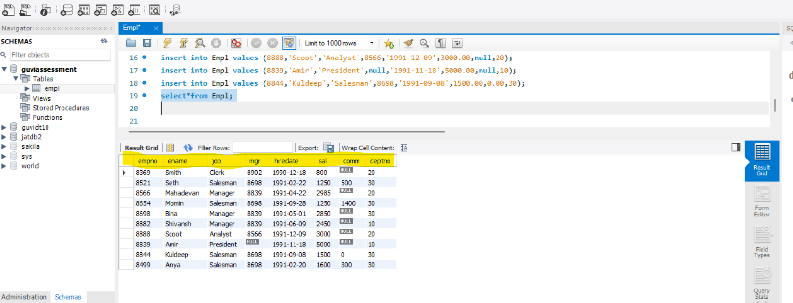

1. **Display Name and Sal of employees whose salary greater than or equal to 2200**

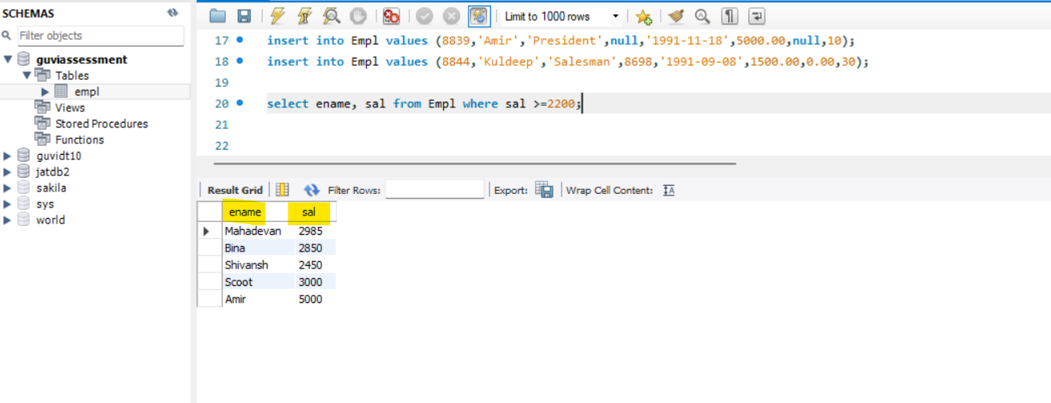

1. **Display details of employees, who are not getting commission**

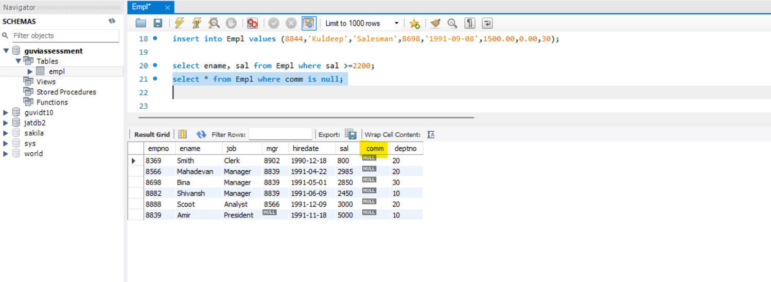

1. **Display names and Sal of employees, who don’t have salary range between 2500 to 4000**

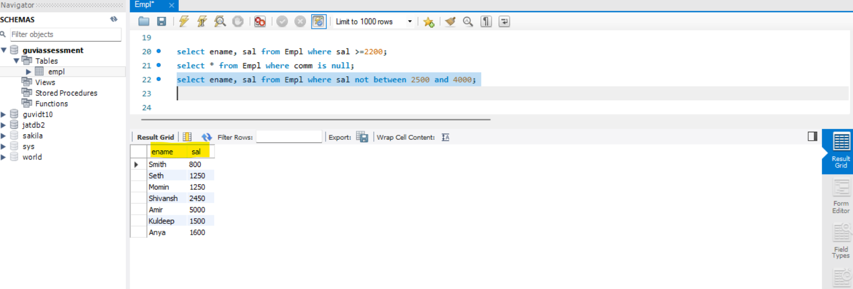

1. **Display names, job title and salary of employees, who don’t have manager**

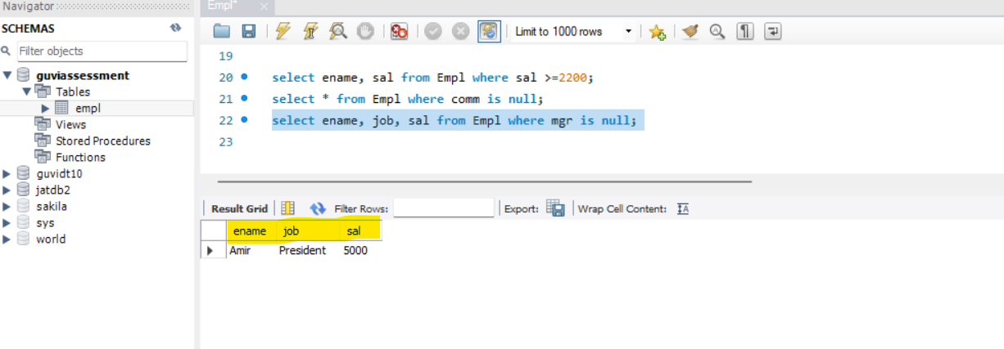

1. **Display names of an employees, whose name contains ‘A’ as third alphabet**

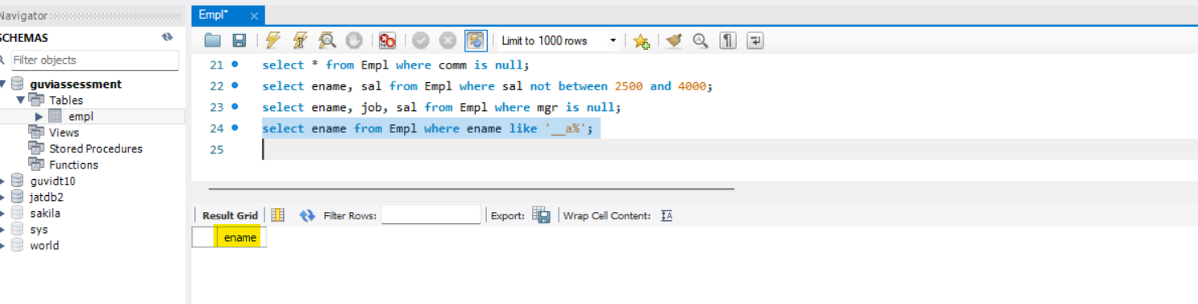

1. **Display names of an employees, whose name contains ‘T’ as the last alphabet**

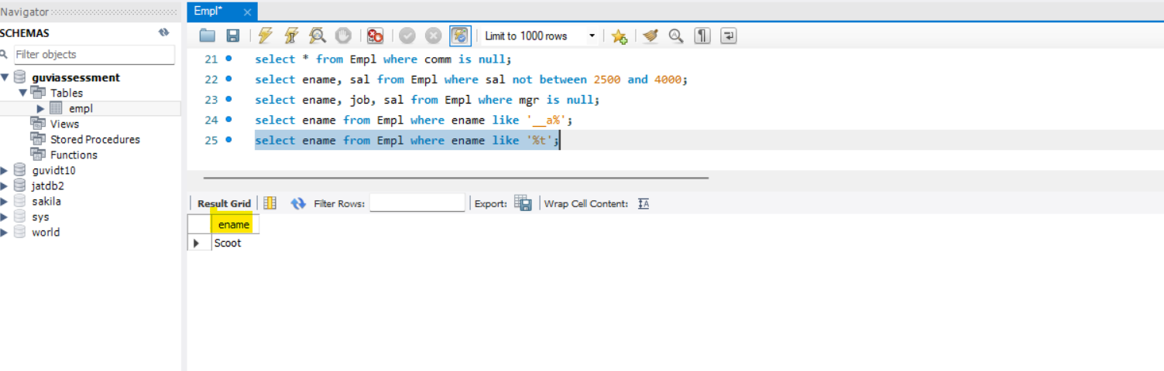

**2) Program for JDBC connectivity and insert the data**

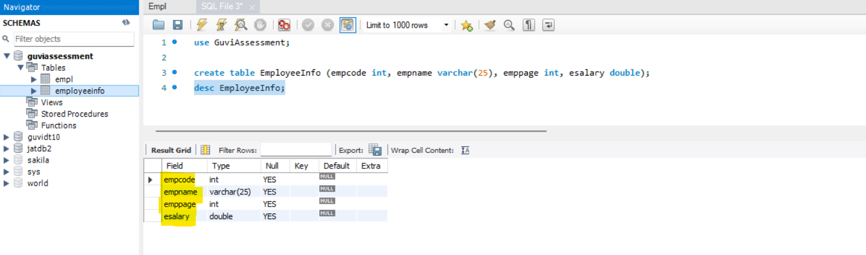

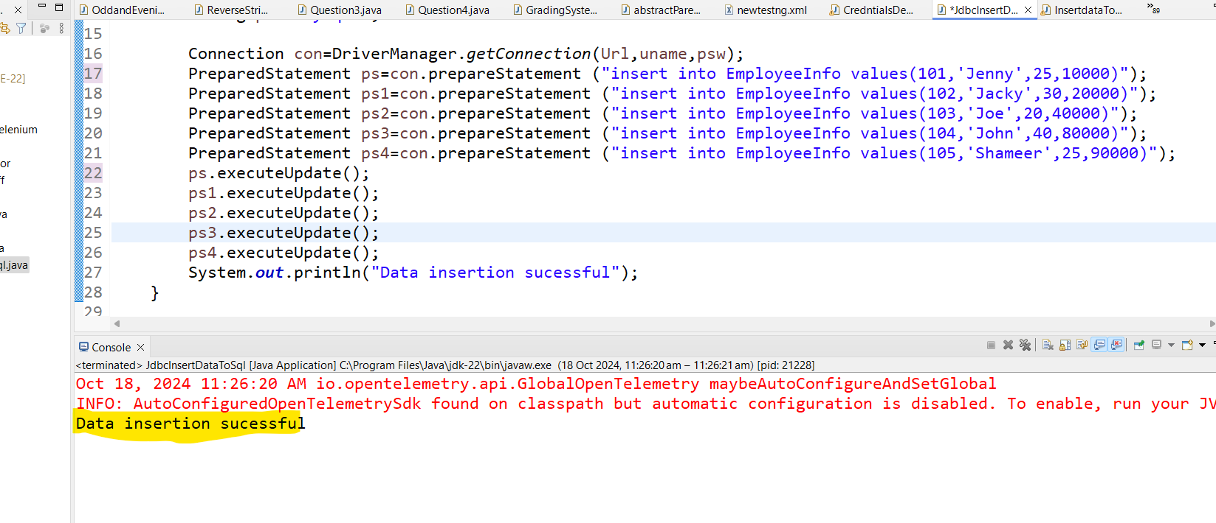

**Approach1: inserting data to Sql**

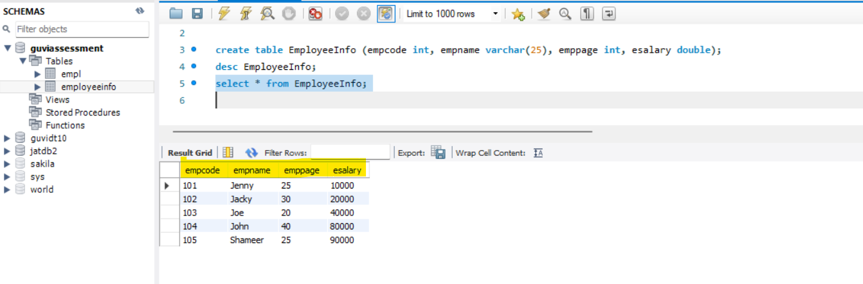

**Approach 2: Inserting data to Sql**