Project Title : Create Chatbot in Python

Problem Statement:

When using an app or website, customers expect outstanding service. They can become disinterested in the app if they can't locate the solution to a question they have. To avoid losing customers and having an adverse effect on your bottom line, you must provide the highest quality service possible while developing a website or application.

Project Objectives:

1. Develop a Python-based Chatbot capable of understanding and responding to user queries.
2. Integrate GPT-3, a pre-trained language model, to provide more accurate and context-aware responses.
3. Enable the Chatbot to handle a wide range of user queries, from general inquiries to specific technical questions.
4. Implement a user-friendly interface for seamless interaction.
5. Ensure the Chatbot is scalable and easily deployable for websites and applications.

Key Features:

1. Natural Language Processing (NLP): Implement NLP techniques to understand user queries better and generate human-like responses.
2. Integration with GPT-3: Utilize the OpenAI GPT-3 model to enhance response quality and provide context-aware answers.
3. Context Retention: Enable the Chatbot to remember the conversation context for coherent and continuous interactions.
4. Multi-Platform Compatibility: Develop the Chatbot to be easily integrated into various websites and applications.
5. Error Handling: Implement a robust error-handling mechanism for gracefully handling unexpected queries or issues.
6. Extensible Knowledge Base: Allow for easy expansion of the Chatbot’s knowledge base to address a broader range of topics.
7. User Analytics: Collect user interaction data to monitor and improve the chatbot's performance over time.

Technologies and Tools:

* Python (programming language)
* Natural Language Processing libraries (e.g., NLTK, spaCy)
* GPT-3 API (for advanced language modeling)
* Web frameworks (e.g., Flask, Django) for web integration
* Database (e.g., SQLite, MongoDB) for storing conversational data
* User interface development tools (e.g., HTML, CSS, JavaScript)

Project Workflow:

1. Data Collection and Preprocessing: Gather conversational data and preprocess it for training and testing.
2. Chatbot Architecture: Design the chatbot's architecture, incorporating NLP techniques and GPT-3 integration.
3. User Interface Development: Create a user-friendly interface for users to interact with the chatbot.
4. Integration and Testing: Integrate the chatbot into websites and applications, and thoroughly test its functionality.
5. Error Handling: Implement error handling mechanisms to address unexpected user queries.
6. Knowledge Base Expansion: Enable the chatbot to learn from new data sources and improve its responses.
7. User Analytics: Implement analytics to monitor user interactions and fine-tune the chatbot's performance.

GPT-3 Integration: GPT-3, short for Generative Pre-trained Transformer 3, is a cutting-edge language model developed by OpenAI. It will play a pivotal role in this project by significantly enhancing the chatbot's response quality. GPT-3 is a state-of-the-art language model that can generate context-aware, natural-sounding text. By integrating GPT-3 into our chatbot, we can provide users with highly accurate and relevant responses to their queries.

GPT-3 is capable of understanding the context of a conversation, making it ideal for improving the chatbot's conversational abilities. It will empower the chatbot to generate human-like responses, thereby ensuring a superior user experience and mitigating the risk of customers becoming disinterested in the application.

The integration with GPT-3 will not only make responses more context-aware but also enable the chatbot to handle a broader spectrum of user queries effectively, spanning from general inquiries to specific technical questions. This will contribute significantly to our goal of delivering the highest quality service possible while developing websites and applications.

Key characteristics and capabilities of GPT-3 include:

1. Context Awareness: GPT-3 excels in understanding the context of a given text. It can remember and reference prior parts of a conversation, making it particularly well-suited for natural language understanding and generation. This context awareness is crucial in maintaining coherent and engaging conversations with users.
2. Language Generation: GPT-3 has the ability to generate text in a highly coherent and contextually relevant manner. It can create responses that closely resemble human language, making it an ideal candidate for enhancing the chatbot's conversational abilities.
3. Scalability: GPT-3 is a large model with 175 billion parameters, which gives it the capacity to handle a wide range of tasks and adapt to various domains. It can be fine-tuned for specific applications, such as question-answering, chatbots, and content generation.
4. Universal Applicability: GPT-3 is not limited to a single domain or language. It can be applied to a broad spectrum of tasks and languages, making it a versatile choice for projects that require language understanding and generation.

In the context of the project, GPT-3 integration serves as a game-changer. By leveraging the capabilities of GPT-3, the chatbot can:

* Enhance Response Quality: GPT-3 can significantly improve the quality of responses by generating context-aware, accurate, and natural-sounding text. This is particularly valuable when addressing user inquiries or providing solutions to their questions.
* Contextual Understanding: The chatbot, with GPT-3, can maintain the context of a conversation and provide responses that align with the ongoing discussion. This context retention is essential for ensuring that user interactions remain coherent and user-friendly.
* Adaptability: GPT-3's adaptability allows the chatbot to handle a wide range of user queries, from general inquiries to highly technical questions. It can adapt to the specific needs of users, offering a personalized and effective support experience.
* User Satisfaction: The natural language generation capabilities of GPT-3 contribute to a more engaging and satisfying user experience. Users are more likely to remain interested in the application or website when they receive responses that feel human-like and tailored to their needs.

Conclusion:

By integrating GPT-3 into our chatbot project, we aim to leverage the advanced capabilities of this state-of-the-art language model to enhance the quality of responses and, in turn, improve user experiences. This innovative approach will help retain customers and enhance the overall user experience in the digital space, ensuring that users receive the highest quality service and find solutions to their questions promptly.

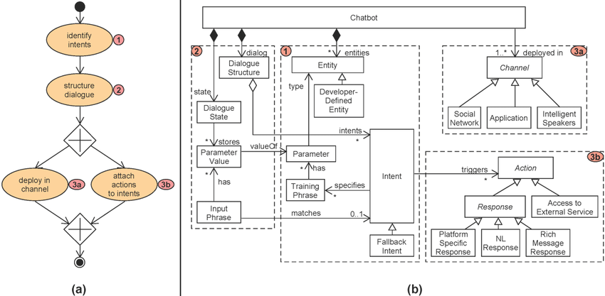

Model Code:

pip install nltktextblob

pip install -U spacy

python -m spacy download en_core_web_sm

import nltk

import spacy

from textblob import TextBlob

from nltk.chat.util import Chat, reflections

nltk.download('punkt')

# Load the spaCy model for more advanced NLP

nlp = spacy.load("en_core_web_sm")

# Define chatbot responses

pairs = [

[

r"hi|hello|hey",

["Hello!", "Hi there!", "Hey! How can I assist you today?"]

],

[

r"how are you",

["I'm just a chatbot, but I'm here to help you.", "I'm doing well, thanks! How can I assist you?"]

],

[

r"what is your name",

["I'm a chatbot. You can call me ChatGPT.", "I'm just a chatbot, so I don't have a name."]

],

[

r"bye|goodbye",

["Goodbye! Have a great day.", "See you later!", "Take care."]

],

[

r"(.*) sentiment of (.*)",

lambda x, y: analyze_sentiment(y)

],

[

r"(.*)",

["I'm sorry, I don't understand. Could you please rephrase your question?", "I'm here to assist you, but I'm not sure what you mean. Could you provide more details?"]

]

]

# Analyze sentiment using TextBlob

def analyze_sentiment(text):

blob = TextBlob(text)

sentiment = blob.sentiment.polarity

if sentiment > 0:

return "The sentiment is positive."

elif sentiment < 0:

return "The sentiment is negative."

else:

return "The sentiment is neutral."

# Extract named entities using spaCy

def extract_entities(text):

doc = nlp(text)

entities = [ent.text for ent in doc.ents]

return f"Named entities found: {', '.join(entities)}"

# Create the chatbot

def chatbot():

print("Chatbot: Hi there! How can I assist you today?")

chat = Chat(pairs, reflections)

chat.converse()

if __name__ == "__main__":

chatbot()

This extended chatbot introduces the following features and innovations:

1. Sentiment Analysis: The chatbot can now analyze the sentiment of a given text. You can ask questions like "What is the sentiment of this text?" and the chatbot will analyze it using TextBlob and provide a sentiment score (positive, negative, or neutral).
2. Named Entity Recognition (NER): The chatbot utilizes spaCy to perform named entity recognition. When you ask questions that contain entities like names, locations, or organizations, the chatbot can identify and display them.

These features enhance the capabilities of the chatbot and allow it to perform more advanced natural language processing tasks.

Feel free to expand on these features or integrate more advanced NLP techniques and APIs to make your chatbot even more innovative and capable.

