Midterm Group Project - Part 3: Adding Cassandra for Real-Time Order Ingestion

Part 1: Setup & Cassandra Exploration
Task 1.1: Start the Part 3 Environment
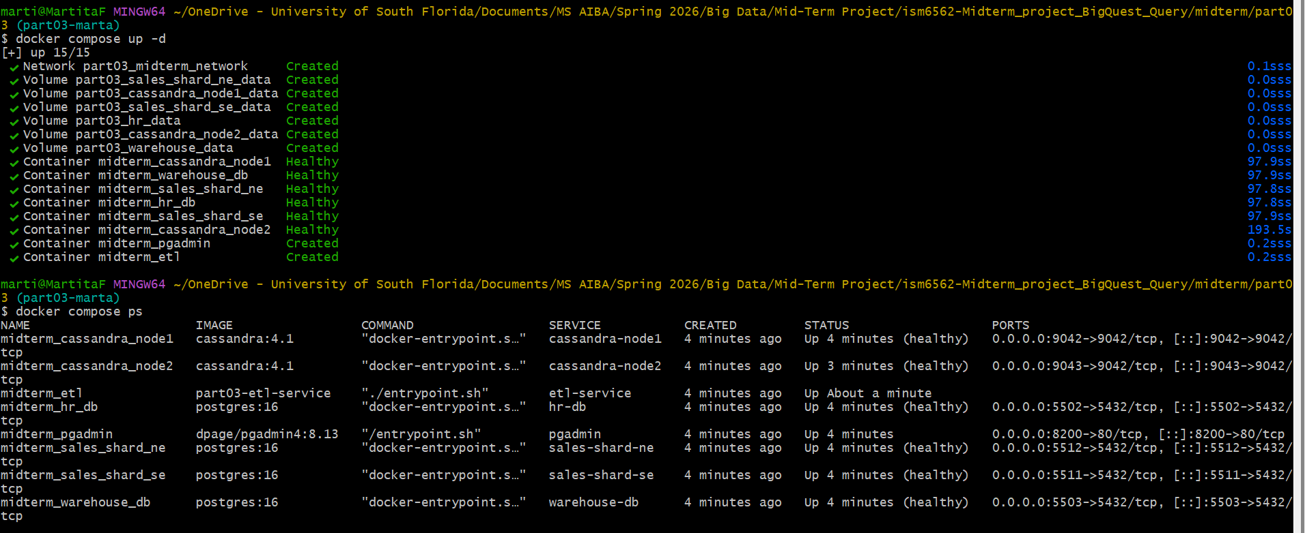
Task 1.2: Explore the Cassandra Cluster
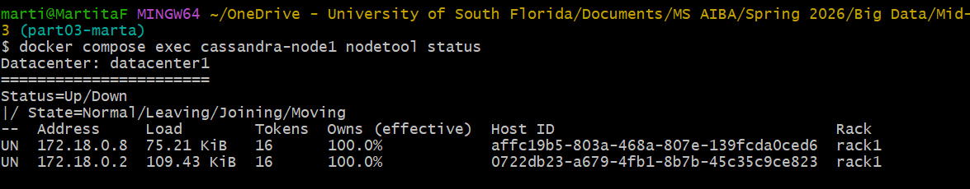
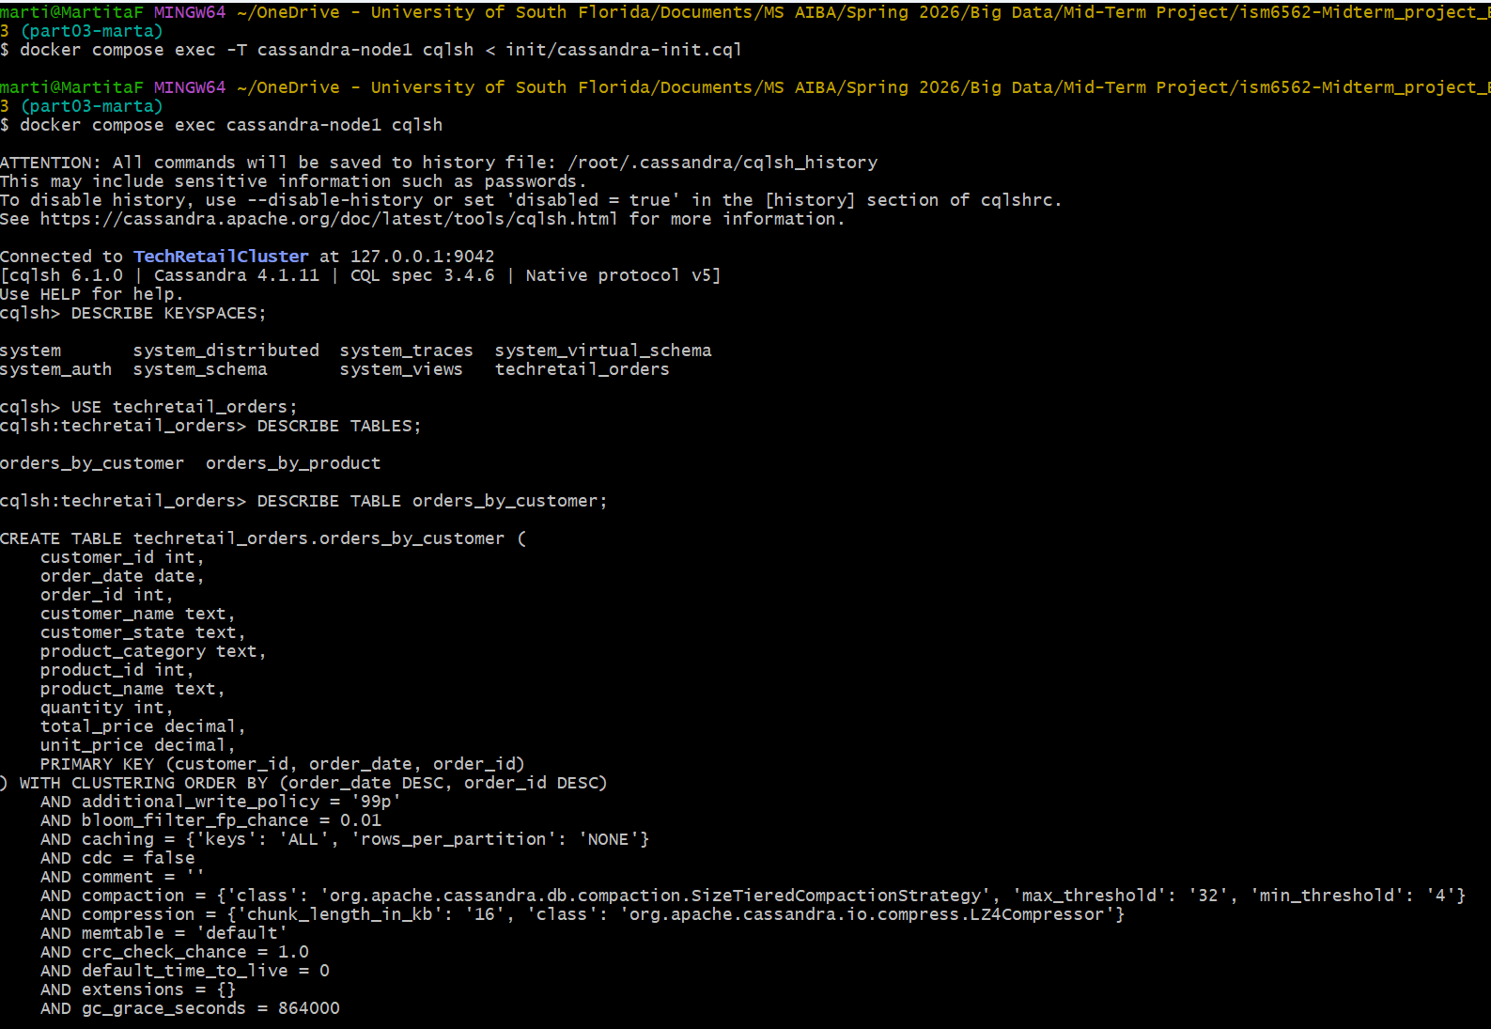
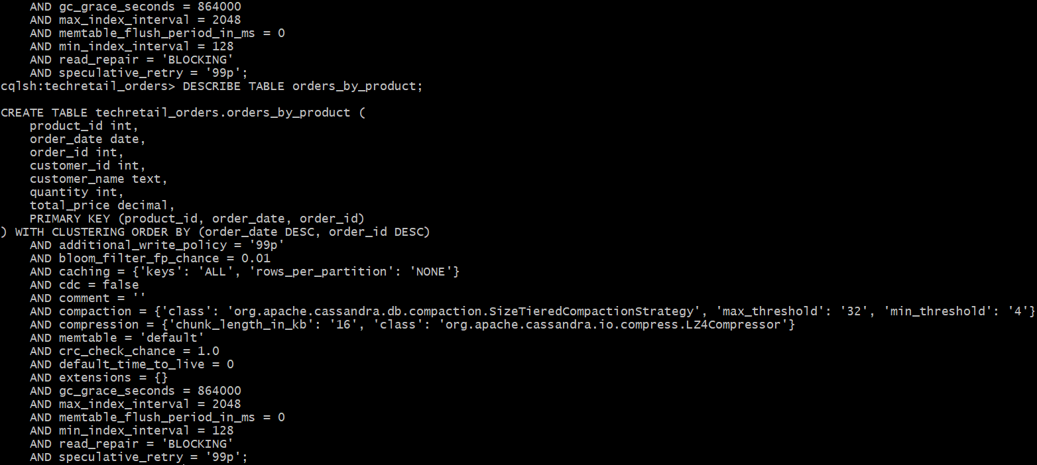

Task 1.3: Compare Cassandra and PostgreSQL Table Design
Written Response (150–200 words): Compare the orders_by_customer Cassandra table to the PostgreSQL orders table from Part 1. Specifically address:
- Why does the Cassandra table include customer_name and customer_state directly in each order row, while PostgreSQL stores this in a separate customers table with a foreign key?
The Cassandra table includes customer_name and customer_state directly in each order row because denormalization is a good practice in Cassandra. It follows a query-first design, where tables are built to support specific queries. Since JOINs across nodes are not efficiently supported, data is duplicated so all required information can be retrieved in a single query. In contrast, PostgreSQL uses normalization and foreign keys to reduce redundancy and relies on JOINs to combine related data.
- Why are there TWO Cassandra tables (orders_by_customer and orders_by_product) for what is essentially the same order data?
There are two Cassandra tables with repetitive order data because each table is designed to serve a specific query. Cassandra tables are created based on how data will be accessed, and since JOINs across tables are costly, data is duplicated to allow efficient querying. The orders_by_customer table supports queries by customer, while orders_by_product supports queries by product, each including all necessary order information.

Part 2: Query-First Design Analysis
Task 2.1: Run Valid Cassandra Queries
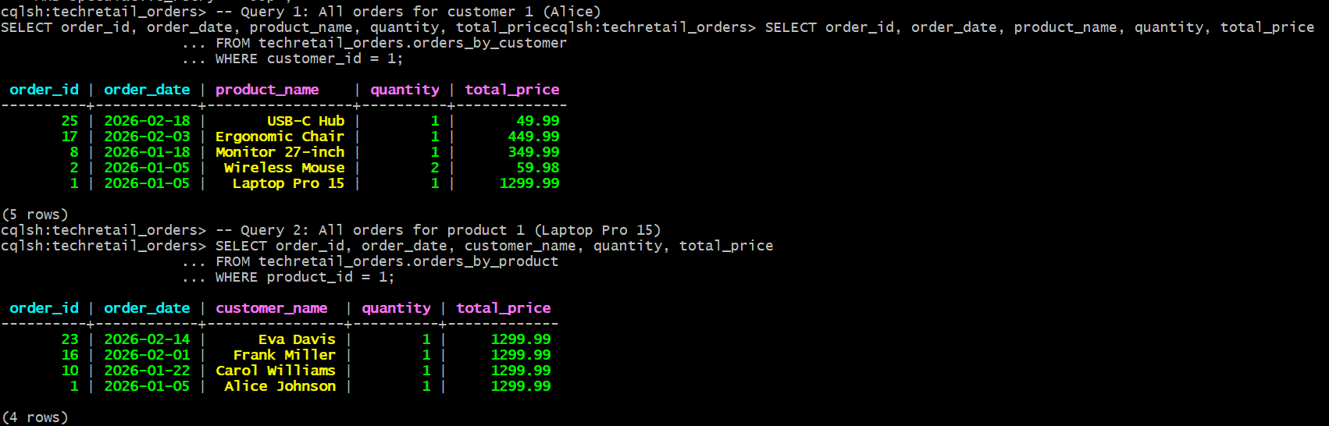
Task 2.2: Attempt an Invalid Query
Written Response (100–150 words): Explain why Cassandra rejects this query. How does the partition key design of orders_by_customer (partition key = customer_id) relate to how Cassandra stores and retrieves data? How does query-first design address this limitation?
Cassandra rejects this query because the orders_by_customer table is partitioned by customer_id, meaning data is physically stored based on that key. If a query filters by product_id instead, the data may be spread across multiple partitions, making it inefficient or unsupported to retrieve. Cassandra stores and retrieves data by partition key, so queries must include the partition key to efficiently locate data. Without it, Cassandra would need to scan multiple partitions, which it avoids by rejecting the query.
Query-first design addresses this limitation by creating tables tailored to specific query patterns. Instead of relying on flexible queries, Cassandra denormalizes data and creates separate tables, such as orders_by_product, to support different access patterns without requiring cross-partition operations.

Part 3: Write Orders to Cassandra
Task 3.1: Insert a New Order into Both Tables
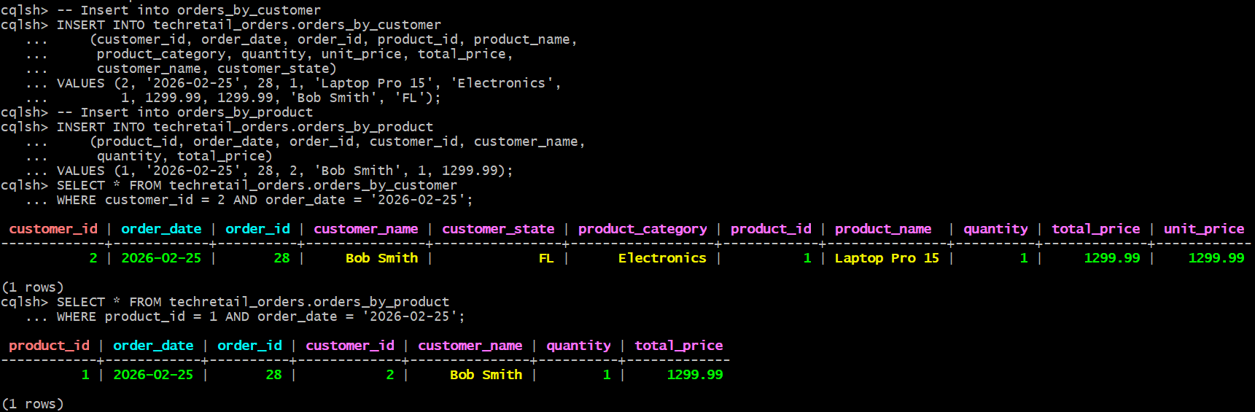
Task 3.2: Dual-Write Consistency Challenge
Written Response (100–150 words): What happens if one INSERT succeeds and the other fails? For example, the order appears in orders_by_customer but not in orders_by_product. How would you handle this in production? Connect your answer to Cassandra’s logged batch statements (covered in Week 5).
If one INSERT succeeds and the other fails, it creates data inconsistency because the order would exist in one table but not in the other. This can lead to incomplete query results depending on which table is queried. Simply retrying the failed insert could also introduce issues if not handled carefully. In production, this can be addressed using Cassandra’s logged batch statements. A logged batch ensures that all updates are written to a batch log before being applied, allowing Cassandra to retry failed operations and maintain consistency across tables. While it does not provide full ACID guarantees, it helps ensure that either all updates are eventually applied or the system can recover and complete them, reducing the risk of partial writes.

Part 4: Update ETL Pipeline
Task 4.1: Analyze the Current ETL Script
Written Response (100–150 words): The current ETL extracts orders from the PostgreSQL shards. You need to change it to extract orders from Cassandra instead. Identify what needs to change:
- What new Python import is needed? (from cassandra.cluster import Cluster)
The new ETL needs to extract orders from Cassandra instead of PostgreSQL shards, therefore we need: from cassandra.cluster import Cluster.
- What new function would you write to extract orders from Cassandra?
To extract orders from Cassandra I would write the new function: extract_orders_from_cassandra(). This function would query the appropriate keyspace and retrieve order data.
- Which existing lines in run_etl() need to change?
These are the lines that would need to change since they are pulling orders from PostgreSQL.
# Extract from SE shard
se_conn = get_connection("SALES_SHARD_SE")
se_customers, se_products, se_orders = extract_sales_from_shard(se_conn, "sales-shard-se")
se_conn.close()

# Extract from NE shard
ne_conn = get_connection("SALES_SHARD_NE")
ne_customers, ne_products, ne_orders = extract_sales_from_shard(ne_conn, "sales-shard-ne")
ne_conn.close()

# Merge shard results
customers = se_customers + ne_customers
products = se_products # Products are identical on both shards (reference table)
orders = se_orders + ne_orders

- What stays the same? (Customer and product extraction from PostgreSQL, all transform and load phases)
Customer and product extraction from the PostgreSQL shards remains unchanged, including the connections and use of extract_sales_from_shard(). The extraction of employee data from the HR database also stays the same. Additionally, all transformation steps and the loading process into the data warehouse remain unchanged.

Task 4.2: Modify the ETL to Extract from Cassandra
- Add the Cassandra import at the top of the file:
import os
import sys
from datetime import date, timedelta

from cassandra.cluster import Cluster
import psycopg2
from psycopg2.extras import execute_values

- Add a new function to extract orders from Cassandra:

def extract_orders_from_cassandra():
"""Extract orders from Cassandra's orders_by_customer table."""
hosts = os.environ["CASSANDRA_HOSTS"].split(",")
keyspace = os.environ["CASSANDRA_KEYSPACE"]
cluster = Cluster(hosts)
session = cluster.connect(keyspace)

# Query all orders — need to get all customer_ids first
# For simplicity, query with a full table scan (small dataset)
rows = session.execute("SELECT order_id, customer_id, product_id, quantity, total_price, order_date FROM orders_by_customer")

# Deduplicate by order_id (in case of overlapping partitions)
seen = set()
orders = []
for row in rows:
if row.order_id not in seen:
seen.add(row.order_id)
orders.append((
row.order_id,
row.customer_id,
row.product_id,
row.quantity,
float(row.total_price),
row.order_date.date()
))

print(f" Extracted {len(orders)} orders from Cassandra")
cluster.shutdown()
return orders

- In run_etl(), replace the order extraction from PostgreSQL shards with the Cassandra function. Keep customer and product extraction from PostgreSQL.
def run_etl():
"""Execute the full ETL pipeline."""
print("=" * 60)
print("ETL Pipeline Starting")
print("=" * 60)

# --- EXTRACT ---
print("\n[EXTRACT] Reading from operational databases...")

# Extract from SE shard
se_conn = get_connection("SALES_SHARD_SE")
se_customers, se_products, _ = extract_sales_from_shard(se_conn, "sales-shard-se")
se_conn.close()

# Extract from NE shard
ne_conn = get_connection("SALES_SHARD_NE")
ne_customers, ne_products, _ = extract_sales_from_shard(ne_conn, "sales-shard-ne")
ne_conn.close()

# Merge shard results
customers = se_customers + ne_customers
products = se_products # Products are identical on both shards (reference table)
orders = extract_orders_from_cassandra()
print(f" Merged: {len(customers)} customers, {len(products)} products, {len(orders)} orders")

hr_conn = get_connection("HR")
employees = extract_hr(hr_conn)
hr_conn.close()

# --- TRANSFORM ---
print("\n[TRANSFORM] Preparing dimension data...")
dim_date_rows = generate_dim_date_rows(2026)
print(" Employee dimension: denormalized with department info (done in extract query)")

# --- LOAD ---
print("\n[LOAD] Writing to data warehouse...")
wh_conn = get_connection("WAREHOUSE")
cur = wh_conn.cursor()

load_dim_date(cur, dim_date_rows)
load_dim_customer(cur, customers)
load_dim_product(cur, products)
load_dim_employee(cur, employees)
load_fact_sales(cur, orders)

wh_conn.commit()
cur.close()
wh_conn.close()

print("\n" + "=" * 60)
print("ETL Pipeline Complete")
print("=" * 60)

Modified ETL code:
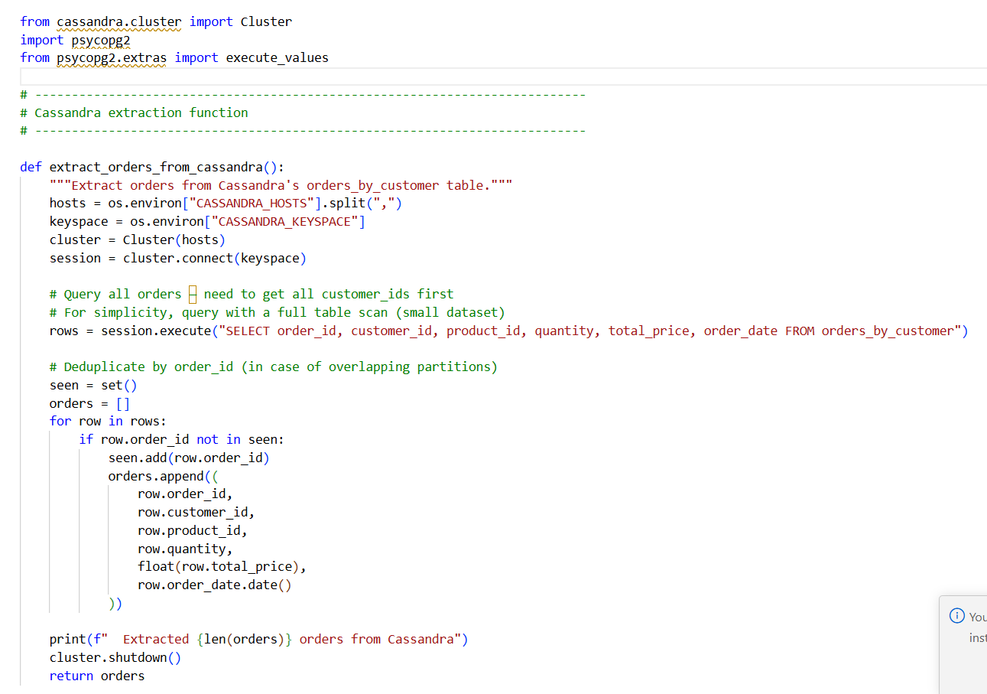
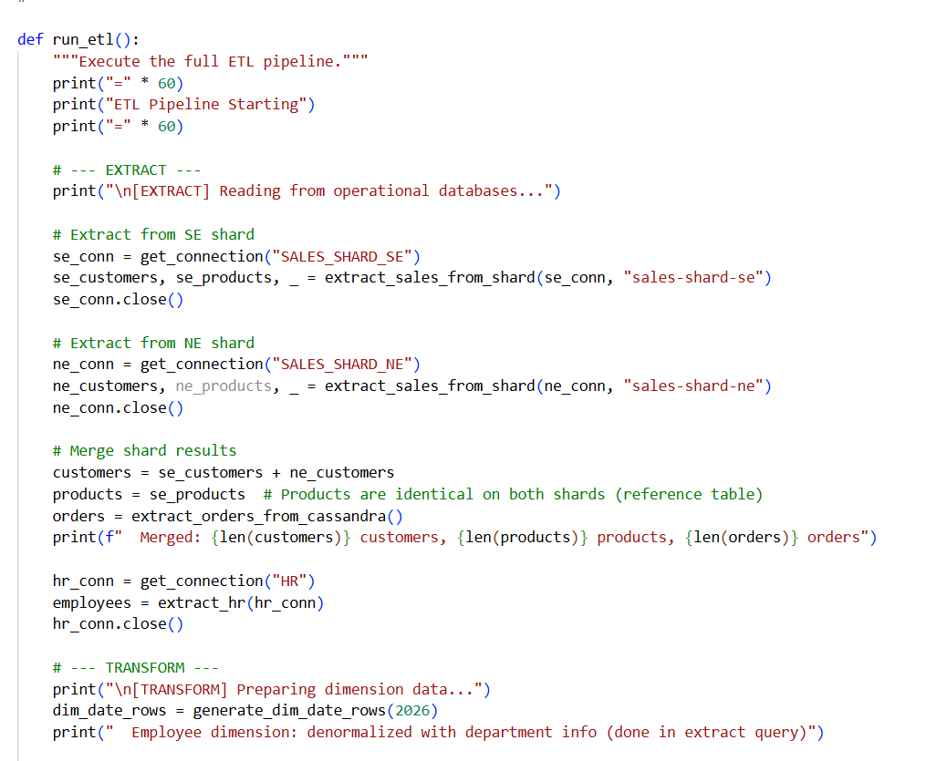

Successful output: 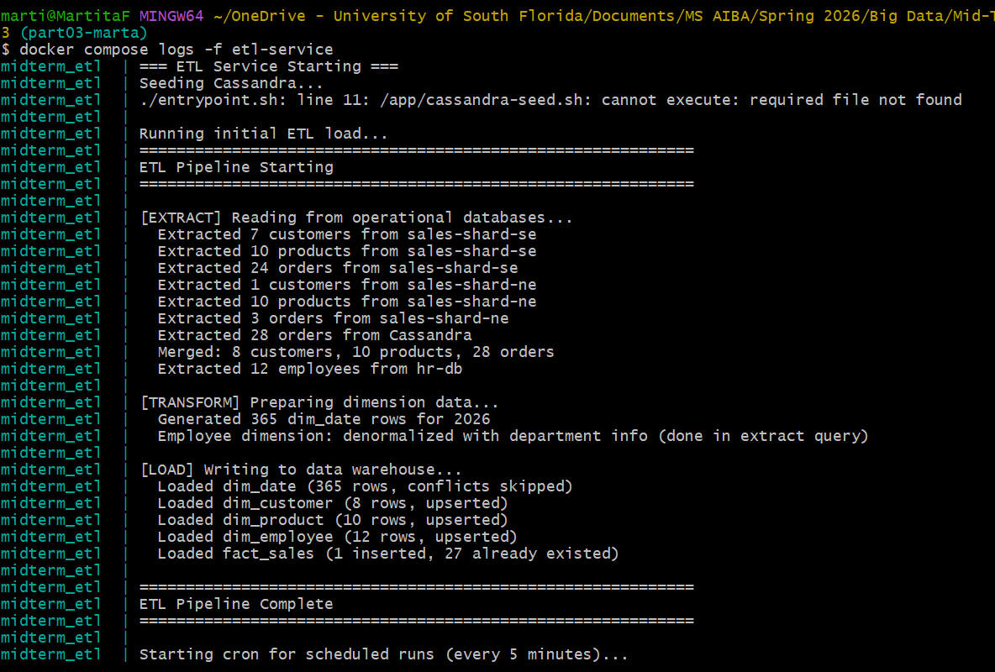

Warehouse verification:
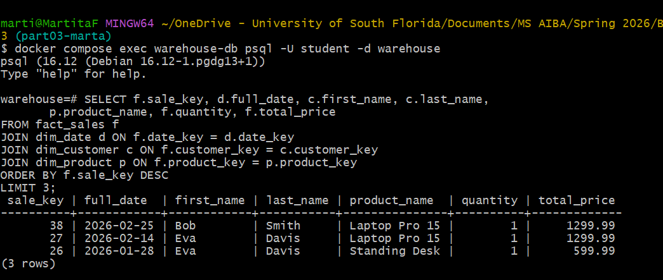

Part 5: Polyglot Persistence Reflection
Task 5.1: Compare the Three Database Roles
Create a comparison table and written response.
Aspect | PostgreSQL (Shards) | Cassandra (Ingestion) | PostgreSQL (Warehouse)
Primary role | Transactional system (OLTP) storing operational data across shards | High-throughput ingestion layer for scalable writes | Analytics for reporting and querying (OLAP)
CAP positioning | CA | AP | CA
Consistency model | Strong consistency (ACID transactions) | Tunable consistency (eventual consistency by default) | Strong consistency (ACID, reliable reporting)
Best for | Structured transactions, joins, normalized data | High write throughput, distributed data, scalability | Complex queries, aggregations, business intelligence
Limitation | Hard to scale horizontally, expensive joins across shards | Limited joins, data duplication, eventual consistency | Not optimized for high-frequency writes, slower ingestion, only vertical scaling

Written Response (200–250 words): Explain how each database technology in this architecture serves a different purpose and why a single database technology cannot efficiently handle all three roles.
Each database technology in this architecture serves a different purpose based on its strengths. PostgreSQL shards are best suited for ACID transactions and reference data, as they efficiently handle structured transactions and normalized data. However, for high-velocity write workloads, Cassandra is the better choice because it provides high write throughput, scalability, and distributed data handling. Finally, for analytical queries on a star schema, the PostgreSQL data warehouse is the most appropriate option, as it can efficiently support complex queries, joins, and relationships.

Task 5.2: Argue For or Against Cassandra as a Warehouse (2 pts)
Written Response (200–250 words): Argue for or against replacing the PostgreSQL warehouse with Cassandra for analytical queries. Consider the following:
- Can Cassandra support star schema JOINs between fact and dimension tables?
Cassandra does not support star schema JOINs between fact and dimension tables because it follows a query-first design. Since Cassandra distributes data across partitions, performing joins across partitions is inefficient and not supported in the same way as relational databases. Instead, data is denormalized and tables are designed to match query patterns.
- How does Cassandra handle GROUP BY aggregations compared to PostgreSQL?
Cassandra only allows grouping on columns that are part of the partition key and does not support aggregations across large datasets or multiple partitions efficiently. In many cases, queries require the use of ALLOW FILTERING, which can lead to full table scans and poor performance. In contrast, PostgreSQL fully supports GROUP BY operations, enabling efficient aggregations, complex queries, and analytical functions across entire tables.
- What consistency guarantees do analytical workloads typically require?
Analytical workloads typically require strong consistency to ensure that query results are accurate, complete, and reliable. Since these workloads are used for reporting and decision-making, they rely on consistent and stable data rather than eventually consistent data that may be temporarily outdated or incomplete.
- Is Cassandra’s query-first design compatible with ad-hoc analytical queries?
Cassandra’s query-first design is not compatible with ad-hoc analytical queries because tables must be designed in advance based on known query patterns.
Expected conclusion: Cassandra is a poor fit for the warehouse role because (1) it does not support JOINs needed for star schema queries, (2) GROUP BY aggregations require ALLOW FILTERING and are inefficient, (3) analytical workloads need strong consistency for accurate reporting, and (4) the query-first design requires knowing all queries in advance, which conflicts with ad-hoc analytics.

