This is sample application , intended to show the functionalities of fabric-node-sdk and interaction with chaincode

Chain code concepts covered :

* 1. Transaction with StateData

* 2. Endorsement policy

* 3. Private Data Collection

* 4. Transaction History

* 5. Query - pagination, composite key

* 6. Rich Query - Couch Db - index, Pagination

fabric-node-sdk concepts covered :

* 1. fabric-network package

* 2. wallets

please note : fabric-network package provides higher level abstraction for chaincode interaction.

Ex. conenct to the network and invoke/Query the chain code.

fabric-client package provides full access to the network.

Ex access on network,channel,peer,chaincodeinstall/instantiate/upgrade/endorsement/PDC

### In this project we only used fabric-nerwork package ###

prerequisite: nerwork is up and chaincode is already instantiated in the nerwork.

Folder name : go/contract

This file contains chaincode implementation.

contract.go - Entry point of chaincode also PDC implementation. Please start from this file

pagination.go - Implementation of Range With Pagination concepts.

It works with state levelDB

compositequery.go - Implementation of composite key with state levelDB

getEmployeeById.go - Rich Query : GetQueryResult function

userQuery.go - Rich Query

getEmployeeByCompany.go - Rich Query with Pagination

pcollection.json - Contains (Private data collection) PDC rule

META-INF - Contains index rule

add2000employees.sh - It creates 2000+ employee records in the couch Db, use it only if requied

Folder name : contract-app

This folder contains fabric-node-sdk implementation.

app.js - Rest Api implementation.

dispatcher/wallet-dev.js - Add/list/export user identity context(certificate and private keys)

dispatcher/gateway-dev.js - Implementation of fabric-nerwork package. Used to connect to the nerwork and perform Invoke/Query operations

connection-profiles - contains network details

crypto-config - contains crypto-files of user. this is created by cryptogenx tool

contract.postman_collection.json - please import this collection to access all REST API from postman

As represented in the below diagram, in this project we developed client SDK using fabric-network package and chaincode using Go language.

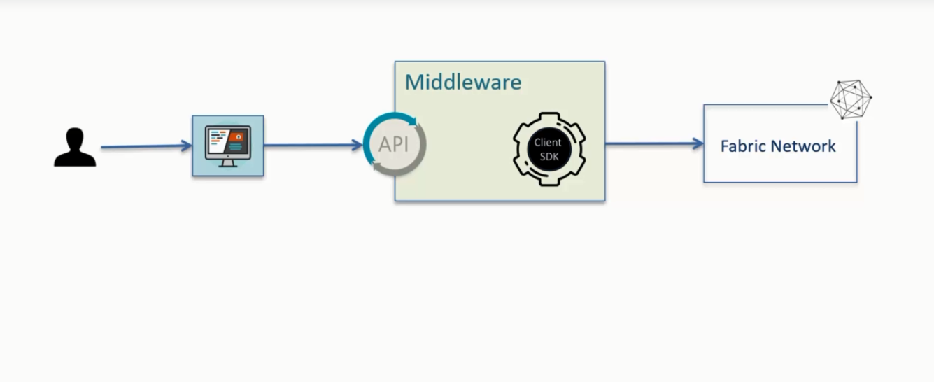

The client-sdk code flow is explained in the below diagram.

