Project Compass
Technical Specification & Project Completion Report

Document Version: 1.2
Status: Production Ready / Handover
Date: May 6, 2026

1. Executive Summary
Project Compass is an institutional-grade financial simulation solution that provides real-time, multivariate Monte Carlo simulations for investment portfolios. By transitioning to a Pure-Lambda architecture, the project achieves significant performance gains and operating cost reductions of over 95% compared to traditional instance-based hosting.

2. System Architecture & Resource Inventory
The architecture is designed for extreme scalability and zero maintenance. It leverages AWS managed services to handle load balancing, security, and compute automatically.
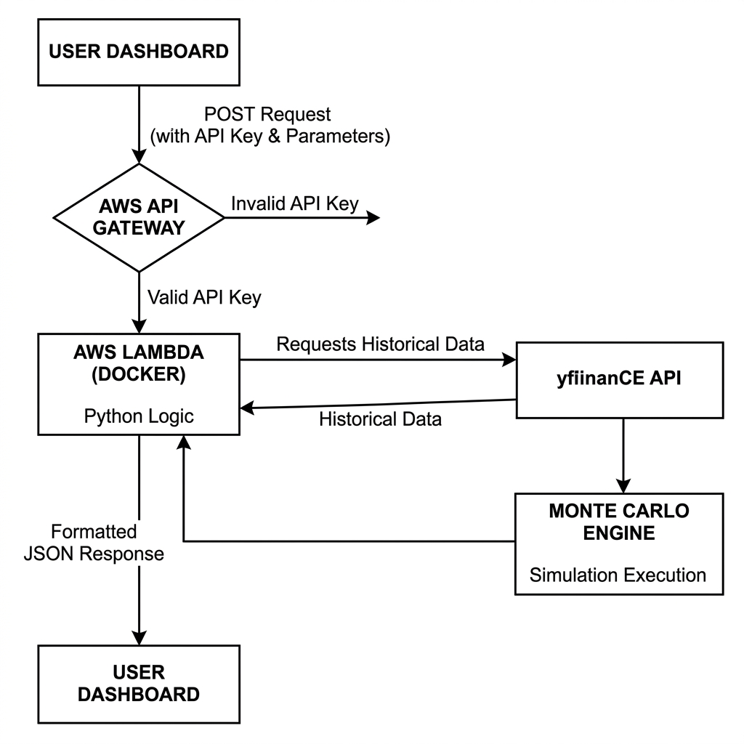

2.1 Cloud Resource Inventory
Resource | Function
AWS Lambda | Serverless compute (3008 MB RAM) running Dockerized math engine.
AWS API Gateway | Secure HTTP/2 interface with x-api-key protection.
AWS ECR | Elastic Container Registry hosting the engine image.
AWS IAM | Granular roles and policies for secure internal communication.
AWS S3 | Optional storage for audit logs and simulation snapshots.

3. Technical Specifications & Configurations
The engine is configured to balance precision, speed, and cost.
Configuration | Setting / Version
Runtime | Python 3.12 (Standard Lambda Environment)
Compute Architecture | Linux / x86_64 (AMD64)
Memory Allocation | 3,008 MB (Optimized for CPU Performance)
Execution Timeout | 29 Seconds (Aligned with API Gateway)
Math Library | NumPy (Vectorized / SIMD Acceleration)
Data Provider | yfinance (Resilient Multi-Period Fetching)
Simulation Logic | Multivariate Geometric Brownian Motion (Student-t)

4. API Reference Specification
The API is a RESTful service accepting POST requests.

4.1 Request Payload (Input)
Content-Type: application/json
{
"portfolio_id": "test_001",
"holdings": [
{"symbol": "RELIANCE.NS", "quantity": 10},
{"symbol": "TCS.NS", "quantity": 5}
],
"num_sims": 2000,
"horizon_months": 60
}

4.2 Response Payload (Output)
{
"portfolio_id": "test_001",
"current_value": 148893.50,
"scenarios": {
"optimistic": { "terminal_value": 175000.0, "cagr_pct": 3.5, "monthly_values": [...] },
"expected": { "terminal_value": 120000.0, "cagr_pct": -4.2, "monthly_values": [...] },
"pessimistic": { "terminal_value": 85000.0, "cagr_pct": -11.0, "monthly_values": [...] }
},
"probability_scores": {
"probability_of_profit": 25.5,
"probability_of_doubling": 0.8,
"var_drawdown_pct": 56.5
}
}

5. Cost Analysis & Scalability
Based on an estimated load of 1,000 active users performing 10 simulations per day (300,000 total requests/month):
Service | Usage Pattern | Cost (USD)
AWS Lambda | 1,000,000 Free Requests / Month | $ 0.00
AWS API Gateway | $ 1.00 per Million Requests | $ 0.30
AWS ECR Storage | 0.5 GB Image Storage | $ 0.05
Data Transfer | Standard Egress (Minimal JSON payload) | $ 0.05
Estimated Total | Monthly Operating Cost | $ 0.40

5. Future Roadmap

- Individual Stock Forecasting: Simulating paths for specific tickers from current value.
- Interactive What-if Analysis: Real-time UI sliders for adjusting allocations.
- Advanced Portfolio Rebalancing: AI triggers for risk-based reallocation.
- Global News Sentiment: Integration with Tavily API for news-weighted returns.

Project Compass - Confidential Technical Documentation

