**HyperText Markup Language**

Ex.No:1

<!--<HTML> TAG-->

<html>

<p>welcome</p>

<p>welcome to IT Department</p>

</html>

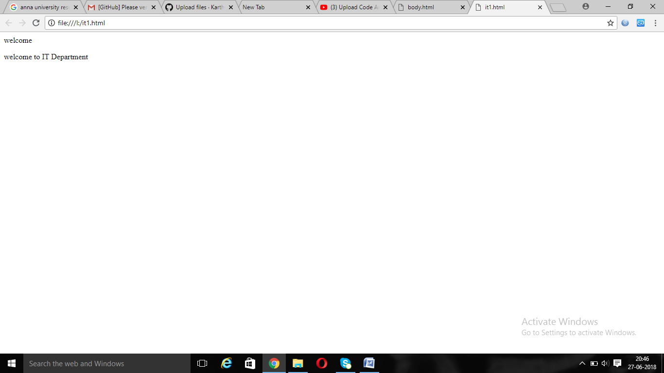

Ex.No:2

<!--<TITLE>Tag-->

<html>

<title>Hello</title>

<h1>hello</h1>

<p>Hi I am Karthikeyan</p>

</html>

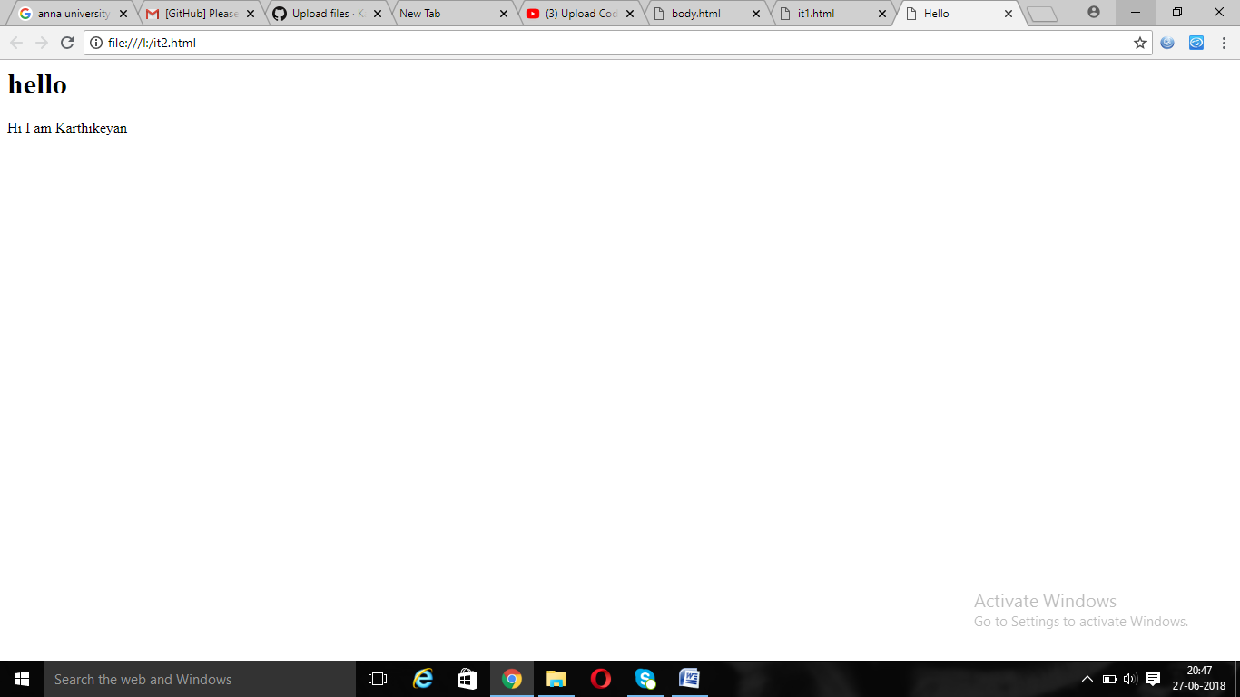

Ex.No:3

<!—Body-->

<html>

<body>

<h1>hello</h1>

<p>Hi how are you</p>

</body>

</html>

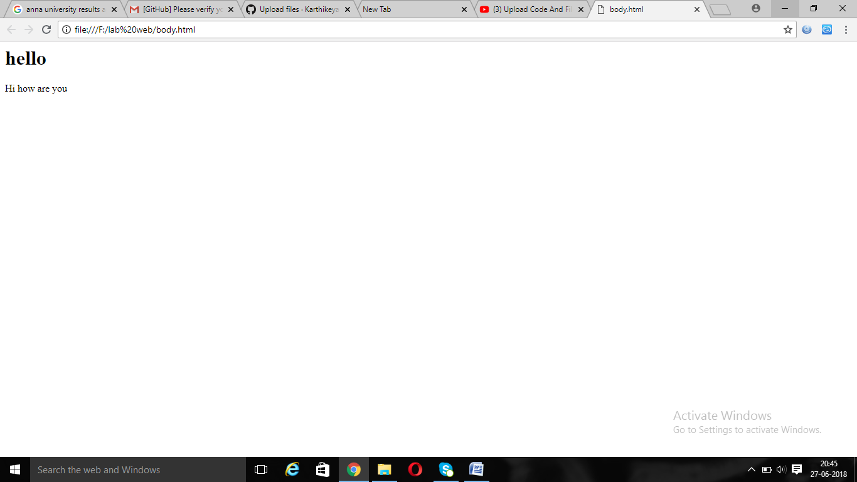

Ex.No:4

<!—Paragraph-->

<html>

<body>

<h1>Web Technology</h1>

<p>paragraph</p>

</body>

</html>

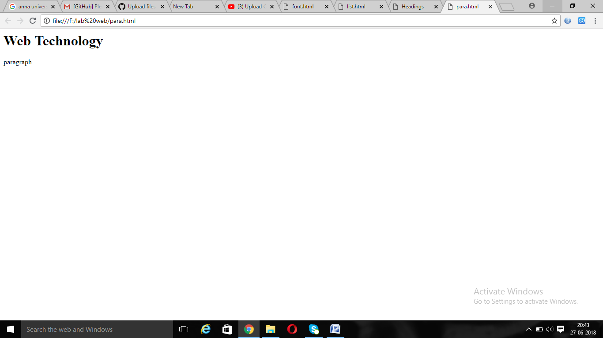

Ex.No:5

HEADINGS

<html>

<title>Headings</title>

<body>

<h1>Web Technology</h1>

<h2>Web Technology</h2>

<h3>Web Technology</h3>

<h4>Web Technology</h4>

<h5>Web Technology</h5>

<h6>Web Technology</h6>

</body>

</html>

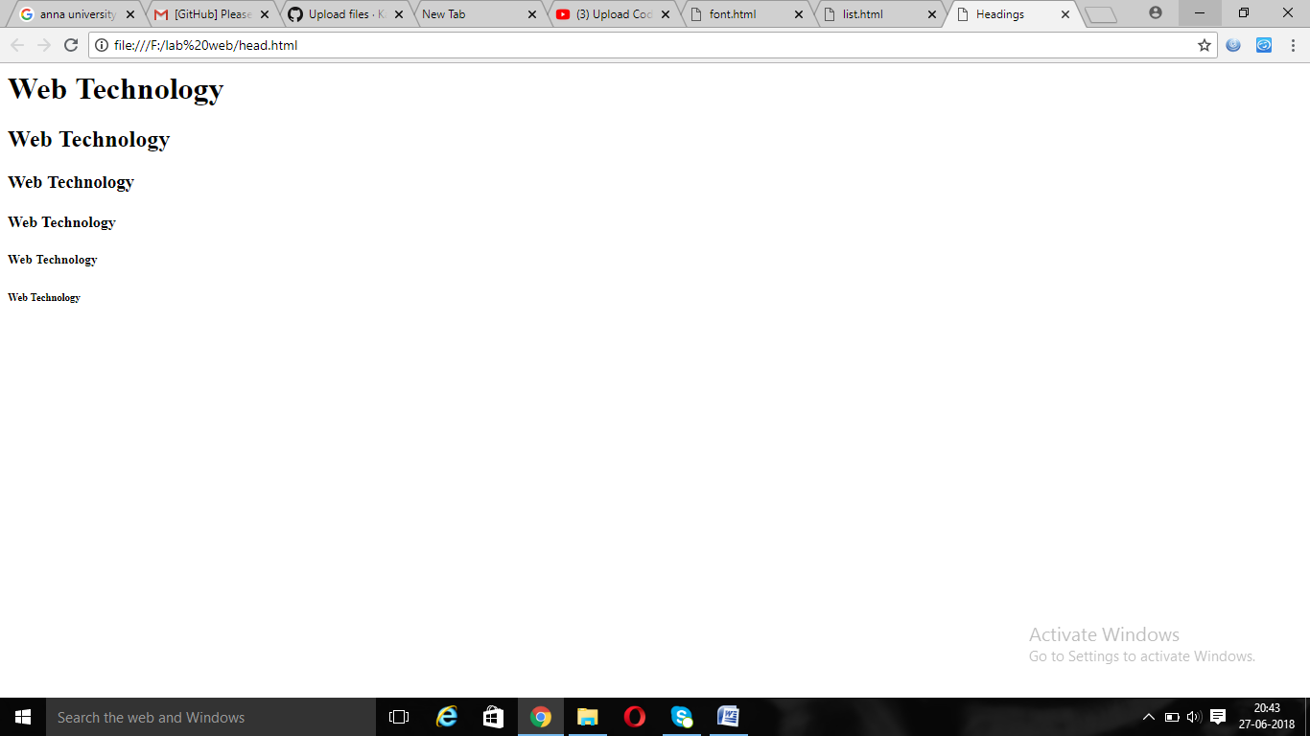

Ex.No:6

<!--<b><i><strong><sup><sub><del><code>-->

<html>

<title>Bold</title>

<body>

<b>WELCOME TO WEB TECHNOLOGY</b><br>

<strong>It is used create an website</strong><br>

<i>It is very easy to learn</i><br>

easy<sup>2</sup>easy<br>

web<sub>2</sub>world<br<BR>

<del>Mech</del><BR>

<code>Html css js php</code><BR>

</body>

</html>

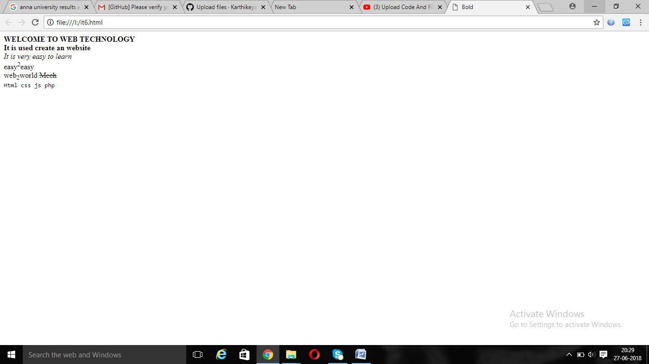

Ex.No:7

<!—BREAK Statement-->

<html>

<body>

<h1>Web Technology</h1><br>

<p>Web</p><br>

<p>Technology</p>

</body>

</html>

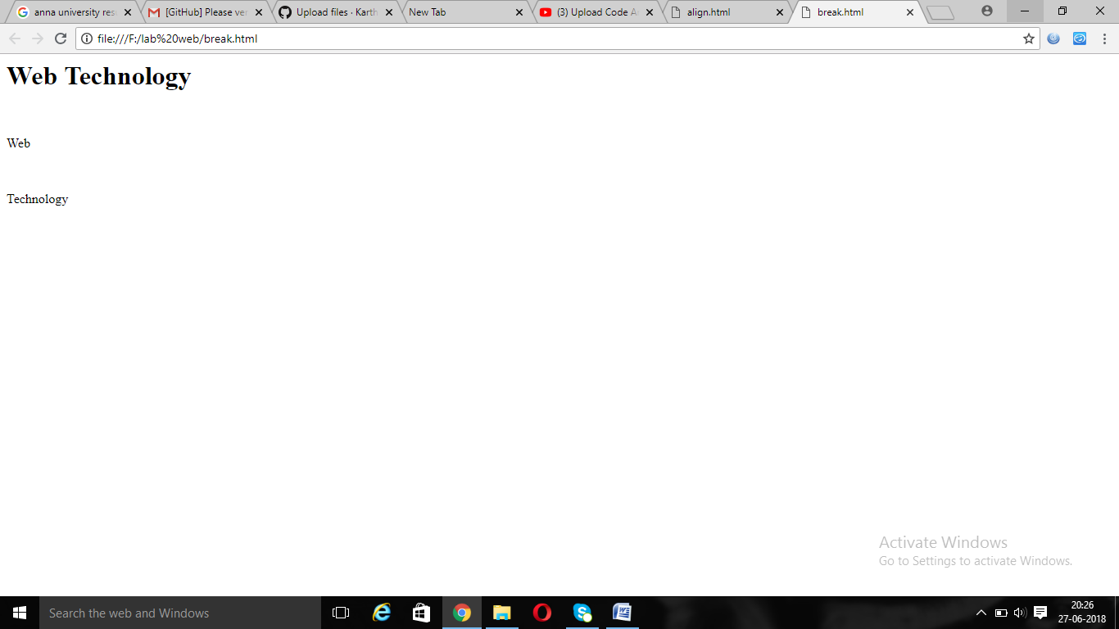

Ex.No:8

<!--<PRE> Statement-->

<html>

<body>

<h1>Web Technology</h1><br>

<pre>Web Technology</pre>

</body>

</html>

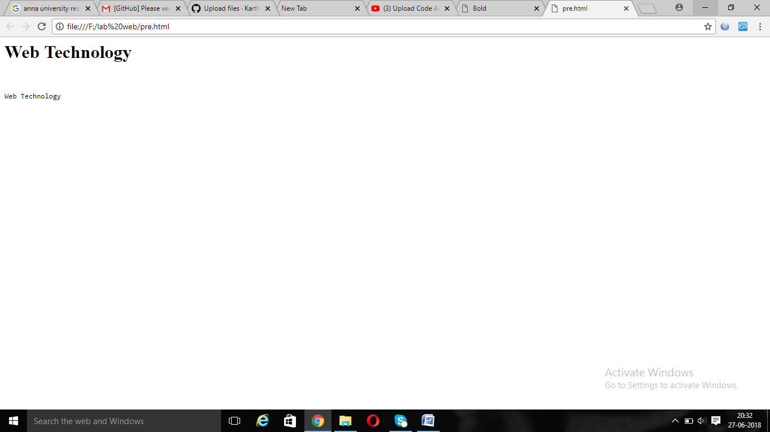

Ex.No:9

<!—ALIGN Tag-->

<html>

<body>

<h1>Web Technology</h1><br>

<p align="right">Web Technology</p>

</body>

</html>

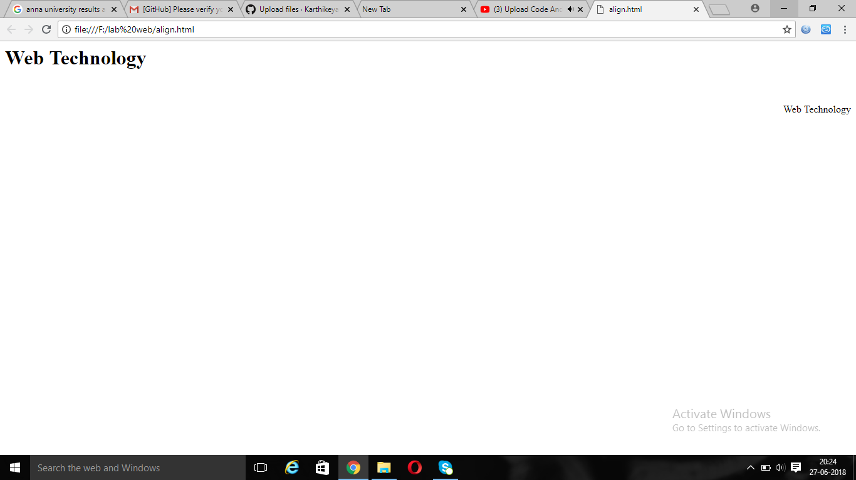

Ex.No:10

<!--<FONT> Tag-->

<html>

<body>

<h1>Web Technology</h1><br>

<font size="20" color="red" face="Lemon"><p>Web Technology</p>

</body>

</html>

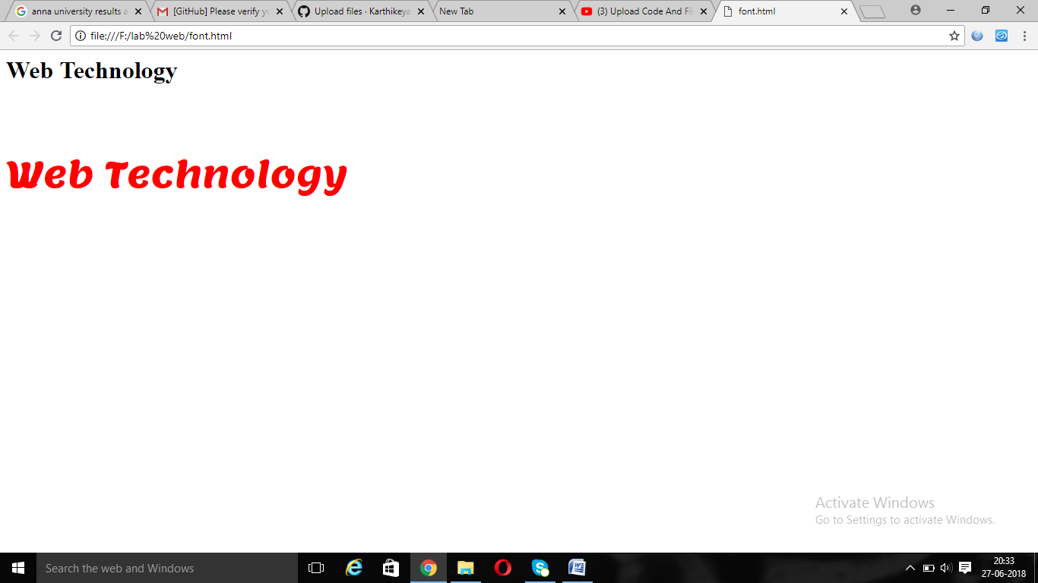

Ex.No:11

<!—LINK Tag-->

<html>

<body>

<h1>Web Technology</h1><br>

<a href="http://google.co.in"><p>Web Technology</p></a>

</body>

</html>

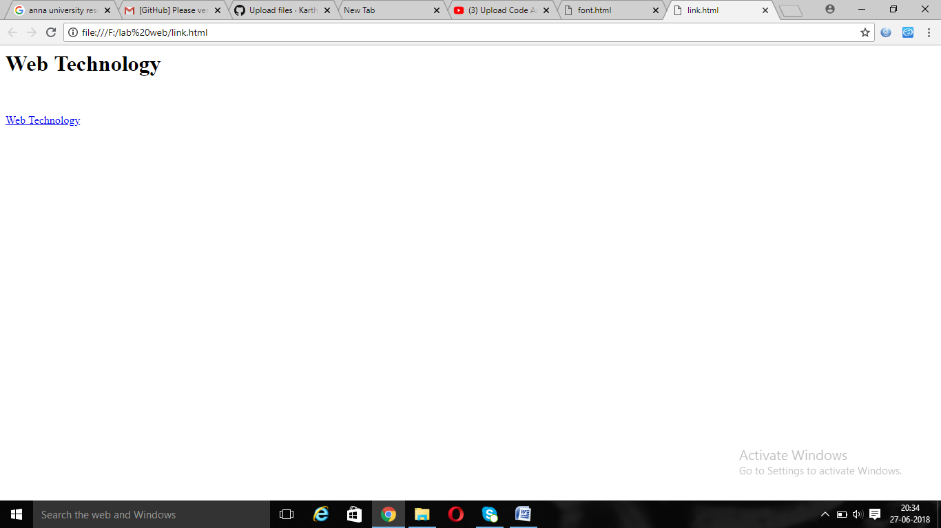

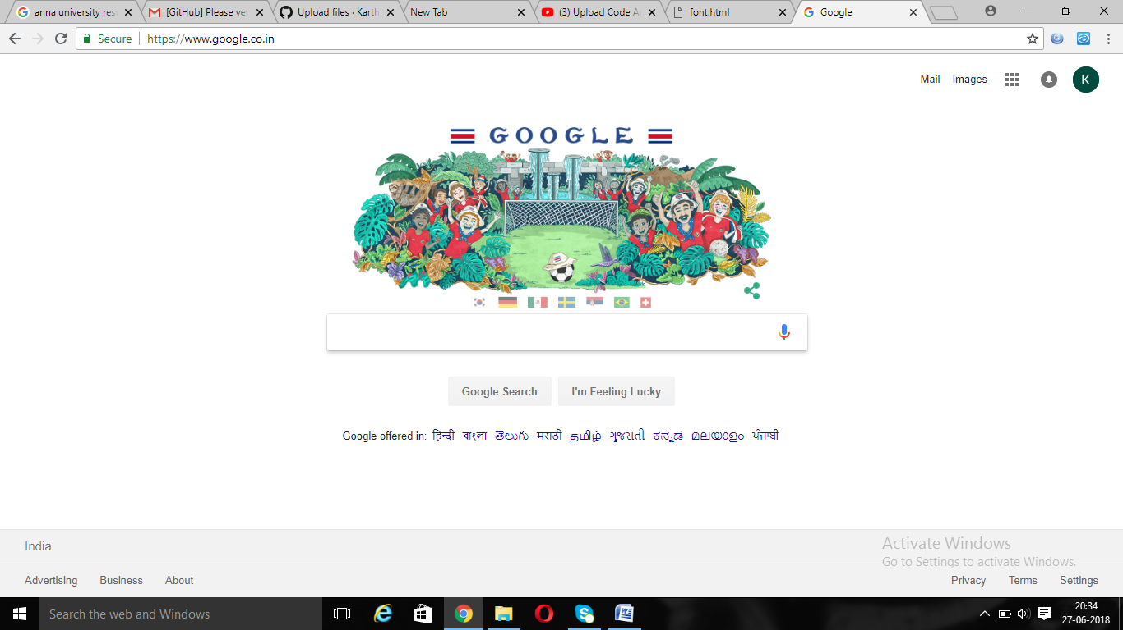

Ex.No:12

<!- -Ordered and Unordered List-->

<html>

<body>

<ol>

<b><dt>Web Technology</dt></b>

<li>HTML</li>

<li>CSS</li>

<li>JAVASCRIPT</li>

<li>PHP</li>

</ol>

<ul>

<b><dt>J2EE</dt></b>

<li>RMI</li>

<li>Sevlets</li>

<li>JSP</li>

<ul style="list-style-type:circle">

<b><dt>J2EE</dt></b>

<li>RMI</li>

<li>Sevlets</li>

<li>JSP</li>

</body>

</html>

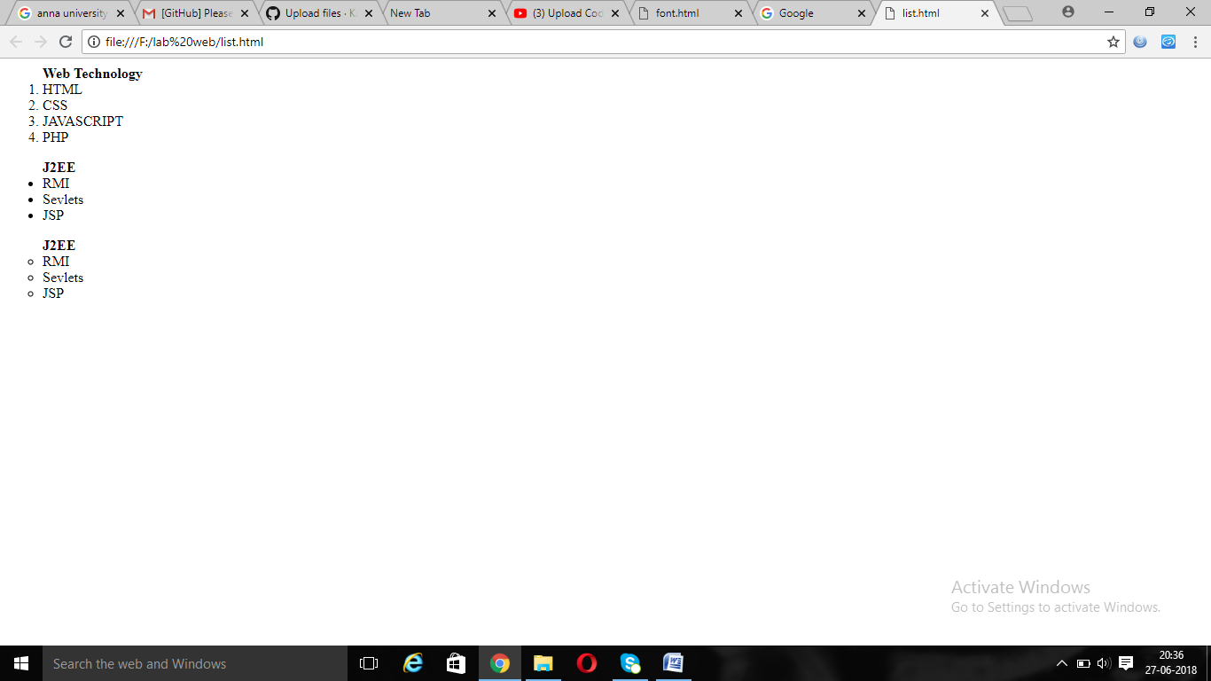

Ex.no:13

<!—Demonstrate definition list tag-->

<html>

<body>

<dl>

<dt>PROGRAMMING LANGUAGE</dt>

<dd>C</dd>

<dd>C++</dd>

<dd>Java</dd>

</dl>

</body>

</html>

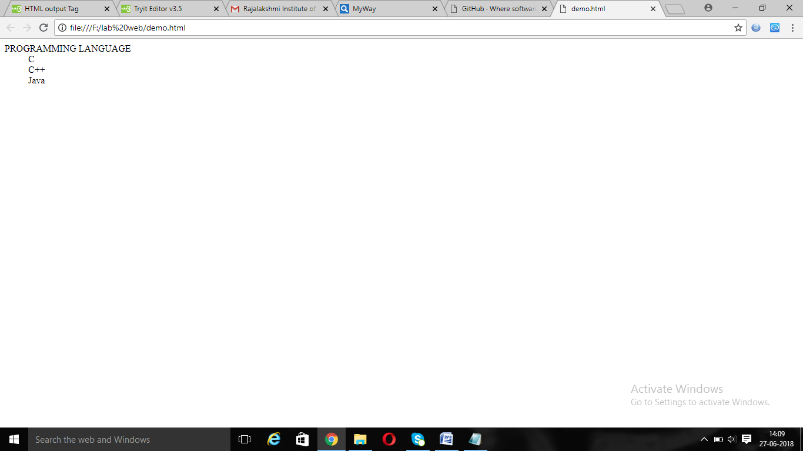

Ex.No:14

<!—Image Tag-->

<html>

<body>

<p>FRIED RICE</p>

<center><img src="fried.jpg" height="200" width="150" border="10" ></center>

</body>

</html>

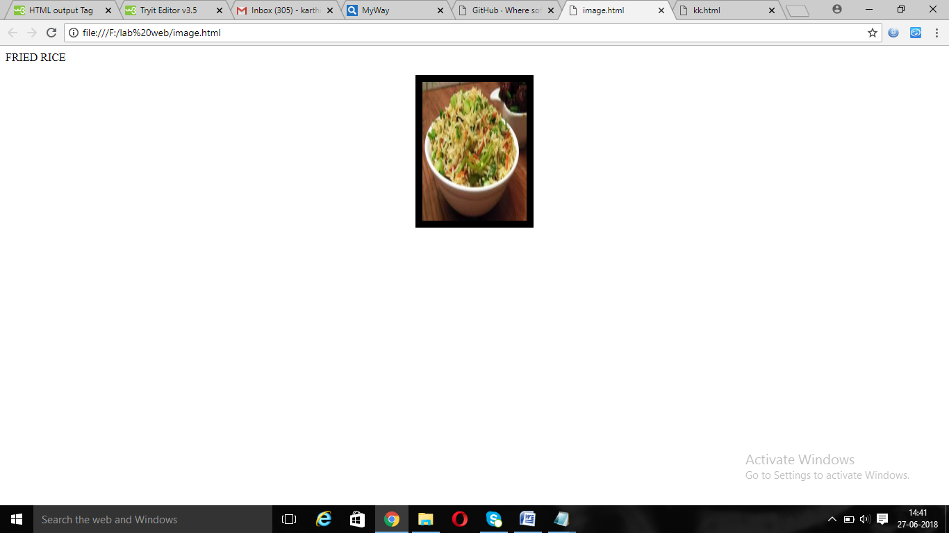

Ex.No:15

<!—Table-->

<html>

<body>

<table>

<th>Name</th>

<th>Mark</th>

<tr>

<td>karthi</td>

<td>470</td>

</tr>

<tr>

<td>Dineesh</td>

<td>470</td>

</tr>

</table>

</body>

</html>

