**Ex.no:29**

<!—Forms-->

<html>

<head>

<style>

p

{

text-align:right;

}

</style>

</head>

<body>

<center>

<h1>HTML FORMS</h1>

NAME:<input type="text" placeholder="Enter your name"><BR><BR><BR>

DOB:<input type="date"><BR><BR><BR>

PASSWORD<input type="password" placeholder="Enter your Password" title="avinash"><BR><BR><BR>

Gender:<input type="radio">M<input type="radio">F<input type="radio">T<BR><BR><BR>

Hobbies:<input type="checkbox">H1<input type="checkbox">H2<input type="checkbox">H3<BR><BR><BR>

<input type=”submit”>

</center>

</body>

</html>

**OUTPUT**

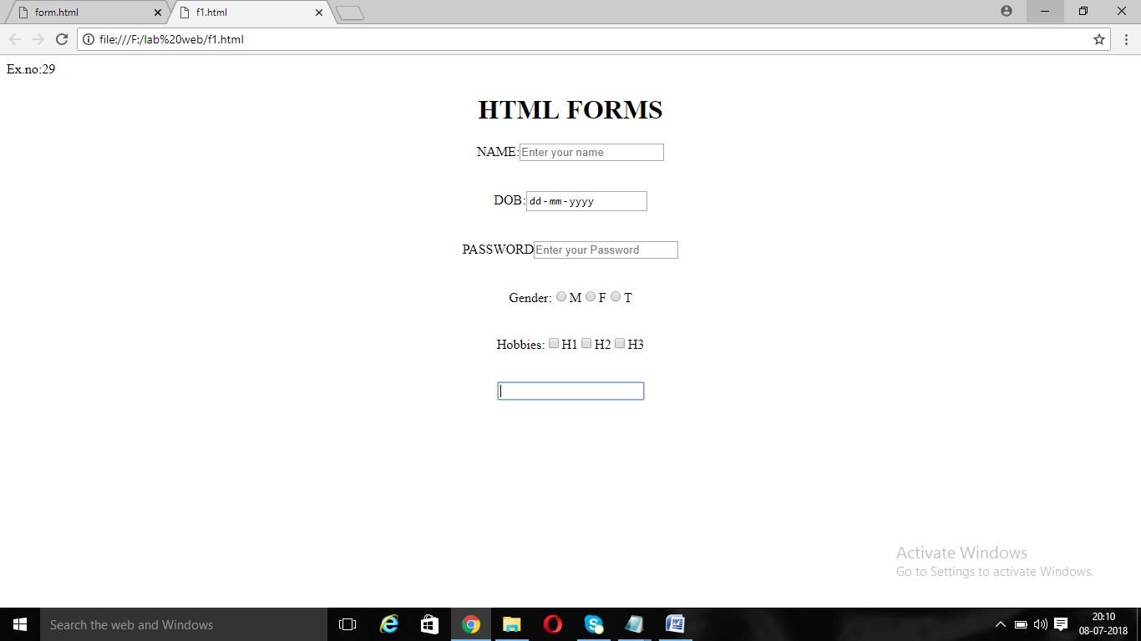

**EX.NO:30**

<html>

<body>

<center>

USERNAME:<input type="text" placeholder="Username" name="t"><br>

<input type = "submit" value="Ok"><br>

</form>

</center>

</body>

</html>

**OUTPUT**

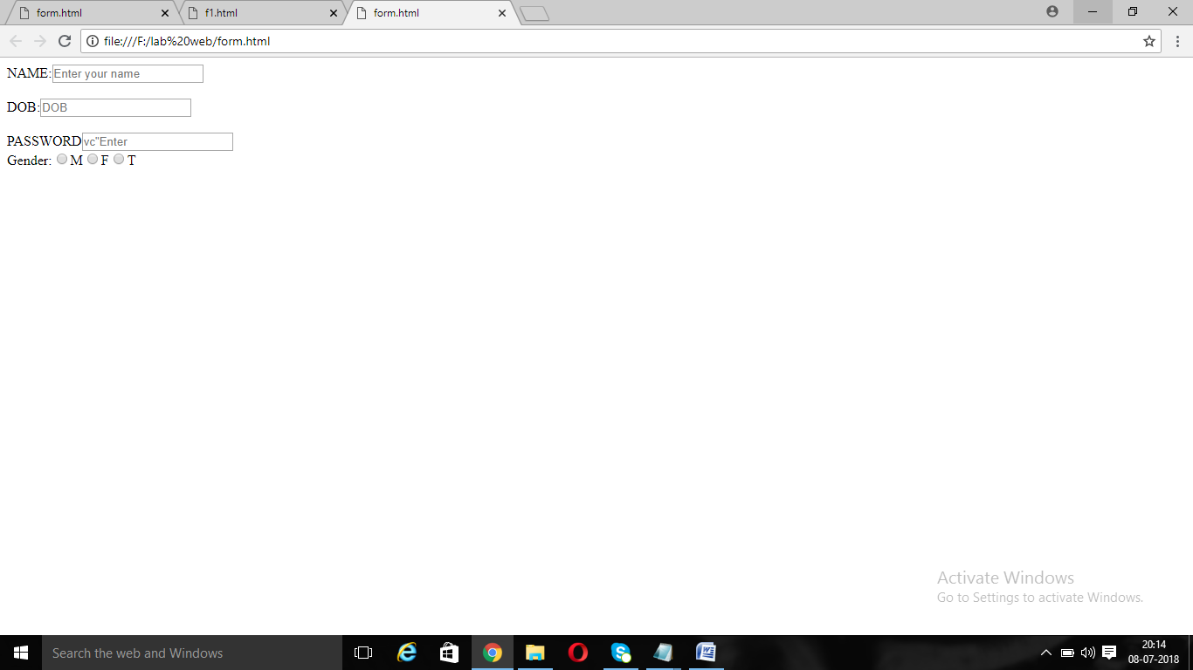

**EX.NO:31**

<html>

<body>

<center>

<form method="get" action="quiz.html" >

USERNAME:<input type="text" placeholder="Username" name="t"><br>

PASSWORD:<input type="password" placeholder="Password" name="te"><br>

<input type = "submit" value="Ok"><br>

</form>

</center>

</body>

</html>

**OUTPUT:**

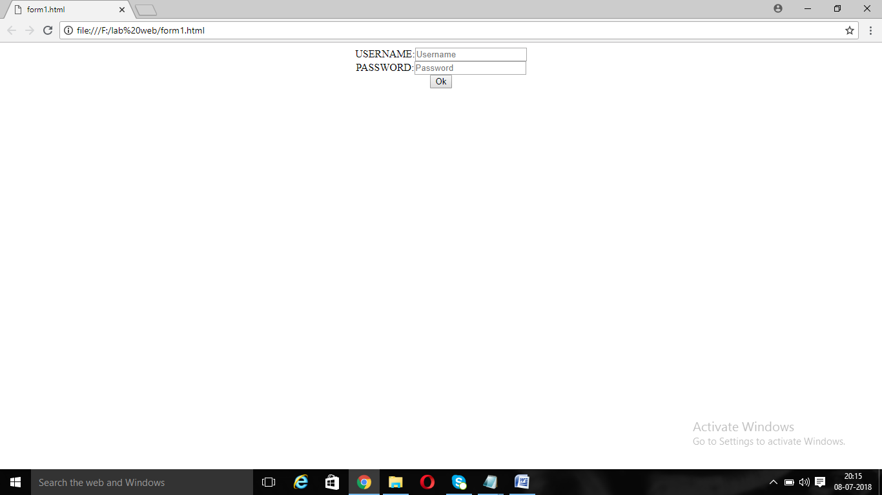

**EX.NO:31**

<html>

<body>

NAME:<input type="text" placeholder="Enter your name"><br><br>

DOB:<input type="text" placeholder="DOB"><br><br>

photo <img src="karthi.jpg">

PASSWORD<input type="password" placeholder="Enter your Password"><br>

Gender:<input type="radio">M<input type="radio">F<input type="radio">T<br>

</body>

</html>

**OUTPUT:**

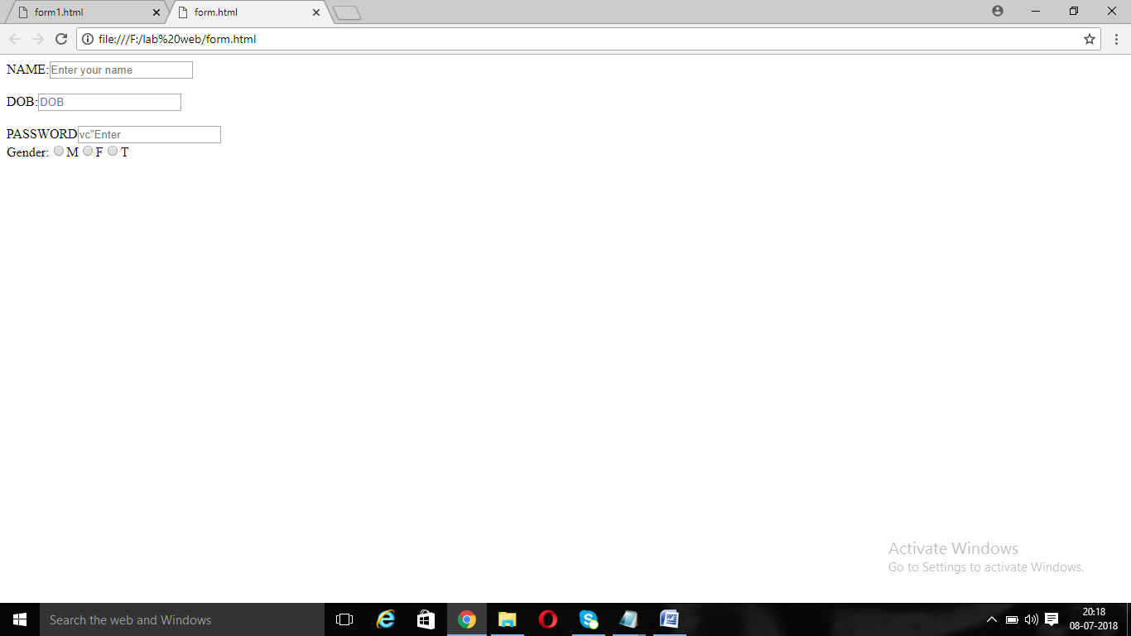

**EX.NO:32**

<html>

<body>

NAME:<input type="text" placeholder="Enter your name"><br><br>

DOB:<input type="text" placeholder="DOB"><br><br>

<!--photo <img src="karthi.jpg">-->

PASSWORD<input type="password" placeholder=vc"Enter your Password"><br>

Gender:<input type="radio">M<input type="radio">F<input type="radio">T<br>

<input type="reset">

</body>

</html>

**OUTPUT:**

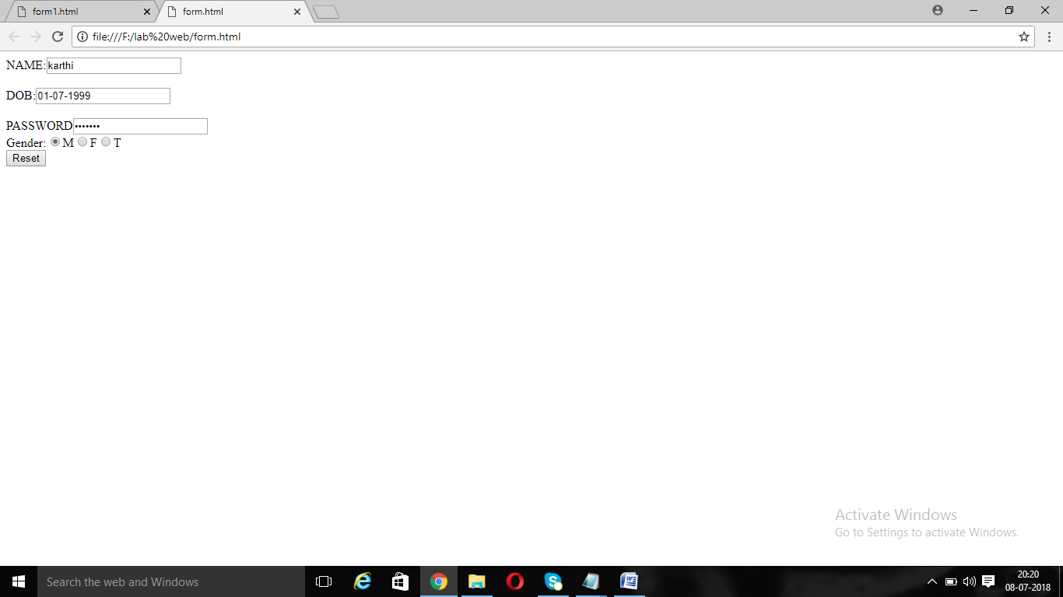

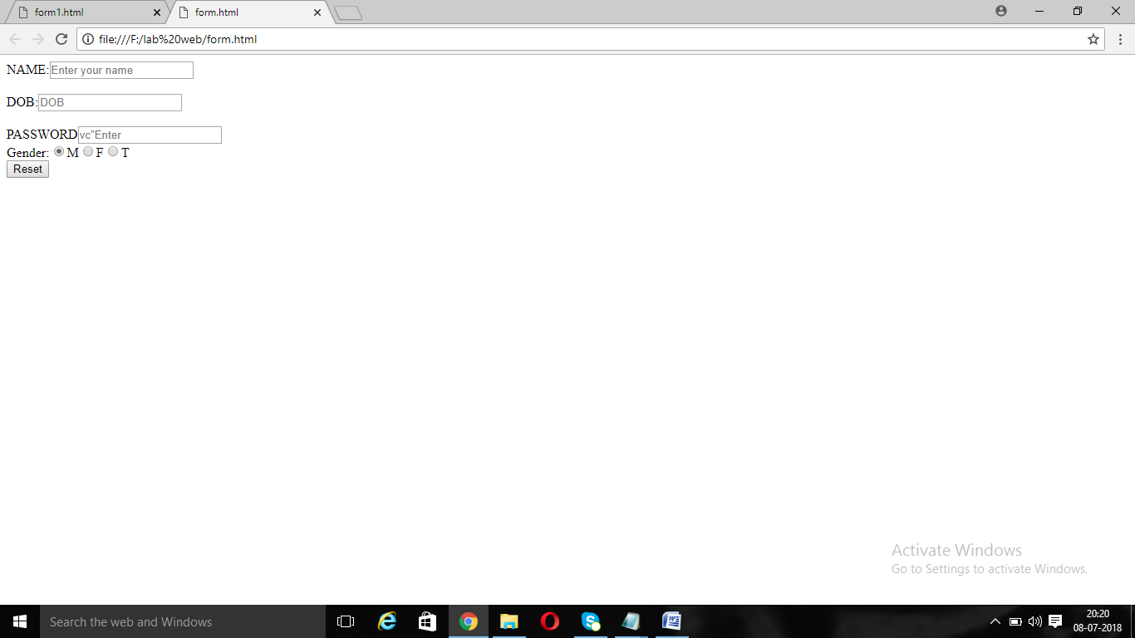

**EX.NO:33**

<!—Forms-->

<html>

<head>

<style>

p

{

text-align:right;

}

</style>

</head>

<body>

<center>

<h1>HTML FORMS</h1>

NAME:<input type="text" placeholder="Enter your name"><BR><BR><BR>

DOB:<input type="date"><BR><BR><BR>

PASSWORD<input type="password" placeholder="Enter your Password" title="avinash"><BR><BR><BR>

Gender:<input type="radio">M<input type="radio">F<input type="radio">T<BR><BR><BR>

Hobbies:<input type="checkbox">H1<input type="checkbox">H2<input type="checkbox">H3<BR><BR><BR>

<input type=”submit”>

</center>

</body>

</html>

**OUTPUT:**

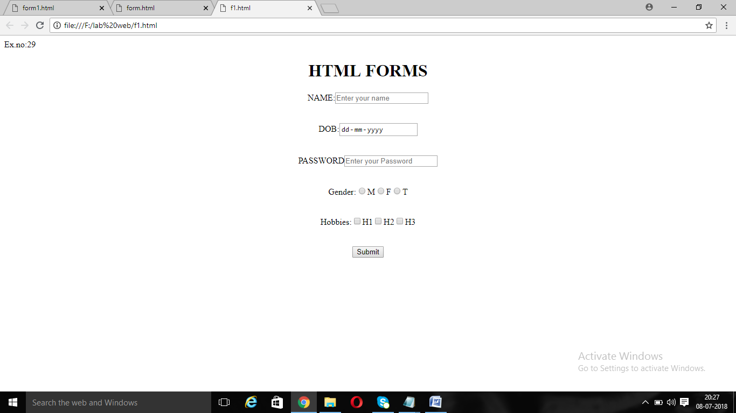

**EX.NO:34**

<html>

<body>

<center>

<h1>Fruits</h1>

Mango<input type="checkbox"><BR>

Apple<input type="checkbox"><Br>

Orange<input type="checkbox"><BR>

</center>

</body>

</html>

**OUTPUT**

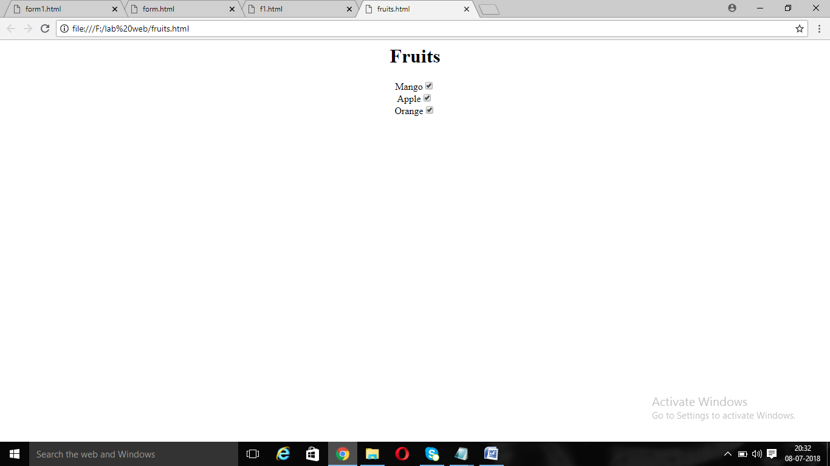

**EX.NO:35**

<html>

<body>

<center>

<h1>Fruits</h1>

Mango<input type="radio"><BR>

Apple<input type="radio"><Br>

Orange<input type="radio"><BR>

</center>

</body>

</html>

**OUTPUT:**

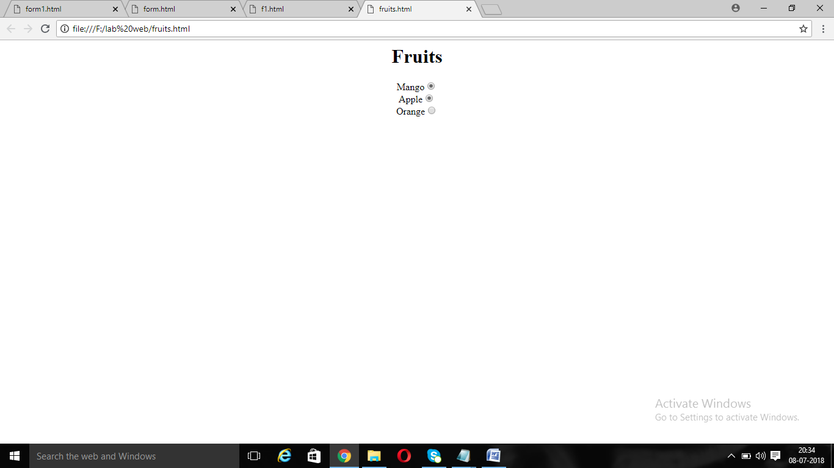

**EX.NO:36**

<html>

<body>

<center>

<h1>Fruits</h1>

<select>

<option>---Select Fruits---</option>

<option>Mango</option><BR>

<option>Apple</option><Br>

<option>Orange</option><BR>

</select>

</center>

</body>

</html>

**OUTPUT**

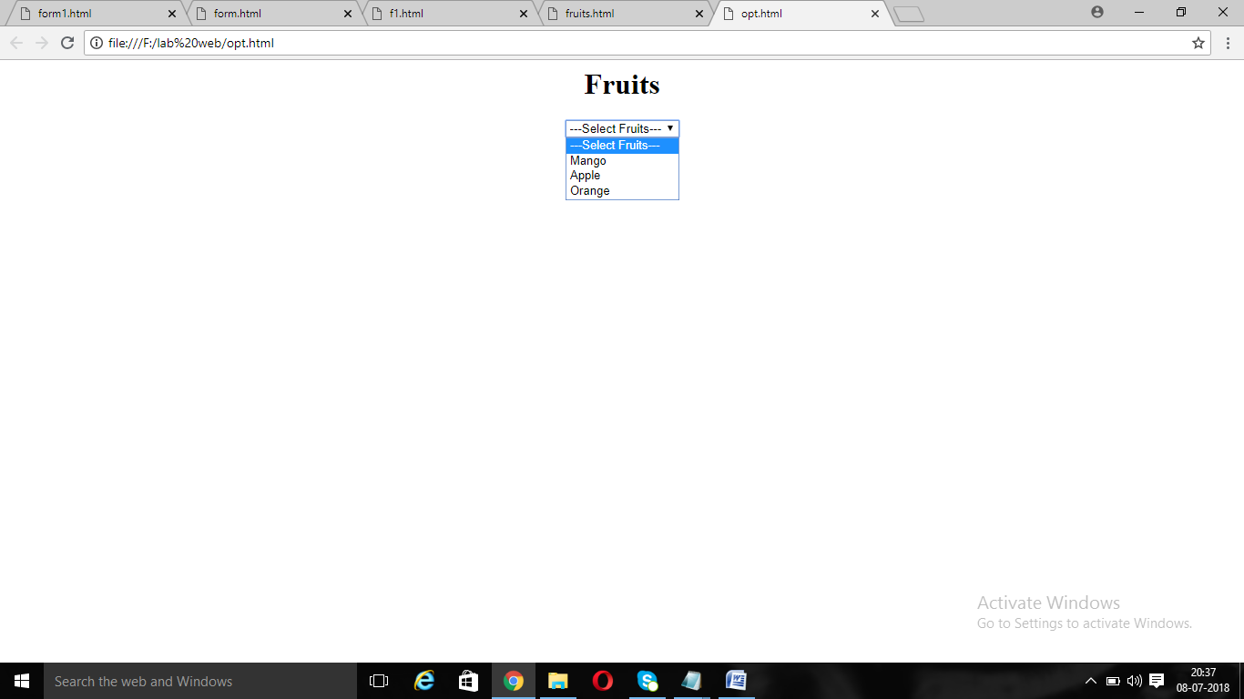

**EX.NO:37**

<html>

<body>

Password:<input type="hidden">

</body>

</html>

**OUTPUT:**

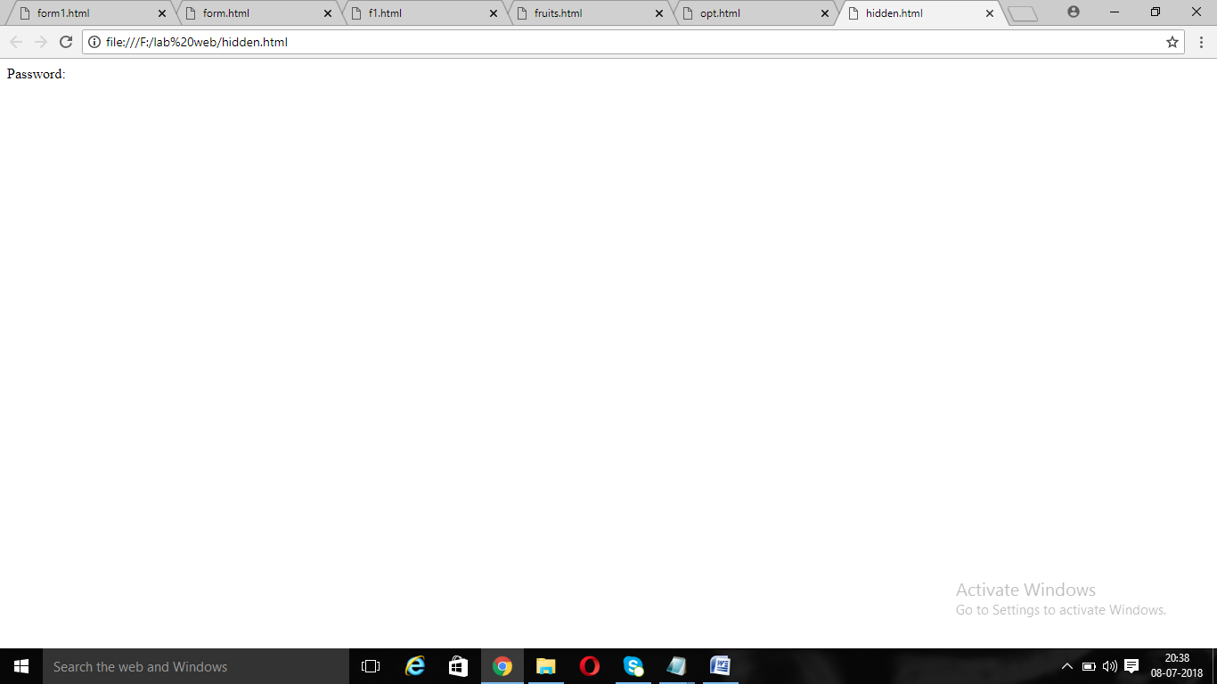

**EX.NO:38**

<html>

<body>

<center>

<h1>Choosen File</h1>

<input type="file">

</center>

</body>

</html>

**OUTPUT**

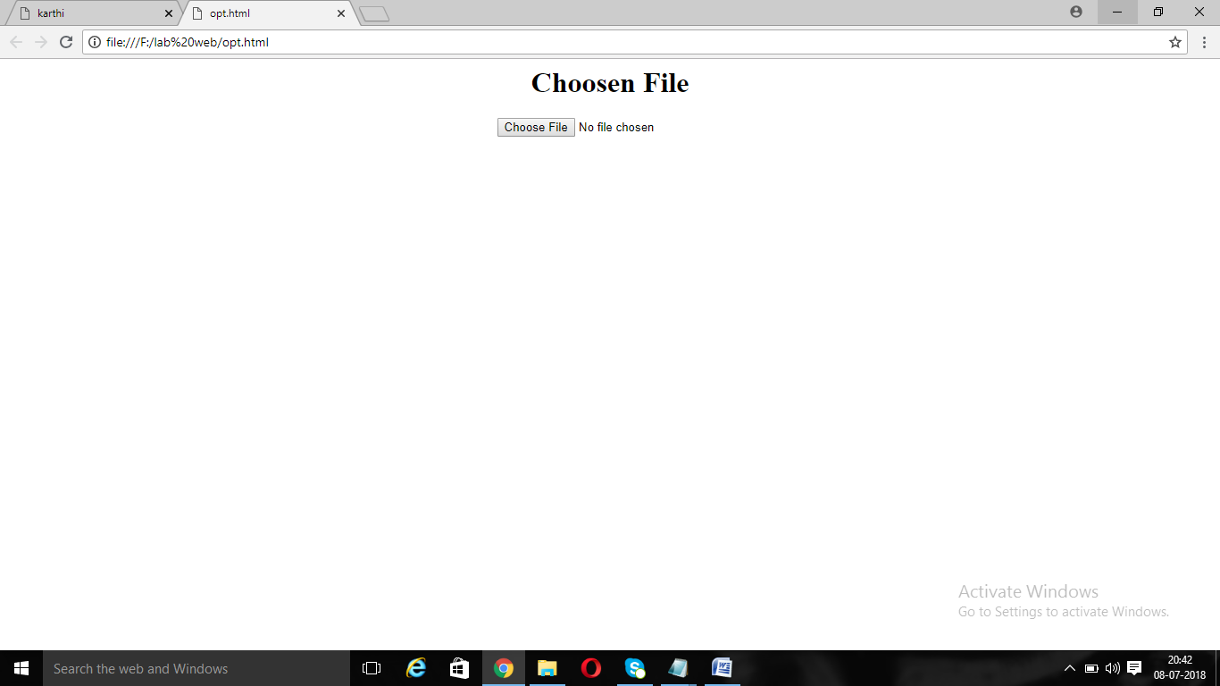

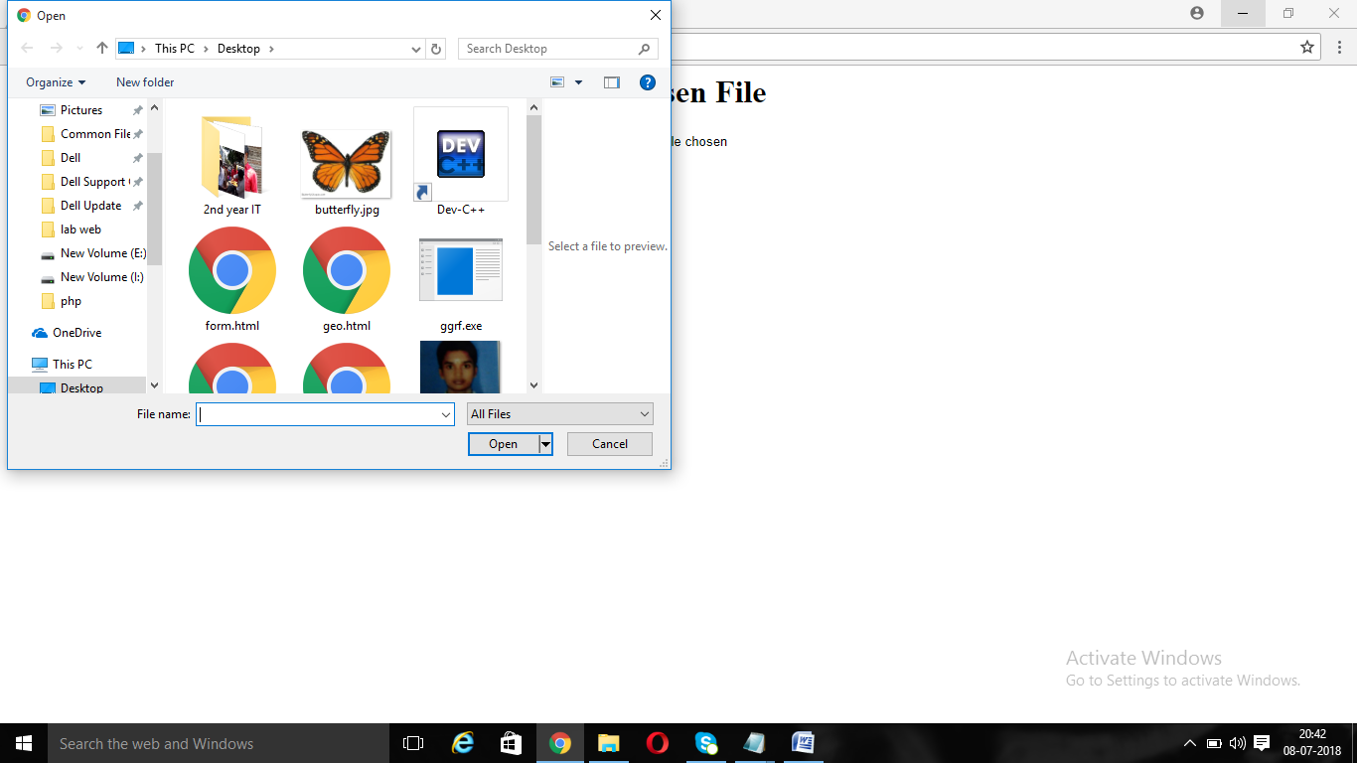

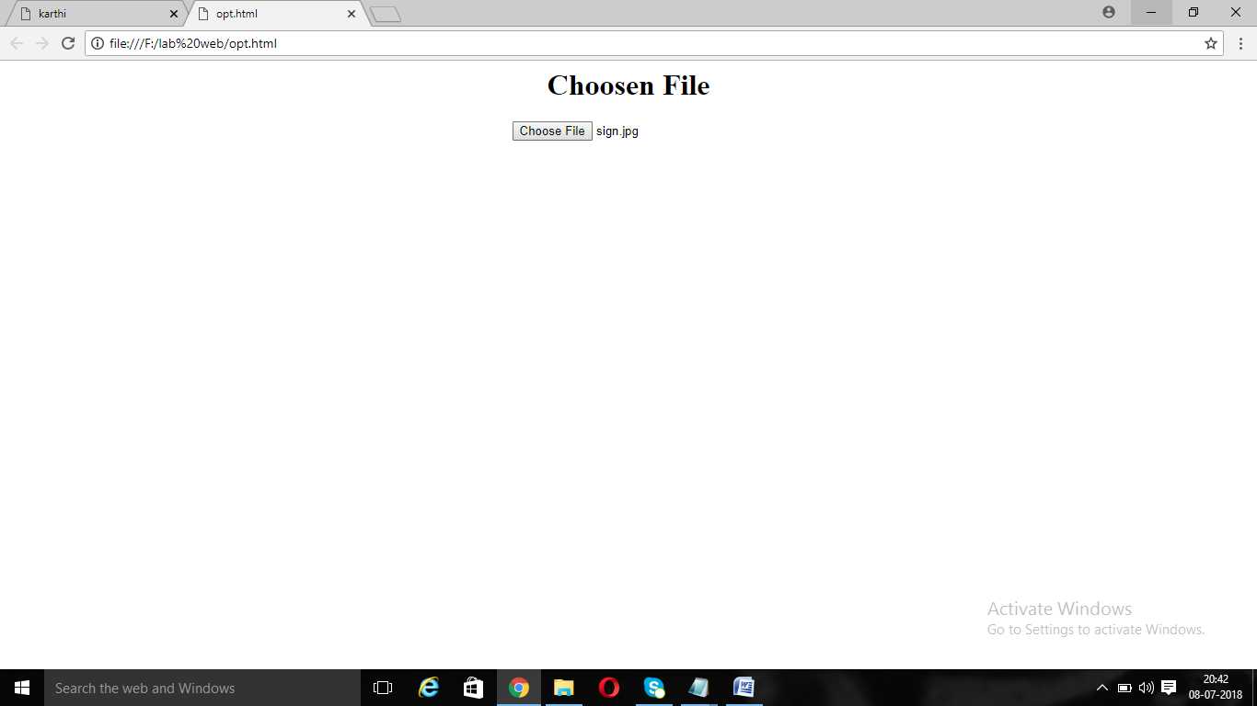

**EX.NO:39**

<html>

<body>

<center>

NAME<input type="text"><BR>

DOB<input type="date"><BR>

ADDRESS<input type="text area"><BR>

</center>

</body>

</html>

**OUTPUT:**

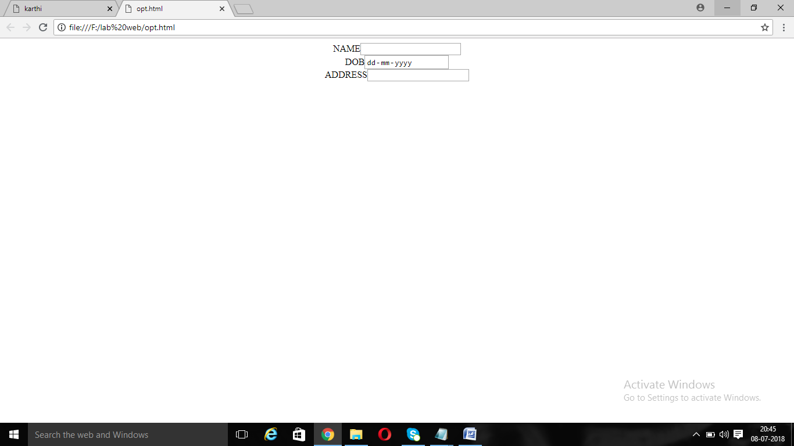

**EX.NO:40**

<html>

<head>

<style>

div {

border: 1px solid black;

margin-top: 100px;

margin-bottom: 100px;

margin-right: 150px;

margin-left: 80px;

background-color: lightblue;

}

</style>

</head>

<body>

<div>IT(INFORMATION TECHNOLOGY)</div>

</body>

</html>

**OUTPUT:**

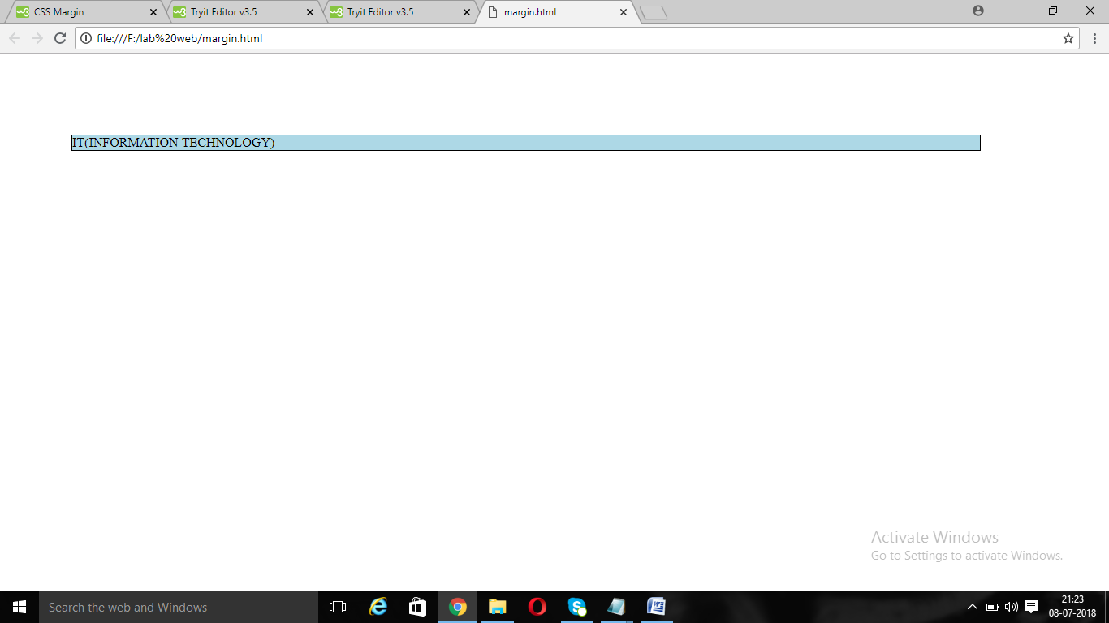

**EX.NO:41**

<html>

<head>

<style>

div {

border: 1px solid black;

padding-top: 100px;

padding-bottom: 100px;

padding-right: 150px;

padding-left: 80px;

background-color:yellow;

}

</style>

</head>

<body>

<div>IT(INFORMATION TECHNOLOGY)</div>

</body>

</html>

**OUTPUT:**

