**Exp1.jsp**

<%@ page import = "java.io.*,java.util.*" %>

<html>

<head>

<title>HTTP Header Request Example</title>

</head>

<body>

<center>

<h2>HTTP Header Request Example</h2>

<table width = "100%" border = "1" align = "center">

<tr bgcolor = "#949494">

<th>Header Name</th>

<th>Header Value(s)</th>

</tr>

<%

Enumeration headerNames = request.getHeaderNames();

while(headerNames.hasMoreElements()) {

String paramName = (String)headerNames.nextElement();

out.print("<tr><td>" + paramName + "</td>\n");

String paramValue = request.getHeader(paramName);

out.println("<td> " + paramValue + "</td></tr>\n");

}

%>

</table>

</center>

</body>

</html>

**OUTPUT**

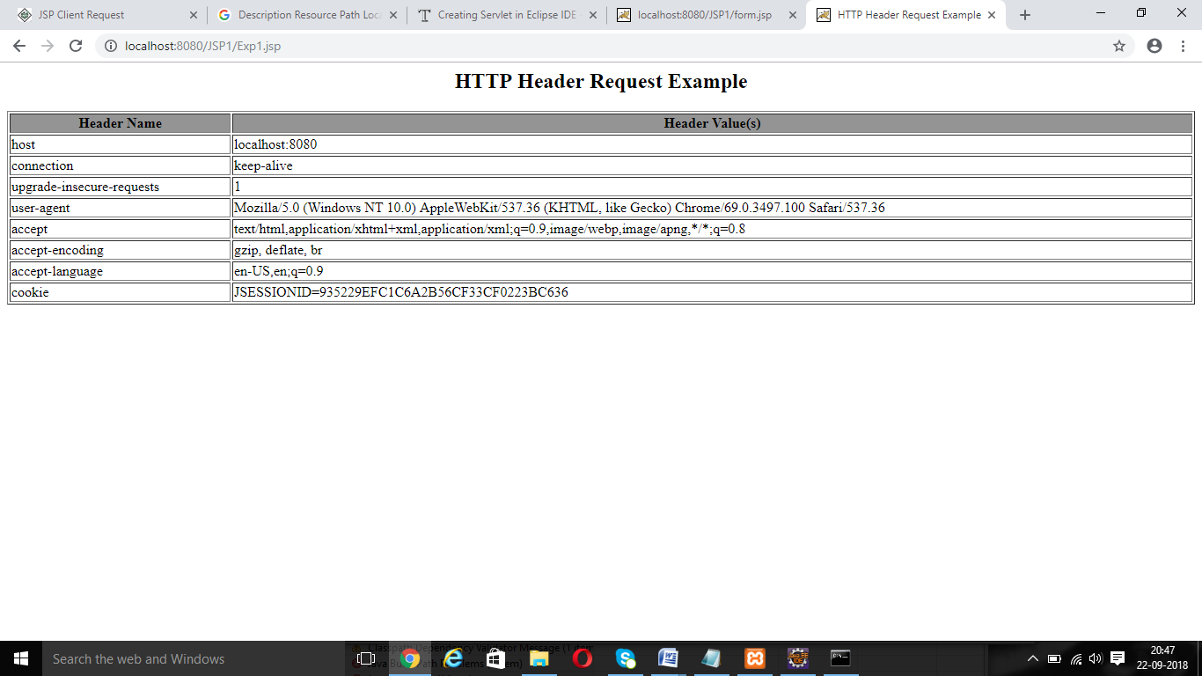

**Exp2.jsp**

<%@ page import = "java.io.*,java.util.*" %>

<html>

<head>

<title>Auto Refresh Header Example</title>

</head>

<body>

<center>

<h2>Auto Refresh Header Example</h2>

<%

// Set refresh, autoload time as 5 seconds

response.setIntHeader("Refresh", 5);

// Get current time

Calendar calendar = new GregorianCalendar();

String am_pm;

int hour = calendar.get(Calendar.HOUR);

int minute = calendar.get(Calendar.MINUTE);

int second = calendar.get(Calendar.SECOND);

if(calendar.get(Calendar.AM_PM) == 0)

am_pm = "AM";

else

am_pm = "PM";

String CT = hour+":"+ minute +":"+ second +" "+ am_pm;

out.println("Current Time is: " + CT + "\n");

%>

</center>

</body>

</html>

**OUTPUT**

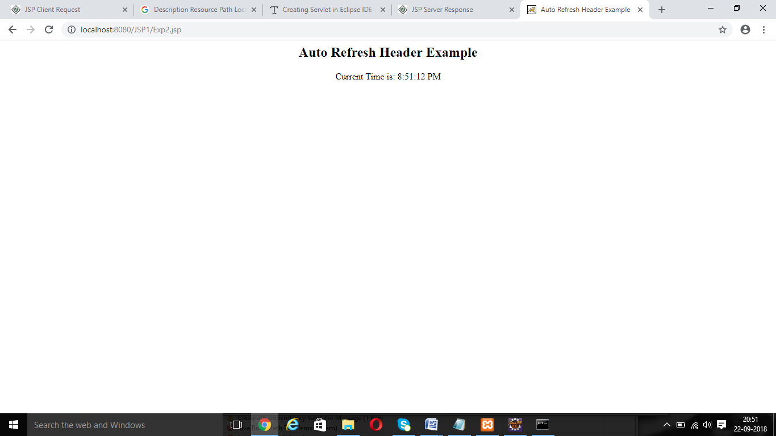

**Exp3.jsp**

<html>

<head>

<title>Setting HTTP Status Code</title>

</head>

<body>

<%

// Set error code and reason.

response.sendError(407, "Need authentication!!!" );

%>

</body>

</html>

**OUTPUT**

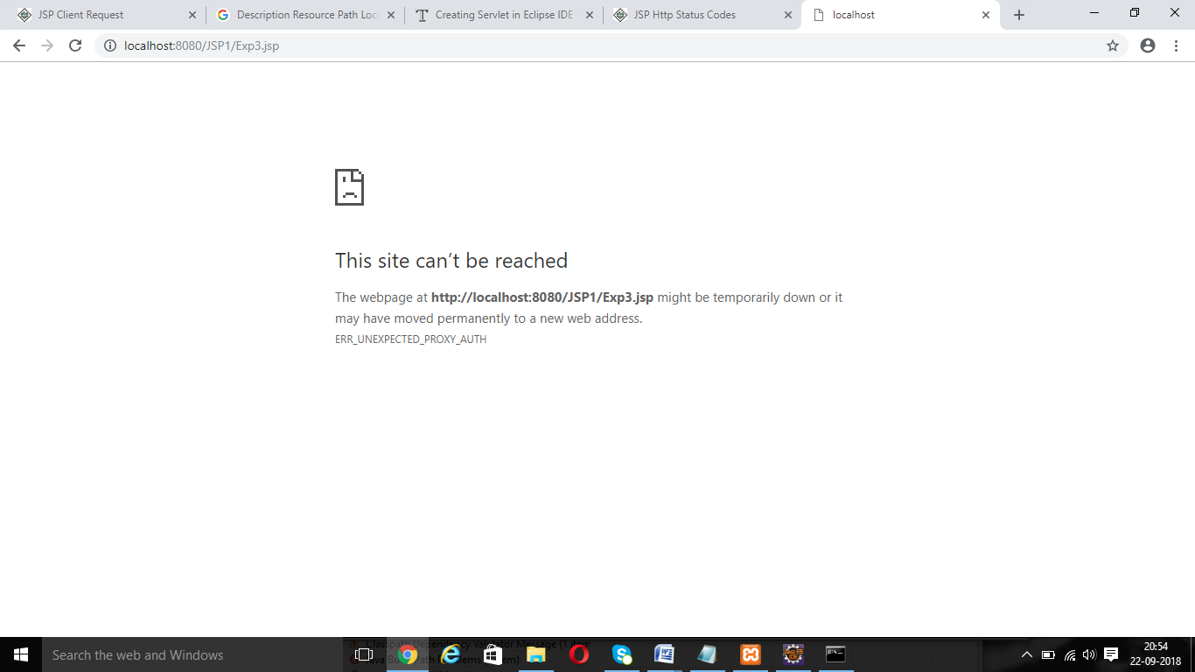

**Exp4.jsp**

<html>

<body>

<form action = "main.jsp" method = "GET">

First Name: <input type = "text" name = "first_name">

<br />

Last Name: <input type = "text" name = "last_name" />

<input type = "submit" value = "Submit" />

</form>

</body>

</html>

**Main.jsp**

<%

// Create cookies for first and last names.

Cookie firstName = new Cookie("first_name", request.getParameter("first_name"));

Cookie lastName = new Cookie("last_name", request.getParameter("last_name"));

// Set expiry date after 24 Hrs for both the cookies.

firstName.setMaxAge(60*60*24);

lastName.setMaxAge(60*60*24);

// Add both the cookies in the response header.

response.addCookie( firstName );

response.addCookie( lastName );

%>

<html>

<head>

<title>Setting Cookies</title>

</head>

<body>

<center>

<h1>Setting Cookies</h1>

</center>

<ul>

<li><p><b>First Name:</b>

<%= request.getParameter("first_name")%>

</p></li>

<li><p><b>Last Name:</b>

<%= request.getParameter("last_name")%>

</p></li>

</ul>

</body>

</html>

**OUTPUT**

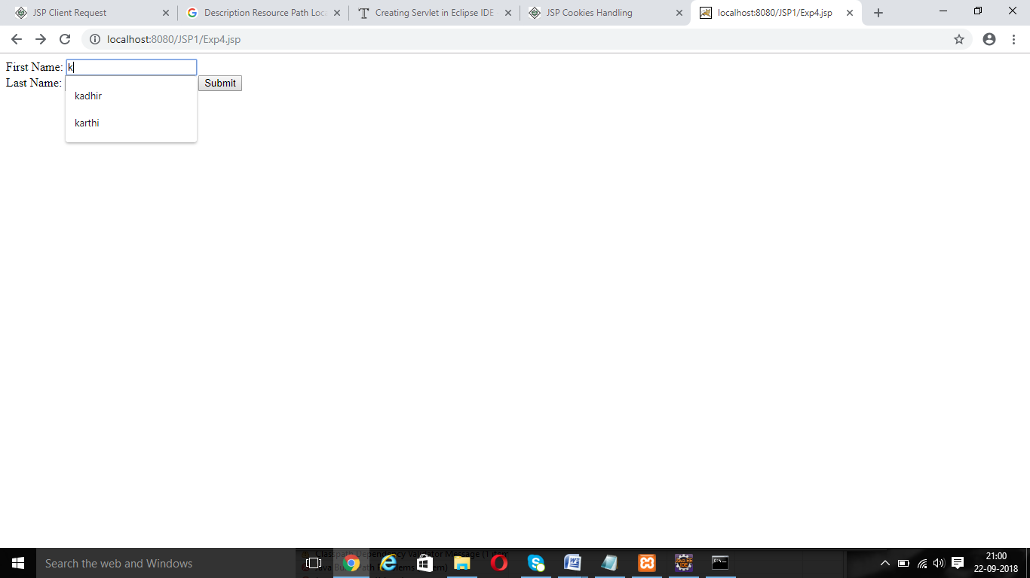

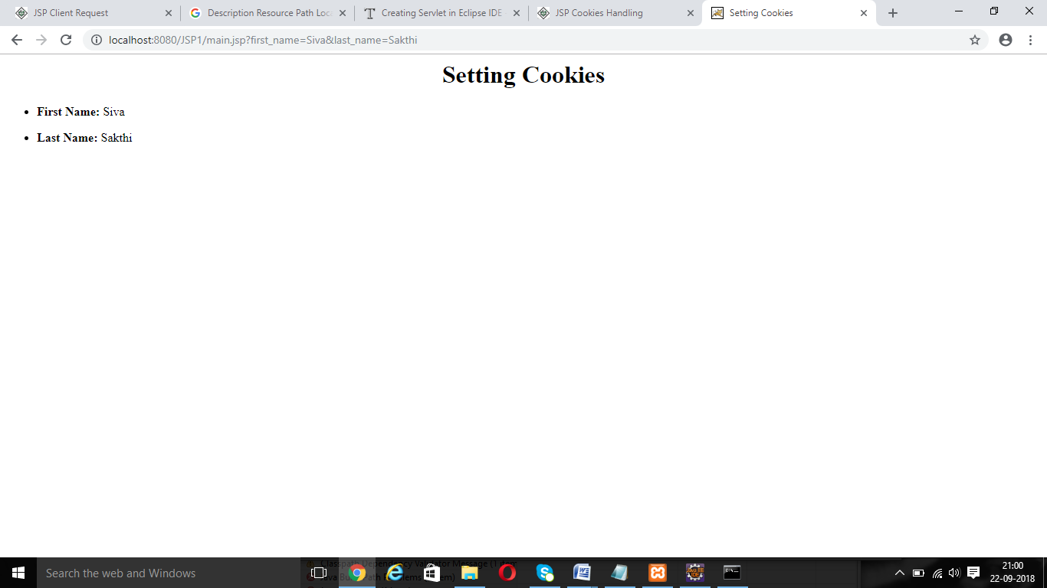

**Exp5.jsp**

<%@ page import = "java.io.*,java.util.*" %>

<%

// Get session creation time.

Date createTime = new Date(session.getCreationTime());

// Get last access time of this Webpage.

Date lastAccessTime = new Date(session.getLastAccessedTime());

String title = "Welcome Back to my website";

Integer visitCount = new Integer(0);

String visitCountKey = new String("visitCount");

String userIDKey = new String("userID");

String userID = new String("ABCD");

// Check if this is new comer on your Webpage.

if (session.isNew() ){

title = "Welcome to my website";

session.setAttribute(userIDKey, userID);

session.setAttribute(visitCountKey, visitCount);

}

visitCount = (Integer)session.getAttribute(visitCountKey);

visitCount = visitCount + 1;

userID = (String)session.getAttribute(userIDKey);

session.setAttribute(visitCountKey, visitCount);

%>

<html>

<head>

<title>Session Tracking</title>

</head>

<body>

<center>

<h1>Session Tracking</h1>

</center>

<table border = "1" align = "center">

<tr bgcolor = "#949494">

<th>Session info</th>

<th>Value</th>

</tr>

<tr>

<td>id</td>

<td><% out.print( session.getId()); %></td>

</tr>

<tr>

<td>Creation Time</td>

<td><% out.print(createTime); %></td>

</tr>

<tr>

<td>Time of Last Access</td>

<td><% out.print(lastAccessTime); %></td>

</tr>

<tr>

<td>User ID</td>

<td><% out.print(userID); %></td>

</tr>

<tr>

<td>Number of visits</td>

<td><% out.print(visitCount); %></td>

</tr>

</table>

</body>

</html>

**OUTPUT**

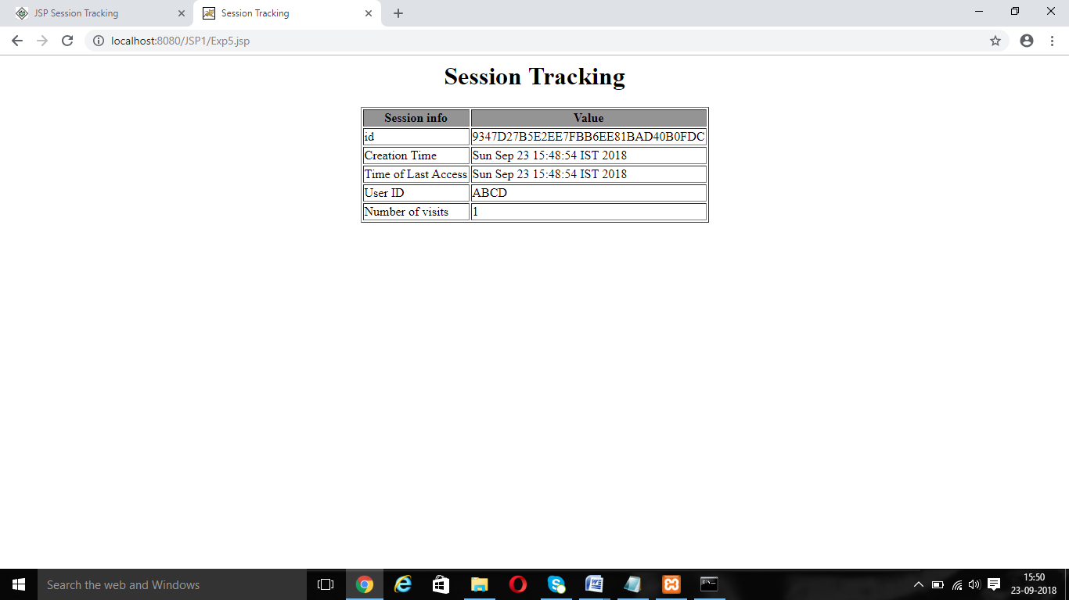

**Exp6.jsp**

<html>

<head>

<title>File Uploading Form</title>

</head>

<body>

<h3>File Upload:</h3>

Select a file to upload: <br />

<form action = "UploadServlet" method = "post"

enctype = "multipart/form-data">

<input type = "file" name = "file" size = "50" />

<br />

<input type = "submit" value = "Upload File" />

</form>

</body>

</html>

**UploadServlet.jsp**

<%@ page import = "java.io.*,java.util.*, javax.servlet.*" %>

<%@ page import = "javax.servlet.http.*" %>

<%@ page import = "org.apache.commons.fileupload.*" %>

<%@ page import = "org.apache.commons.fileupload.disk.*" %>

<%@ page import = "org.apache.commons.fileupload.servlet.*" %>

<%@ page import = "org.apache.commons.io.output.*" %>

<%

File file ;

int maxFileSize = 5000 * 1024;

int maxMemSize = 5000 * 1024;

ServletContext context = pageContext.getServletContext();

String filePath = context.getInitParameter("file-upload");

// Verify the content type

String contentType = request.getContentType();

if ((contentType.indexOf("multipart/form-data") >= 0)) {

DiskFileItemFactory factory = new DiskFileItemFactory();

// maximum size that will be stored in memory

factory.setSizeThreshold(maxMemSize);

// Location to save data that is larger than maxMemSize.

factory.setRepository(new File("c:\\temp"));

// Create a new file upload handler

ServletFileUpload upload = new ServletFileUpload(factory);

// maximum file size to be uploaded.

upload.setSizeMax( maxFileSize );

try {

// Parse the request to get file items.

List fileItems = upload.parseRequest(request);

// Process the uploaded file items

Iterator i = fileItems.iterator();

out.println("<html>");

out.println("<head>");

out.println("<title>JSP File upload</title>");

out.println("</head>");

out.println("<body>");

while ( i.hasNext () ) {

FileItem fi = (FileItem)i.next();

if ( !fi.isFormField () ) {

// Get the uploaded file parameters

String fieldName = fi.getFieldName();

String fileName = fi.getName();

boolean isInMemory = fi.isInMemory();

long sizeInBytes = fi.getSize();

// Write the file

if( fileName.lastIndexOf("\\") >= 0 ) {

file = new File( filePath +

fileName.substring( fileName.lastIndexOf("\\"))) ;

} else {

file = new File( filePath +

fileName.substring(fileName.lastIndexOf("\\")+1)) ;

}

fi.write( file ) ;

out.println("Uploaded Filename: " + filePath +

fileName + "<br>");

}

}

out.println("</body>");

out.println("</html>");

} catch(Exception ex) {

System.out.println(ex);

}

} else {

out.println("<html>");

out.println("<head>");

out.println("<title>Servlet upload</title>");

out.println("</head>");

out.println("<body>");

out.println("<p>No file uploaded</p>");

out.println("</body>");

out.println("</html>");

}

%>

**Web.xml**

<web-app>

....

<context-param>

<description>Location to store uploaded file</description>

<param-name>file-upload</param-name>

<param-value>

I:\Xampp2\tomcat\webapps\ROOT\

</param-value>

</context-param>

....

</web-app>

**OUTPUT**

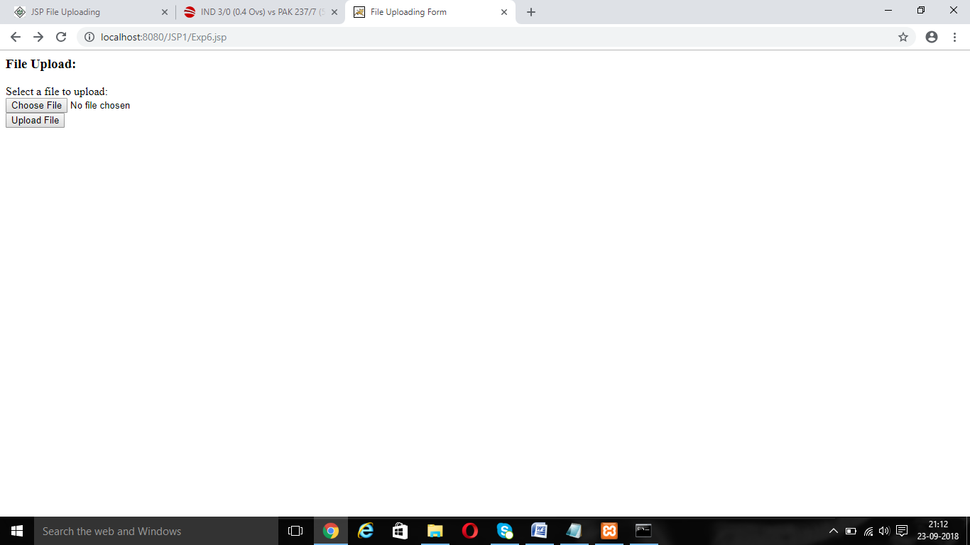

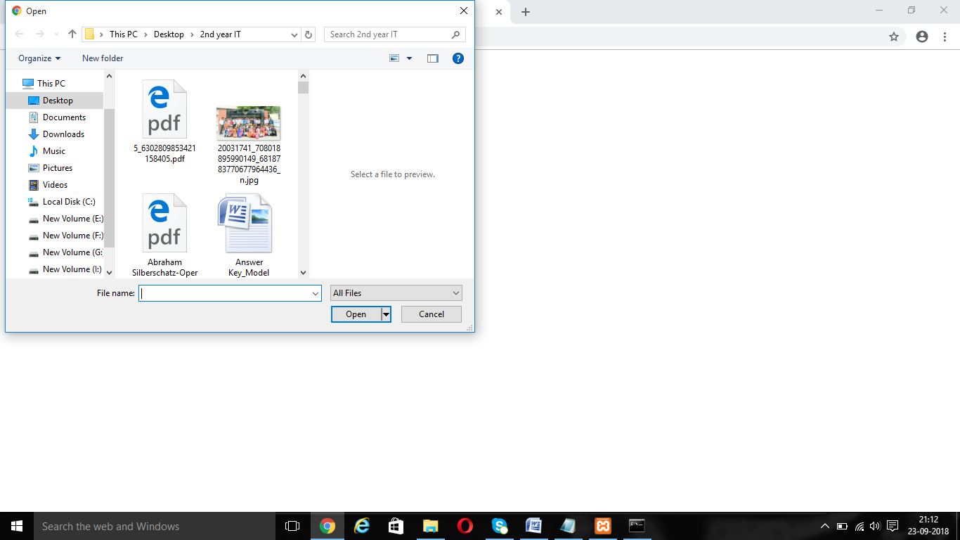

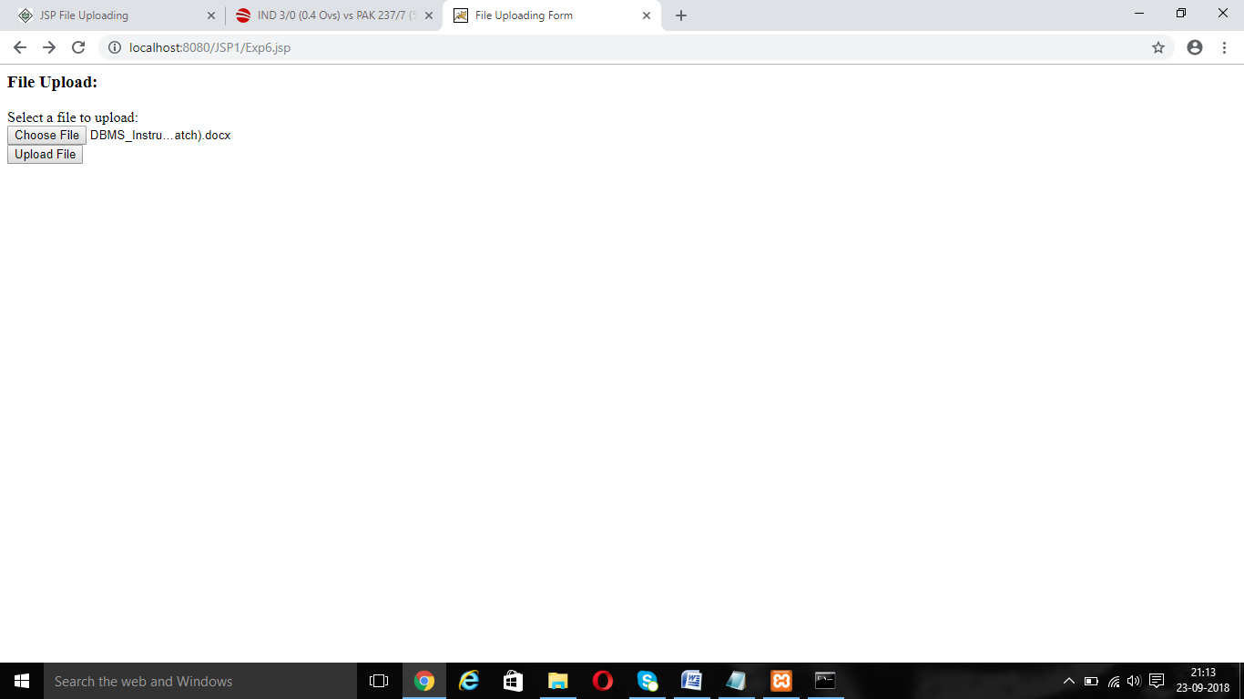

**Exp7.jsp**

<%@ page import = "java.io.*,java.util.*" %>

<html>

<head>

<title>Page Redirection</title>

</head>

<body>

<center>

<h1>Page Redirection</h1>

</center>

<%

// New location to be redirected

String site = new String("http://www.ritchennai.org");

response.setStatus(response.SC_MOVED_TEMPORARILY);

response.setHeader("Location", site);

%>

</body>

</html>

**OUTPUT**



**Exp8.jsp**

<%@ page import = "java.io.*,java.util.*" %>

<html>

<head>

<title>Auto Refresh Header Example</title>

</head>

<body>

<center>

<h2>Auto Refresh Header Example</h2>

<%

// Set refresh, autoload time as 5 seconds

response.setIntHeader("Refresh", 5);

// Get current time

Calendar calendar = new GregorianCalendar();

String am_pm;

int hour = calendar.get(Calendar.HOUR);

int minute = calendar.get(Calendar.MINUTE);

int second = calendar.get(Calendar.SECOND);

if(calendar.get(Calendar.AM_PM) == 0)

am_pm = "AM";

else

am_pm = "PM";

String CT = hour+":"+ minute +":"+ second +" "+ am_pm;

out.println("Crrent Time: " + CT + "\n");

%>

</center>

</body>

</html>

**OUTPUT**

