**PROGRAM**

package ex1;

/**

*

* @author Karthikeyan

*/

public class Ex1 {

/**

* @param args the command line arguments

*/

public static void main(String[] args) {

// TODO code application logic here

System.out.println("Hello");

System.out.println("Karthikeyan");

}

}

**OUTPUT**

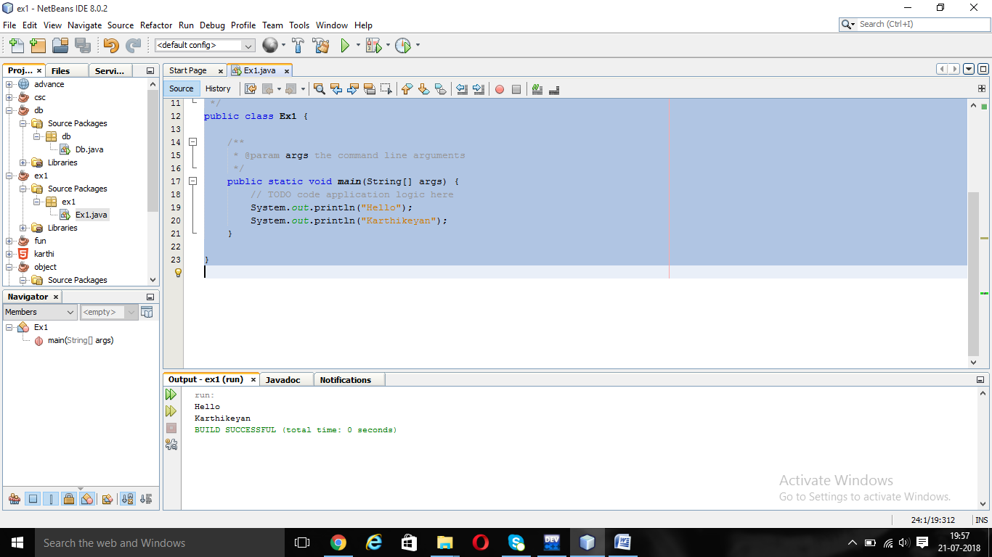

**PROGRAM**

package ex2;

import java.io.*;

import java.util.*;

/**

*

* @author Karthikeyan

*/

public class Ex2 {

/**

* @param args the command line arguments

*/

public static void main(String[] args) {

// TODO code application logic here

int a,b,c;

Scanner s=new Scanner(System.in);

System.out.println("Enter the A and B values=");

a=s.nextInt();

b=s.nextInt();

c=a+b;

System.out.println("The Sum is"+c);

}

}

**OUTPUT**

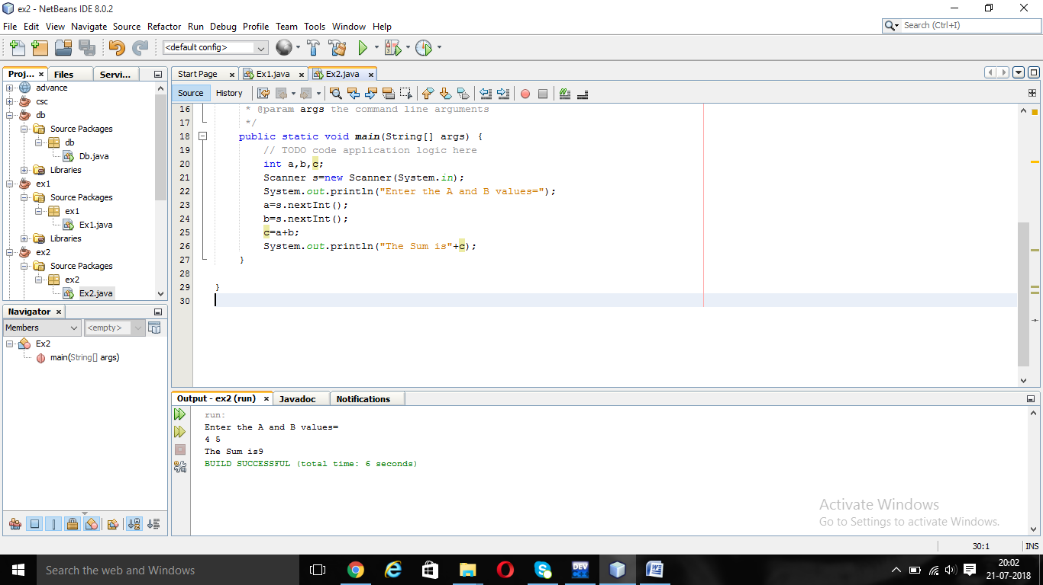

**PROGRAM**

package ex3;

import java.io.*;

import java.util.*;

/**

*

* @author Karthikeyan

*/

public class Ex3 {

/**

* @param args the command line arguments

*/

public static void main(String[] args) {

// TODO code application logic here

int a,b,c;

Scanner s=new Scanner(System.in);

System.out.println("Enter the A and B values=");

a=s.nextInt();

b=s.nextInt();

c=a/b;

System.out.println("The answer is"+c);

}

}

**OUTPUT**

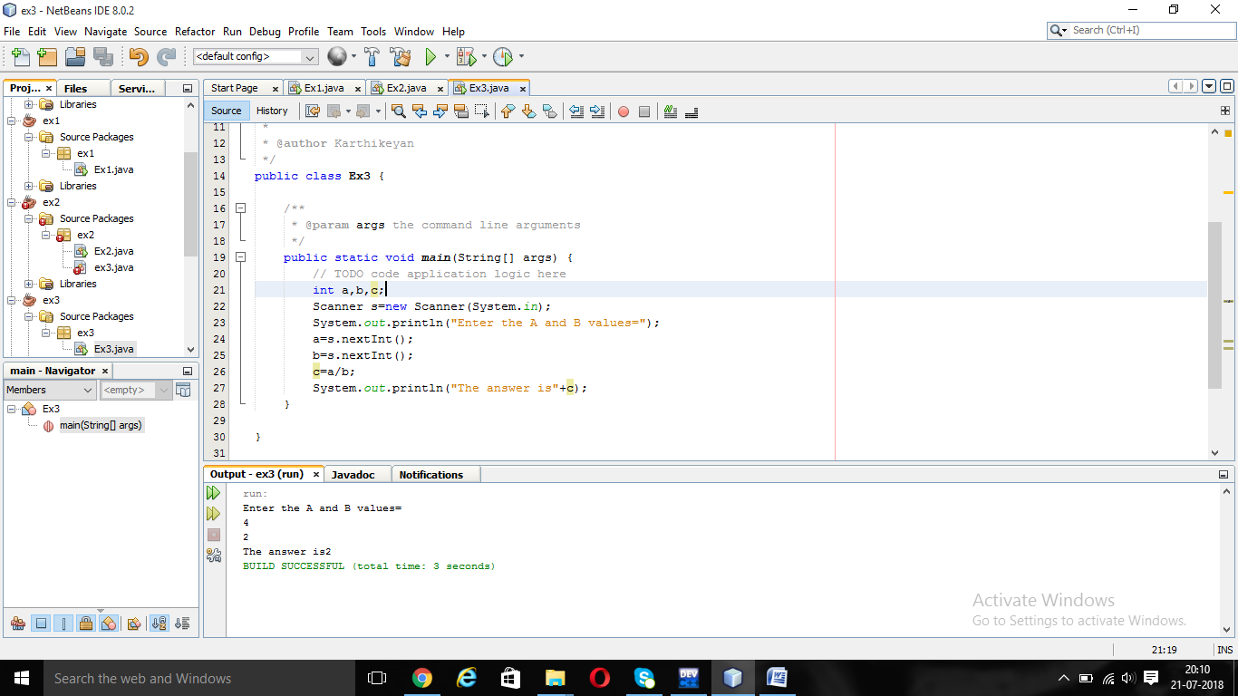

**PROGRAM**

package ex4;

/**

*

* @author Karthikeyan

*/

public class Ex4 {

/**

* @param args the command line arguments

*/

public static void main(String[] args) {

// TODO code application logic here

System.out.println(-5+8*6);

System.out.println((55+9)%9);

System.out.println(20+-3*5/8);

System.out.println(5+15/3*2-8%3);

}

}

**OUTPUT**

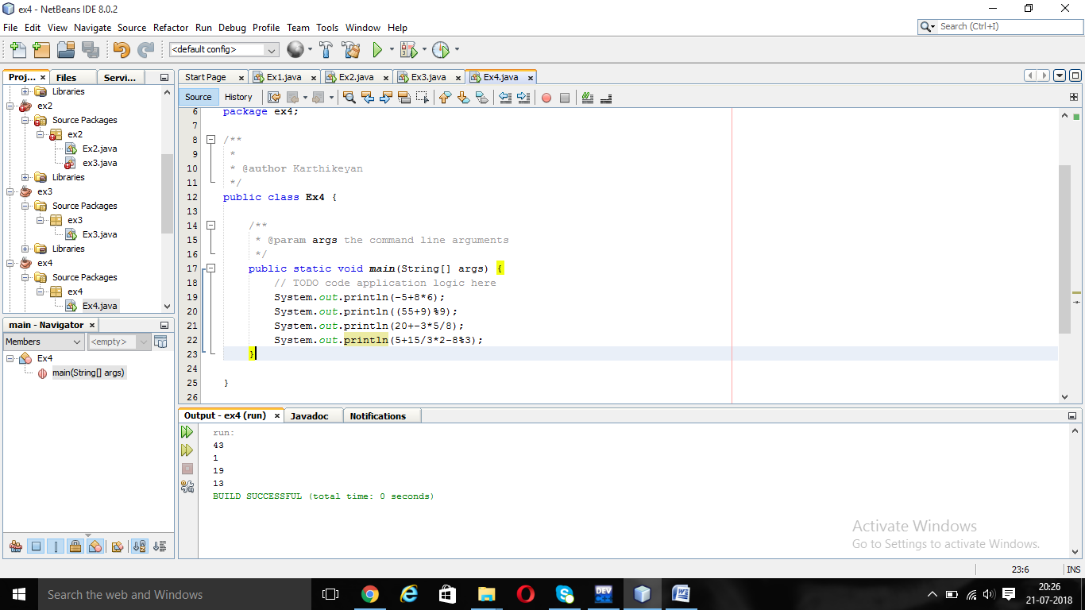

**PROGRAM**

/*

* To change this license header, choose License Headers in Project Properties.

* To change this template file, choose Tools | Templates

* and open the template in the editor.

*/

package ex5;

import java.io.*;

import java.util.*;

/**

*

* @author Karthikeyan

*/

public class Ex5 {

/**

* @param args the command line arguments

*/

public static void main(String[] args) {

// TODO code application logic here

int a,b,c;

Scanner s=new Scanner(System.in);

System.out.println("Enter the A and B value=");

a=s.nextInt();

b=s.nextInt();

c=a*b;

System.out.println(a+"*"+b+"="+c);

}

}

**OUTPUT:**

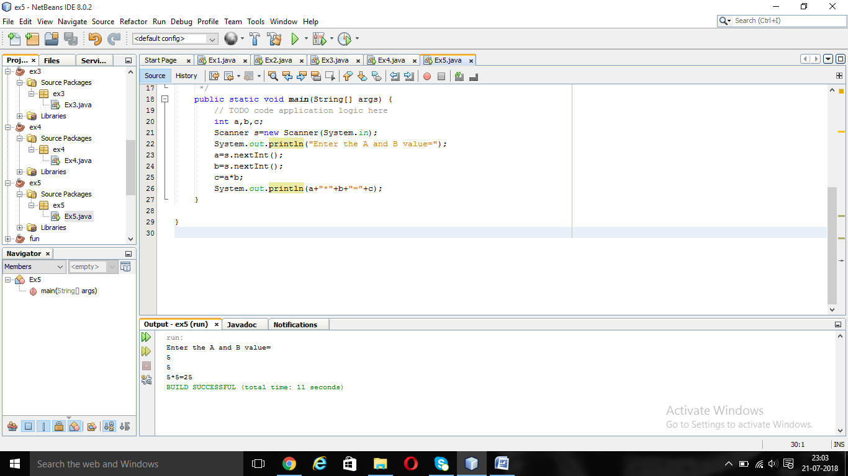

**PROGRAM**

/*

* To change this license header, choose License Headers in Project Properties.

* To change this template file, choose Tools | Templates

* and open the template in the editor.

*/

package ex6;

import java.io.*;

import java.util.*;

/**

*

* @author Karthikeyan

*/

public class Ex6 {

/**

* @param args the command line arguments

*/

public static void main(String[] args) {

// TODO code application logic here

int a,b,c;

Scanner s=new Scanner(System.in);

System.out.println("Enter the A and B value=");

a=s.nextInt();

b=s.nextInt();

System.out.println(a+"+"+b+"="+(a+b));

System.out.println(a+"-"+b+"="+(a-b));

System.out.println(a+"*"+b+"="+(a*b));

System.out.println(a+"/"+b+"="+(a/b));

System.out.println(a+"%"+b+"="+(a%b));

}

}

**OUTPUT**

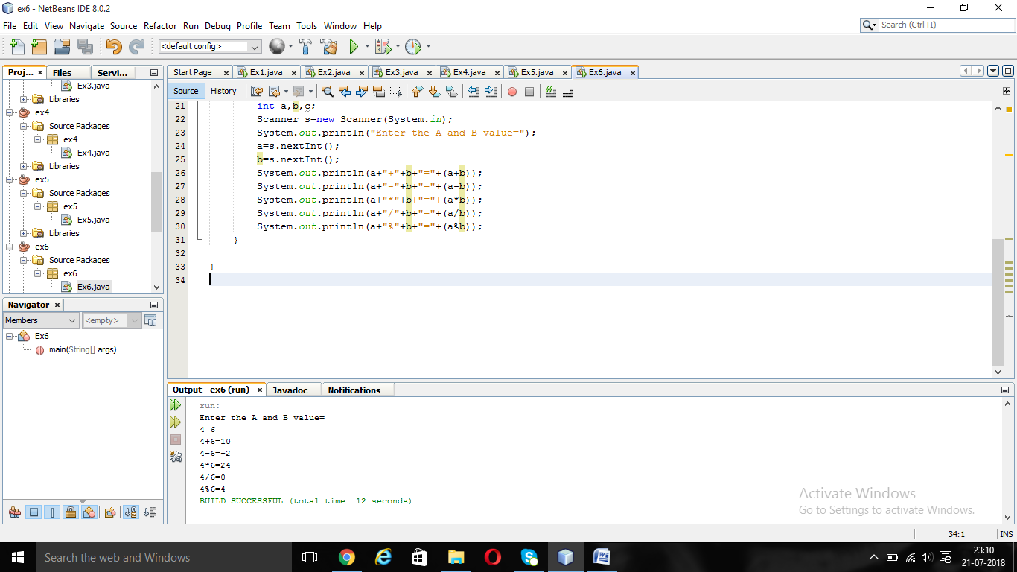

**PROGRAM**

/*

* To change this license header, choose License Headers in Project Properties.

* To change this template file, choose Tools | Templates

* and open the template in the editor.

*/

package ex7;

import java.io.*;

import java.util.*;

/**

*

* @author Karthikeyan

*/

public class Ex7 {

/**

* @param args the command line arguments

*/

public static void main(String[] args) {

// TODO code application logic here

int n,i;

Scanner s=new Scanner(System.in);

System.out.println("Enter the tables do you want=");

n=s.nextInt();

for(i=1;i<=10;i++)

{

System.out.println(n+"*"+i+"="+(n*i));

}

}

}

**OUTPUT**

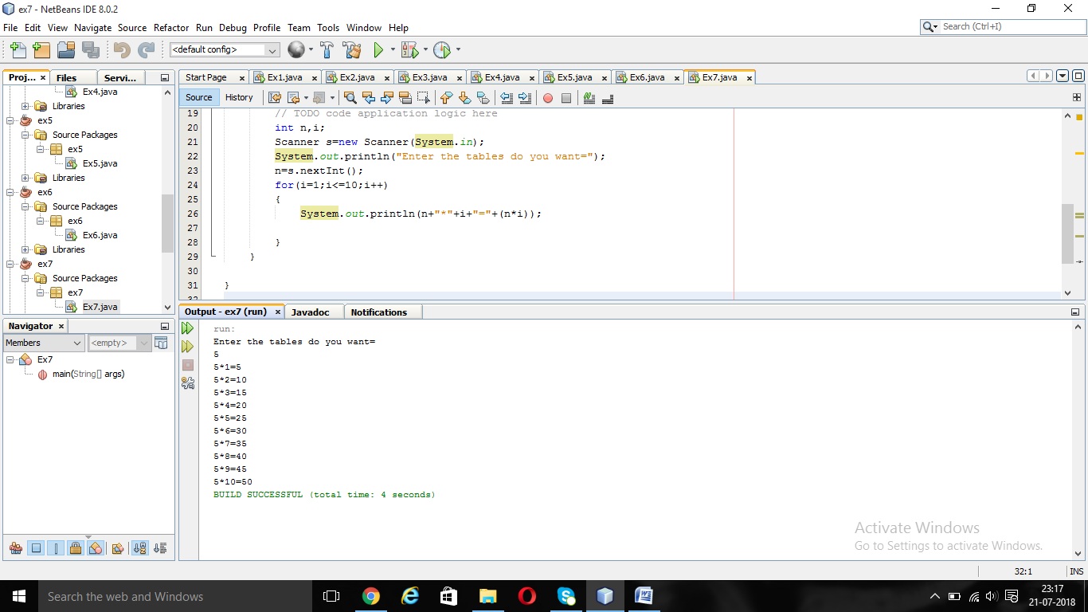

**PROGRAM**

/*

* To change this license header, choose License Headers in Project Properties.

* To change this template file, choose Tools | Templates

* and open the template in the editor.

*/

package ex8;

/**

*

* @author Karthikeyan

*/

public class Ex8 {

/**

* @param args the command line arguments

*/

public static void main(String[] args) {

// TODO code application logic here

int i,j;

for(i=1;i<=5;i++)

{

for(j=1;j<=5;j++)

{if((i==1&&j==5)||(i==2&&j==5)||(i==4&&j==5)||(i==3&&j==5)||i==5)

System.out.print("J");

else

{

System.out.print(" ");

}

/*if((i==5&&j==2)||(i==4&&j==1))

{

printf("J");

}

if(i==5&&j==5)

{

printf("*");

}

//if remove this p is displayed

if(i==4||j==5||i==5)

{

printf("\b");

}*/

}

System.out.println();

}

for(i=1;i<=5;i++)

{

for(j=1;j<=5;j++)

{if(i==1||j==1||i==3||j==5)

System.out.print("a");

else

{

System.out.print(" ");

}

/*if(i==5&&j==5)

{

printf("*");

}

//if remove this p is displayed

if(i==4||j==5||i==5)

{

printf("\b");

}*/

}

System.out.println();

}

for(i=1;i<=5;i++)

{

for(j=1;j<=9;j++)

{if((i==1&&(j==1||j==9))||(i==2&&(j==2||j==8))||(i==3&&(j==3||j==7))||(i==4&&(j==4||j==6))||(i==5&&j==5))

System.out.print("v");

else

{

System.out.print(" ");

}

/*if(i==5&&j==5)

{

printf("*");

}

//if remove this p is displayed

if(i==4||j==5||i==5)

{

printf("\b");

}*/

}

System.out.println();

}

for(i=1;i<=5;i++)

{

for(j=1;j<=5;j++)

{if(i==1||j==1||i==3||j==5)

System.out.print("a");

else

{

System.out.print(" ");

}

/*if(i==5&&j==5)

{

printf("*");

}

//if remove this p is displayed

if(i==4||j==5||i==5)

{

printf("\b");

}*/

}

System.out.println();

}

//return 0;

}

}

**OUTPUT**

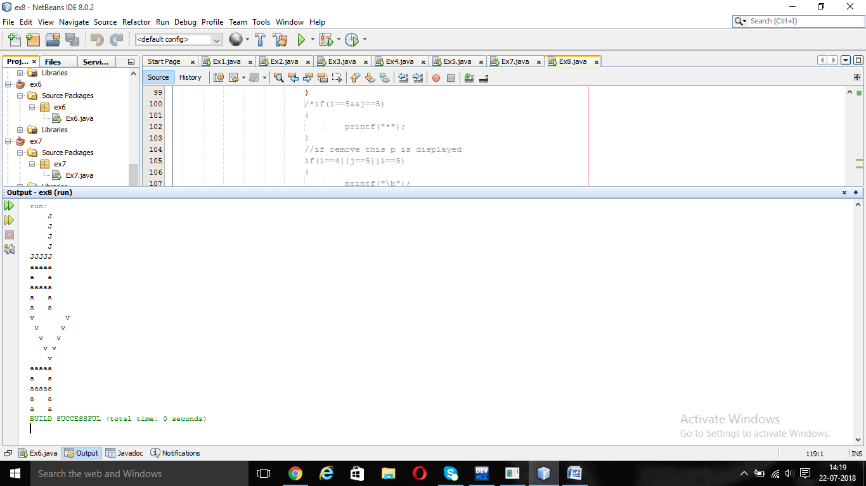

**PROGRAM**

/*

* To change this license header, choose License Headers in Project Properties.

* To change this template file, choose Tools | Templates

* and open the template in the editor.

*/

package ex9;

/**

*

* @author Karthikeyan

*/

public class Ex9 {

/**

* @param args the command line arguments

*/

public static void main(String[] args) {

// TODO code application logic here

System.out.println(((25.5 * 3.5 - 3.5 * 3.5) / (40.5 - 4.5)));

}

}

**OUTPUT**

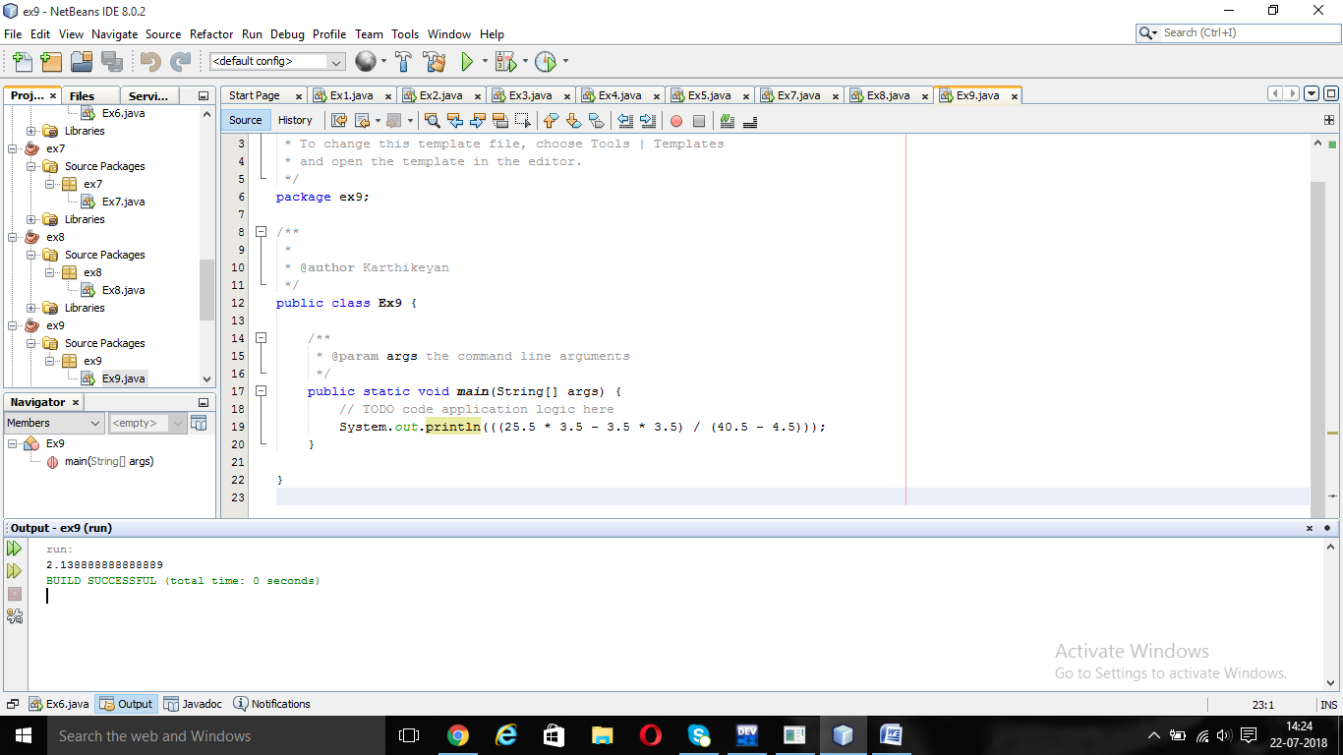

**PROGRAM**

/*

* To change this license header, choose License Headers in Project Properties.

* To change this template file, choose Tools | Templates

* and open the template in the editor.

*/

package ex10;

/**

*

* @author Karthikeyan

*/

public class Ex10 {

/**

* @param args the command line arguments

*/

public static void main(String[] args) {

// TODO code application logic here

System.out.println(4.0 * (1 - (1.0/3) + (1.0/5) - (1.0/7) + (1.0/9) - (1.0/11)));

}

}

**OUTPUT**

