<html>

<head>

<script>

document.write("Hi Karthikeyan");

</script>

</head>

</html>

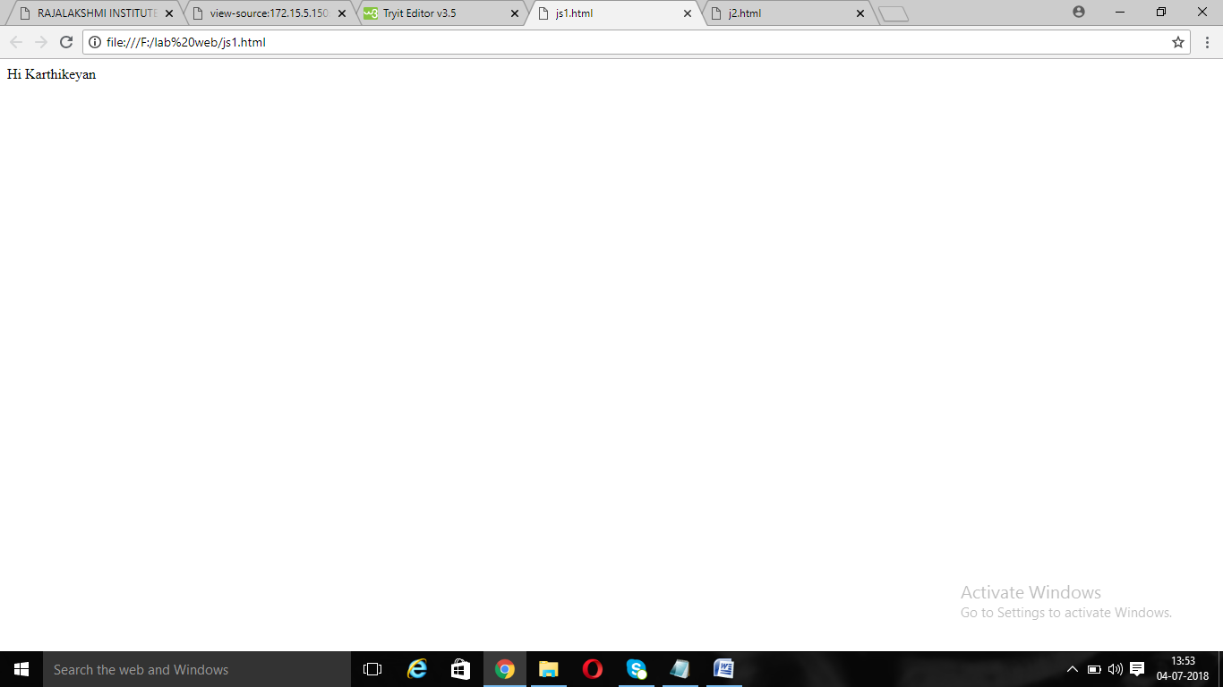

<html>

<head>

<script>

function karthi()

{

alert("Hi karthikeyan");

}

</script>

<style>

button

{

width:50px;

}

</style>

</head>

<body>

<button onclick="karthi()" >Click Me</button>

</body>

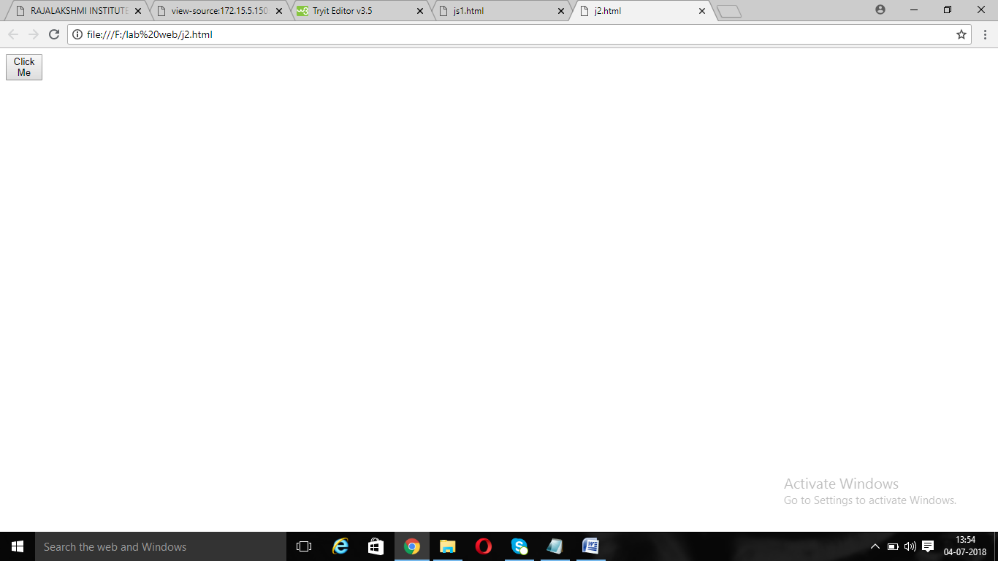

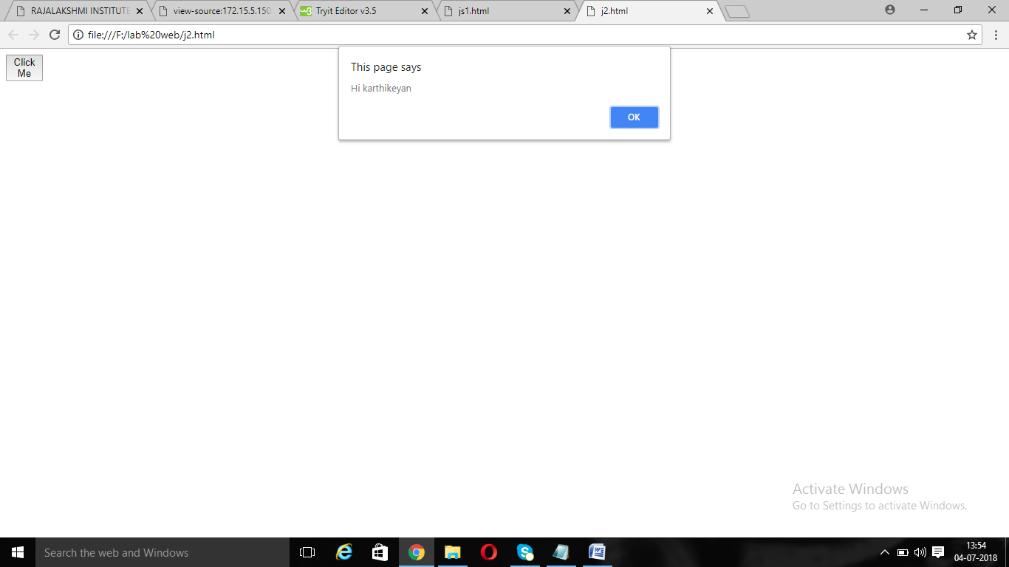

**Ext.js**

function karthi()

{

alert("Hi karthikeyan");

}

**J2.html**

<html>

<head>

<style>

button

{

width:50px;

}

</style>

</head>

<body>

<script src="ext.js"></script>

<button onclick="karthi()" >Click Me</button>

</body>

</html>

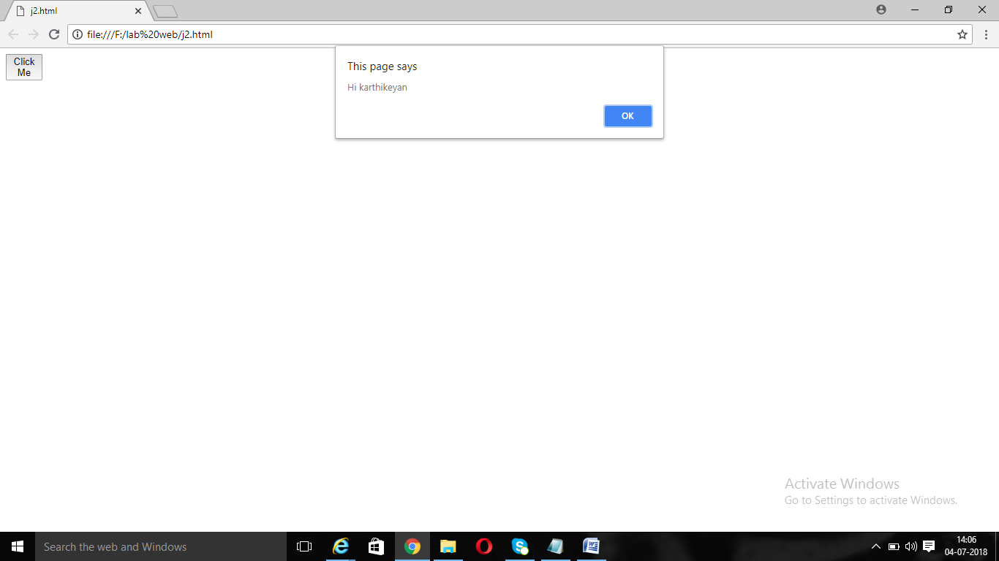

<html>

<body>

<center>

<h1>JavaScript Program to find EVEN OR ODD</h1>

<p style="font-size:20">This program display the result if the given value is even</p><BR><BR><BR>

<script>

var n=prompt("Enter the value");

if(n%2==0)

{document.write(n+"is EVEN");

}

</script>

</center>

</body>

</html>

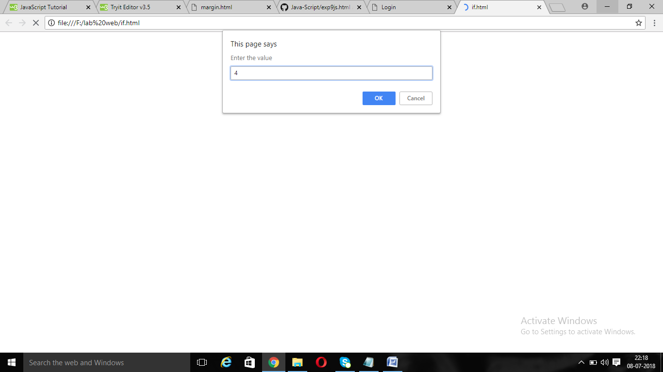

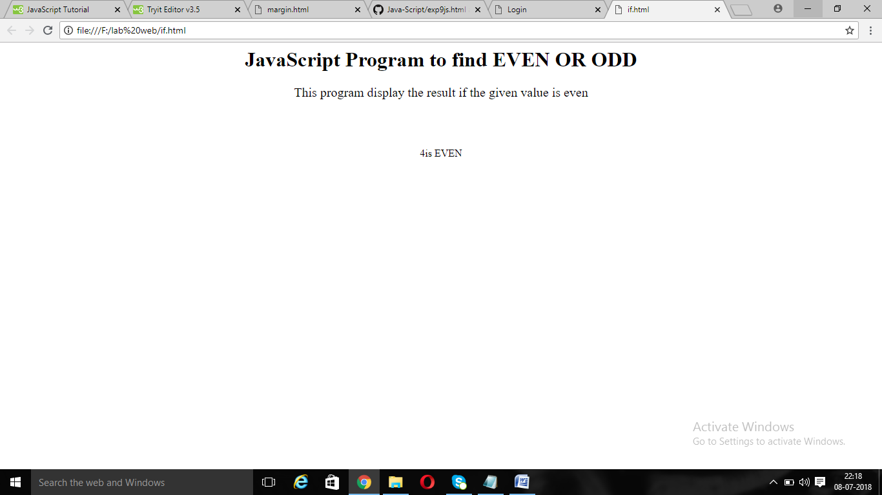

<html>

<body>

<center>

<h1>JavaScript Program to find EVEN OR ODD</h1>

<p style="font-size:20">This program display the result if the given value is even</p><BR><BR><BR>

<script>

var n=prompt("Enter the value");

if(n%2==0)

{document.write(n+"is EVEN");

}

else

{

document.write(n+"is ODD");

}

</script>

</center>

</body>

</html>

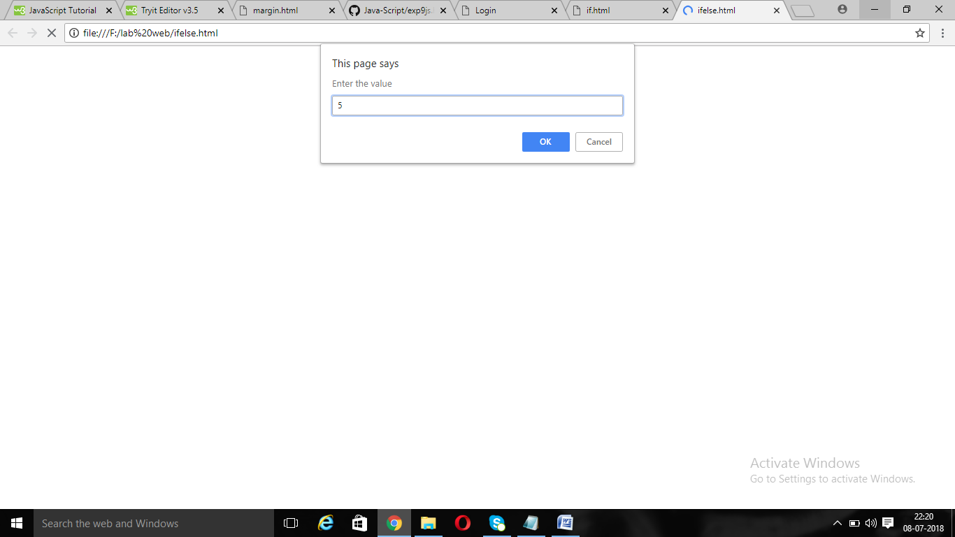

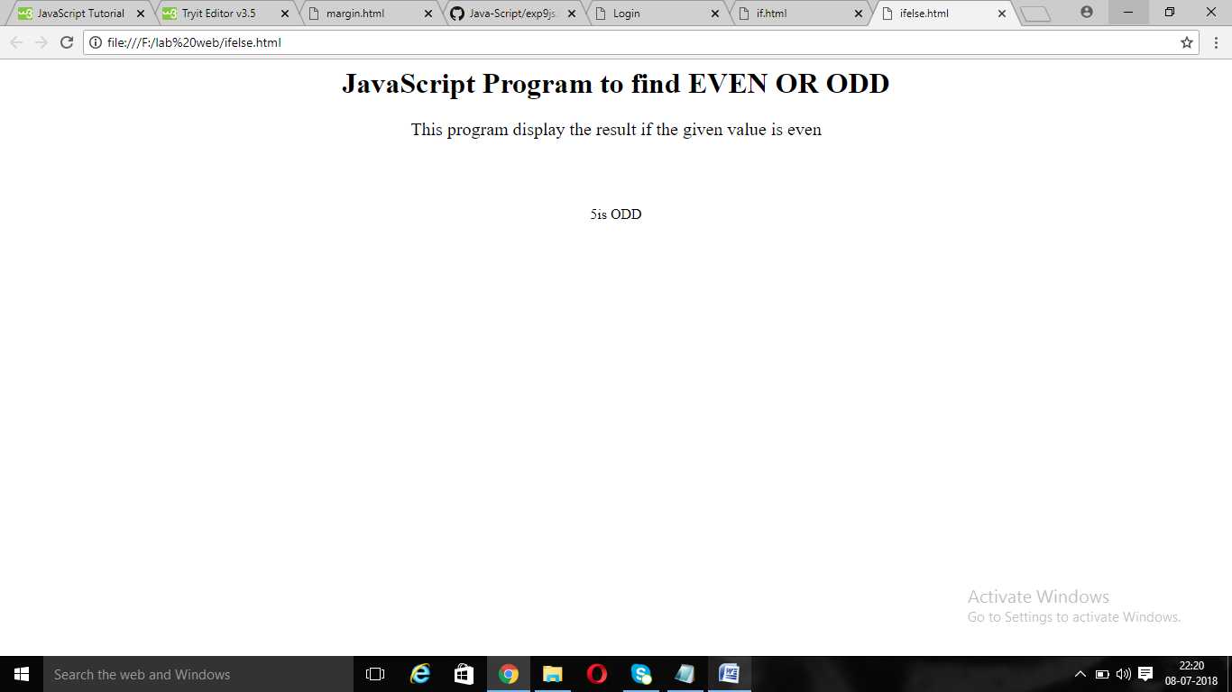

<html>

<head>

<style>

div

{

color:blue;

}

</style>

</head>

<body>

<center>

<h1>JavaScript Program to print name using WHILE LOOP</h1>

<BR><BR><BR>

<div>

<script>

var n=0;

while(n<10)

{document.write("KARTHIKEYAN IT"+"<br>");

n++;

}

</script>

</div>

</center>

</body>

</html>

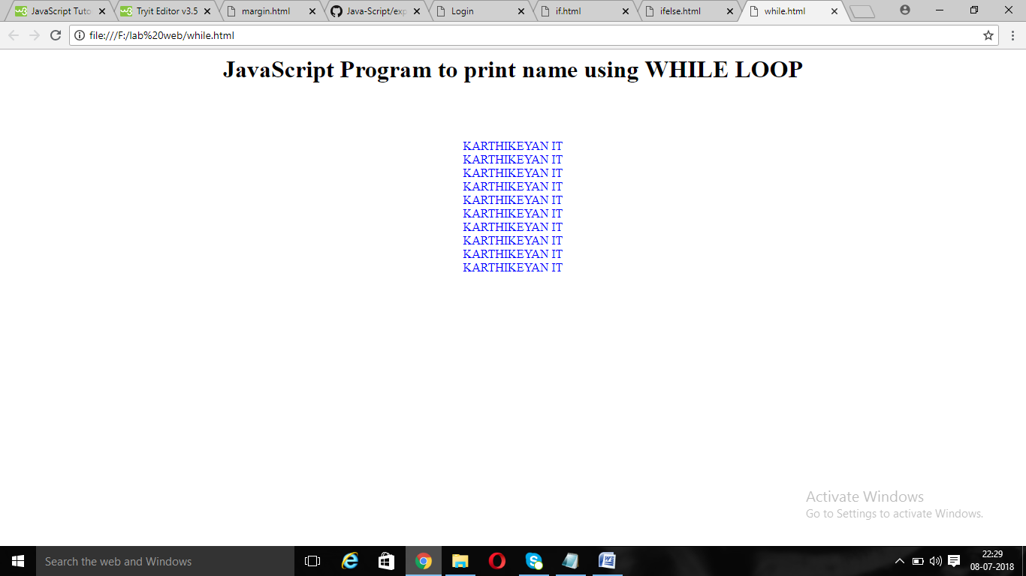

<html>

<head>

<style>

div

{

color:blue;

}

</style>

</head>

<body>

<center>

<h1>JavaScript Program to find FACTORIAL using FOR LOOP</h1>

<BR><BR><BR>

<div>

<script>

var i;

var n=prompt("Enter the value");

var fact=1;

for(i=1;i<=n;i++)

{fact=fact*i;

}

document.write(fact+"is a factorial of"+n);

</script>

</div>

</center>

</body>

</html>

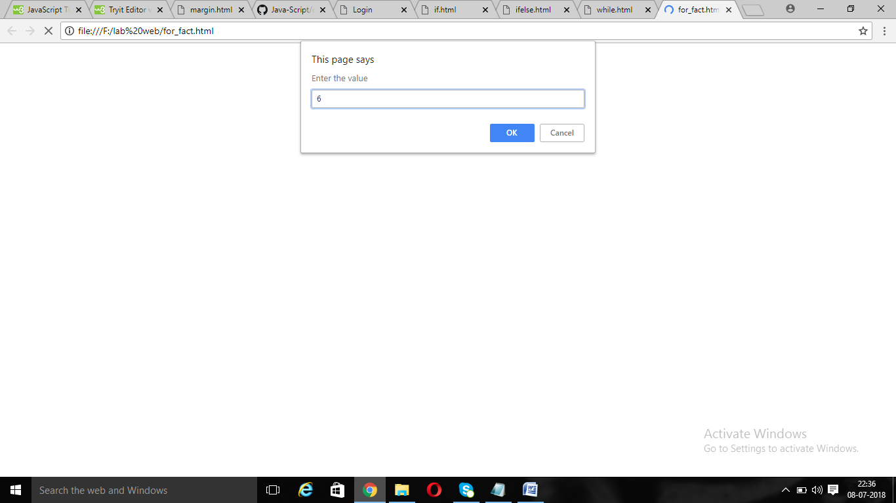

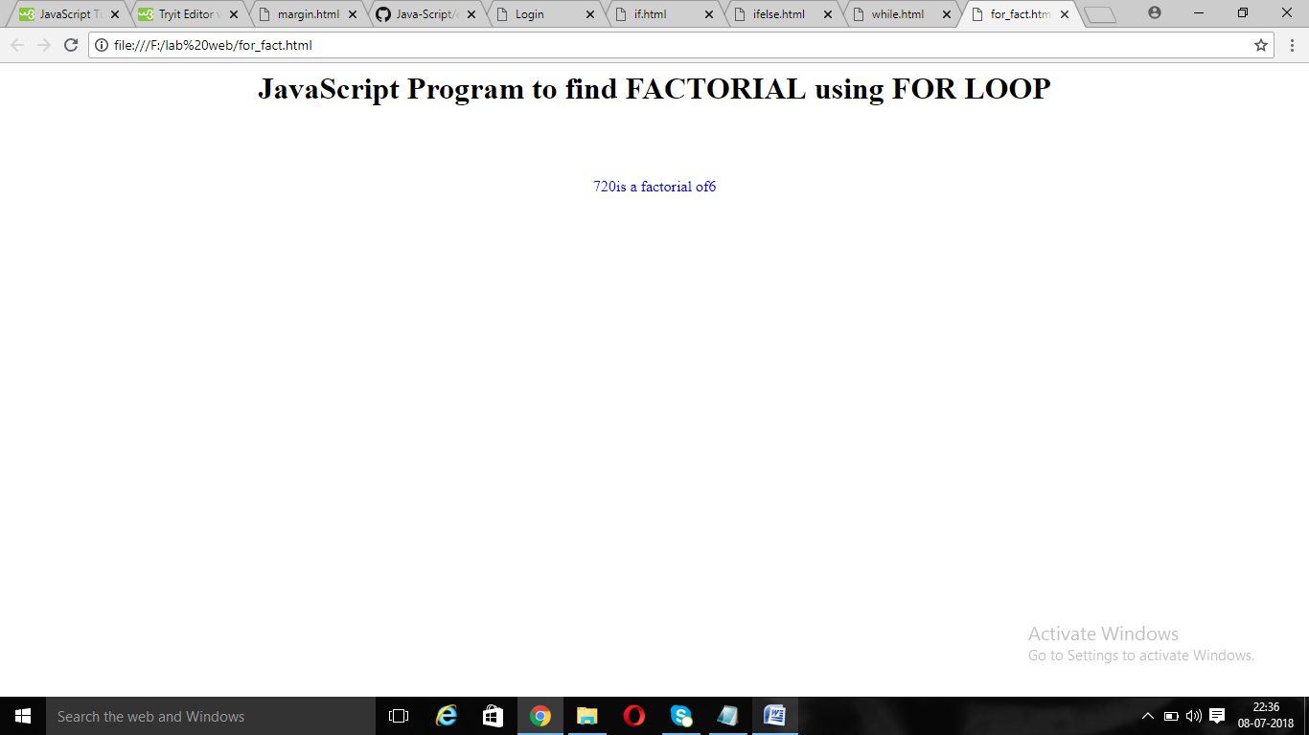

<html>

<head>

<style>

div

{

color:blue;

}

</style>

</head>

<body>

<center>

<h1>JavaScript Program to print name using ARRAYS</h1>

<BR><BR><BR>

<div>

<script>

var name =new Array("karthikeyan");

for(i=0;i<name.length;i++)

{

document.write(name[i]+"<br>");

}

</script>

</div>

</center>

</body>

</html>

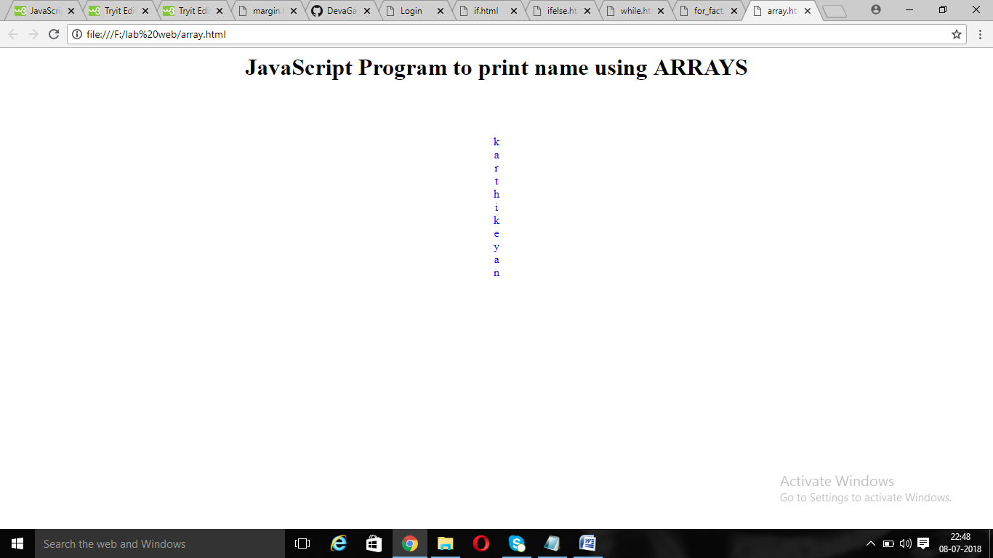

<html>

<head>

<style>

div

{

color:blue;

}

</style>

</head>

<body>

<center>

<h1>JavaScript Program to show ALERT</h1>

<BR><BR><BR>

<div>

<script>

function kar()

{

alert("HI Karthikeyan");

}

</script>

<button onClick="kar()">Click me</button>

</center>

</body>

</html>

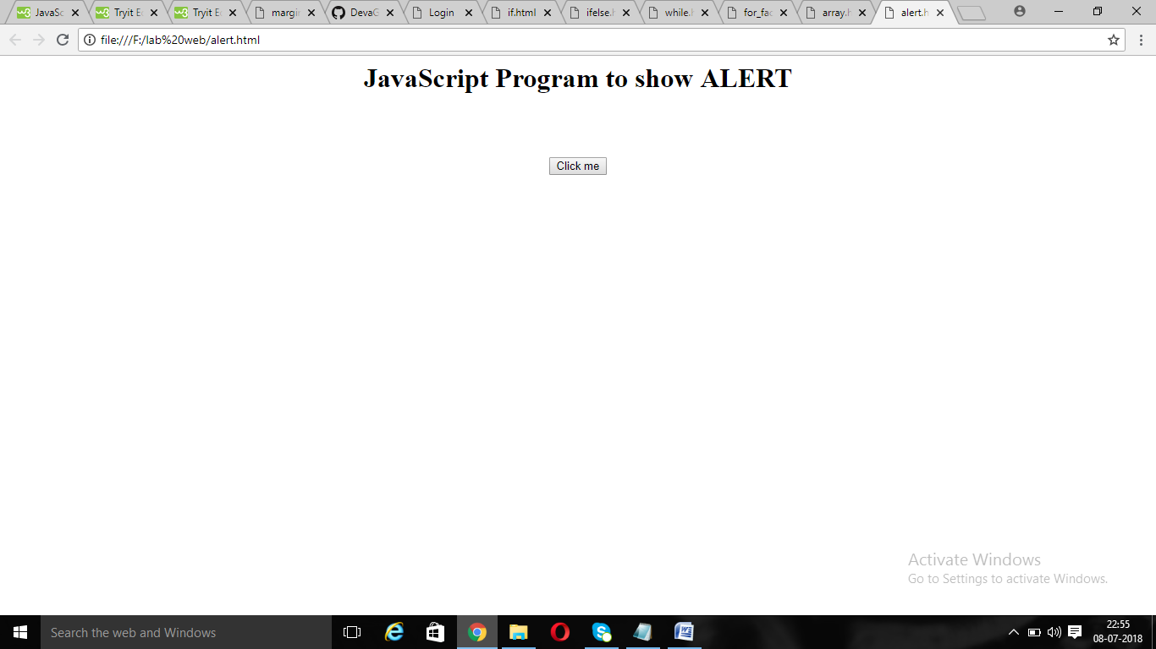

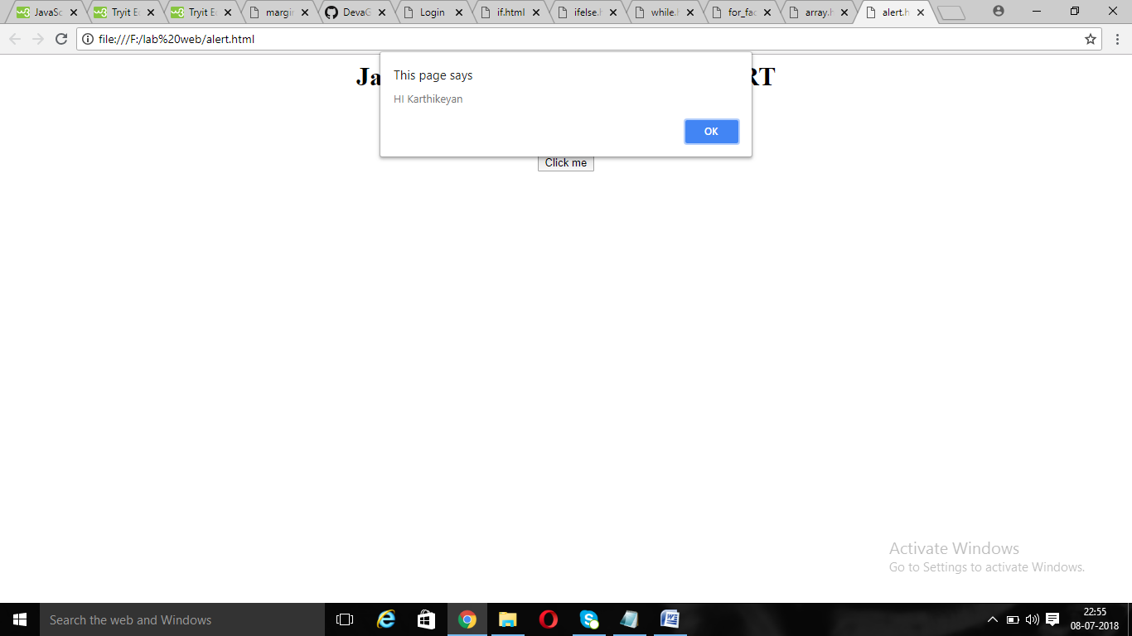

<html>

<head>

<style>

div

{

color:blue;

}

</style>

</head>

<body>

<center>

<h1>JavaScript Program to show ALERT</h1>

<BR><BR><BR>

<div>

<script>

function kar()

{

if(confirm("Press OK to print Karthi"))

document.write("HI Karthikeyan");

else

document.write("Information Technology");

}

</script>

<button onClick="kar()">Click me</button>

</center>

</body>

</html>

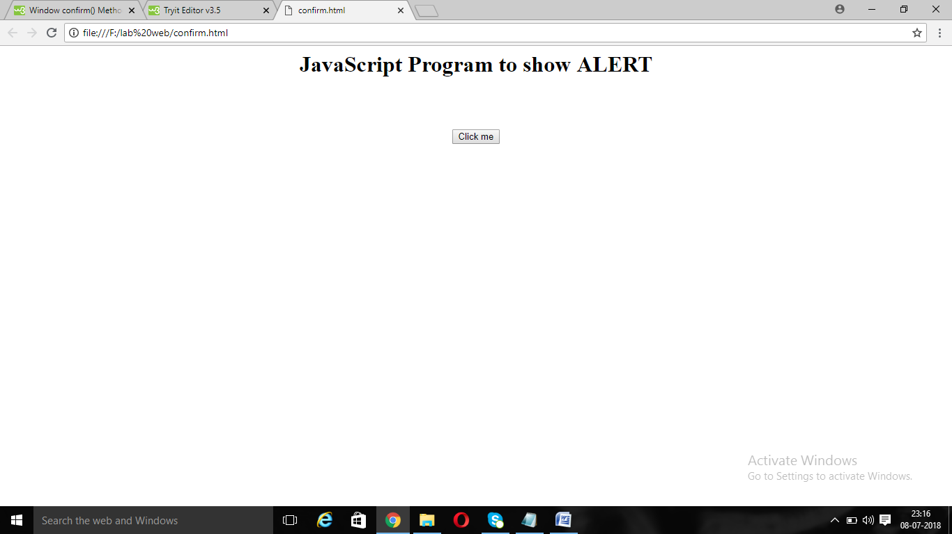

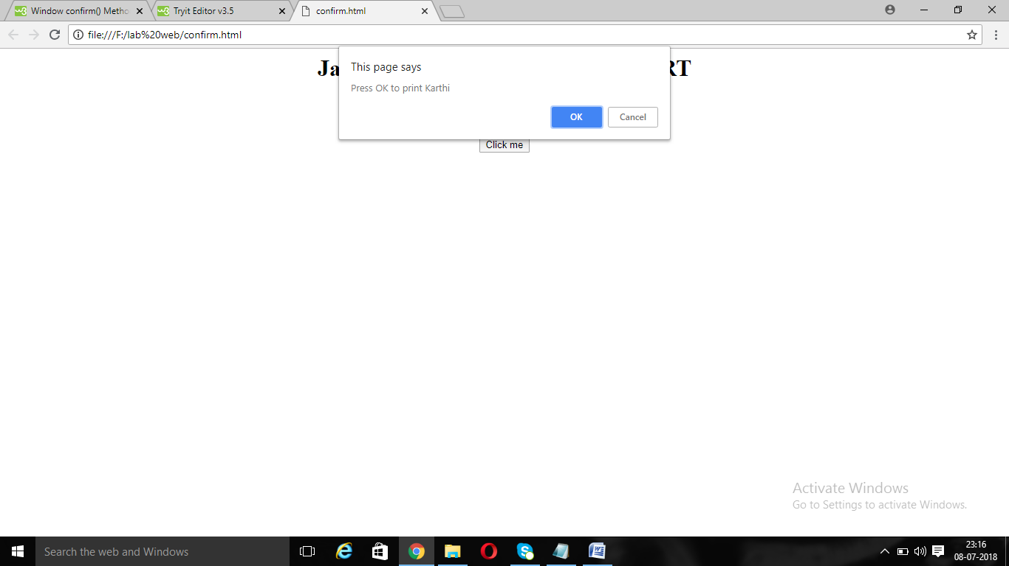

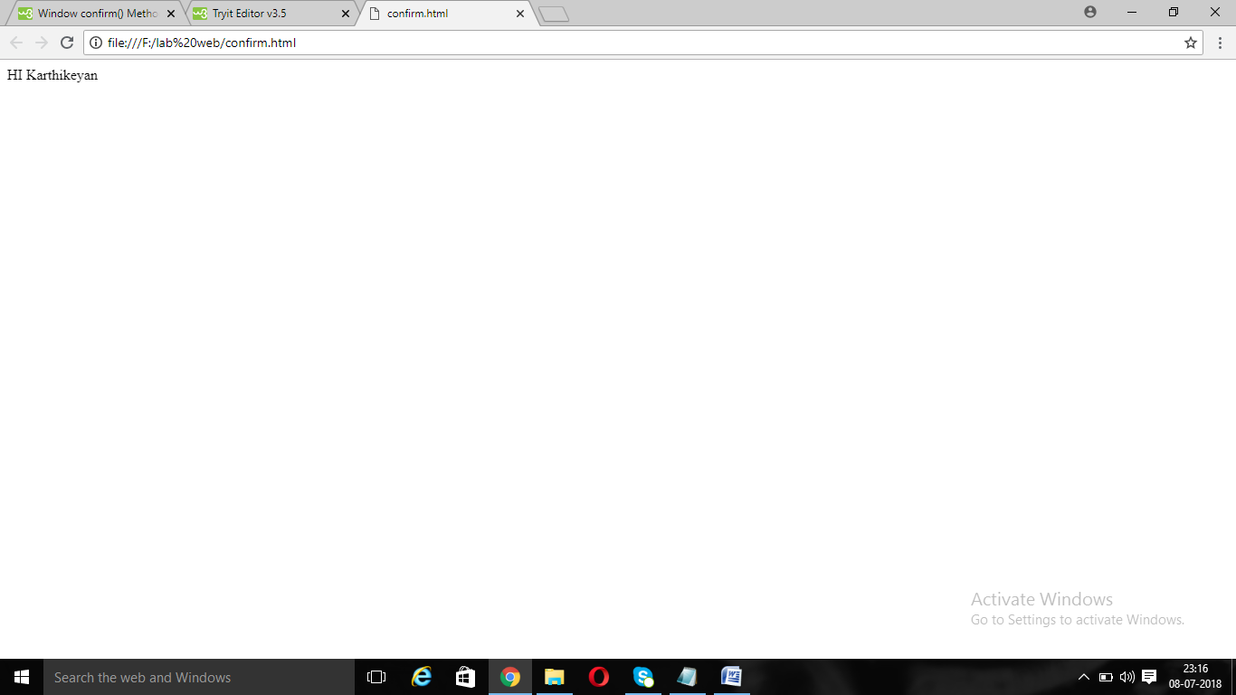

<html>

<body>

<center>

<h1>JavaScript Program to find EVEN OR ODD</h1>

<p style="font-size:20">This program display the result if the given value is even</p><BR><BR><BR>

<script>

var a=prompt("Enter the value");

function kar()

{document.write("Hi "+a+" How are you?");

}

</script>

<button onclick="kar()">Click Me</button>

</center>

</body>

</html>

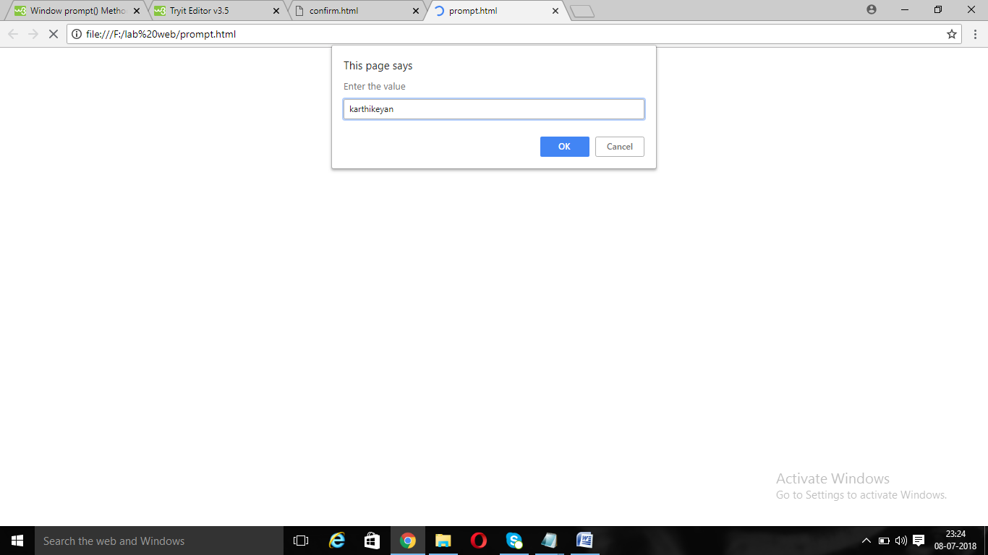

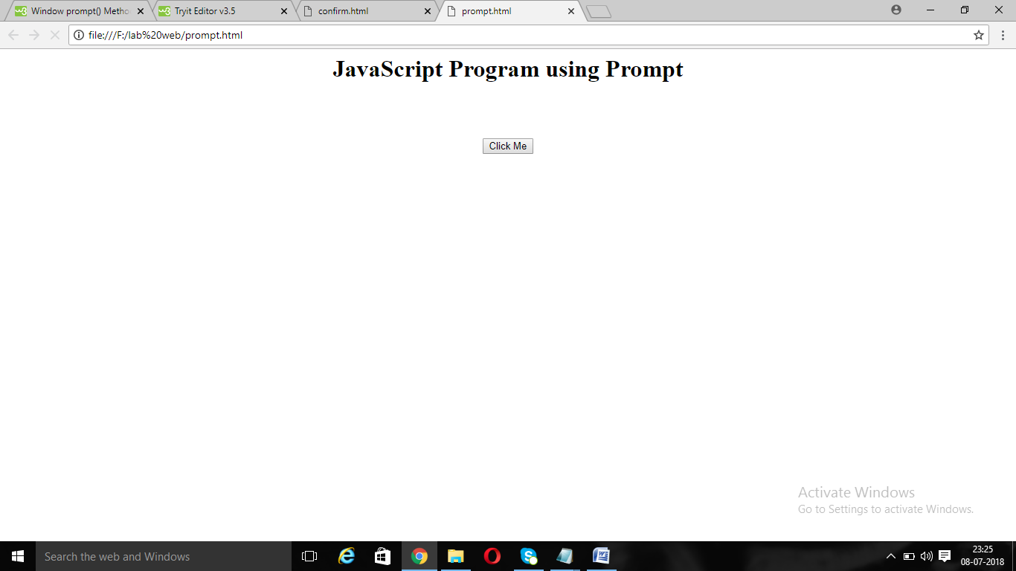

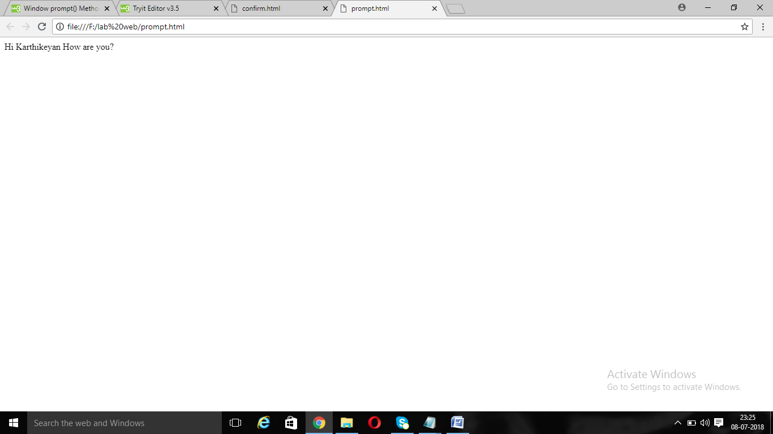

<html>

<body>

<h1>JavaScript program to print the current page.</h1>

<button onclick="kar()">Print</button>

<script>

function kar()

{

window.print();

}

</script>

</body>

</html>

