**PROGRAM:**

#Finding Greater than 3 Numbers.

a=int(input("Enter the A value="))

b=int(input("Enter the B value="))

c=int(input("Enter the C value="))

if (a>b) and (a>c):

print(a)

elif (b>c):

print(b)

else:

print(c)

**OUTPUT:**

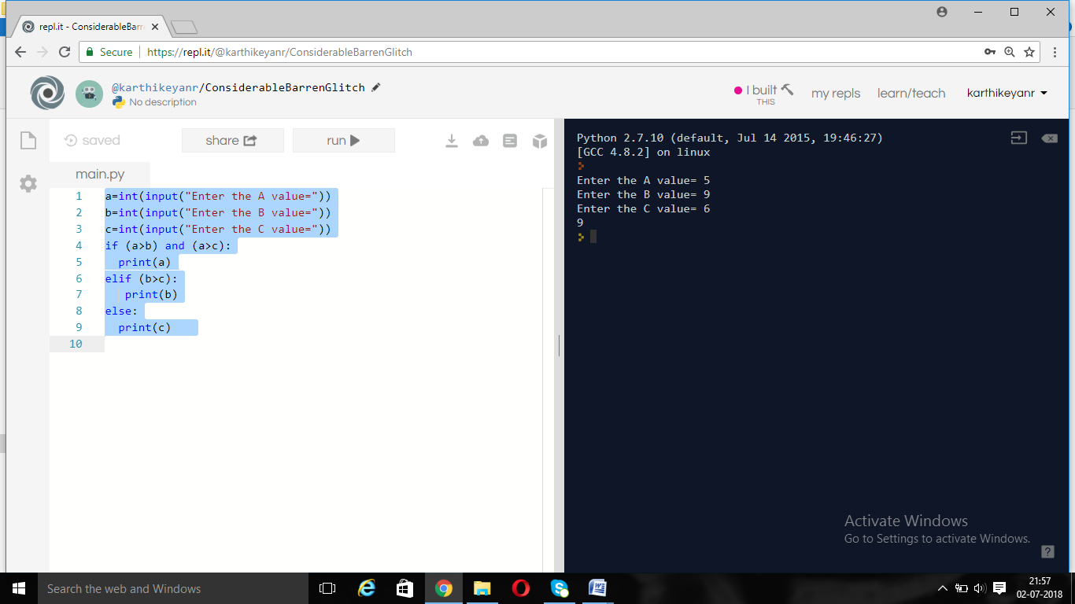

**PROGRAM:**

#Addition of Two numbers.

a=int(input("Enter the A value="))

b=int(input("Enter the B value="))

c=a+b

print(c)

**OUTPUT:**

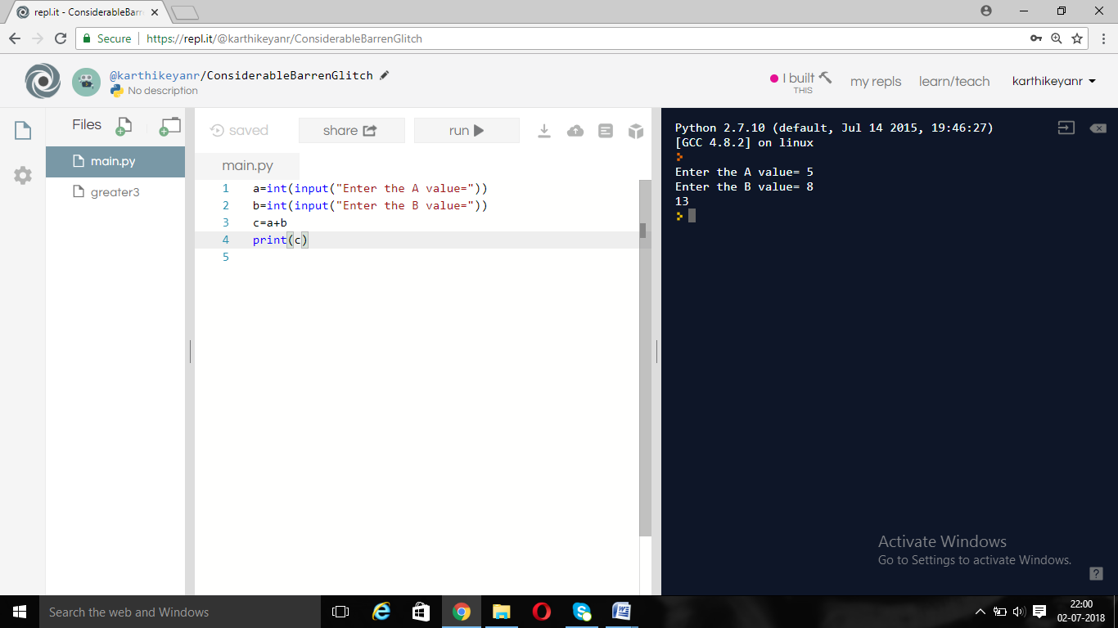

**PROGRAM:**

#Subtraction of two numbers

a=int(input("Enter the A value="))

b=int(input("Enter the B value="))

c=a-b

print(c)

**OUTPUT:**

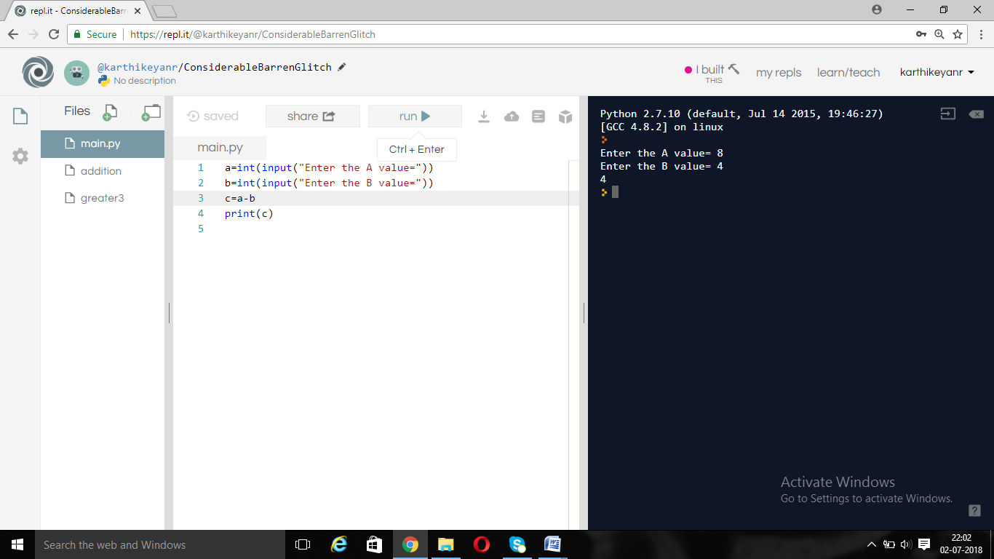

**PROGRAM:**

#Multiplication of Two Numbers.

a=int(input("Enter the A value="))

b=int(input("Enter the B value="))

c=a*b

print(c)

**OUTPUT:**

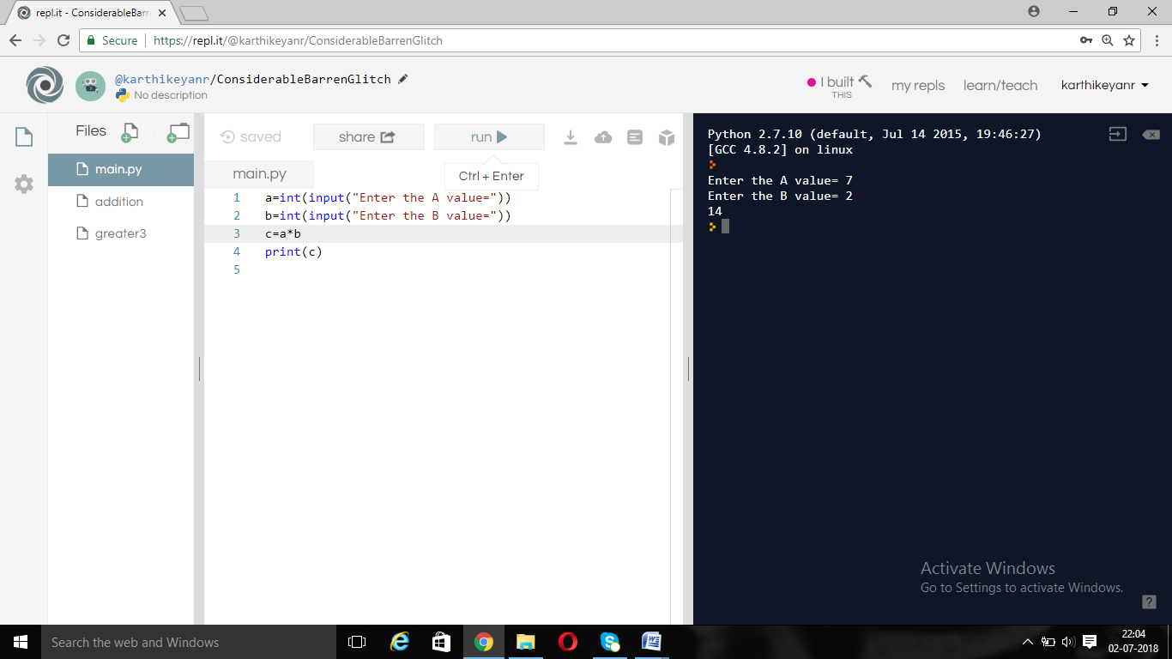

**PROGRAM:**

#Division of two numbers

a=int(input("Enter the A value="))

b=int(input("Enter the B value="))

c=a/b

print(c)

**OUTPUT:**

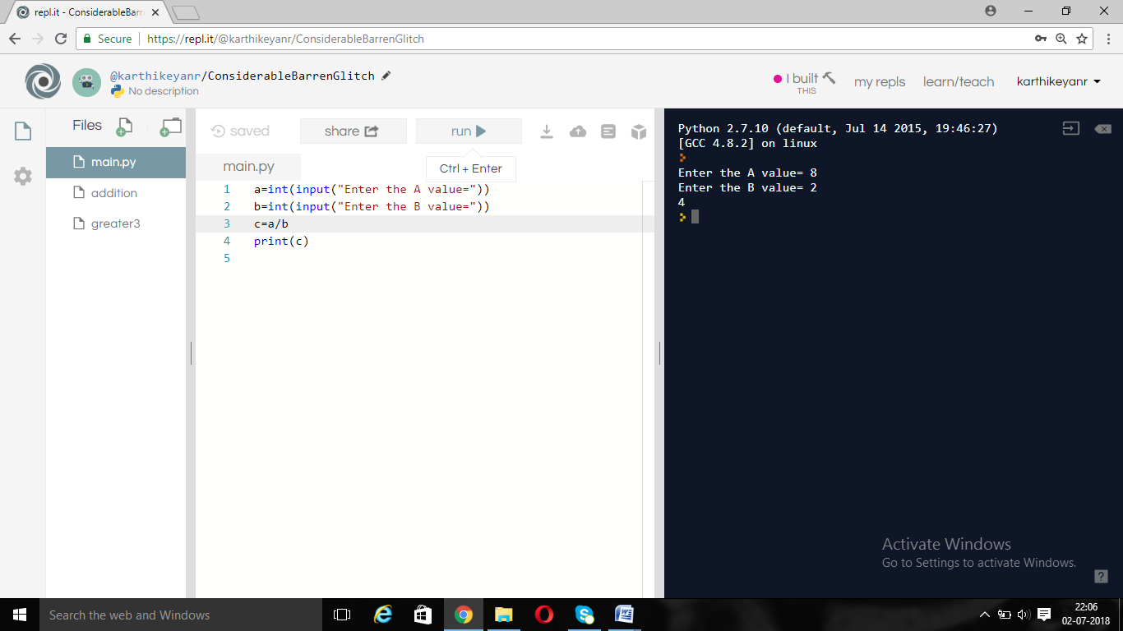

**PROGRAM:**

#Modulo of two numbers

a=int(input("Enter the A value="))

b=int(input("Enter the B value="))

c=a%b

print(c)

OUTPUT:

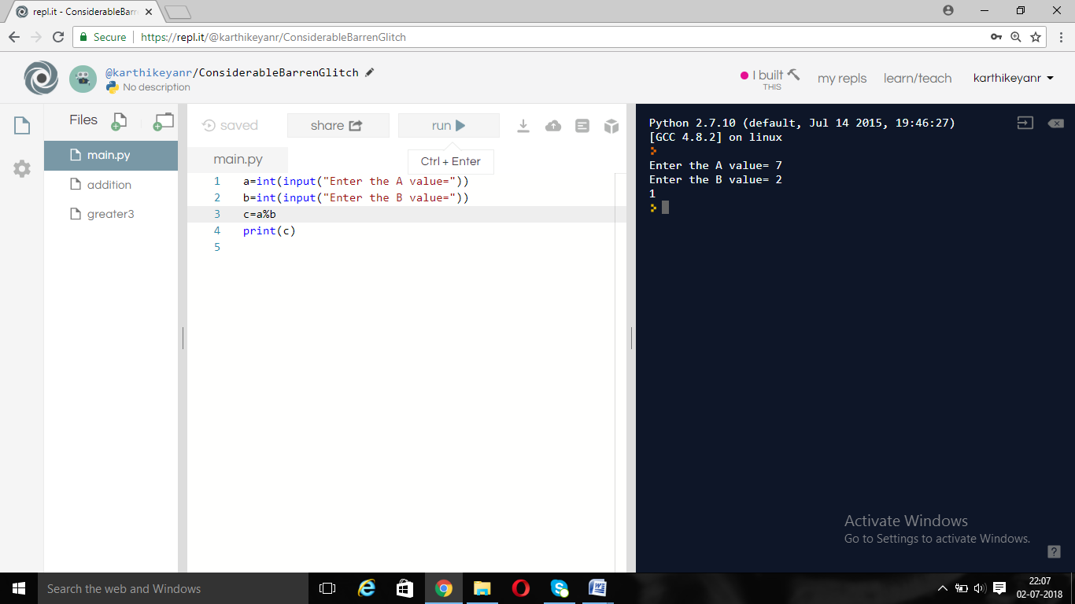

**PROGRAM:**

#Printing the hello python

print("Hello Python*****")

**OUTPUT:**

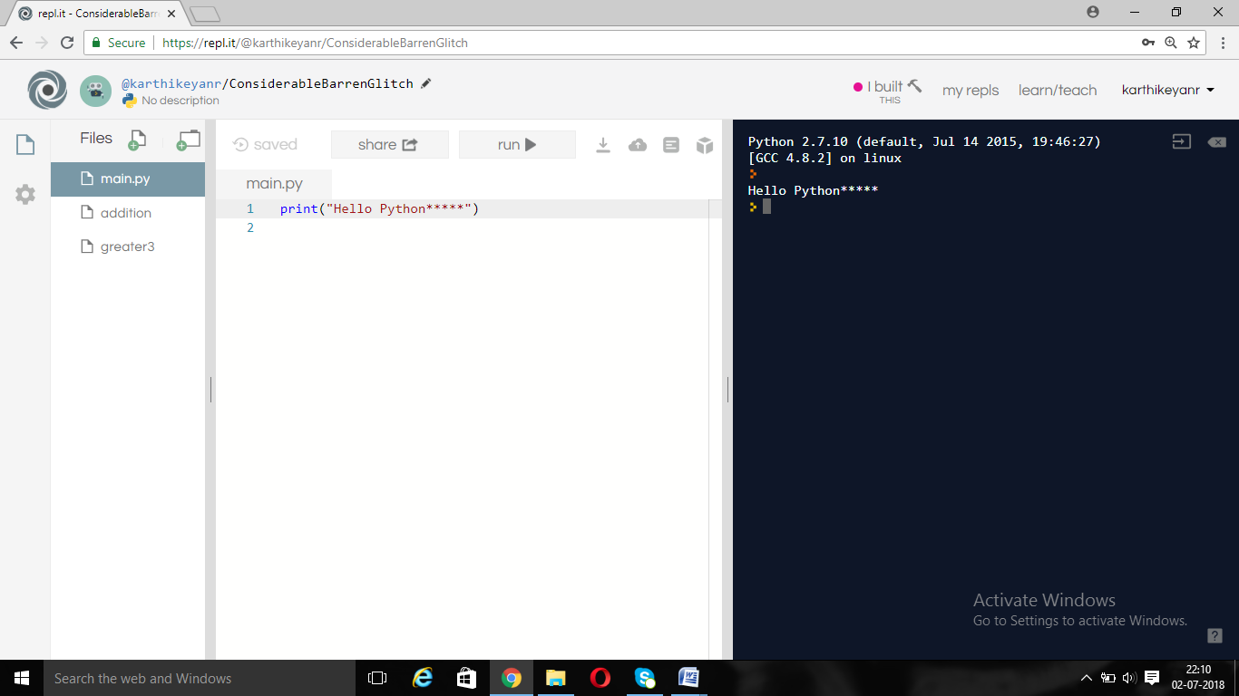

**PROGRAM:**

#Getting input and printing

a=int(input("Enter the A value="))

b=int(input("Enter the B value="))

print("A value=",a)

print("B value=",b)

**OUTPUT:**

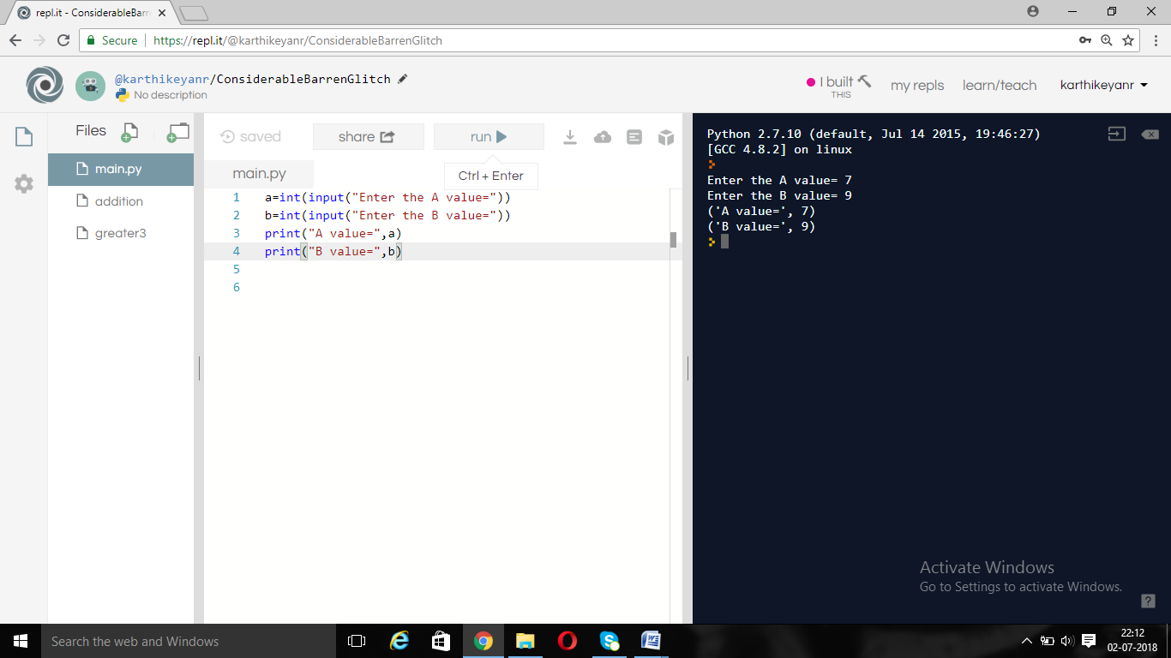

**PROGRAM:**

#Fibbonacci Series

n=int(input("Enter the range value="))

a=0

b=1

i=2

print("Fibbonacci Series upto range=",n)

print(a)

print(b)

while (i<n):

c=a+b

print(c)

a=b

b=c

i=i+1

**OUTPUT:**

