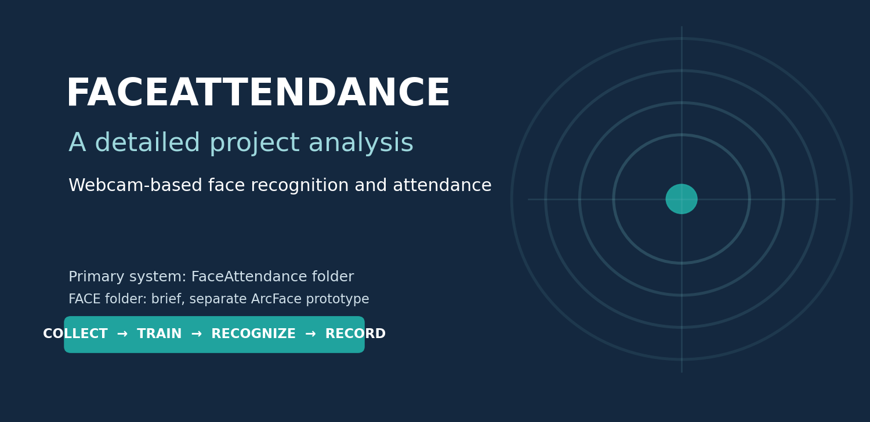
PROJECT ANALYSIS & TECHNICAL REPORT
Primary scope: FaceAttendance
Detailed implementation, workflow, benefits, limitations, risks,
operational guidance, and improvement roadmap
Prepared from static source-code review | 26 October 2026
Prototype assessment — no model accuracy or field performance is claimed.

Document guide
Section | What it covers
Executive summary | What the main application does, what is complete, and what remains unverified.
Project purpose and boundaries | Primary FaceAttendance application versus the smaller FACE experiment.
Architecture and lifecycle | From webcam enrollment and training through live recognition and CSV output.
Technical implementation | Collection, preprocessing, model, training strategy, thresholds, and attendance logic.
Advantages and disadvantages | Balanced assessment of practical strengths and current limitations.
Risks and responsible use | Biometric privacy, false matches, data quality, security, and operational safeguards.
Setup and operation | Environment preparation, run order, configuration and troubleshooting.
Evaluation and roadmap | What to measure, how to validate, and prioritized improvements.

Reading note The report describes the code that exists. Suggested enhancements are labeled as recommendations; they are not claimed as implemented features.

1. Executive summary
FaceAttendance is the main project in this workspace. It is a local webcam-based attendance prototype that collects labeled face crops, trains a custom PyTorch convolutional neural network (CNN), detects faces in a live camera stream, predicts an enrolled identity, and records a person's first accepted attendance event for the local calendar date in a CSV file.
The system brings together a complete sequence of practical components: OpenCV Haar-cascade image collection, a folder-based image dataset, a CNN training script with validation-based checkpointing, MediaPipe live face detection, confidence and prediction-margin gates, and duplicate-per-day attendance logging. A separate folder named FACE contains a smaller InsightFace/ArcFace enrollment and verification demonstration. It is not the primary application and is not wired into the attendance logger.
Most important implementation finding preprocess_faces.py writes resized images to processed_dataset/, but train_cnn.py reads images from dataset/ directly. The preprocessing script is therefore not part of the active training path as currently coded.

Evidence boundary This report was prepared by inspecting source code and configuration. There was no model-training run, dataset review, live-camera test, or measured accuracy analysis. The report makes no claim that recognition is accurate or production-ready.

Dimension | Current state
Primary use | Experimental webcam attendance for enrolled staff/student identities.
Recognition approach | Closed-set CNN classifier: each detected face is assigned to one configured class or rejected by heuristic thresholds.
Attendance storage | One CSV per local date; duplicate person ID in that day's file is not appended again.
Hardware mode | PyTorch selects CUDA when available and otherwise uses CPU; actual hardware compatibility was not tested.
Readiness | Prototype. Accuracy, fairness, spoof resistance, security controls, and operational reliability are unverified.

2. Project purpose and scope

2.1 Intended problem
The main application explores whether face recognition can reduce manual attendance marking in a small controlled environment. An operator collects sample images for known identities, trains the classifier, then starts a webcam session. Accepted predictions are written to a date-stamped attendance file.

2.2 What the software currently does
- Organizes known identities under staff and students categories, each with a person-specific folder.
- Captures face crops only after an operator presses S while a face is detected.
- Resizes collected faces to a consistent 128 × 128 pixel image shape.
- Builds identity classes from category and folder name and trains a small grayscale CNN.
- Detects faces in a live stream with MediaPipe and runs the CNN on each detected crop.
- Requires both a minimum top-class score and a minimum gap over the runner-up class before accepting a prediction.
- Logs a newly accepted ID once per day and displays a present/already-marked status in the camera window.

2.3 What it does not establish
- It does not prove identity or provide secure authentication; there is no liveness or spoof-detection mechanism.
- It does not provide measured recognition performance, a validated demographic assessment, or a guaranteed false-match rate.
- It does not use the processed_dataset output for training in its current form.
- It does not provide a central database, multi-device synchronization, user accounts, role-based access, audit history, or attendance correction workflow.
- It does not connect the separate FACE/ArcFace demo to attendance records.

3. Repository map and responsibility
File / folder | Role | Key behavior
FaceAttendance/collect_photo.py | Data capture | Category/ID selection; Haar face detection; manual S capture; saved JPEG and metadata row.
FaceAttendance/preprocess_faces.py | Image preparation | Resizes source files to 128×128 and writes a parallel processed_dataset tree.
FaceAttendance/train_cnn.py | Model training | Reads dataset/, creates class-wise splits, augments training images, trains CNN, saves best checkpoint.
FaceAttendance/recognize_faces.py | Live inference | Loads checkpoint; MediaPipe face detection; CNN prediction; threshold gate; invokes attendance writer.
FaceAttendance/mark_attendance.py | Attendance persistence | Creates date-specific CSV, suppresses duplicate person IDs, maps IDs to configured names.
FaceAttendance/requirements.txt | Dependencies | PyTorch, torchvision, OpenCV, NumPy, MediaPipe.
FACE/demo.py | Separate experiment | ArcFace enrollment/verification CLI; cosine similarity; not integrated with FaceAttendance.
FACE/enrolled.pkl | Sensitive runtime data | Serialized enrollment embedding database; should be treated as biometric data.

Data protection FaceAttendance/.gitignore excludes its dataset, processed data, model, attendance records, and CSV files. Confirm whether FACE/enrolled.pkl is tracked or shared before distributing the project.

4. System architecture and end-to-end workflow
The operational path has two phases: offline enrollment/training and online recognition/attendance. The diagram also shows the preprocessing branch and highlights that it is currently disconnected from training.
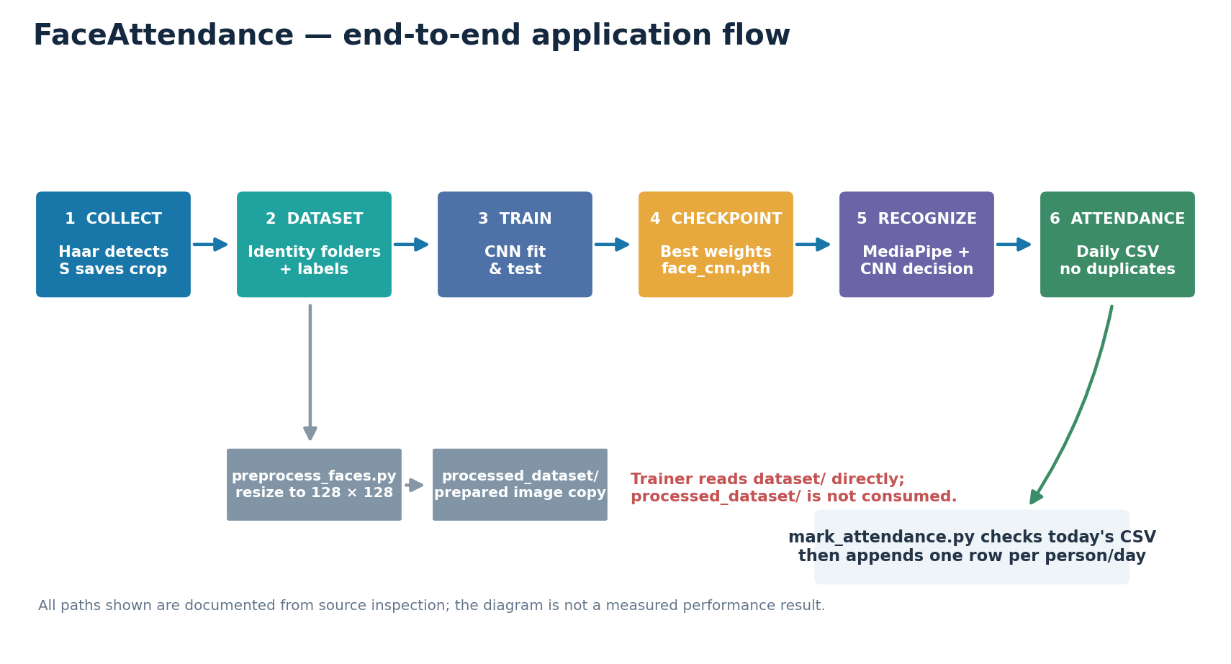
Figure 1. Source-based FaceAttendance architecture. The preprocessing branch is not consumed by the trainer.

4.1 Phase A — enrollment and model preparation
Choose an identity — The collection utility asks for Staff or Student, validates the person ID against configured IDs, and requests a display name.
Open camera and detect — OpenCV opens the configured camera index and uses the built-in frontal-face Haar cascade. The largest detected face is highlighted.
Capture labeled examples — The operator presses S to save a detected face. The crop receives a 20% margin based on face size, is resized to 128×128, and is saved under dataset/<category>/<ID>.
Prepare images — The standalone preprocessing script can read JPEG/JPEG/PNG images, skip unreadable images, resize the rest, and create processed_dataset/<category>/<ID>.
Train classifier — The trainer discovers identity folders under dataset/, assigns labels, creates per-class train/validation/test lists, and optimizes the CNN.
Save checkpoint — The checkpoint stores model weights, class_names, image_size, and an architecture identifier at models/face_cnn.pth.

4.2 Phase B — live recognition and attendance
- The recognition script loads the checkpoint and reconstructs the same CNN architecture.
- It downloads the MediaPipe BlazeFace asset if that local asset is absent, then initializes the detector.
- For each webcam frame, it detects face bounding boxes, adds a fixed 30-pixel crop margin, converts the crop to grayscale, resizes it to 128×128, and scales pixel intensities into [0, 1].
- The CNN produces identity logits; softmax produces class scores. The highest and second-highest scores are compared with configured thresholds.
- If accepted, the corresponding ID is passed to mark_attendance(). The daily CSV is checked before appending.
- If the ID was not yet logged today, the new row is appended. Repeated detections in the same camera session are also tracked in memory to avoid repeated writer calls.
- If the thresholds fail, the frame shows Unknown. Press Q to stop the live loop and release the camera/detector.

5. Image collection and data organization

5.1 Capture behavior
The current capture target is 50 images per person. Existing JPEG files are counted to allow a capture session to continue. A 0.4-second minimum interval limits rapid consecutive saves. Images are manually triggered, which gives the operator control but also means the collection quality depends on the operator deliberately varying pose, expression, distance, lighting, and camera position.
Dataset element | Current implementation
Categories | staff and students
Identity key | Configured person ID, used as the identity folder name.
Image path | dataset/<category>/<person_id>/<person_id>_NNNN.jpg
Image dimensions | 128 × 128 pixels; color images are stored by collection, then converted to grayscale by the trainer.
Metadata CSV | dataset/metadata.csv with image_path, person_id, person_name, category columns.
Capture device | OpenCV camera index 2 by default; change the script constant if this does not map to the intended webcam.

5.2 Data quality guidance
- Collect varied examples rather than many near-identical frames; diversity across sessions matters more than a large count of duplicates.
- Use consistent consented capture conditions and ensure each identity is correctly labeled before training.
- Avoid collecting bystanders or unrelated individuals. The largest detected face is selected; multi-person framing could select the wrong person.
- Review image readability and class counts before training. The trainer warns when an identity has fewer than 20 images and recommends 50 or more varied examples.
- Keep a separate evaluation capture session so adjacent or near-duplicate capture frames do not appear across train and test splits.
Potential capture issue The collection script records to metadata.csv in append mode. If a previous dataset directory or metadata file is reused after selectively deleting images, its metadata can become stale; the trainer uses folders, not this CSV, as its source of truth.

6. Preprocessing and data split

6.1 What preprocess_faces.py does
This script loops over staff and students, finds per-person directories, reads JPEG/JPEG/PNG files, skips unreadable inputs, resizes valid images to 128×128, and writes JPEG output with the same basename under processed_dataset/. It reports processed and skipped counts.

6.2 Integration gap
The trainer declares DATA_DIR = Path('dataset') and scans that tree. It independently reads and grayscales the source image inside FaceDataset. Therefore, running preprocess_faces.py is currently optional and does not change the images used for training. The same shape is enforced inside the trainer, so the preprocessing program duplicates part of the in-memory resizing rather than serving as an actual input stage.

6.3 Split strategy and caveat
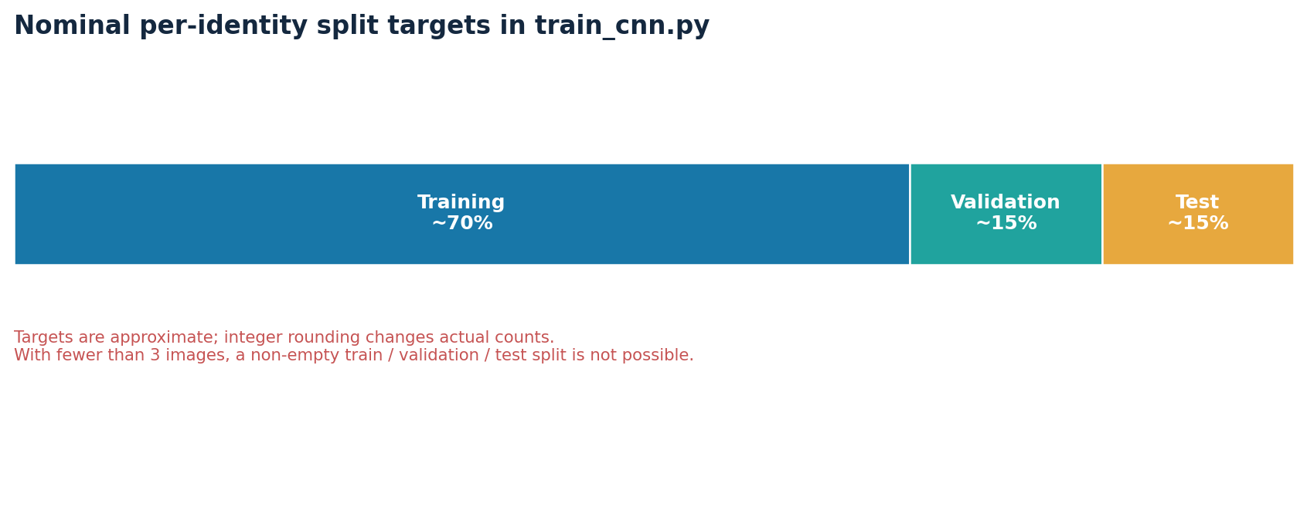
Figure 2. Approximate split targets coded per identity; exact sample counts depend on integer rounding and class size.
For each identity class, the script shuffles image paths with the seeded Python random generator, assigns approximately 70% to training and 15% to validation, then assigns the remainder to test. It ensures at least one training and validation image in its normal operating range. With very small classes, split fractions are unstable: for fewer than three images there cannot be a meaningful non-empty train, validation, and test set. The script's adjustment logic can leave the test set empty for small classes.
Evaluation risk A random image-level split can put visually similar frames from one capture session into both training and test sets. This can overstate generalization. Prefer capture-session-separated evaluation and include people not enrolled in training.

7. CNN model and learning process
The primary application uses a custom, compact grayscale CNN implemented with PyTorch. It is a supervised multi-class classifier: each output class corresponds to a category/person ID discovered in the dataset. At live runtime, a face is mapped to one of these known classes, subject to the rejection thresholds.
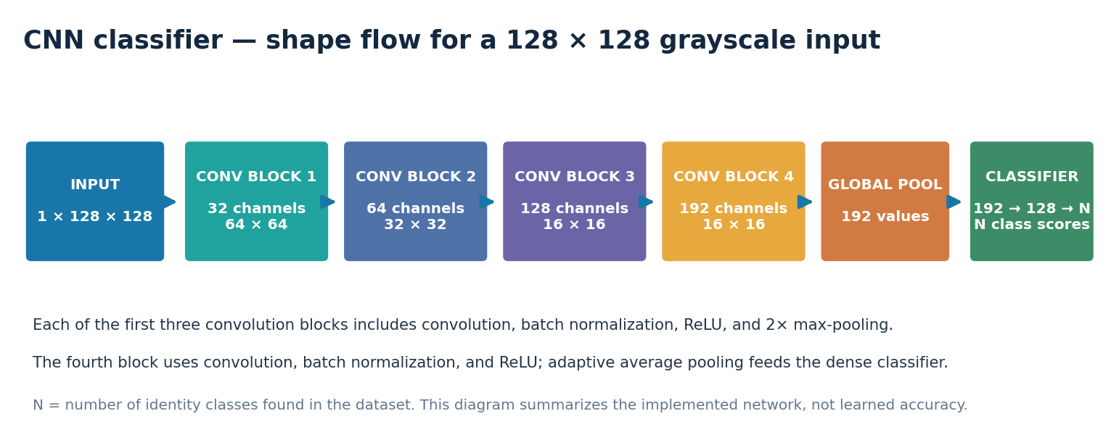
Figure 3. CNN layer/shape summary based on the network defined in train_cnn.py and mirrored in recognize_faces.py.

7.1 Network structure
Stage | Implemented blocks | Approximate output
Input | Grayscale face image | 1 × 128 × 128
Feature block 1 | Conv 1→32; BatchNorm; ReLU; MaxPool 2× | 32 × 64 × 64
Feature block 2 | Conv 32→64; BatchNorm; ReLU; MaxPool 2× | 64 × 32 × 32
Feature block 3 | Conv 64→128; BatchNorm; ReLU; MaxPool 2× | 128 × 16 × 16
Feature block 4 | Conv 128→192; BatchNorm; ReLU | 192 × 16 × 16
Pooling | Adaptive average pooling | 192 values
Classifier | Flatten; Linear 192→128; ReLU; Dropout 0.4; Linear 128→N | N identity scores

7.2 Training settings in source
Setting | Configured value / method | Interpretation
Input size | 128 × 128, grayscale | Same target shape used in live recognition.
Batch size | 16 | Number of training examples per optimizer batch.
Epoch limit | 60 | Upper bound; early stopping may end training sooner.
Early stopping | Patience 10 on validation loss | Stops after 10 consecutive epochs without improved validation loss.
Seed | 42 for Python, NumPy, Torch | Improves repeatability, but does not guarantee full deterministic execution.
Augmentation | Random horizontal flip, ±10° rotation, 0.9–1.1 scale, brightness/contrast | Applied to training samples only.
Loss | Class-weighted cross entropy | Attempts to offset different class counts.
Optimizer | AdamW, learning rate 0.001, weight decay 0.0001 | Parameter optimization settings.
Scheduler | ReduceLROnPlateau; factor 0.5; patience 3 | Reduces learning rate after validation loss stalls.
Device | CUDA if available; else CPU | Automatic device selection.
Checkpoint | Best validation-loss model | Stores weights, classes, image size, and architecture name.

7.3 Training outputs
Each epoch prints training loss/accuracy and validation loss/accuracy. The best checkpoint is saved when validation loss improves. After training, the script reloads that best checkpoint and evaluates the test loader, printing test accuracy and the checkpoint path. No training log, checkpoint, dataset, or actual test result was available for this report, so no result value is presented.

8. Live face detection, classification, and decision gate

8.1 Detector versus recognizer
MediaPipe BlazeFace locates faces in the webcam frame; it is not the identity classifier. The CNN performs the identity classification. This separation is useful: a detector proposes face regions and a recognizer assigns a class. At training capture time, OpenCV Haar cascades are used instead, so the enrollment and live paths use different face detectors.

8.2 Runtime crop and classifier
The recognition script expands each detected bounding box by 30 pixels where frame limits permit, extracts that region, converts it from BGR to grayscale, resizes to 128×128, divides pixel values by 255, and passes a one-channel tensor to the CNN. This must remain compatible with the trainer's grayscale sizing and model architecture.

8.3 Rejection thresholds
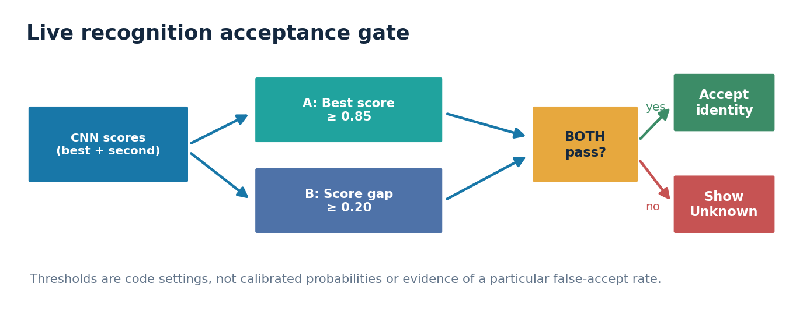
Figure 4. Implemented decision logic. The values are fixed source settings and have not been calibrated from validation data.
A prediction is accepted when the best softmax score is at least 0.85 and the difference between the best and second-best scores is at least 0.20. If either condition fails, the UI shows Unknown. These thresholds can reduce ambiguous matches, but softmax scores are not guaranteed to be calibrated confidence values. A closed-set classifier can still assign a high score to an unregistered person.
Operational consequence Changing the threshold trades missed enrollments against false acceptance. Select settings only after measuring both false-accept and false-reject behavior on a representative, held-out evaluation set.

9. Attendance rules and stored records

9.1 Current recording behavior
- The attendance folder is anchored beside mark_attendance.py and is created when the module is imported.
- The filename is attendance_YYYY-MM-DD.csv using the computer's local date.
- The first write creates headers: Person ID, Name, Date, Time, Status.
- Before appending, the writer reads the day's CSV and scans for a matching Person ID; if found, it reports already present and returns False.
- New records use local time formatted to seconds and status Present.
- The camera loop keeps an in-memory set so a person is not sent to the writer repeatedly during the same session.
Column | Purpose | Example format (synthetic)
Person ID | Stable identity key | SD000
Name | Name resolved from the mapping | Example Person
Date | Local system date | YYYY-MM-DD
Time | Local time to seconds | HH:MM:SS
Status | Attendance state | Present

9.2 Boundaries of CSV storage
A daily CSV is simple to inspect and export, but it is not a transactional or access-controlled database. Simultaneous writers can race, a file can be edited without detection, and local clock changes affect date/time. There is no built-in retention schedule, record correction flow, signing, encryption, central backup, or audit history.

10. User operation and setup

10.1 Software and hardware
Requirement | Notes
Python | Use a supported Python version compatible with the listed packages; no exact tested version is documented in the workspace.
Packages | torch, torchvision, opencv-python, numpy, mediapipe as listed in FaceAttendance/requirements.txt.
Camera | Webcam visible to OpenCV; current FaceAttendance scripts use camera index 2.
Network | Recognition downloads MediaPipe BlazeFace TFLite asset if it is not already present.
GPU | Optional. Training/inference select CUDA when PyTorch reports it available; CPU is the fallback.
Working directory | Run FaceAttendance scripts with the FaceAttendance directory as the current directory because dataset/model/asset paths are relative.

10.2 Windows setup
cd FaceAttendance
py -m venv .venv
.\.venv\Scripts\Activate.ps1
python -m pip install --upgrade pip
python -m pip install -r requirements.txt

10.3 Suggested run order
Step | Command | Outcome
1 | python collect_photo.py | Collect face images for each identity; S saves, Q exits.
2 | python preprocess_faces.py (optional) | Creates processed_dataset; currently not used by trainer.
3 | python train_cnn.py | Trains model and writes models/face_cnn.pth.
4 | python recognize_faces.py | Starts live recognition and creates daily CSV attendance.

10.4 Common startup checks
- If the camera fails to open, confirm permissions and try another camera index in collect_photo.py and recognize_faces.py.
- If the trainer reports fewer than two identity folders, confirm there are at least two non-empty person folders under dataset/staff or dataset/students.
- If recognition reports that the checkpoint is missing, train first and launch from the FaceAttendance working directory.
- If the MediaPipe asset cannot download, verify network access and write permission under the models directory.
- If predicted names are missing or incorrect, review the hard-coded PERSON_NAMES mapping in mark_attendance.py and keep IDs consistent with folder IDs.

11. Advantages and disadvantages
Area | Advantages | Disadvantages / trade-offs
End-to-end workflow | Source contains capture, training, recognition, and attendance logging stages. | Preprocessing output is disconnected; the scripts do not yet form a clean single-command pipeline.
Local processing | Images/model can be handled locally; no cloud recognition API is required by FaceAttendance. | Local files still need protection, backup, retention policy, and access controls.
Custom model | Architecture and training process are visible and modifiable; checkpoint includes class labels. | Small custom CNN may generalize poorly; model quality is unknown without a proper benchmark.
Data augmentation | Training transforms expose model to some flips, rotations, scale changes, and lighting variation. | Augmentation cannot replace representative real capture data and may not reflect actual conditions.
Unknown rejection | Score and top-two margin checks provide a basic ambiguity gate. | Softmax thresholds are uncalibrated; unknown people can still be assigned high class scores.
Attendance CSV | Simple, human-readable, easy to export, and duplicate-per-day suppression is implemented. | No transactional safety, concurrency handling, tamper evidence, access control, or correction workflow.
Visual feedback | Live overlay shows identity/score or Unknown and attendance state. | No guided recovery, enrollment quality check, or review queue for uncertain cases.
Separate ArcFace demo | Provides a second embedding-based experiment and basic enroll/list/delete commands. | Separate dependency, data store, camera setting, and model; not integrated with attendance.

11.1 Overall strengths
- Clear modular responsibilities across image collection, training, recognition, and CSV writing.
- Identity folders provide a straightforward dataset layout.
- Model architecture and training settings are visible rather than hidden behind an external service.
- The runtime recreates the same CNN architecture and checks a checkpoint architecture label.
- The system attempts to reject ambiguous predictions and avoid duplicate daily attendance.
- The project has a useful foundation for learning computer vision, data preparation, CNN training, and application integration.

11.2 Overall weaknesses
- No automated tests, model evaluation report, or reproducible benchmark artifacts are provided.
- Training consumes raw dataset paths, not the output of the explicitly named preprocessing program.
- The confidence thresholds have no documented calibration basis.
- The closed-set classifier is not a robust open-set identity-verification solution.
- A fixed camera index and current-working-directory paths make startup environment-sensitive.
- Names are embedded in source and attendance records are unprotected CSV files.
- No liveness, spoof defense, enrollment authorization flow, or human-review mechanism is implemented.

12. Privacy, safety, and security
Face images, embeddings, identity mappings, and attendance history are sensitive. Even a classroom or demonstration dataset can identify individuals and reveal their presence or absence at specific times.
Risk | Why it matters | Recommended control
Unconsented collection | People may not expect face images or attendance to be recorded. | Obtain appropriate authorization/consent, provide notice, and limit capture to the intended participants.
Biometric data exposure | Images and embeddings can identify people and are difficult to replace after exposure. | Restrict access, keep artifacts out of public repos, protect backups, define deletion and retention.
False match | A wrong identity may create an incorrect attendance record. | Measure false accepts, require human correction/appeal, and do not use as the sole attendance authority.
Missed match | Lighting, pose, camera, or detector errors may fail to recognize an enrolled person. | Provide manual attendance fallback and track false-reject rates.
Presentation attack | A photo or replay may be accepted because no liveness defense exists. | Do not treat this as secure access control; evaluate presentation-attack risk before use.
Pickle trust boundary | Python pickle can execute unsafe object deserialization if the file is maliciously replaced. | Only load a trusted FACE/enrolled.pkl; use a safer versioned format if the boundary is not trusted.
Record tampering | CSV records can be edited or deleted without detection. | Limit filesystem access and consider an audited database if records matter operationally.

Responsible-use boundary Use only with appropriate consent and a human-verifiable fallback. Do not use this prototype as the sole basis for discipline, access, grading, employment, or other consequential decisions.

13. Evaluation plan — what should be measured
A model score should not be inferred from the existence of a training script. The following evaluation plan is recommended before interpreting or deploying recognition results.
Measure | Purpose | Suggested reporting
Closed-set accuracy | How often enrolled identities are classified correctly. | Overall and per identity, with sample counts.
Confusion matrix | Which identities are confused with one another. | Counts and normalized percentages; hide personal names in shared reports.
False accept rate | How often unknown/non-enrolled people are assigned an enrolled identity. | At each selected score/margin threshold.
False reject rate | How often enrolled people are rejected as unknown. | At the same thresholds and across conditions.
Precision/recall per identity | Class-level imbalance and missed-class patterns. | Macro averages plus per-class results.
Robustness slices | Variation by light, pose, distance, camera, and session. | Report each condition separately where sample size permits.
Latency | Operational responsiveness on target hardware. | Median and tail latency, device, resolution, and CPU/GPU mode.
Attendance correctness | Whether accepted predictions create the intended one-per-day rows. | Test duplicate, restart, date-boundary, and concurrent-write scenarios.

13.1 Recommended evaluation protocol
- Collect data with authorization, across multiple independent sessions and realistic camera conditions.
- Split by capture session, not simply by adjacent image files, to reduce near-duplicate leakage.
- Reserve unknown people who are absent from training classes to evaluate open-set rejection.
- Tune thresholds on validation data, then freeze them before the final test.
- Report exact sample counts, class counts, hardware, library versions, and confidence intervals where feasible.
- Keep personal identity details out of circulated result plots; use pseudonymous labels.
No fabricated charts The visuals in this report explain architecture and configured settings. There are no accuracy or performance graphs because no actual experiment output was supplied.

14. Prioritized improvement roadmap
Priority | Work item | Expected value
P0 | Resolve preprocessing/trainer input mismatch; explicitly choose whether trainer reads dataset/ or processed_dataset/ and document it. | Reliable, reproducible data path.
P0 | Add a dry-run dataset audit: class counts, unreadable files, duplicates, too-small classes, and paths. | Catch bad training input before long runs.
P0 | Create a consented, session-separated evaluation plan with unknown identities. | Evidence for recognition and rejection performance.
P1 | Centralize configuration (camera index, paths, thresholds, capture target) and validate it at startup. | Fewer environment-specific surprises.
P1 | Add tests for checkpoint loading, preprocessing parity, class mapping, threshold decisions, and duplicate attendance behavior. | Reduce regressions and logic errors.
P1 | Add a human review/correction path and manual fallback. | Mitigate false matches and missed attendance.
P1 | Replace or protect hard-coded names; define access, retention, backup, and deletion policy. | Improve privacy and operational governance.
P2 | Consider session-aware sampling, better face alignment/quality checks, and calibration after baseline evaluation. | Improve robustness based on measured evidence.
P2 | Use transactional storage/audit logging if the application becomes operationally important. | Reduce record races and improve traceability.
P2 | Keep FACE/ArcFace as a separate experiment unless a specific integration requirement is approved. | Avoid mixing incompatible models and data formats prematurely.

15. Brief overview of FACE/ArcFace
The FACE folder is a smaller, separate demonstration, not the main attendance project. Its demo.py script uses InsightFace's buffalo_l model to create face embeddings. Enrollment captures five samples, averages their embeddings, and stores a name-to-embedding mapping in enrolled.pkl. Verification compares a live embedding with stored references using cosine similarity and a configured threshold, then locks on a positive match until the operator resets or exits.
Property | FaceAttendance (main) | FACE (small experiment)
Purpose | Identity classification plus daily attendance recording. | Enrollment and live verification demonstration.
Model | Custom supervised grayscale CNN. | InsightFace ArcFace embedding model.
Enrollment data | Labeled image folders under dataset/. | Averaged embeddings in enrolled.pkl.
Detector/camera | MediaPipe at runtime; OpenCV Haar during collection; camera index 2. | InsightFace pipeline; camera index 0.
Attendance output | Daily CSV through mark_attendance.py. | No attendance integration.
Dependencies | Declared in FaceAttendance/requirements.txt. | Requires insightface, absent from that manifest.

Scope decision This report treats FaceAttendance as the primary deliverable. FACE is described only to clarify repository scope and to avoid presenting it as part of the attendance pipeline.

16. Conclusion
FaceAttendance is a valuable end-to-end prototype for exploring webcam face capture, supervised CNN training, live inference, and simple attendance persistence. Its modular scripts make the intended workflow understandable, and the training program includes useful techniques such as data augmentation, class weighting, a validation scheduler, early stopping, and best-checkpoint saving.
The central gap is not the absence of more model complexity; it is the need for a consistent data pipeline and trustworthy evidence. First align preprocessing with training, verify the identity/data mapping, and build a session-separated evaluation that includes unknown identities. Then measure false acceptance, false rejection, per-class behavior, and latency. Privacy, consent, human review, and data protection must be addressed alongside accuracy before any consequential use.
Bottom line The code demonstrates how a face-attendance pipeline can be assembled. It does not yet demonstrate that the pipeline is accurate, fair, secure, spoof-resistant, or ready for production.

Appendix A — selected configuration reference
Parameter | Current setting | Source
Collection image size | 128 × 128 | collect_photo.py
Collection target | 50 images/person | collect_photo.py
Attendance camera index | 2 | collect_photo.py and recognize_faces.py
Training data root | dataset/ | train_cnn.py
Preprocessing output | processed_dataset/ | preprocess_faces.py
Model checkpoint | models/face_cnn.pth | train_cnn.py / recognize_faces.py
Epoch limit / patience | 60 / 10 epochs | train_cnn.py
Batch size / seed | 16 / 42 | train_cnn.py
Recognition score / margin | 0.85 / 0.20 | recognize_faces.py
MediaPipe detector minimum confidence | 0.5 | recognize_faces.py
ArcFace threshold / enroll shots | 0.5 / 5 | FACE/demo.py

Appendix B — terms
Term | Meaning in this report
Face detection | Finding a face location/bounding box in an image.
Face recognition | Assigning an identity or identity class to a detected face.
Closed-set classifier | A classifier whose known output classes are the enrolled identities; unknown people require a separate rejection strategy.
Embedding | A numeric vector representing a face, compared by similarity in the ArcFace demo.
Softmax score | Normalized model output across known classes; not automatically a calibrated probability of correctness.
False accept | An unknown person is accepted as an enrolled identity.
False reject | An enrolled person is rejected or not recognized.
Liveness detection | A method intended to distinguish a live subject from a photo, replay, or other presentation attack.

