

22-07-2024

TO WHOMSOEVER IT MAY CONCERN
This is to certify that Mr.D.KARTHIKEYAN – 311422622024, MCA student from Meenakshi College of Engineering, Chennai. He has successfully completed his academic project titled “Implementation of Cloaking Wall Model with Leakage - Suppressed and Light Weight Access Control for Cloud Data Storage” developed with Python and MySQL from March 2024 to August 2024.The project on evaluation fulfills all the stated criteria and the student’s findings are his original work. I hereby certify his work was satisfactory to the best of my knowledge.
All the best for his future endeavors.

Best Regards

For Nineteen Hour IT vt. Ltd

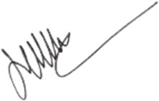
Authorized Signator

