UCS 2312 Data Structures Lab
Assignment 7: Implementation of AVL Tree

QUESTION 1 : Design an ADT for the AVL Tree data structure with the following functions. Each node consists of a character data, address of left, right and parent nodes [CO1, K3]

- insertAVL(t, data) – insert data into BST
ALGORITHM:
INPUT:
i)struct tree *
ii)int
OUTPUT: struct tree *
- if (t==NULL)
{
t=(struct tree *)malloc(sizeof(struct tree));
t->data = x;
t->height = 0;
t->left=t->right=NULL;
}
- else if (x<t->data)
{
t->left = insert(t->left,x);
if (height(t->left)-height(t->right)==2)
{
if (x<t->left->data)
t=sll(t);
else
t=drl(t);
}
}
- else if (x>t->data)
{
t->right=insert(t->right,x);
if (height(t->right)-height(t->left)==2)
{
if (x>t->right->data)
t=srr(t);
else
t=dlr(t);
}
}
- t->height = max(height(t->left),height(t->right))+1;
- return t;

- hierarchical(t) – display the tree in hierarchical fashion
ALGORITHM:
INPUT:
i)struct tree *
OUTPUT: None
- if (t!=NULL)
{
print(t->data,x);
if (t->left!=NULL)
levelorder(t->left,x+1);
if (t->right!=NULL)
levelorder(t->right,x+1);
}

- findParent(t, key) – will return the parent of the given data
ALGORITHM:
INPUT:
i)struct tree *
OUTPUT: int

- if (t!=NULL)
{
if (t->left->data ==k || t->right->data==k)
return t->data;
else if (k<t->data)
findparent(t->left,k);
else if (k>t->data)
findparent(t->right,k);
}

CODE:
Treeadt.h
#include <stdio.h>
#include <stdlib.h>
#include <math.h>
struct tree
{
int data,height;
struct tree *left,*right;
};

int max(int a,int b)
{
if (a>b)
return a;
else
return b;
}

int height(struct tree *t)
{
if (t==NULL)
return -1;
else
return t->height;
}

struct tree *sll(struct tree *k2)
{
struct tree *k1;
k1=k2->left;
k2->left=k1->right;
k1->right=k2;
k2->height= max(height(k2->left),height(k2->right))+1;
k1->height = max(height(k1->left),height(k1->right))+1;
return k1;

}

struct tree *srr(struct tree *k1)
{
struct tree *k2;
k2=k1->right;
k1->right = k2->left;
k2->left=k1;
k1->height = max(height(k1->left),height(k1->right))+1;
k2->height= max(height(k2->left),height(k2->right))+1;
return k2;
}

struct tree *dlr(struct tree *k1) //left subtree right child
{
k1->right = sll(k1->right);
return srr(k1);
}

struct tree *drl(struct tree *k1) //right subtree of left child
{
k1->left = srr(k1->left);
return sll(k1);
}

struct tree *insert(struct tree *t,int x)
{
if (t==NULL)
{
t=(struct tree *)malloc(sizeof(struct tree));
t->data = x;
t->height = 0;
t->left=t->right=NULL;
}
else if (x<t->data)
{
t->left = insert(t->left,x);
if (height(t->left)-height(t->right)==2)
{
if (x<t->left->data)
t=sll(t);
else
t=drl(t);
}
}
else if (x>t->data)
{
t->right=insert(t->right,x);
if (height(t->right)-height(t->left)==2)
{
if (x>t->right->data)
t=srr(t);
else
t=dlr(t);
}
}
t->height = max(height(t->left),height(t->right))+1;
return t;
}

void inorder(struct tree *t)
{
if (t->left!=NULL)
inorder(t->left);
printf("%d ",t->data);
if (t->right!=NULL)
inorder(t->right);
}

void print(int e,int x)
{
for (int i =0;i<x;i++)
{
printf("\t");
}
printf("%d\n",e);
}

void levelorder(struct tree *t,int x)
{
if (t!=NULL)
{
print(t->data,x);
if (t->left!=NULL)
levelorder(t->left,x+1);
if (t->right!=NULL)
levelorder(t->right,x+1);
}
}

int findparent(struct tree *t,int k)
{
if (t!=NULL)
{
if (t->left->data ==k || t->right->data==k)
return t->data;
else if (k<t->data)
findparent(t->left,k);
else if (k>t->data)
findparent(t->right,k);
}

}

Tree.c
#include <stdio.h>
#include <stdlib.h>
#include "treeadt.h"
void main()
{
struct tree *t;
t=NULL;
printf("enter the number of nodes:");
int n;
scanf("%d",&n);
for (int i = 0;i<n;i++)
{
printf("enter the value :");
int a;
scanf("%d",&a);
t=insert(t,a);
}
printf("--INORDER---\n");
inorder(t);
printf("\n---LEVEL ORDER---\n");
levelorder(t,0);
printf("enter the key to find the parent : ");
int k;
scanf("%d",&k);
printf("%d ",findparent(t,k));
}

OUTPUT:

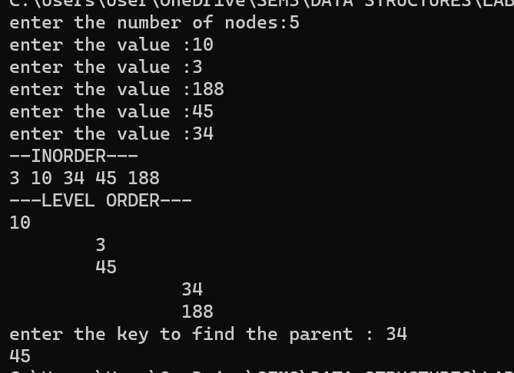

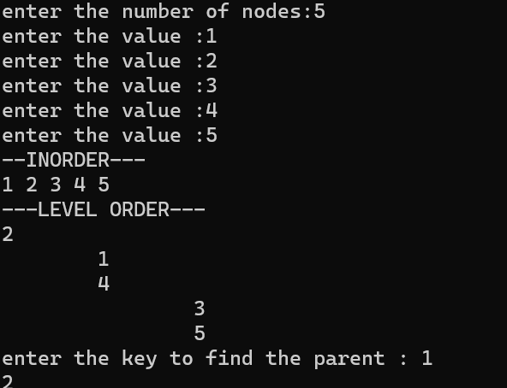

QUESTION 2 : Demonstrate the AVL ADT with the insertion of the following character data one at a time.
H, I, J, B, A, E, C, F, D, G, K, L

CODE:
Chartreeadt.h
#include <stdio.h>
#include <stdlib.h>
#include <math.h>
struct tree
{
char data;
int height;
struct tree *left,*right;
};

int max(char a,char b)
{
if ((int)a>(int)b)
return a;
else
return b;
}

int height(struct tree *t)
{
if (t==NULL)
return -1;
else
return t->height;
}

struct tree *sll(struct tree *k2)
{
struct tree *k1;
k1=k2->left;
k2->left=k1->right;
k1->right=k2;
k2->height= max(height(k2->left),height(k2->right))+1;
k1->height = max(height(k1->left),height(k1->right))+1;
return k1;

}

struct tree *srr(struct tree *k1)
{
struct tree *k2;
k2=k1->right;
k1->right = k2->left;
k2->left=k1;
k1->height = max(height(k1->left),height(k1->right))+1;
k2->height= max(height(k2->left),height(k2->right))+1;
return k2;
}

struct tree *dlr(struct tree *k1) //left subtree right child
{
k1->right = sll(k1->right);
return srr(k1);
}

struct tree *drl(struct tree *k1) //right subtree of left child
{
k1->left = srr(k1->left);
return sll(k1);
}

struct tree *insert(struct tree *t,char x)
{
if (t==NULL)
{
t=(struct tree *)malloc(sizeof(struct tree));
t->data = x;
t->height = 0;
t->left=t->right=NULL;
}
else if ((int)x<(int)t->data)
{
t->left = insert(t->left,x);
if (height(t->left)-height(t->right)==2)
{
if ((int)x<(int)t->left->data)
t=sll(t);
else
t=drl(t);
}
}
else if ((int)x>(int)t->data)
{
t->right=insert(t->right,x);
if (height(t->right)-height(t->left)==2)
{
if ((int)x>(int)t->right->data)
t=srr(t);
else
t=dlr(t);
}
}
t->height = max(height(t->left),height(t->right))+1;
return t;
}

void inorder(struct tree *t)
{
if (t->left!=NULL)
inorder(t->left);
printf("%c ",t->data);
if (t->right!=NULL)
inorder(t->right);
}

void print(int e,int x)
{
for (int i =0;i<x;i++)
{
printf("\t");
}
printf("%c\n",e);
}

void levelorder(struct tree *t,int x)
{
if (t!=NULL)
{
print(t->data,x);
if (t->left!=NULL)
levelorder(t->left,x+1);
if (t->right!=NULL)
levelorder(t->right,x+1);
}
}

int findparent(struct tree *t,int k)
{
if (t!=NULL)
{
if (t->left->data ==k || t->right->data==k)
return t->data;
else if (k<t->data)
findparent(t->left,k);
else if (k>t->data)
findparent(t->right,k);
}

}

Chartree.c

#include <stdio.h>
#include <stdlib.h>
#include "chartreeadt.h"

void main()
{
struct tree *t;
t=NULL;
printf("enter the number of nodes:");
int n;
scanf("%d",&n);
for (int i = 0;i<n;i++)
{
printf("enter the value :");
char ch[1];
scanf("%s",ch);
t=insert(t,ch[0]);
}
printf("--INORDER---\n");
inorder(t);
printf("\n---LEVEL ORDER---\n");
levelorder(t,0);
printf("enter the key to find the parent : ");
char k[1];
scanf("%s",k);
printf("%c ",findparent(t,k[0]));
}

OUTPUT:
