UCS 2312 Data Structures Lab
Assignment 5: BSTADT and its application
Date of Assignment: 20.10.2023
Create an ADT for the binary search tree data structure with the following functions. Each node which consists of integer data, address of left and right children. [CO2, K3]
- insertBST(t,data) – insert data into BST
- inorder(t) – display the tree using inorder traversal
- preorder(t) – display the tree using preorder traversal
- postorder(t) – display the tree using postorder traversal
- levelorder(t) – display the tree hierarchically
- findmin(t)– returns the minimum element in the tree
- search(t,key) – returns the element found, otherwise returns NULL
- delete(t,elt) – delete the given elt from tree
- Demonstrate the BSTADT with the following test case
Insert(t,29)
Insert(t,23)
Insert(t,4)
Insert(t,13)
Insert(t,39)
Insert(t,31)
Insert(t,45)
Insert(t,56)
Insert(t,49)
Inorder(t) 4,13,23,29,31,39,45,49,56
Levelorder(t) 1st Level 29
2nd level 23, 39
3rd Level 4, 31, 45
4th Level 13, 56 5th Level 49
Findmin(t) 4
Find(t, 13) Found, value is 3 Find(t,3) Not found

Best practices to be followed:
- Design before coding
- Usage of algorithm notation
- Use of multi-file C program
- Versioning of code

CODE:
Bstadt.h
#include <stdio.h>
#include <stdlib.h>

struct tree
{
int data;
struct tree *left,*right;
};

struct tree *insert(struct tree *t,int x)
{
if (t==NULL)
{
t=(struct tree *)malloc(sizeof(struct tree));
t->data=x;
t->left=t->right=NULL;
}
else if (x>t->data)
{
t->right=insert(t->right,x);

}
else if (x<t->data)
{
t->left=insert(t->left,x);
}
return t;
}

void inorder(struct tree *t)
{
if (t->left!=NULL)
inorder(t->left);
printf("%d ",t->data);
if (t->right!=NULL)
inorder(t->right);
}

void preorder(struct tree *t){
printf("%d ",t->data);
if(t->left!=NULL)
preorder(t->left);
if(t->right!=NULL)
preorder(t->right);

}

void postorder(struct tree *t){
if(t->left!=NULL)
postorder(t->left);
if(t->right!=NULL)
postorder(t->right);
printf("%d ",t->data);
}

void printname(struct tree *t,int x)
{
for (int i = 0;i<x;i++)
{
printf("\t");
}
printf("%d\n",t->data);

}

void levelorder(struct tree *t,int x)
{
printname(t,x);
if (t->left!=NULL)
levelorder(t->left,x+1);
if (t->right!=NULL)
levelorder(t->right,x+1);
}

struct tree* findmin(struct tree *t)
{
if (t->left==NULL)
return t;
else
findmin(t->left);
}

int search(struct tree *t,int key)
{
if (t!=NULL)
{
if (key==t->data)
return 1;
else if(key<t->data)
search(t->left,key);
else if (key>t->data)
search(t->right,key);

}
else
return 0;
}

struct tree *delete(struct tree *t,int x)
{
struct tree *tmp;
if (x<t->data)
t->left=delete(t->left,x);
else if (x>t->data)
t->right=delete(t->right,x);
else if (t->left &&t->right)
{
tmp=findmin(t->right);
t->data=tmp->data;
t->right=delete(t->right,tmp->data);
}
else
{
tmp=t;
if (t->right==NULL)
t=t->left;
else if (t->left==NULL)
t=t->right;
free(tmp);
}
return t;
}

Main.c
#include <stdio.h>
#include <stdlib.h>
#include "bstadt.h"

void main()
{
struct tree *t;
t=NULL;
printf("enter the number of nodes :");
int n;
scanf("%d",&n);
for (int i = 0;i<n;i++)
{
printf("enter the value :");
int a;
scanf("%d",&a);
t=insert(t,a);
}
printf("--INORDER--\n");
inorder(t);
printf("\n--PREORDER---\n");
preorder(t);
printf("\n--POSTORDER---\n");
postorder(t);
printf("\n--LEVEL ORDER--\n");
levelorder(t,0);
printf("\n--FIND MINIMUM--\n");
struct tree *res = findmin(t);
printf("MINIMUM : %d",res->data);
printf("\n--SEARCH--\n");
printf("enter the key :");
int key;scanf("%d",&key);
int r=search(t,key);
if (r==1)
printf("ELEMENT PRESENT!\n");
else
printf("ELEMENT IS NOT PRESENT!\n");
printf("\n--DELETION--\n");
printf("enter the element to be deleted:");
int del;scanf("%d",&del);
delete(t,del);
printf("\n--AFTER DELETION--\n");
printf("--INORDER--\n");
inorder(t);
printf("\n--PREORDER---\n");
preorder(t);
printf("\n--POSTORDER---\n");
postorder(t);
printf("\n--LEVEL ORDER--\n");
levelorder(t,0);
}

OUTPUT:
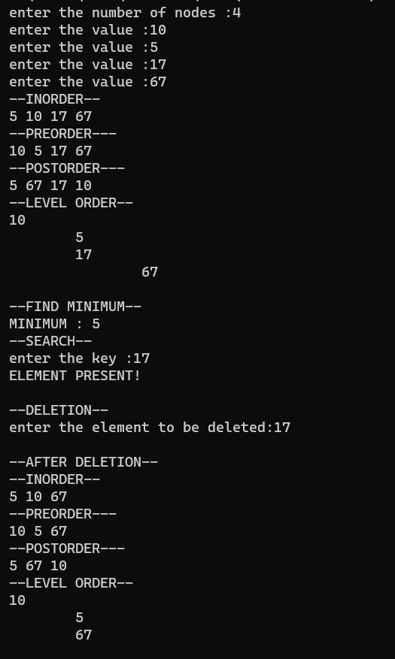

Test case for the Application (a)

Input: Tree 1
10
/ \
5 50
/ / \
1 40 100

Input: Tree2
10
/ \
5 50
/ / \
1 40 100

Tree1 and Tree2 are identical with a set of elements (b)
Tree1 not complete (c)
Tree1 Range: [5, 45]
Output: 3
Nodes are 5, 10, 40

Tree2 Range: [1, 45]
Output: 4
Nodes are 1,5, 10, 40

Given two binary search trees root1 and root2, return a list containing all the integers from both trees sorted in ascending order.

- Write an application to do the following
  - Check whether the two BST contains the same set of elements

ALGORITHM:
FUNCTION NAME:check
INPUT:
i)struct tree *
ii)struct tree *
OUTPUT:int

- if (t->left!=NULL && t1->left!=NULL)
check(t->left,t1->left);
- if (t->data != t1->data)
return 1;
- if (t->right!=NULL && t1->right!=NULL)
check(t->right,t1->right);

OUTPUT:

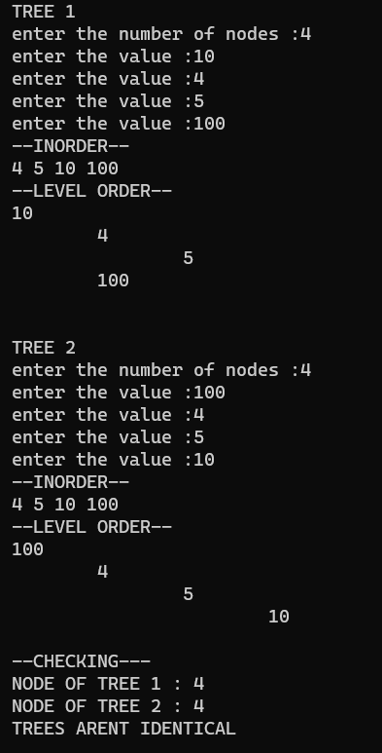
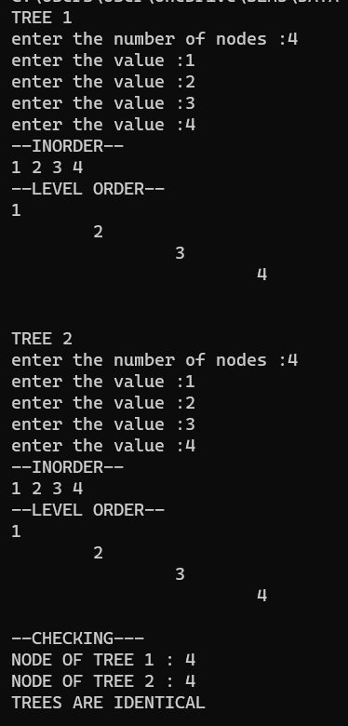

  - Count the number of nodes in tree within the given range

FUNCTION NAME: num
INPUT:
i)struct tree *
ii)int
iii)int
OUTPUT:int

- static int n=0;
- if (t==NULL)
return n;
- else
{
if (t->data>=l && t->data<=h)
{
n+=1;
printf("%dst NODE :",n);
printf(" %d\n",t->data);

num(t->left,l,h);
num(t->right,l,h);

}
if (t->data<l)
{
num(t->right,l,h);
}
if (t->data>h)
{
num(t->left,l,h);
}
}

OUTPUT:
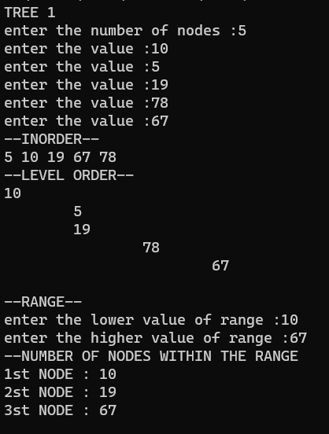

  - Find sum of k smallest elements in the given BST

FUNCTION NAME:sum
INPUT:
i)struct tree *
ii)int
OUTPUT:int

- static int s=0;static int n=0;
- if (t->left!=NULL)
sum(t->left,k);
- if (n!=k)
{
s+=t->data;
n++;}
- if (n==k)
return s;
- if (t->right!=NULL)
sum(t->right,k);

OUTPUT:
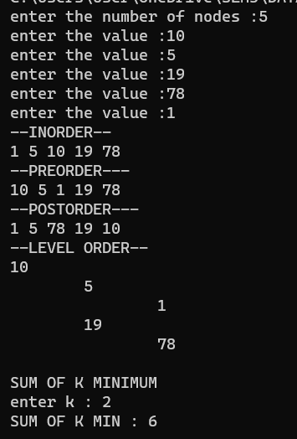
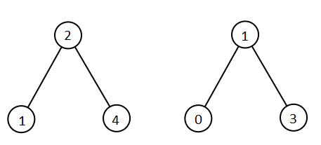

QUESTION 3:
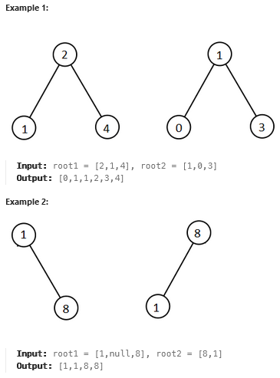
ALGORITHM:
FUNCTION NAME: sort
INPUT:
i)int []
ii)int[]
OUTPUT: int *
- int i=0,j=0,k=0;
- while(i<n1 && j<n2)
{
if (root1[i]<root2[j])
{
res[k]=root1[i];
i++;
k++;
}
else
{
res[k]=root2[j];
j++;
k++;
}
}
- while (i<n1)
{
res[k]=root1[i];
k+=1;i+=1;
}
- while (j<n2)
{
res[k]=root2[j];
k++;j++;
}
- return res;

OUTPUT:
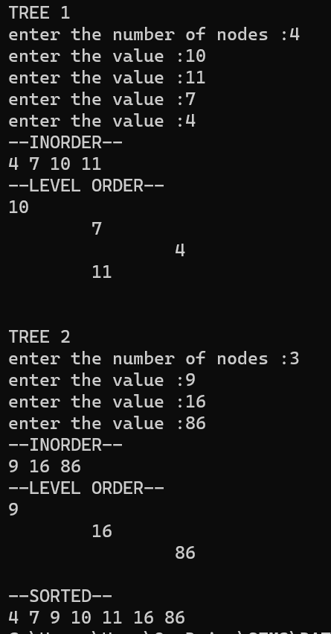

QUESTION 4: Write a function to check whether the given tree is BST
FUNCTION NAME: check
INPUT:
i)struct tree *
OUTPUT: int
- if (t==NULL)
return 1;
- if (t->right==NULL && t->left==NULL)
return 1;
- int lmax,rmin;
- if (t->left!=NULL)
lmax=maxinleft(t->left); //returns max value in left subtree of a node
- else
lmax=0;
- if (t->right!=NULL)
rmin=mininright(t->right); //returns the minimum value in the right subtree of a node
- else
rmin=t->data;

- if (lmax>t->data || t->data > rmin)
{
return 0;
}
- int a,b;
- a=checkbst(t->left);
- b=checkbst(t->right);
- if (a==1 && b==1)
return 1;
- else
return 0;
OUTPUT:
