UCS 2312 Data Structures Lab
Assignment 3: Doubly Linked List and its applications

Create an ADT for the doubly linked list data structure with the following functions. Each node which consists of integer data, address of left and right nodes [CO1, K3]

Create a ListADT which has implementations for the following operations
- Insert an item in the front of the list
void insertFront(listADT L, int c)
- Insert an item at the end of the list
void insertEnd(listADT L, int c)
- Insert an item ‘d’ after the first occurrence ‘c’ of the list
void insertMiddle(listADT L, int c, int d)
- Display the items from the list
void displayItems(listADT L)
- Delete the item present in the list
void deleteItem(listADT L, int c)
- Search an element in the list and return the number of occurrences
int searchItem(listADT L, int c)

Write a program in C to test the ListADT for its operations with the following test cases.

Testcase:
Initially L is Empty
insertFront(L,6) header6
insertEnd(L,2) header26
insertMiddle(L,2,1) header216
insertMiddle(L,2,1) header2116
search(L,1) 2

In addition, do the following operations:
- Check whether the list contains duplicates?
- Create separate lists containing even and odd numbers from the list
- Add two 10-digit numbers using the list

DATA STRUCTURE – DOUBLY LINKED LIST
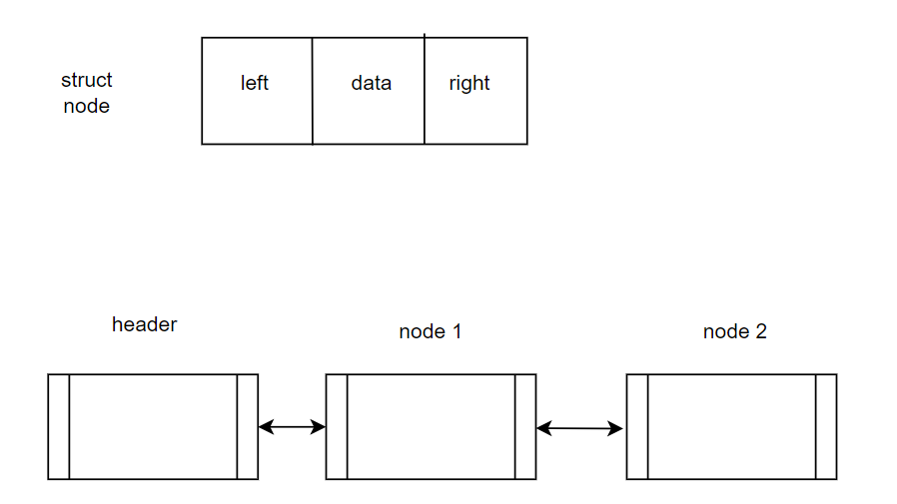

ALGORITHMS:

1.FUNCTION NAME: insertFront
INPUT:
i)struct node *
ii)int
OUTPUT:None

- struct node *temp;
- temp=(struct node *)malloc(sizeof(struct node));
- temp->data = ele;
- if (h->right == NULL)
{
temp->right = h->right;
h->right = temp;
temp->left = h;
}
- else
{
struct node *ptr;
ptr=h->right;
temp->left=h;
temp->right = ptr;
ptr->left = temp;
h->right = temp;
}

2.FUNCTION NAME:insertEnd
INPUT:
i)struct node *
ii)int
OUTPUT:None
- struct node *ptr, *prev;
- ptr = h->right;
- if (ptr == NULL) {
struct node *temp;
temp = (struct node *)malloc(sizeof(struct node));
temp->data = ele;
temp->right = h->right;
temp->left = h;
h->right = temp;
}
- else {
while (ptr != NULL) {
prev = ptr;
ptr = ptr->right;
}
struct node *temp;
temp = (struct node *)malloc(sizeof(struct node));
temp->data = ele;
temp->right = prev->right;
prev->right = temp;
temp->left = prev;
}

3.FUNCTION NAME:insertmiddle
INPUT:
i)struct node *
ii)int
OUTPUT:None
- struct node *ptr;
- ptr = search(h,key);
- if (ptr==NULL)
printf("Key not found!!\n");
- else if (ptr->right != NULL)
{
struct node *temp,*next;
next = ptr->right;
temp=(struct node *)malloc(sizeof(struct node));
temp->data = ele;
temp->right = ptr->right;
temp->left = next->left;
next->left = temp;
ptr->right = temp;
}
- else
{
struct node *temp,*next;
temp=(struct node *)malloc(sizeof(struct node));
temp->data = ele;
temp->right = ptr->right;
ptr->right = temp;
temp->left=ptr;
}

4.FUNCTION NAME:display
INPUT:
i)struct node *
OUTPUT:None

- struct node *ptr,*prev;
- ptr=h->right;
- while(ptr!=NULL)
{
printf("%d ",ptr->data);
prev=ptr;
ptr=ptr->right;
}
- while (prev->left!=NULL)
{
printf("%d ",prev->data);
prev=prev->left;
}

5.FUNCTION NAME:delete
INPUT:
i)struct node *
ii)int
OUTPUT:None
- struct node *res;
- res=search(h,ele);
- if (res==NULL)
printf("Key not found!!\n");
- else if (res->right!=NULL)
{
struct node *p1,*p2;
p1=res->left;
p2=res->right;
p1->right=p2;
p2->left=p1;
}
- else
{
struct node *p1;
p1=res->left;
p1->right=NULL;
}

6.FUNCTION NAME:search
INPUT:
i)struct node *
OUTPUT:struct node *
- struct node *ptr;
- ptr = h->right;
- while (ptr!=NULL)
{
if (ptr->data == ele)
return ptr;
ptr = ptr->right;
}
- return NULL;

7.FUNCTION NAME:duplicate
INPUT:
i)struct node *
OUTPUT:int
- struct node *ptr,*pt;
- int dup;
- ptr = h->right;
- pt = ptr->right;
- while(ptr!=NULL)
{
dup=ptr->data;
while(pt!=NULL)
{
if (dup==pt->data)
return 1;
else
pt=pt->right;
}
ptr=ptr->right;
}
- return 0;

8.FUNCTION NAME:oddeven
INPUT:
i)struct node *
ii)struct node *
OUTPUT:None

- struct node *ptr;
- ptr=h->right;
- while(ptr!=NULL)
{
if ((ptr->data)%2==0)
{insertfront(h1,ptr->data);
ptr=ptr->right;}
else
{insertfront(h2,ptr->data);
ptr=ptr->right;
}
}

9.FUNCTION NAME:sum
INPUT:
i)struct node *
ii)struct node *
OUTPUT:None
- struct node *ptr, *pt;
- ptr = h->right;
- int len = 0;
- while (ptr != NULL) {
len = len + 1;
ptr = ptr->right;
}
- int n = 0;
- pt = h->right;
- while (pt != NULL) {
len = len - 1;
n += ((pt->data) * ((int)pow(10, len)));
pt = pt->right;
}
- struct node *ptr1, *pt1;
- ptr1 = h1->right;
- int len1 = 0;
- while (ptr1 != NULL) {
len1 = len1 + 1;
ptr1 = ptr1->right;
}
- int n1 = 0;
- pt1 = h1->right;
- while (pt1 != NULL) {
len1 = len1 - 1;
n1 += ((pt1->data) * ((int)pow(10, len1)));
pt1 = pt1->right;
}
- int sum = n1+n;

- struct node *h2;
- h2=(struct node *)malloc(sizeof(struct node));
- h2->left=h2->right=NULL;
- while (sum > 0)
{
insertfront (h2, sum % 10);
sum = sum / 10;
}
display(h2);

CODE:
listadt.h

#include <stdio.h>
#include <stdlib.h>
#include <math.h>
struct node
{
int data;
struct node *left;
struct node *right;
};
struct node* search(struct node *h,int ele)
{
struct node *ptr;
ptr = h->right;
while (ptr!=NULL)
{
if (ptr->data == ele)
return ptr;
ptr = ptr->right;
}
return NULL;
}

void insertfront(struct node *h,int ele)
{
struct node *temp;
temp=(struct node *)malloc(sizeof(struct node));
temp->data = ele;
if (h->right == NULL)
{
temp->right = h->right;
h->right = temp;
temp->left = h;
}
else
{
struct node *ptr;
ptr=h->right;
temp->left=h;
temp->right = ptr;
ptr->left = temp;
h->right = temp;
}
}

void insertend(struct node *h, int ele) {

struct node *ptr, *prev;
ptr = h->right;
if (ptr == NULL) {
struct node *temp;
temp = (struct node *)malloc(sizeof(struct node));
temp->data = ele;
temp->right = h->right;
temp->left = h;
h->right = temp;
} else {
while (ptr != NULL) {
prev = ptr;
ptr = ptr->right;
}
struct node *temp;
temp = (struct node *)malloc(sizeof(struct node));
temp->data = ele;
temp->right = prev->right;
prev->right = temp;
temp->left = prev;
}
}

void insertmiddle(struct node *h,int key,int ele)
{
struct node *ptr;
ptr = search(h,key);
if (ptr==NULL)
printf("Key not found!!\n");
else if (ptr->right != NULL)
{
struct node *temp,*next;
next = ptr->right;
temp=(struct node *)malloc(sizeof(struct node));
temp->data = ele;
temp->right = ptr->right;
temp->left = next->left;
next->left = temp;
ptr->right = temp;
}
else
{
struct node *temp,*next;
temp=(struct node *)malloc(sizeof(struct node));
temp->data = ele;
temp->right = ptr->right;
ptr->right = temp;
temp->left=ptr;
}
}

void display(struct node *h)
{
struct node *ptr,*prev;
ptr=h->right;
printf("FORWARD :");
while(ptr!=NULL)
{
printf("%d ",ptr->data);
prev=ptr;
ptr=ptr->right;
}
printf("\n");
printf("BACKWARD:");
while (prev->left!=NULL)
{
printf("%d ",prev->data);
prev=prev->left;
}
}

void delete(struct node *h,int ele)
{
struct node *res;
res=search(h,ele);
if (res==NULL)
printf("Key not found!!\n");
else if (res->right!=NULL)
{
struct node *p1,*p2;
p1=res->left;
p2=res->right;
p1->right=p2;
p2->left=p1;
}
else
{
struct node *p1;
p1=res->left;
p1->right=NULL;
}
}
int duplicate(struct node *h)
{
struct node *ptr,*pt;
int dup;
ptr = h->right;
pt = ptr->right;
while(ptr!=NULL)
{
dup=ptr->data;
while(pt!=NULL)
{
if (dup==pt->data)
return 1;
else
pt=pt->right;
}
ptr=ptr->right;
}
return 0;
}

void evenodd(struct node *h,struct node *h1,struct node *h2)
{
struct node *ptr;
ptr=h->right;
while(ptr!=NULL)
{
if ((ptr->data)%2==0)
{insertfront(h1,ptr->data);
ptr=ptr->right;}
else
{insertfront(h2,ptr->data);
ptr=ptr->right;
}
}
}
void posneg(struct node *h,struct node *h1,struct node *h2)
{
struct node *ptr;
ptr=h->right;
while(ptr!=NULL)
{
if ((ptr->data>0))
{insertfront(h1,ptr->data);
ptr=ptr->right;}
else
{insertfront(h2,ptr->data);
ptr=ptr->right;
}
}
}

void add(struct node *h, struct node *h1) {
struct node *ptr, *pt;
ptr = h->right;
int len = 0;
while (ptr != NULL) {
len = len + 1;
ptr = ptr->right;
}
//printf("%d \n", len);
int n = 0;
pt = h->right;
while (pt != NULL) {
len = len - 1;
n += ((pt->data) * ((int)pow(10, len)));
pt = pt->right;
}
struct node *ptr1, *pt1;
ptr1 = h1->right;
int len1 = 0;
while (ptr1 != NULL) {
len1 = len1 + 1;
ptr1 = ptr1->right;
}
//printf("%d \n", len);
int n1 = 0;
pt1 = h1->right;
while (pt1 != NULL) {
len1 = len1 - 1;
n1 += ((pt1->data) * ((int)pow(10, len1)));
pt1 = pt1->right;
}
printf("%d %d\n",n,n1);
int sum = n1+n;
int temp=sum;

struct node *h2;
h2=(struct node *)malloc(sizeof(struct node));
h2->left=h2->right=NULL;
while (sum > 0)
{
insertfront(h2, sum % 10);
sum = sum / 10;
}
display(h2);
}

int palindrome(struct node *h, int num) {
int temp = num;
int rev = 0;
int i = 0;

while (temp > 0) {
rev = (rev * 10) + (temp % 10);
temp = temp / 10;
i = i + 1;
}
if (rev==num)
return 1;
else
return 0;
}

int findmiss(struct node *h,int k)
{
struct node *ptr;
ptr=h->right;
int k1=0;
for (int i=1;i<25;i++)
{
if (ptr->right!=NULL)
{
if ((i!=ptr->data)&&(i<ptr->data))
{
k1++;
if (k1==k)
return i;
}
else
{
ptr=ptr->right;
}
}
else
{
if (k1==k)
return i;
else
k1+=1;
}
}
}

int divisor(struct node *h)
{
struct node *ptr;
int i=1;
int k =1;
while(k=1)
{
int sum=0;
ptr=h->right;
while(ptr!=NULL)
{
sum+=ceil((ptr->data)/i);
ptr=ptr->right;
}
if (sum<=8)
{
break;
}
else
{i+=1;}
}
return i;
}

Main.c
#include <stdio.h>
#include <stdlib.h>
#include "listadt.h"

void main()
{
struct node *header;
header = (struct node *)malloc(sizeof(struct node));
header->left = NULL;
header->right = NULL;
printf("----INSERT FRONT---\n");
printf("enter the number of elements :");
int n;
scanf("%d",&n);
for (int i = 0;i<n;i++)
{
printf("ELEMENT : %d\n",(i+1));
printf("enter the element :");
int a;
scanf("%d",&a);
insertfront(header,a);
}
printf("---DISPLAY---\n");
display(header);
printf("\n");

printf("---LEAST COMMON DIVISOR--\n");
printf("Least common divisor is : %d \n",divisor(header));
struct node *h1,*h2;
h1=(struct node *)malloc(sizeof(struct node));
h1->left=h1->right=NULL;
h2=(struct node *)malloc(sizeof(struct node));
h2->left=h2->right=NULL;
posneg(header,h1,h2);
printf("\n--POSITIVE----\n ");
display(h1);
printf("\n--NEGATIVE----\n ");
display(h2);
printf("\n");

printf("---FINDING MISSING ELEMENT ---\n");
printf("enter which missing element you wwant to find :");
int k;
scanf("%d",&k);
printf("MISSING ELEMENT : %d",findmiss(header,k));
printf("----INSERT END---\n");
printf("enter the number of elements :");
int n1;
scanf("%d",&n1);
for (int i = 0;i<n1;i++)
{
printf("ELEMENT : %d\n",(i+1));
printf("enter the element :");
int a;
scanf("%d",&a);
insertend(header,a);
}
printf("---DISPLAY---\n");
display(header);
printf("\n");
printf("---INSERT MIDDLE----\n");
printf("enter the number of elements to be inserted in middle:");
int n2;
scanf("%d",&n2);
for (int i = 0;i<n2;i++)
{
printf("ELEMENT : %d\n",(i+1));
printf("enter the element :");
int a;
scanf("%d",&a);
printf("enter the key after which the element will be inserted:");
int ah;
scanf("%d",&ah);
insertmiddle(header,ah,a);
}
printf("---DISPLAY---\n");
display(header);
printf("\n");
printf("----SEARCH----\n");
struct node *re;
printf("enter the element to be searched:");
int elt;
scanf("%d",&elt);
re=search(header,elt);
if (re==NULL)
printf("NOT FOUND!\n");
else
printf("FOUND!!\n");
printf("--DELETION--\n");
printf("enter the element to be deleted :\n");
int a;
scanf("%d",&a);
delete(header,a);
printf("\n---DISPLAY---\n");
display(header);
printf("\n");
printf("---DUPLICATES ----\n");
int res = duplicate(header);
if (res==0)
printf("NO DUPLICATES\n");
else
printf("DUPLICATES FOUND\n");

printf("---EVEN AND ODD---");
struct node *h11,*h22;
h11=(struct node *)malloc(sizeof(struct node));
h11->left=NULL;
h11->right=NULL;
h22=(struct node *)malloc(sizeof(struct node));
h22->left=NULL;
h22->right=NULL;
evenodd(header,h11,h22);
printf("\n---DISPLAY---\n");
display(header);
printf("\nEVEN LIST:\n");
display(h11);
printf("\nODD LIST:\n");
display(h22);
printf("\n");
printf("\n---ADDITION---\n");
printf("enter the number to be added :");
int num;
scanf("%d",&num);
int result = add(header,num);
printf("\n--PALINDROME---\n") ;
int res1 = palindrome(header,result);
if (res1==1)
printf("YES!");
else
printf("NO!");
}

OUTPUT:
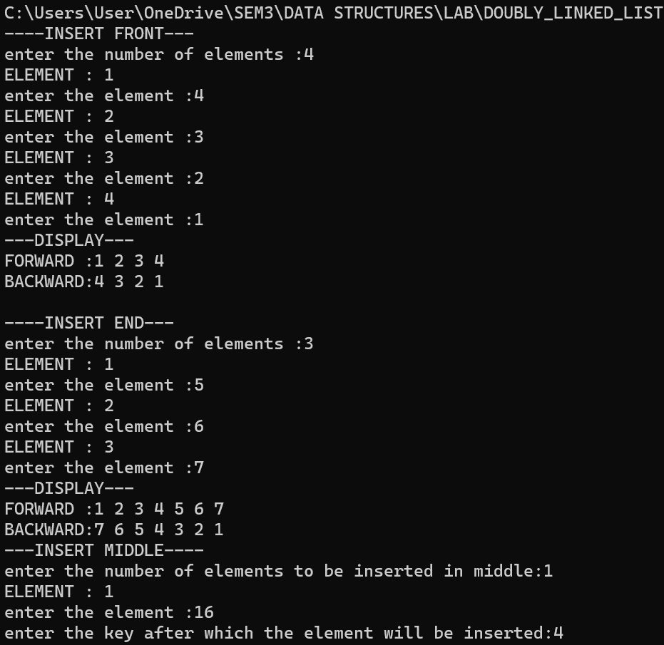

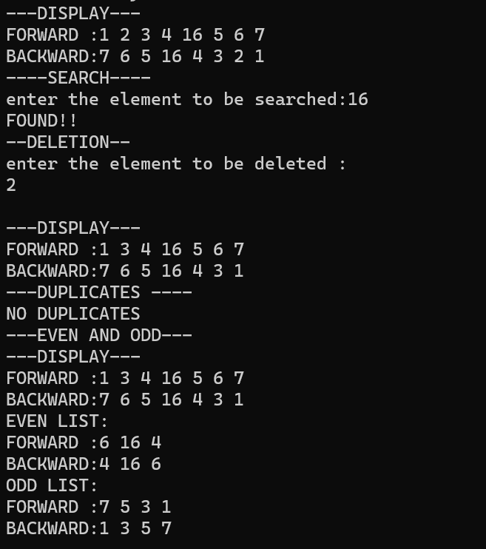

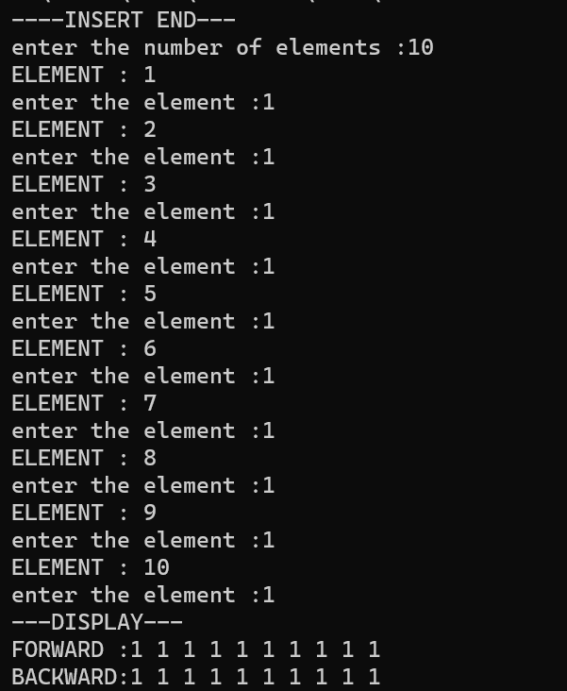

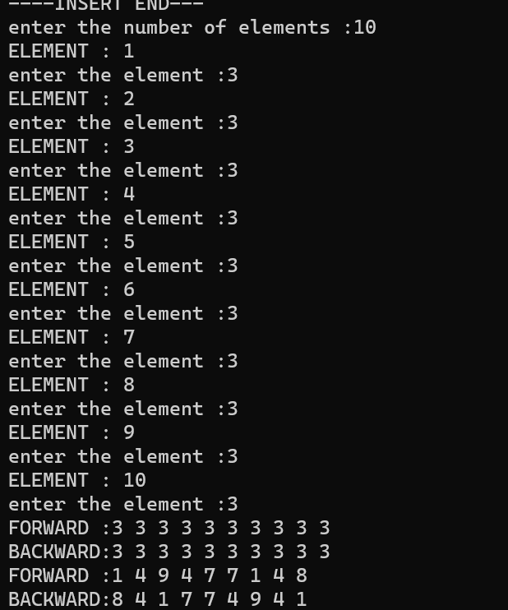

QUESTION 2: Print the k-th missing element

CODE:
int findmiss(struct node *h,int k)
{
struct node *ptr;
ptr=h->right;
int k1=0;
for (int i=1;i<25;i++)
{
if (ptr->right!=NULL)
{
if ((i!=ptr->data)&&(i<ptr->data))
{
k1++;
if (k1==k)
return i;
}
else
{
ptr=ptr->right;
}
}
else
{
if (k1==k)
return i;
else
k1+=1;
}
}
}

OUTPUT:
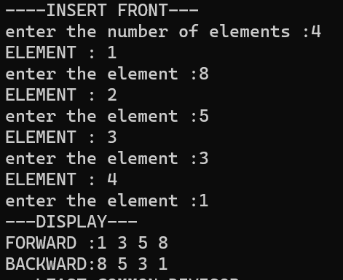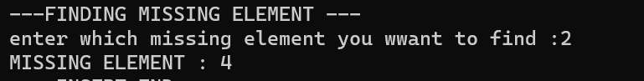

QUESTION 3: Given a linked list, find the least common number when divided by with each element yields a sum less than 8.

CODE:
int divisor(struct node *h)
{
struct node *ptr;
int i=1;
int k =1;
while(k=1)
{
int sum=0;
ptr=h->right;
while(ptr!=NULL)
{
sum+=ceil((ptr->data)/i);
ptr=ptr->right;
}
if (sum<=8)
{
break;
}
else
{i+=1;}
}
return i;
}

OUTPUT:
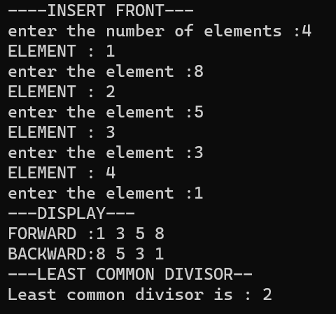

LEARNING OUTCOME:
After the completion of this exercise, doubly linked list and its basic operations like insertion, deletion, searching was learnt. Some other applications of DLL was also learnt.

