UCS 2312 Data Structures Lab
Assignment 4: StackADT and its application
Create an ADT for the stack data structure with the following functions. stackADT will have the integer array, top and size. [CO1, K3]
- createStack(top) – initialize size and top with -1
- push(top,data) – push data into the stack if stack is not full. Print a message when stack is
full
- pop(top) – decrements the top by 1
- peek(top)– returns the element at top, if stack is not empty, otherwise returns -1
- isEmpty(top) – returns 1 if stack empty, otherwise returns 0
- isFull(top) – returns 1 if stack full, otherwise returns 0
Test the operations of stackADT with the following test cases
Operation | Expected Output
peek(top) | Empty
push(top,2) | 2
push(top,4) | 4, 2
push(top,6) | 6, 4, 2
push(top,8) | Full
pop(top)
peek(top) | 4
peek(top) | 4
pop(top)
pop(top)
peek(top) | Empty
pop(top)
pop(top)
push(top,11) | 11
peek(top) | 11

Best practices to be followed:
- Design before coding
- Usage of algorithm notation
- Use of multi-file C program
- Versioning of code
Application using Stack
- Evaluate the infix to postfix expression using Stack
Example: (2+3)*(4+5)
Ans: 23+45+*
- Convert the given decimal number into binary using stack
Example: 14
Ans: 1110
- Find next greater element using stack
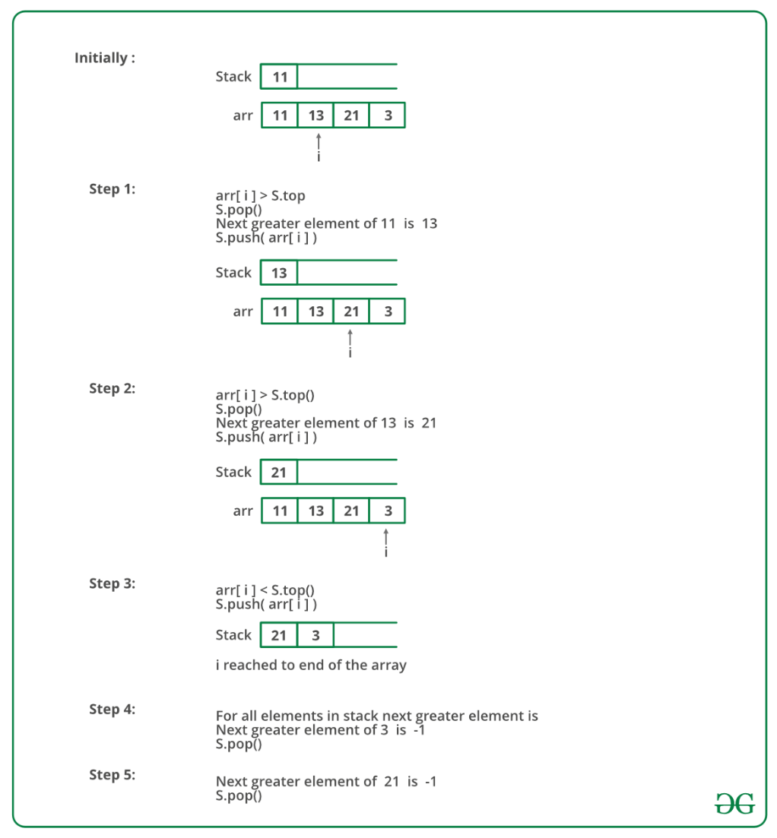
Follow the steps mentioned below to implement the idea:
- Push the first element to stack.
- Pick the rest of the elements one by one and follow the following steps in the loop.
  - Mark the current element as next.
  - If the stack is not empty, compare top most element of stack with next.
  - If next is greater than the top element, Pop element from the stack. next is the next greater element for the popped element.
  - Keep popping from the stack while the popped element is smaller than next. next becomes the next greater element for all such popped elements.
- Finally, push the next in the stack.
- After the loop in step 2 is over, pop all the elements from the stack and print -1 as the next element for them.

ALGORITHMS:

1.FUNCTION NAME:create
INPUT:
i)struct stack *
ii)int
OUTPUT:None

- s->size=size;
- s->top=-1;

2.FUNCTION NAME:push
INPUT:
i)struct stack
ii)int
OUTPUT:None
- if (isfull(s))
DISPLAY STACK IS FULL!
- else
{
s->top+=1;
s->arr[s->top]=ele;
DISPLAY PUSHED
}

3.FUNCTION NAME:pop
INPUT:
i)struct stack *
OUTPUT:None

- if (isempty(s))
DISPLAY EMPTY!
- else
{
DISPLAY s->arr[s->top]
s->top-=1;
}

4.FUNCTION NAME:peek
INPUT:
i)struct stack *
OUTPUT:int

- if (isempty(s))
return -1;
- else
return s->arr[s->top];

5.FUNCTION NAME:isfull
INPUT:
i)struct stack *
OUTPUT:int

- if (s->top==s->size-1)
return 1;
- else
return 0;

6.FUNCTION NAME:isempty
INPUT:
i)struct stack *
OUTPUT:int
- if (s->top==-1)
return 1;
- else
return 0;

7.FUNCTION NAME:postfix
INPUT:
i)struct stack *
ii)char []
OUTPUT:None

int i = 0;
char str1[100];
int k = 0;
while(str[i]!='\0')
{
if (str[i]=='(')
{
push(h,str[i]);
}
else if (alpha(str[i]))
{
str1[k]=str[i];
k+=1;
}
else if (str[i]==')')
{
int res =close(h,str1,k);
k=res;
}
else
{
if (check(h)==-1)
push(h,str[i]);
else
{
if (operator(str[i])<=operator(check(h)))
{
str1[k]=pop(h);
k++;
}
else
push(h,str[i]);
}
}
i++;
}
for (int i = 0;i<k;i++)
{
printf("%c",str1[i]);
}

8.FUNCTION NAME:binary
INPUT:
i)int
OUTPUT:None

- struct stack *s;
- s=(struct stack *)malloc(sizeof(struct stack));
- create(s,10000);
- int temp=n;
- while(n>0)
{
push(s,n%2);
n=n/2;
}
- while(!isempty(s))
{
pop(s);
}

9.FUNCTION NAME:greater
INPUT:
i)struct stack *
OUTPUT:None
- if (s->top==-1)
{
s->arr[++s->top]=ele;

}
- else
{
if (ele<peek(s))
{
s->arr[++s->top]=ele;

}
else
{
while (!isempty(s))
{
if (peek(s)<ele)
{
printf("\n%d has greater element %d",peek(s),ele);
pop(s);
}
else
{break;}
}
s->arr[++s->top]=ele;
}

}

CODE:

Stackadt.h

#include <stdio.h>
#include <stdlib.h>

struct stack
{ int size;
int top;
int arr[100];
};

void create(struct stack *s,int size)
{
s->size=size;
s->top=-1;
}

int isfull(struct stack *s)
{
if (s->top==s->size-1)
return 1;
else
return 0;
}

void push(struct stack *s,int ele)
{
if (isfull(s))
printf("STACK IS FULL!\n");
else
{
s->top+=1;
s->arr[s->top]=ele;

}
}

int isempty(struct stack *s)
{
if (s->top==-1)
return 1;
else
return 0;
}

void pop(struct stack *s)
{
if (isempty(s))
printf("EMPTY!\n");
else
{printf("%d ",s->arr[s->top]);
s->top-=1;}

}

int peek(struct stack *s)
{
if (isempty(s))
return -1;
else
return s->arr[s->top];
}

void binary(int n)
{
struct stack *s;
s=(struct stack *)malloc(sizeof(struct stack));
create(s,10000);
int temp=n;
while(n>0)
{
push(s,n%2);
n=n/2;
}
while(!isempty(s))
{
pop(s);
}
}

void push(struct stack *s,int ele)
{

if (s->top==-1)
{
s->arr[++s->top]=ele;

}
else
{
if (ele<peek(s))
{
s->arr[++s->top]=ele;

}
else
{
while (!isempty(s))
{
if (peek(s)<ele)
{
printf("\n%d has greater element %d",peek(s),ele);
pop(s);
}
else
{break;}
}
s->arr[++s->top]=ele;
}

}

}
int close(struct stack *h,char str1[],int k)
{
int i = h->top;
int j = 1;
while(h->arr[i]!='(')
{
str1[k]=h->arr[i];
i--;
k++;
j++;
}
h->top=h->top-j;
return k;
}

char check(struct stack *h)
{
if (h->top=='(')
return -1;
else
return h->arr[h->top];
}

int operator(char data)
{
if (data=='+'|| data == '-')
return 1;
else if (data == '*' || data=='/')
return 2;
else
return 0;
}

void conv(struct stack *h,char str[])
{
int i = 0;
char str1[100];
int k = 0;
while(str[i]!='\0')
{
if (str[i]=='(')
{
push(h,str[i]);
}
else if (alpha(str[i]))
{
str1[k]=str[i];
printf("%c\n",str1[k]);
k+=1;
}
else if (str[i]==')')
{
int res =close(h,str1,k);
k=res;
}
else
{
if (check(h)==-1)
push(h,str[i]);
else
{
if (operator(str[i])<=operator(check(h)))
{
str1[k]=pop(h);
k++;
}
else
push(h,str[i]);
}
}
i++;
}
for (int i = 0;i<k;i++)
{
printf("%c",str1[i]);
}
}

Main.c

#include <stdio.h>
#include <stdlib.h>
#include "stackadt.h"

void main()
{
struct stack *s;
s=(struct stack *)malloc(sizeof(struct stack));
create(s,4);
push(s,1);
push(s,2);
push(s,3);
push(s,4);
push(s,5);
pop(s);
pop(s);
pop(s);
printf("PEEK : %d",peek(s));
printf("\n---BINARY----\n");
printf("enter the decimal number");
int n;
scanf("%d",&n);
binary(n);

struct stack *h;
h=(struct stack *)malloc(sizeof(struct stack));
printf("enter the string ");
char str[100];
scanf("%[^\n]s",str);
init(h);
conv(h,str);

struct stack *s;
s=(struct stack *)malloc(sizeof(struct stack));
init(s);
printf("elements :");
int n;
scanf("%d",&n);
for (int i =0;i<n;i++)
{
printf("\nenter element :");
int a;
scanf("%d",&a);
push(s,a);
}

while(!isempty(s))
{
printf("\n%d has no greater element ",pop(s));
}
}

OUTPUT:
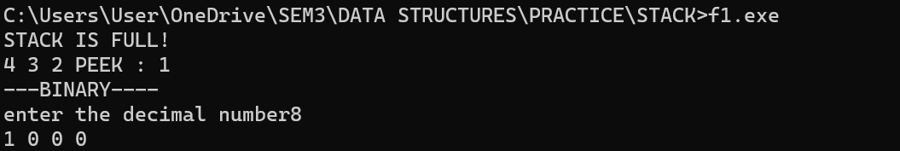

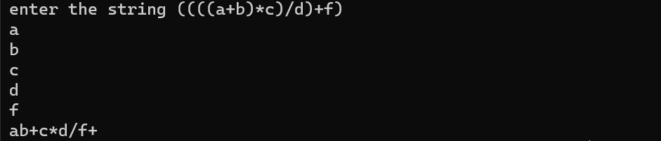

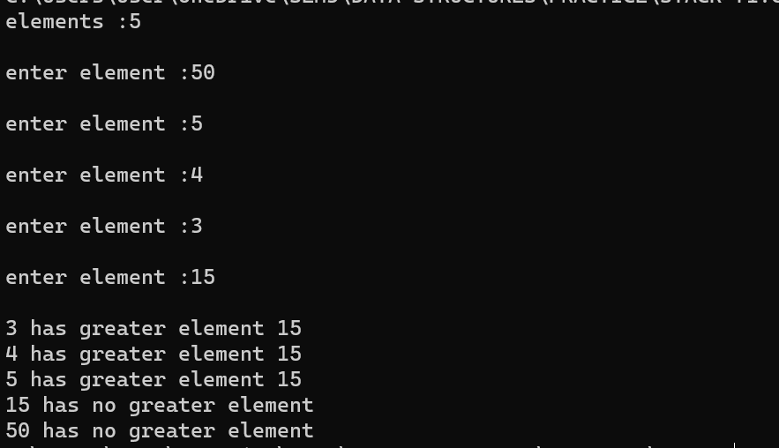

QUESTION 2: Evaluate the postfix expression using stacks

CODE:

int isdigi(char data)
{
int asc=(int)data;
if ((asc >=48) && (asc <= 57) )
{
return 1;
}
else
{
return 0;
}
}

int whichop(char data)
{
if (data=='+')
return 1;
else if (data=='-')
return 2;
else if (data=='*')
return 3;
else if (data == '/')
return 4;
}

int evalpost(struct stack *s,char arr[])
{
int i =0;
while(arr[i]!='\0')
{
if (isdigi(arr[i]))
{
push(s,((int)arr[i]-48));
}
else
{
int ch = whichop(arr[i]);
if (ch == 1)
{
int a = pop(s);
int b = pop(s);

push(s,b+a);
}
else if (ch==2)
{
int a = pop(s);
int b = pop(s);
push(s,b-a);
}
else if (ch == 3)
{
int a = pop(s);
int b = pop(s);
push(s,b*a);
}
else
{
int a = pop(s);
int b = pop(s);
push(s,b/a);
}
}
i++;
}
return (pop(s));
}

OUTPUT:

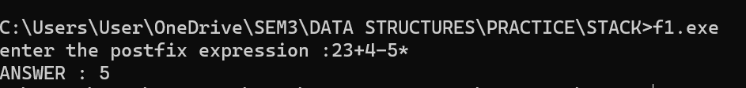

QUESTION 3: Find minimum of the stack in O(1) time complexity. You can use another stack.
CODE:
int min(struct stack *mh)
{
return mh->arr[mh->top];
}

int isempty(struct stack *h)
{
if (h->top==-1)
return 1;
else
return 0;
}

int pop(struct stack *h,struct stack *mh)
{
if (!isempty(h))
{
h->top-=1;
mh->top-=1;
printf("\n MINIMUM : %d\n",min(mh));
}
else
{
return -1;
}
}

OUTPUT:
