**Creating EUS Resource Group and Vnet:**

**FileName: Euvnet.ps1**

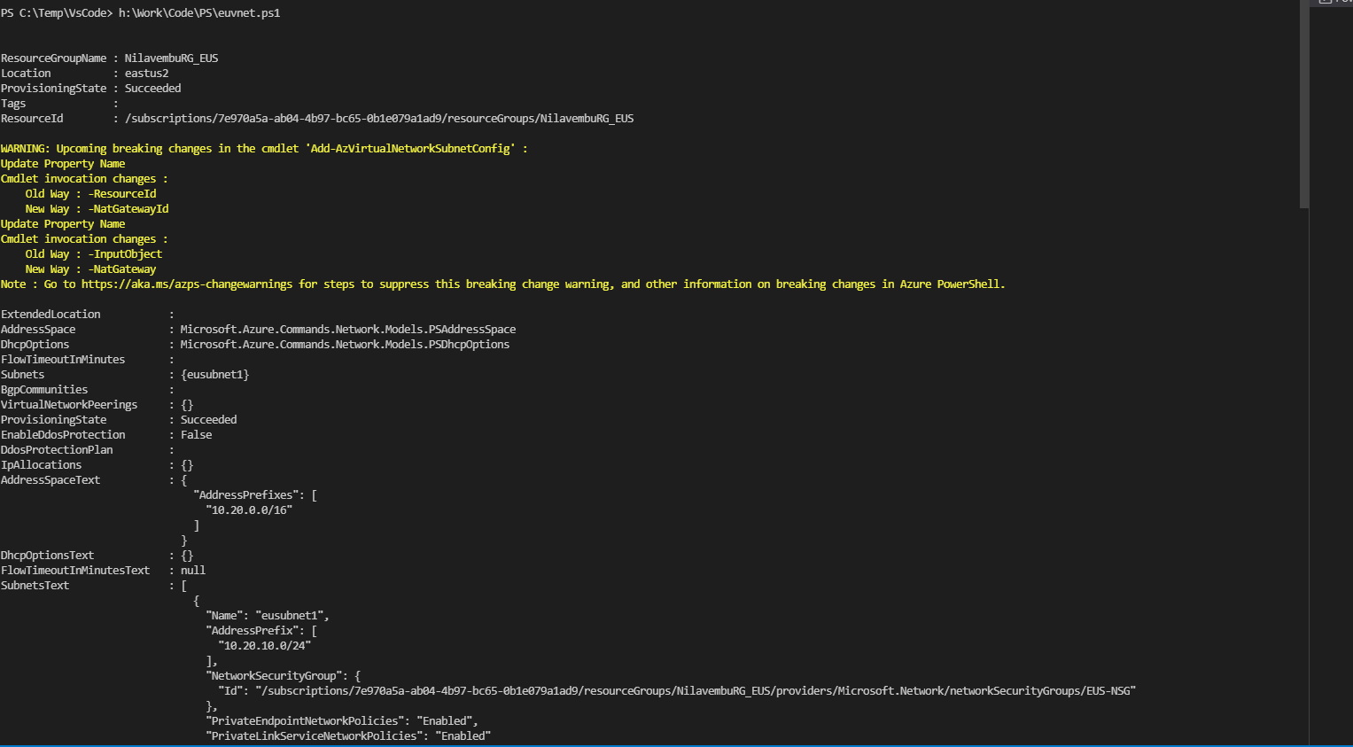

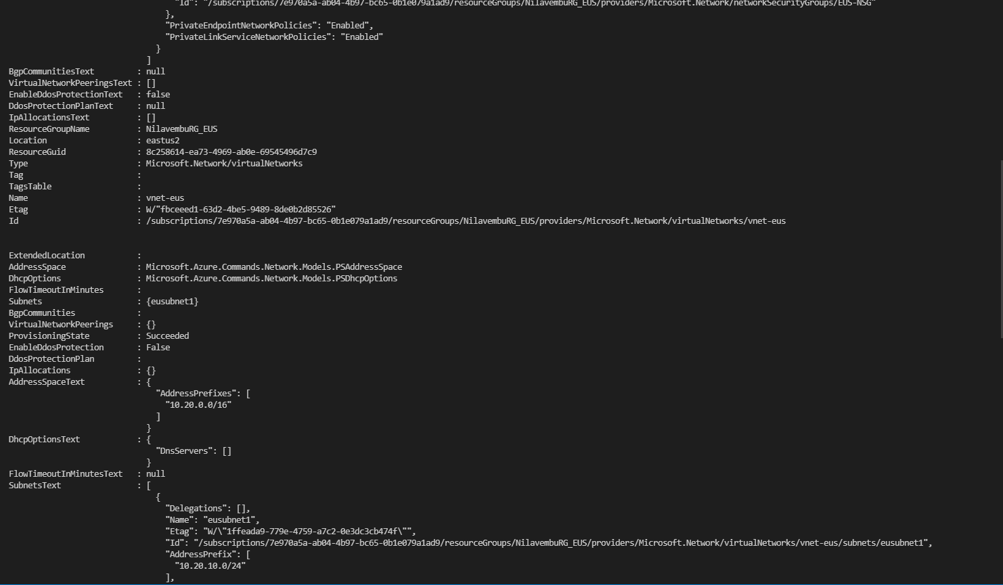

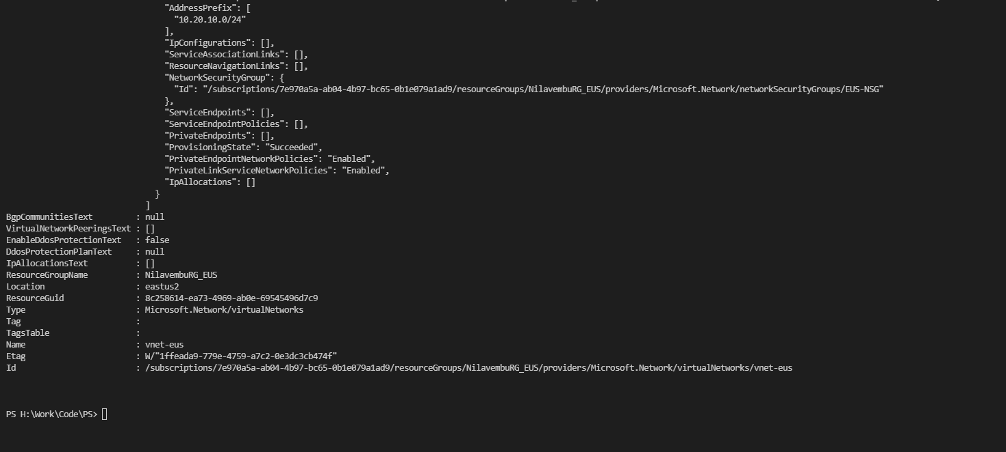

**Creating SEA Resource Group and sea-Vnet:**

**FileName: seanet.ps1**

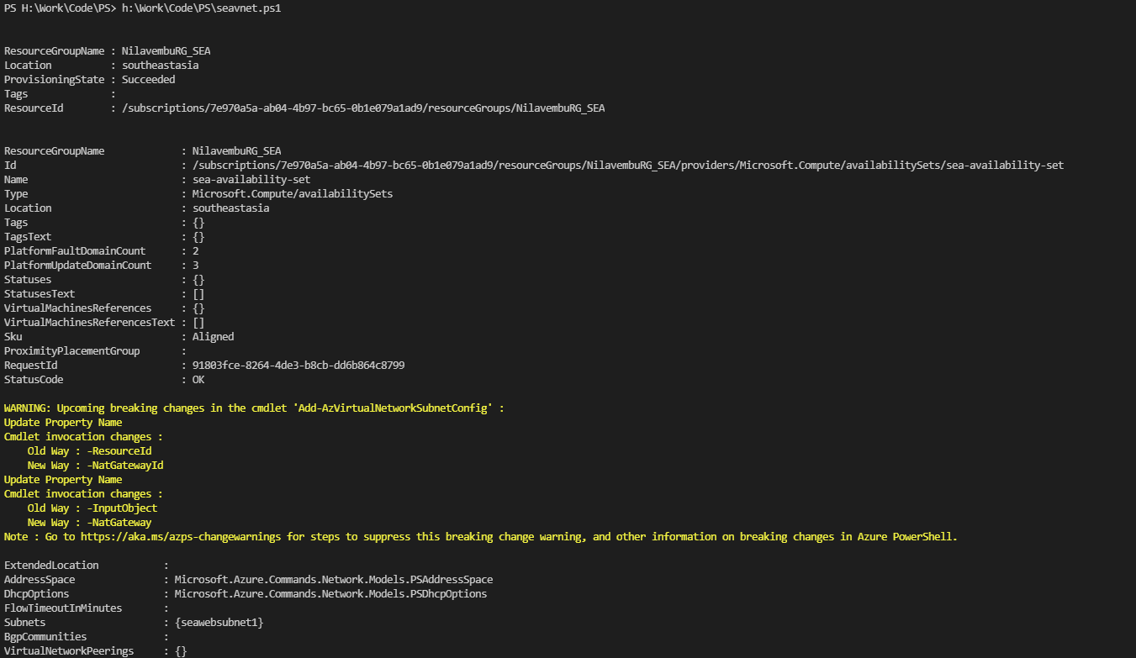

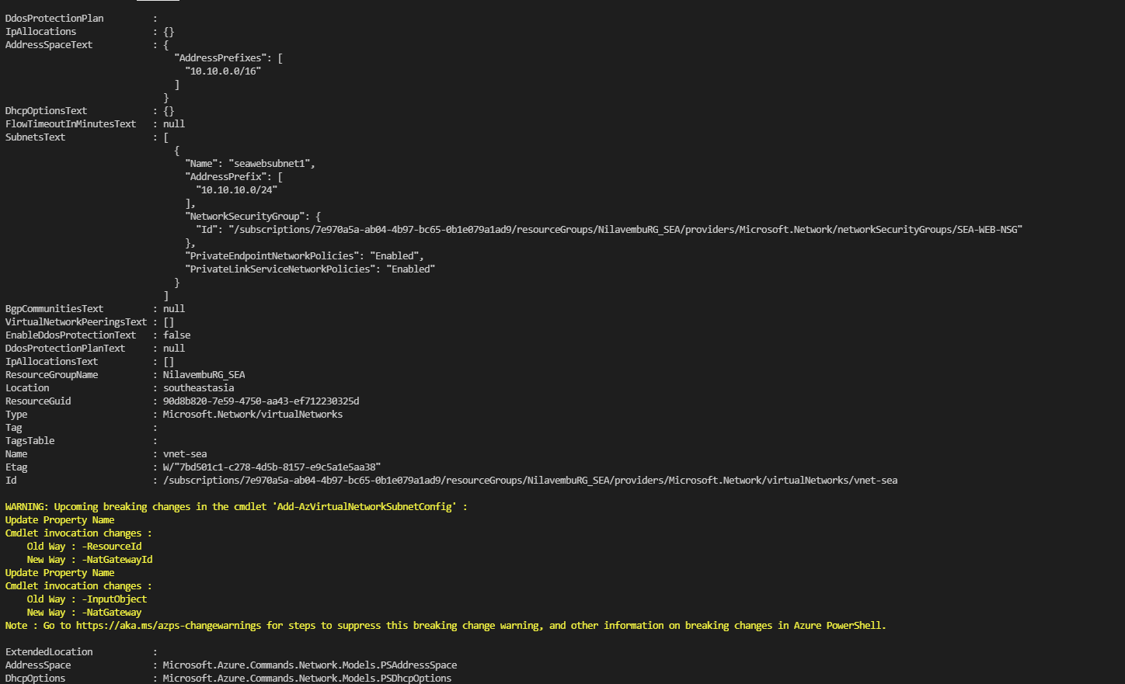

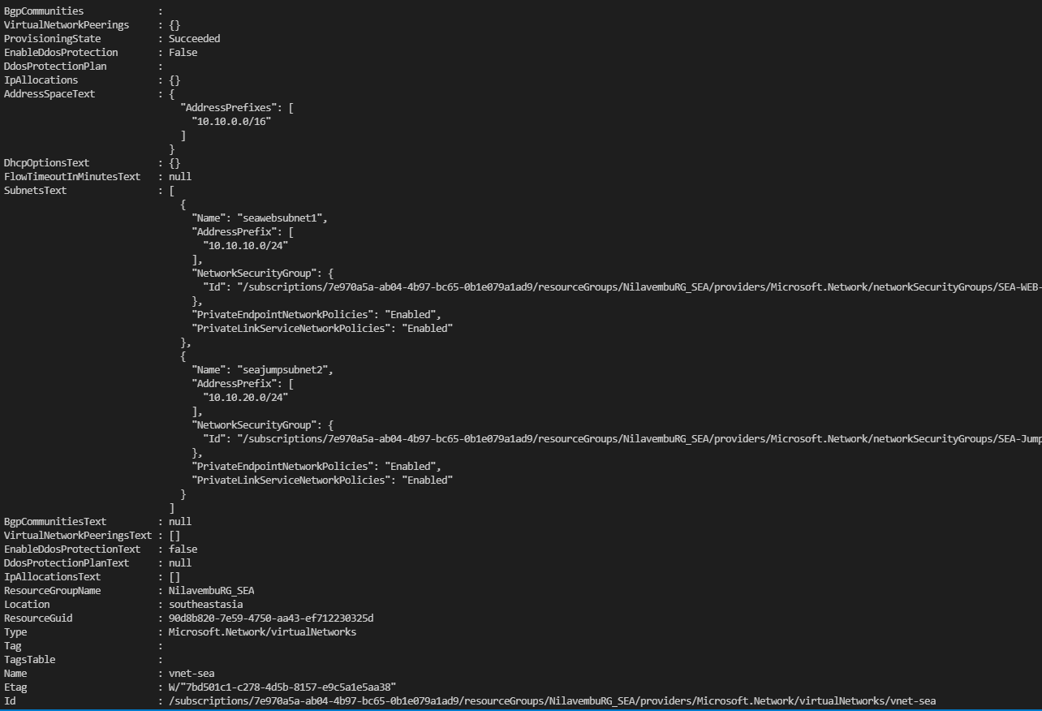

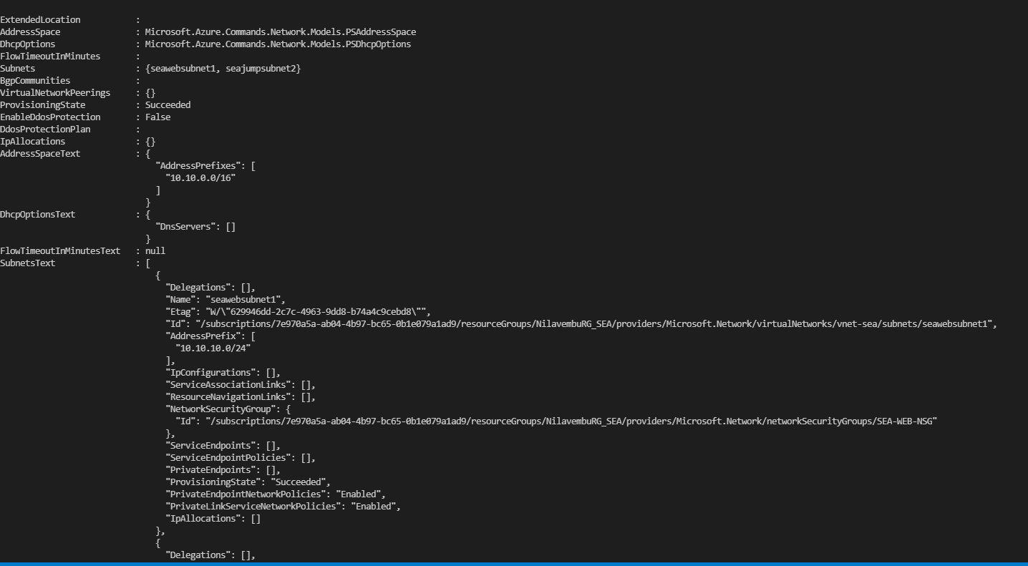

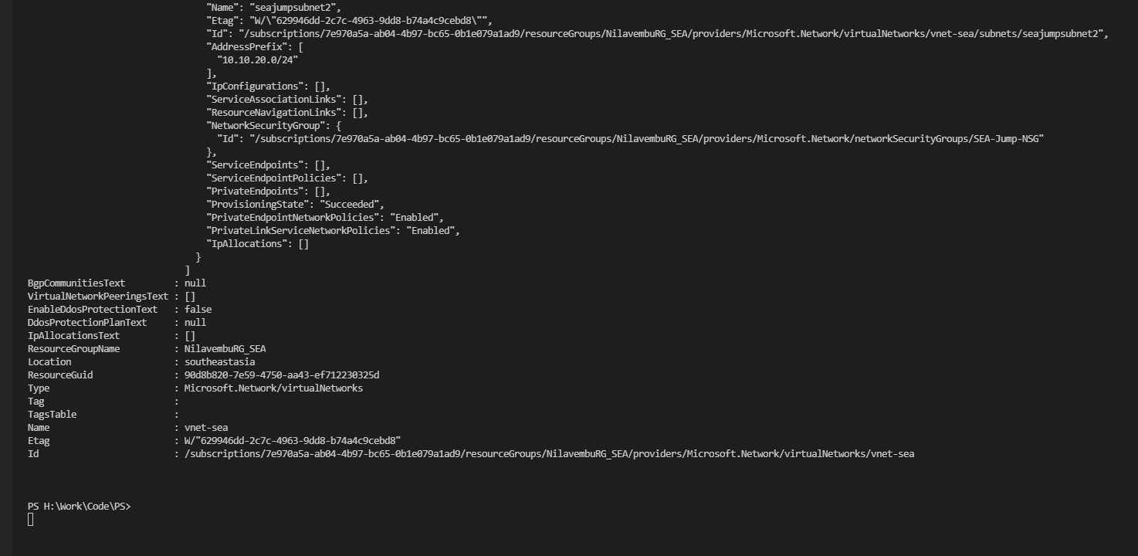

**Creating Webserver 1:**

**Running seawebserver1.ps1:**

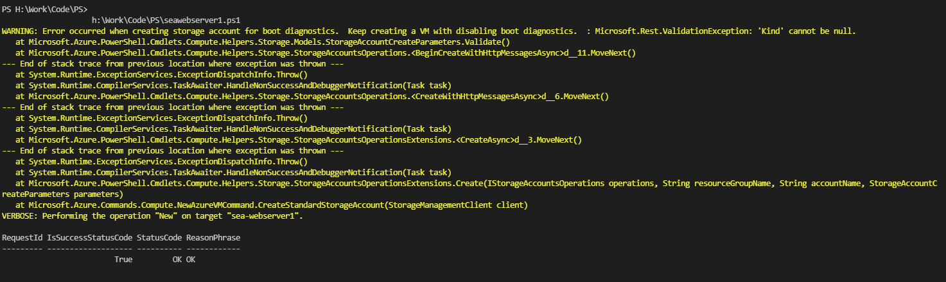

**Creating Webserver 2:**

**Running seawebserver2.ps1:**

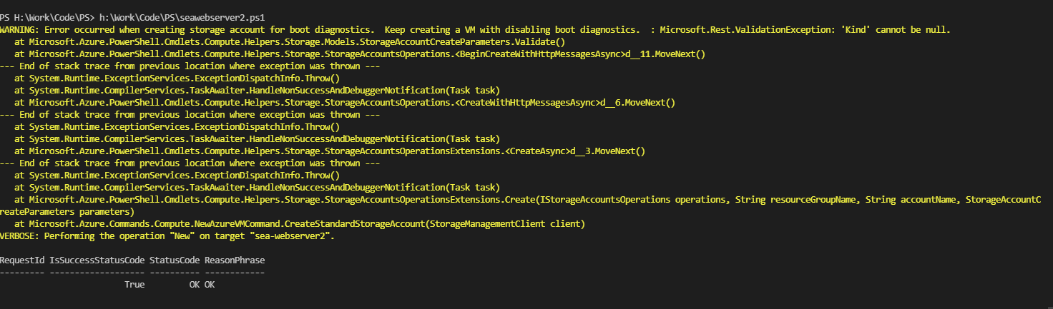

**Creating Jump Host:**

**Running seajumphost.ps1:**

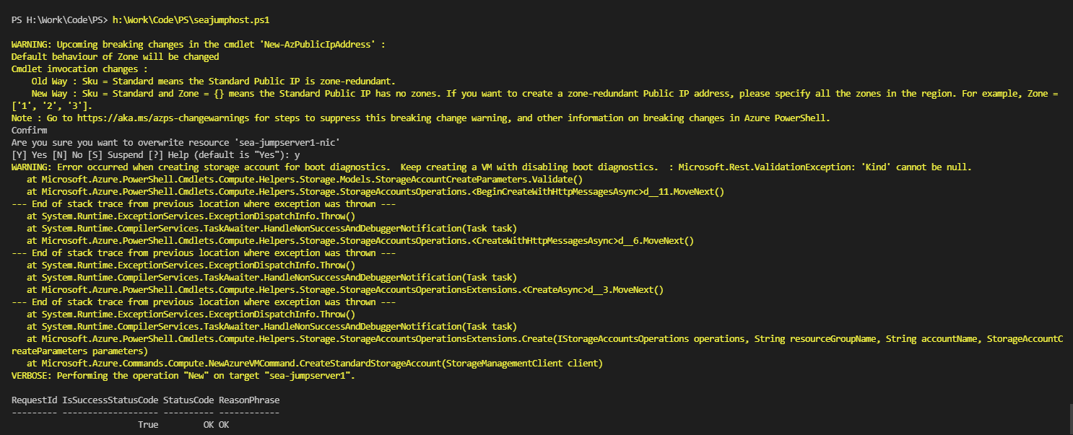

**Creating EUS Webserver:**

**Running euwebserver.ps1:**

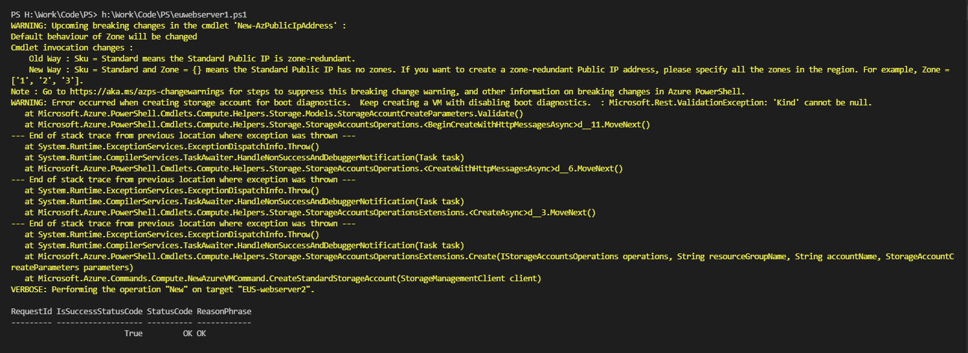

**Creating Load Balancer:**

**Running LB1.ps1:**

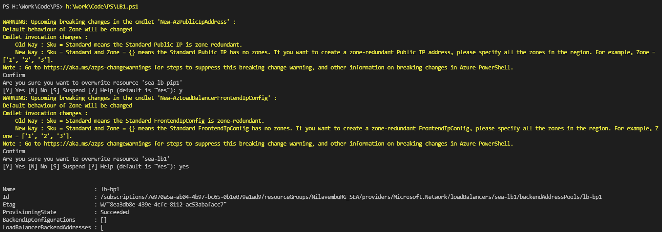

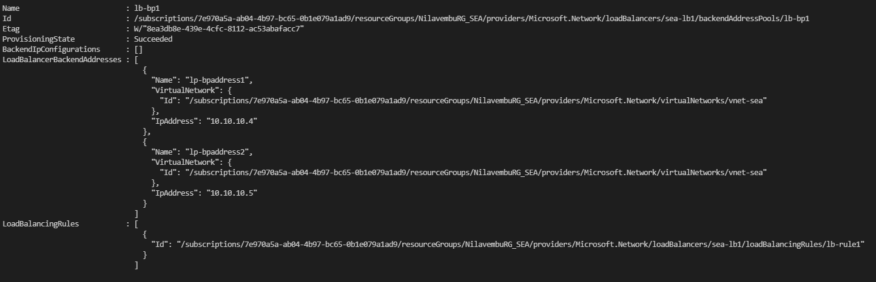

**Creating Vnet Peering:**

**Vnet peering.ps1:**

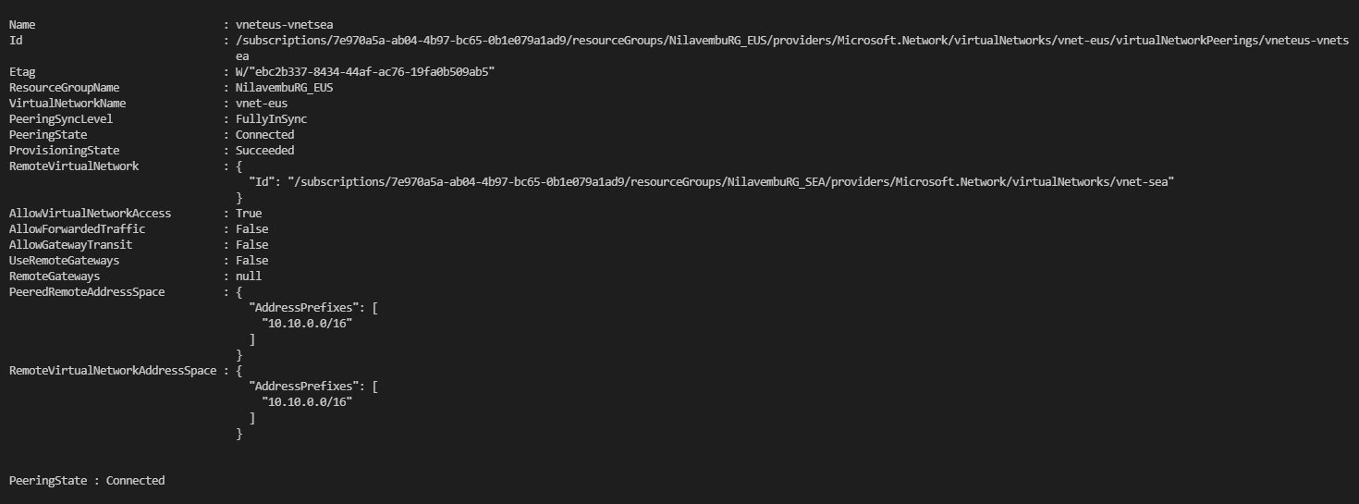

**Creating Two Storage Accounts:**

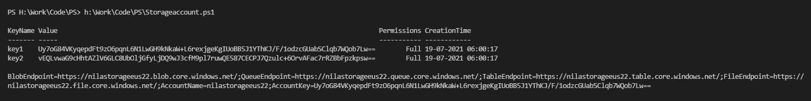

**Running a Backup Job:**

