**Terraform**

**Running Terraform Plan to Create NilavembuRG_SEA:**

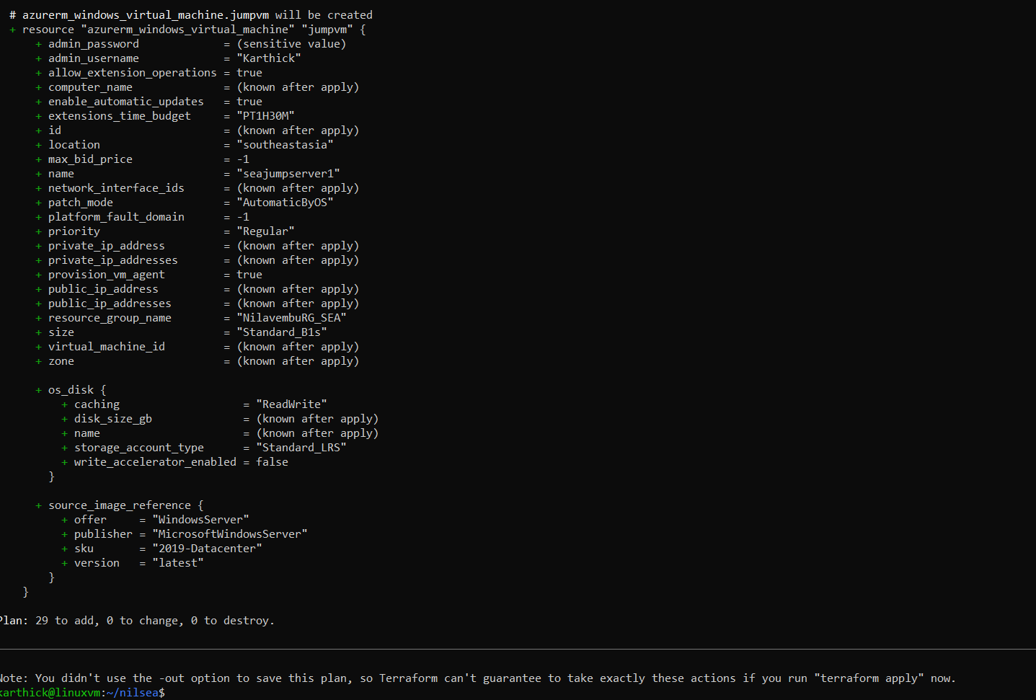

**Terraform Apply to create the Resource Group and all the Resources:**

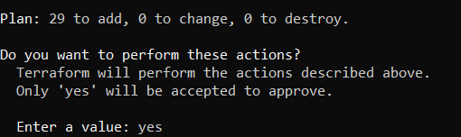

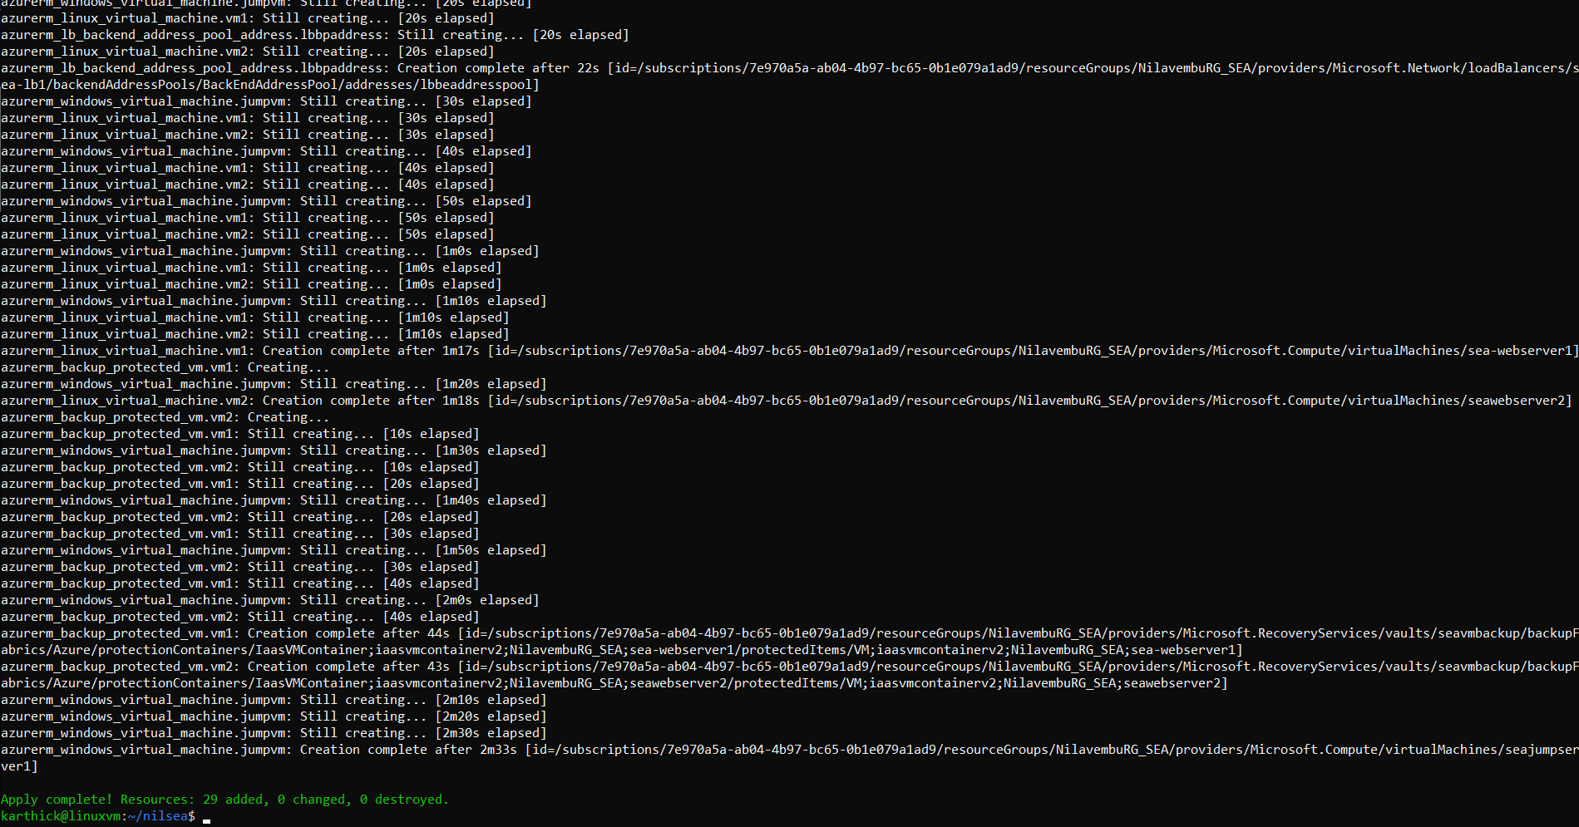

**Now for NilavembuRG_EUS:**

**Since I have created a separate folder, we need to import the RG and VNet to perform the VNet Peering.(Only the first time when creating the TF state)**

terraform import azurerm_resource_group.rg2 <Resource Group Resource id>

terraform import azurerm_virtual_network.vnet2 <Vnet Resource id>

**Terraform Plan:**

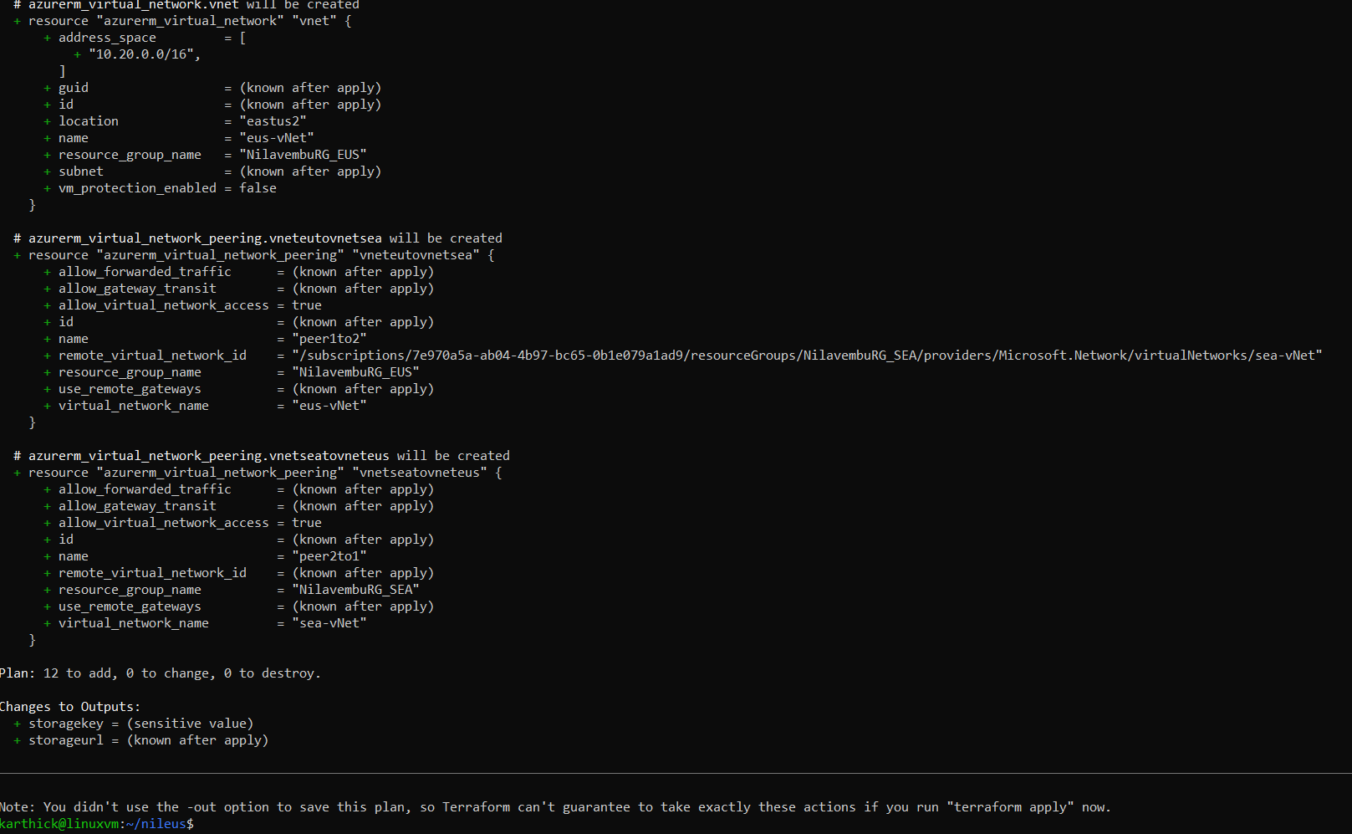

**Terraform Apply:**

