BPR -Exercises:

- List 3 problems in any business process you know.
Business Process: Cash Deposit in Bank Accounts
- Manual visit to branch, long waiting queues and challan filling
- If amount>50k INR, Proof verification/ identity verification
- Approval from manager
- Create a simple AS-IS → TO-BE table.
As-Is | To-BE
Manual visit/ form filling | Automated process through ATMs
Manual verification steps | Automated verification through Aadhar/ Pan links
Manual Approvals | Simplified automated approvals
Process time – 1 day | Reduced processing time- 1 hour

- Identify 2 steps that can be automated in invoice approval.
- Auto – fetching of customer/ product details
- Auto- calculation of GST/HST (taxes) and discounts applied
- Payment links can be promptly added through secure payment gateways

- Draw a small workflow of any process (leave approval, onboarding, etc.)
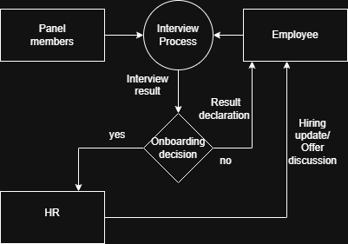
- Write 3 gaps you would look for in a manual process.
- Avoid Repetitive workflow process
- Simplify the approvals steps
- Automate the document verifications

