Business Analysis and Knowledge Areas

Overview
A Business Analyst (BA) ensures that data and business projects solve real business problems.
The BA acts as a bridge between business stakeholders and technical teams.
Goal: Convert business needs into measurable, data‑driven outcomes.

1. What is Business Analysis?
Business Analysis is the practice of understanding a business problem or need.
It enables organizations to make the right changes.
Purpose: Deliver value to the business and its stakeholders.

2. Understanding the Current State
This step focuses on how the business operates today.
Includes:
- Existing processes
- Current systems
- Pain points
- Issues and gaps
This is known as the Current State.

3. Defining the Future State
This step defines what the business wants to achieve.
Examples include:
- Improved performance
- New or enhanced systems
- Better processes
- Cost reduction or business growth
This desired situation is called the Future State.

4. Moving from Current State to Future State
After understanding both states, the BA:
- Identifies required changes
- Defines solutions and actions
- Plans the transition from current to future state

5. When is Business Analysis Done?
Business Analysis can take place:
- Before a project begins
- During project execution
- After project completion (to validate benefits)
Business Analysis is not limited to projects.
It also supports continuous business improvement.

6. Who is a Business Analyst?
A Business Analyst is not defined by job title.
Anyone performing business analysis activities is acting as a Business Analyst.

7. What Does a Business Analyst Do?
A Business Analyst:
- Understands business problems
- Engages with stakeholders
- Collects information from:
  - Documents
  - Systems
  - Processes
- Analyzes business needs
- Supports solution design

8. Real Needs vs Stated Needs
Stakeholders often describe what they want.
This may not represent the actual problem.
The Business Analyst:
- Asks relevant questions
- Analyzes the situation
- Identifies the root cause

9. Ensuring Value Delivery
The Business Analyst ensures that:
- The solution addresses the real business problem
- The solution aligns with business needs
- Expected business value is achieved

Knowledge Areas in Business Analysis

What are Knowledge Areas?
Knowledge Areas group related Business Analysis activities.
They represent the core areas of work performed by a Business Analyst.

The Six Knowledge Areas
1. Business Analysis Planning & Monitoring
- Planning BA activities
- Monitoring and tracking BA work
2. Elicitation & Collaboration
- Gathering information from stakeholders
- Ongoing collaboration and communication
3. Requirements Life Cycle Management
- Managing requirements end‑to‑end
- Handling changes and traceability
4. Strategy Analysis
- Understanding business needs
- Defining current state, future state, and strategy
5. Requirements Analysis & Design Definition
- Structuring and detailing requirements
- Defining solution and design options
6. Solution Evaluation
- Evaluating solution performance
- Measuring value and identifying improvements

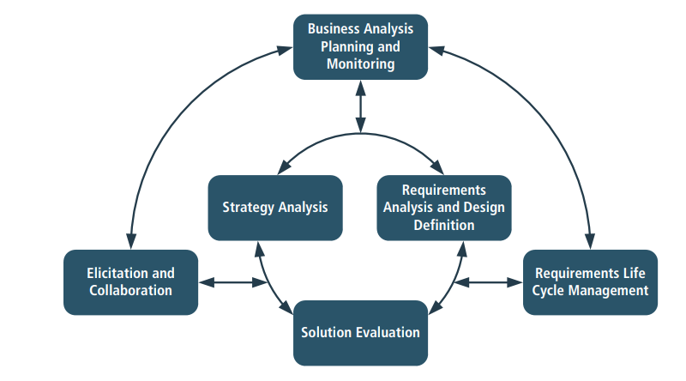

Exercises
Exercise 1: Identifying the Current State
Familiar business process (for example: online food ordering, bank account opening, or internal leave approval).
- List the current steps involved
- Identify one pain point or issue
Exercise 2: Defining the Future State
For the same process:
- Describe what an improved version would look like
- Mention one clear improvement goal
Exercise 3: Real Need vs Stated Need
Scenario: A stakeholder says, “We need a new dashboard.”
- What questions would you ask to understand the real need?
Exercise 4: BA Role Mapping
From the BA activities listed above:
- Identify which ones you have already performed in your current or past role

Key Takeaways
- Business Analysis focuses on solving real business problems, not just documenting requirements
- A Business Analyst bridges business expectations and technical solutions
- Understanding the current state is essential before proposing solutions
- The future state represents measurable business improvement
- Stated requirements may not reflect the actual business need
- Value delivery is the ultimate responsibility of a Business Analyst
- Knowledge Areas define the core scope of Business Analysis work

