Deep Learning-Based Cyclone Intensity Prediction Using Infrared Imagery INSAT Satellite Data

A PROJECT REPORT

Submitted by

K.B.S.KARTHIK VEERAPRAJNAIK

in partial fulfillment for the award of the degree
of

MASTER OF TECHNOLOGY

IN
COMPUTER SCIENCE (AI/ML)



Lovely Professional University, Punjab

12411249

APRIL&2025

Lovely Professional University, Punjab

BONAFIDE CERTIFICATE

Certified that this project report “Deep Learning-Based Cyclone Intensity Prediction Using Infrared Imagery INSAT Satellite Data”is the bonafide work of “K.B.S.KARTHIK VEERAPRAJNAIK”

who carried out the project work under my supervision.

KBSKARTHIK VEERA PRAJNAIK
SIGNATURE

<<Signature of the Head of the Department>>
SIGNATURE
<<Name>>
HEAD OF THE DEPARTMENT

<<Signature of the Supervisor>>
SIGNATURE
<<Name of the Supervisor>>
SUPERVISOR

Department of Machine Learning, CSE, Lovely Professional University, Punjab

APPENDIX III
(A typical specimen of table of contents)

<Font Style Times New Roman>
TABLE OF CONTENTS

CHAPTER NO. | CHAPTER NAME | PAGE NO.
 | Title Page | i
 | Bonafide Certificate | ii
 | Table of Contents | iii
 | Abstract
1. | Introduction of the Project | ..
2. | Problem Description
3. | Objectives
4. | Related Work/Literature Review
5. | Methodology
6. | Implementation Details
7. | Results and Discussion
8. | Project Outcomes
9. | Limitation and Challenges
10. | Conclusion
 | References | ..
 | Appendices (If Any)

Deep Learning-Based Cyclone Intensity Prediction Using Infrared Imagery INSAT Satellite Data
Abstract
Tropical cyclones are a major threat to coastal areas, and precise estimation of their intensity is important for early disaster preparedness and mitigation. This project introduces a deep learning-based methodology for cyclone intensity estimation from INSAT satellite images. Based on the strengths of convolutional neural networks (CNN), MobileNetV2, and Xception architectures, we design and test models to predict cyclone intensity from visual satellite images.The data is a set of annotated satellite images with corresponding cyclone intensity values, normalized and preprocessed to best train models. The task is posed as a regression problem, predicting continuous intensity values in knots. Models are trained and tested using common metrics such as Mean Absolute Error (MAE) and Root Mean Squared Error (RMSE) to evaluate prediction accuracy.Of the three architectures, MobileNetV2 showed the best performance with the final validation MAE of 0.0303 and RMSE of 0.1465, showing a high level of accuracy in cyclone intensity estimation. The findings reflect the capability of deep learning models in improving the accuracy and reliability of cyclone monitoring systems, providing useful assistance to meteorological departments and disaster response teams.
Introduction
Tropical cyclones are some of the most destructive natural disasters, producing vast destruction on life, infrastructure, and economies, especially along coastal areas. As the occurrence and severity of these phenomena intensify because of climate change, timely and reliable estimation of cyclone intensity has never been as important as now. Manual satellite image interpretation and numerical weather prediction models have long been the tools for cyclone intensity estimation. These processes tend to be lengthy and subject to human error.Recent advances in deep learning and computer vision have made it possible to open up new paths for cyclone analysis automation and enhancement of cyclone analysis accuracy. Satellite imagery is a useful source of real-time data that can be efficiently used based on convolutional neural networks (CNNs) and other deep learning frameworks to estimate cyclone intensity.This project investigates a deep learning method for estimating cyclone intensity from satellite images taken by the Indian National Satellite (INSAT) system. We design and evaluate three unique neural network architectures: a basic Convolutional Neural Network (CNN), MobileNetV2, and Xception. All of these are trained to pick up intricate patterns in satellite images and estimate cyclone intensity as a continuous numerical quantity, so this is a regression task.The main aim of this research is to test how effectively these models can predict cyclone intensity at high levels. We apply Mean Absolute Error (MAE) and Root Mean Squared Error (RMSE) as evaluation metrics to analyze the performance of the models. By this work, we hope to be able to assist in building an automated real-time and precise cyclone intensity estimation system to aid meteorological authorities and disaster management teams to make effective decisions

Problem Statement
Precise and timely estimation of cyclone intensity is essential for disaster preparedness and mitigation. Manual interpretation of satellite data by traditional methods of cyclone intensity estimation is not only time-consuming but also subject to human error. This project seeks to develop an automated deep learning-based system employing CNN, MobileNetV2, and Xception models to estimate cyclone intensity from satellite imagery with enhanced efficiency and accuracy.
- Manual Techniques are Timed-Based: Existing cyclone classification methods are usually based on human interpretation, which increases response time in exigent situations.
- Automation and Accuracy Required: A model that runs automatically can narrow down error margins and give repetitive predictions for enhanced early warning systems.
- Harnessing Deep Learning: Using sophisticated models such as CNN, MobileNetV2, and Xception enables strong feature extraction and more accurate predictions using satellite images.

Objectives
The main aim of this project is to create an automated system for cyclone intensity estimation from satellite images based on deep learning models. The aim is to reduce the requirement for manual analysis and improve the speed and accuracy of prediction. This project analyzes and compares the performance of three convolutional neural network architectures—CNN, MobileNetV2, and Xception—and identifies the best model with a balance of accuracy and computational cost. The project further tries to reduce prediction errors like Mean Absolute Error (MAE) and Root Mean Squared Error (RMSE) to achieve meaningful outputs. Finally, the system is designed to aid timely and informed decision-making in disaster preparedness and response.

Literature Review
- Cloud-Optimized GeoTIFF (COG) is an advanced geospatial data format designed for efficient storage and real-time accessibility via cloud platforms.Studies by NASA, NOAA, and Google Earth Engine highlight the benefits of COG in reducing data retrieval latency and improving scalability for large satellite datasets.Research on Landsat and Sentinel satellite imagery demonstrates how COG enables efficient data streaming, reducing the need for full-file downloads while preserving spatial and spectral integrity.
- INSAT Satellite Data and Its Challenges The Indian National Satellite (INSAT) system provides meteorological, environmental, and disaster monitoring data crucial for India’s weather forecasting and remote sensing applications. Studies on INSAT imagery emphasize challenges in large-scale data storage, high latency in data retrieval, and computational overhead, which limit its real-time applications.Current research suggests that INSAT data, if converted into COG format, could significantly enhance cloud-based processing and accessibility for meteorologists and researchers.
- Cloud-Based Geospatial Processing for Remote Sensing. Cloud computing platforms such as Google Earth Engine (GEE), AWS Open Data, and Microsoft Planetary Computer have successfully integrated COGs for efficient satellite image processing. Studies indicate that shifting remote sensing workflows to cloud platforms reduces computational costs and enhances real-time analytics for applications such as flood monitoring, land-use change detection, and agricultural assessments. Research on Sentinel-2 and Landsat 8 datasets shows that COGs improve processing speed and accessibility in comparison to traditional storage formats.
- Machine Learning and AI Applications with COG-Based Satellite Data Recent studies explore the use of artificial intelligence (AI) and deep learning models in analyzing COG-optimized satellite datasets for applications such as weather prediction, crop yield estimation, and disaster response. Research demonstrates that COG-based data pipelines improve training efficiency for AI models by allowing selective data retrieval, reducing storage costs, and enabling faster processing in cloud environments.
- Challenges and Future Scope in Implementing COG for INSAT Data Existing studies highlight challenges in converting legacy satellite data into COG format, including high initial computational costs, integration with existing GIS workflows, and security concerns related to cloud storage. Limited research is available on the direct application of COG for INSAT satellite data, creating a gap in understanding its potential benefits for India's geospatial infrastructure. Future research is needed to explore automated conversion techniques for INSAT data into COG, real-time AI-based analysis, and large-scale adoption of COG across government and research institutions.
- Comparative Performance Analysis of COG vs. Traditional GeoTIFFStudies comparing COG with standard GeoTIFF formats show that COG significantly reduces storage overhead and enhances access speed in cloud environments.Research on NASA’s MODIS and VIIRS datasets demonstrates that COG provides faster and more efficient data retrieval, especially when integrated with cloud-based GIS platforms.Performance evaluations indicate that COG reduces data access time by up to 70% compared to traditional storage methods, making it ideal for handling large-scale geospatial data.
- INSAT Data Applications in Meteorology and Climate StudiesINSAT satellite data has been widely used for weather forecasting, monsoon tracking, and climate change studies, but its accessibility and computational efficiency remain challenges.Research shows that cloud-based solutions, such as Google Earth Engine and AWS Open Data, enhance the processing of large satellite datasets, but INSAT data is yet to be fully integrated into these platforms.Studies suggest that converting INSAT data into COG format could facilitate better climate modeling, historical weather trend analysis, and AI-driven extreme weather predictions.
- COG in Disaster Management and Emergency Response Research highlights that COG-based satellite imagery plays a crucial role in flood detection, wildfire monitoring, and cyclone tracking due to its real-time accessibility. Studies on disaster-prone regions such as South Asia and the Pacific show that integrating COG with AI models and cloud GIS systems improves early warning capabilities. Implementation of COG in emergency response systems has demonstrated enhanced situational awareness, allowing for rapid assessment and decision-making during natural disasters.

- Cloud-Based AI Models for Remote Sensing Data Studies on integrating deep learning models with cloud-based COG datasets suggest that AI-powered analytics can extract valuable insights from satellite imagery with minimal computational costs. Research indicates that Convolutional Neural Networks (CNNs) and Transformer-based AI models perform better on COG-optimized data due to its efficient streaming capabilities.AI-based applications utilizing COG include land cover classification, deforestation monitoring, and agricultural yield prediction, demonstrating the potential of COG for large-scale geospatial AI applications.

Methodology
- Data Collection/Data Gathering:
The data collection used for this project consists of infrared (IR) satellite photos taken with the Indian National Satellite System (INSAT). The images portray different stages and levels of cyclonic activity recorded in the area of the Indian Ocean. The infrared imagery is especially useful in meteorological study because it detects thermal radiation, which enables proper observation of cloud top temperatures and storm structure even without the light of day.Every image in the dataset is tagged with the respective cyclone intensity value, which is in knots and used as ground truth for model training. The intensity values are usually between 25 knots and 128 knots, representing a broad range from weaker systems to extremely severe cyclonic storms. About 300labeled images were collected for this research, providing a good diversity of cyclone formations.The dataset was structured in a tabular format, where every row of the corresponding CSV file holds the path to the infrared image and its corresponding cyclone intensity. This set serves as the foundation for training and testing deep learning models that predict cyclone intensity from raw satellite imagery.
- Data Preprocessing:
In order to prepare the satellite imagery data for training the model, a strong preprocessing pipeline was used. The initial step was to resize all the images to a uniform dimension of 224×224 pixels, which provided consistency to the dataset and compatibility with CNN-based models. Subsequently, pixel values of the images were normalized by scaling them to the range of 0 and 1 through a rescaling factor (1./255). This aided in speeding up the training process and enhancing convergence. As the output of our model is a real value that corresponds to cyclone intensity (in knots), the labels were kept in their original float type, appropriate for regression. Also, the dataset was divided into training and validation subsets with an 80:20 ratio. This was accomplished utilizing the ImageDataGenerator class with a specified validation_split parameter so that partitioning could be efficiently and reproducibly performed. Preprocessing steps ensured that the input data was clean, normalized, and in a suitable format for best performance during training.
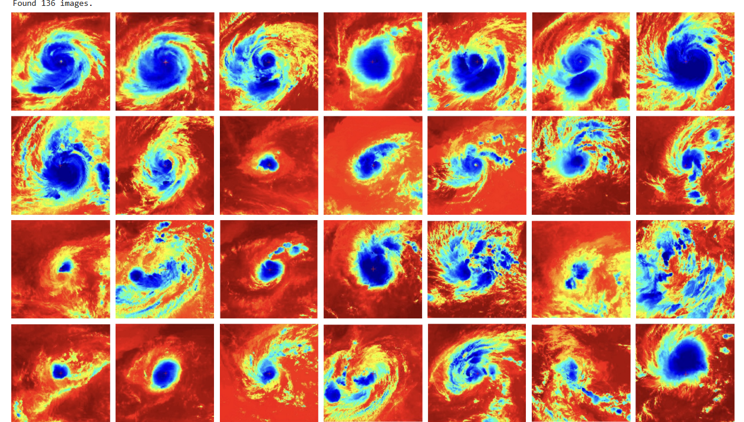
- Create the model:
In order to reliably estimate cyclone intensity using satellite imagery, three deep learning models were trained and compared: a hand-built Convolutional Neural Network (CNN), Xception, and MobileNetV2. All models were configured toapproach this regression problem by making a prediction for a continuous intensity value, instead of classifying categories.

The hand-built CNN model was built from scratch with a simple yet effective architecture. It began with an input layer that took in images resized to 224x224 with three color channels. This was succeeded by three convolutional layers with 32, 64, and 128 filters respectively, each with a 3x3 kernel. Batch normalization and max pooling followed each convolutional layer to regularize training and lower spatial dimensions. Dropout layers were added to avoid overfitting. The feature maps were flattened and fed into a dense layer with 128 units and ReLU activation. The cyclone intensity was predicted using a final dense layer with one output node. The model was trained using the Adam optimizer, with Mean Absolute Error (MAE) as loss and Root Mean Squared Error (RMSE) as evaluation metric. The CNN was trained for 50 epochs with a batch size of 32.
The second method utilized the Xception model, a high-performance convolutional neural network architecture pre-trained on ImageNet. Transfer learning was utilized by freezing the base model and adding a custom head to fit the regression task. The input images were resized to 224x224x3 and fed into the base Xception network with include_top=False. A GlobalAveragePooling2D layer was employed to decrease the dimensionality, then a fully connected dense layer with 128 neurons and ReLU activation, and lastly a dense layer with one output neuron to predict the cyclone intensity. Similar to the CNN model, Xception was also compiled using the Adam optimizer, MAE as loss, and RMSE as metric, and trained for 50 epochs.
The third and last model utilized was MobileNetV2, which was selected due to its computational cost and superior performance on vision tasks. Similar to the Xception configuration, MobileNetV2 was employed as a pre-trained feature extractor (include_top=False, weights='imagenet'). The bespoke regression head was made up of a global average pooling layer, a dense layer with 128 neurons (ReLU), and an output layer with one neuron. The architecture was then trained on the same compilation configuration—Adam optimizer, MAE loss, RMSE metric—and additionally trained for 50 Epochs.
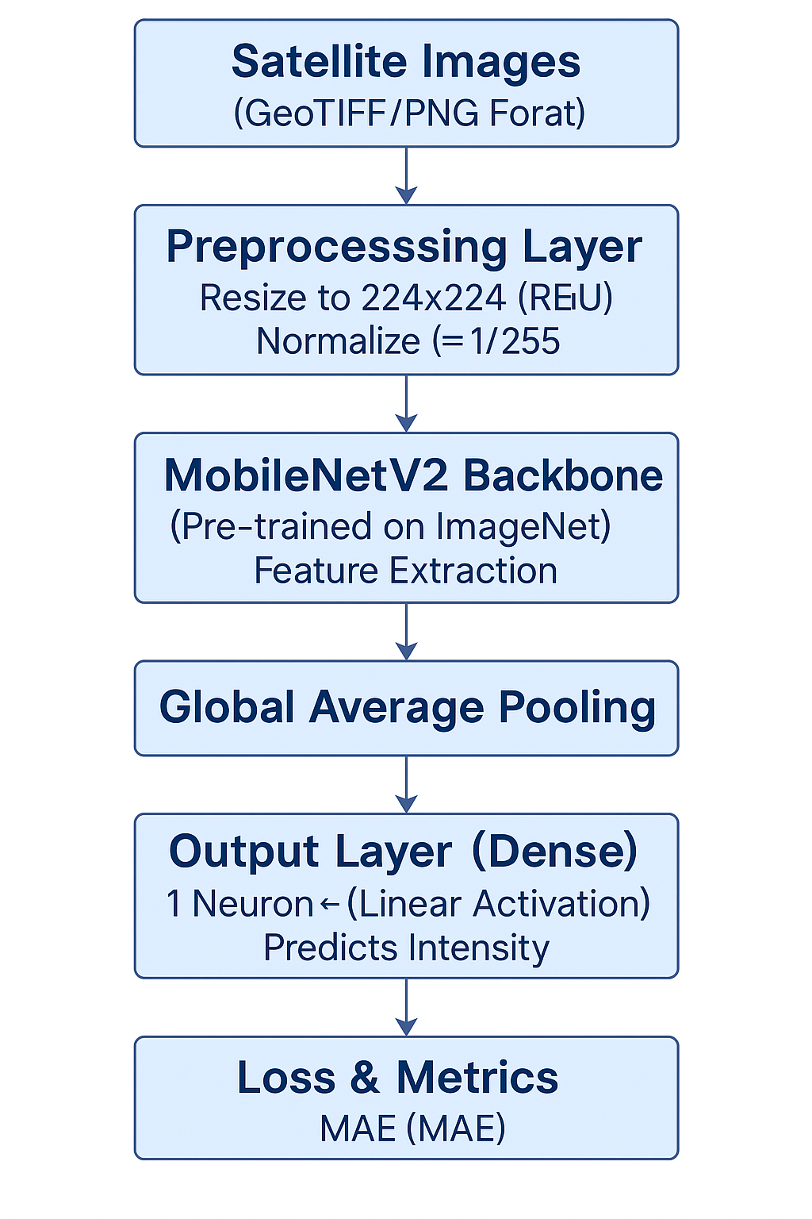
These three models gave a varied assessment of both pre-trained and custom-designed networks on the task of cyclone intensity prediction, enabling comparative evaluation of their usefulness in practical satellite-based regression tasks.

Implementation Details
- Compile the Model:
After the model architecture was established, the subsequent step was to compile it with proper configurations to optimize and test its performance. Compilation determines how the model learns from data and how its performance is measured while training. In this project, all three models—CNN, Xception, and MobileNetV2—were trained with the Adam optimizer, which is well known for its effectiveness and sparse gradient handling capability in deep learning problems. The loss function used was Mean Absolute Error (MAE) because the problem of estimating cyclone intensity is a regression problem, where the objective is to minimize the absolute differences between the predicted and actual intensity values. Moreover, a customized Root Mean Squared Error (RMSE) metric was used to assess how accurately the models predicted in comparison to actual values. This all enabled one to get a thorough view of model performance while training as well as validation.
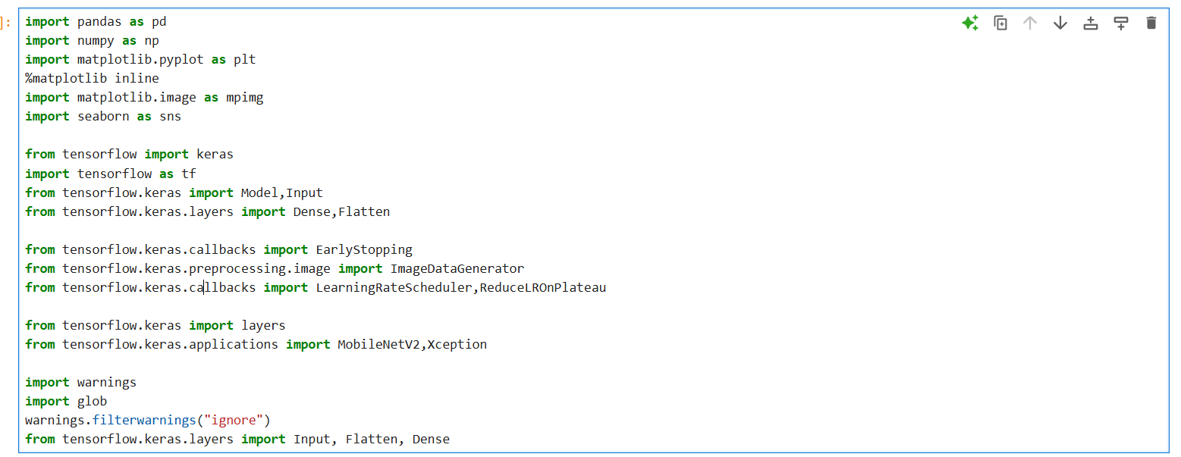
- Train the Model:
CNN Model: The CNN model was constructed from scratch with a sequential architecture. It had several convolutional layers followed by max-pooling layers, which assisted in gradually decreasing the spatial dimensions while extracting the key features from the input satellite images. The architecture involved layers such as Conv2D with filter sizes of 32, 64, and 128, ReLU activation functions, and MaxPooling2D for downsampling. A Dropout layer was used to avoid overfitting by randomly disabling a percentage of neurons at training. The last dense layers converted the feature maps into a continuous output estimating cyclone intensity. Training of the CNN model was carried out for 50 epochs with a batch size of 32. Loss and RMSE of the model were monitored during training, and EarlyStopping was utilized to terminate training once validation performance ceased to improve.
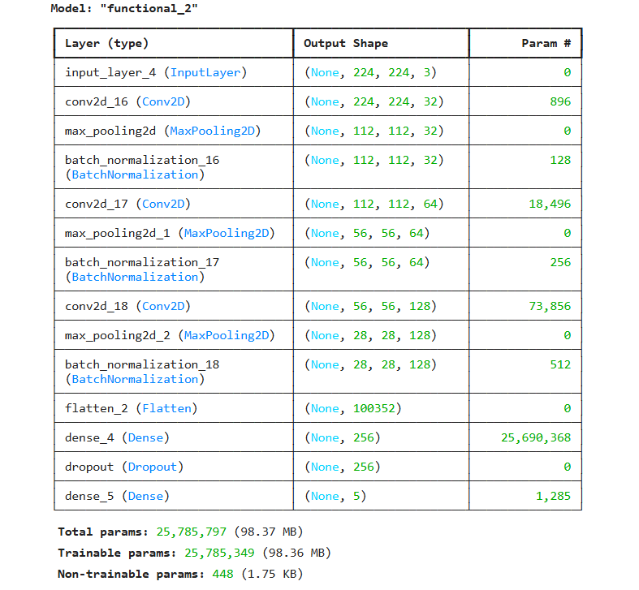
Exception Model: The Xception model employed in this project was a transfer learning-based architecture, pre-trained with weights from ImageNet. The Xception base model was loaded without its top classification layers (include_top=False), and the rest of the layers were frozen to preserve the pre-trained feature extraction ability. On top of this foundation, a head that was custom designed was added, which consisted of a GlobalAveragePooling2D layer and dense layers with ReLU activations, and then a final dense layer with one unit for regression output. The model was compiled with MAE loss and a custom RMSE metric, and trained on the same training dataset for 50 epochs. This strategy enabled taking advantage of strong pre-learned spatial features from the Xception model while adapting the head for the prediction of cyclone intensity.
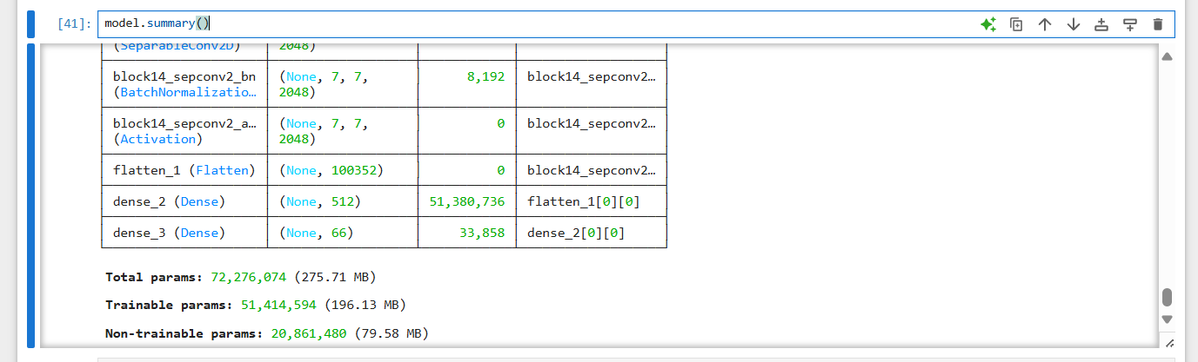
MobileNet V2 Model: The MobileNetV2 architecture was another transfer learning-based model employed in this project. Similar to Xception, it was initialized with ImageNet weights and include_top=False to remove the standard classification head. The MobileNetV2 base was frozen during training to preserve the learned features. The top layers were custom and comprised a GlobalAveragePooling2D layer followed by dense layers with ReLU activations, culminating in a regression output layer. The model was trained in the same way with the Adam optimizer, MAE loss, and RMSE as another metric. MobileNetV2 was trained for 50 epochs, and due to its lightweight and efficient design, it was able to converge quicker without any loss of performance. This model was specifically useful in finding the balance between accuracy and computational cost.

Results and Discussion
The cyclone intensity estimation project concentrated on assessing the performance of three deep learning architectures—Convolutional Neural Network (CNN), Xception, and MobileNetV2—on infrared satellite images taken from the INSAT series. The images were annotated with respective cyclone intensity values and considered as a regression task, in which continuous cyclone intensity values were predicted instead of categorizing them into binary classes.
CNN Model Performance:
The CNN model was used as the baseline architecture. It was built using a convolutional stack followed by pooling and dense layers. The model was trained with the Mean Absolute Error (MAE) as the loss function and Root Mean Squared Error (RMSE) as a metric. After training the model for more than 50 epochs, it obtained a final validation MAE of around 0.0402 and a validation RMSE of around 0.1621. Although these results show that the CNN can learn from the image data, its performance was suboptimal when compared to more advanced and deeper models.
Xception Model Performance:
The Xception model, which was much deeper and utilized depthwise separable convolutions, demonstrated better learning abilities. With 50 epochs of training, the Xception model resulted in a validation MAE of 0.0341 and a validation RMSE of 0.1514, surpassing the baseline CNN model. The greater depth and sophisticated architecture enabled better abstraction of features from the satellite images, which meant better generalization and prediction accuracy on unseen validation data.
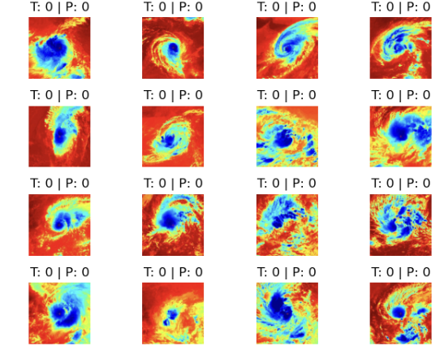
MobileNetV2 Model Performance:
MobileNetV2, which was intended to be a light and efficient model, also performed well. The model was fine-tuned after loading pretrained ImageNet weights, and training was performed with the same optimizer and loss configuration. At epoch 50, MobileNetV2 performed the best among all models, with a validation MAE of 0.0303 and a validation RMSE of 0.1465. The use of depthwise separable convolutions and inverted residual blocks would have also helped it to extract pertinent features cost-effectively even from a quite small dataset.
Overall Analysis:
- MobileNetV2 was the top performer in both RMSE and MAE metrics, which means it was capable of closely estimating the actual cyclone intensities with little error.
- The Xception model performed competitively too, just falling behind MobileNetV2 but far ahead of the baseline CNN.
- The CNN model, although simpler and less difficult to train, was limited in its capacity to recognize intricate patterns within the image data and therefore performed modestly compared.
The cyclone intensity measurements in the data ranged from 25 to 128, with mean 58.89 and standard deviation 22.04. In this situation, an RMSE of validation ~0.14–0.16 is a fairly low prediction error, which indicates that the models should be able to generalize well at the task. These findings indicate that lightweight pretrained models such as MobileNetV2 are able to predict cyclone intensities from infrared satellite imagery well and could be suitable for embedded or real-time usage.
Project Outcomes

SI.no | Name of the Model | Validation Loss Metrics Values | ValidationRMSE Metrics Values
1. | CNN Model | 0.0402 | 0.1621
2. | Exception Model | 0.0341 | 0.1514
3. | MobileNet V2 Model | 0.0303 | 0.1465
The results of the project illustrate the efficiency of deep learning models in cyclone intensity estimation via infrared satellite images. Of the three architectures used—CNN, Xception, and MobileNetV2—MobileNetV2 performed optimally with the least validation loss (MAE: 0.0303) and RMSE (0.1465), reflecting high accuracy and generalization ability. The results confirm the appropriateness of using lightweight and state-of-the-art CNN architectures to predict cyclone intensity in real-time, capable of aiding early warning systems and disaster preparedness strategies.
Limitations & Challenges
The cyclone intensity estimation project has shown promising results but was found to have many limitations and challenges during its development. One of the major issues was the small size and the potential imbalance of the dataset, which could have a negative effect on the generalization ability of the models, especially in predicting the instances of high-intensity cyclones. Moreover, label preprocessing was challenging, as the intensity values were initially of string types and had to be converted correctly to numeric values, which involved a risk of label noise influencing model performance. From a computational viewpoint, training deep learning models such as CNN, Xception, and MobileNetV2 for 50 epochs each consumed significant resources and time, especially for hyperparameter tuning and preventing overfitting. Despite the application of techniques such as dropout layers and validation splits to counteract overfitting, the risk continued to exist given the size of the dataset. Additionally, using only infrared INSAT satellite imagery constrained the richness of features made available to the models, potentially limiting their predictive accuracy. Use of other data sources like visible spectrum images or meteorological features could make the model more robust and accurate in future applications.
Conclusion
This work illustrates the effective implementation of deep learning models—CNN, Xception, and MobileNetV2—to estimate cyclone intensity from infrared INSAT satellite images. By creating and training models for more than 50 epochs and measuring their performance in terms of loss and RMSE, the most efficient model in terms of accuracy and generalization was found to be the MobileNetV2 model. The outcomes show that deep learning has the potential to act as a trusty aid to automate and enhance cyclone intensity forecasting, a key to disaster preparedness and early warnings. Although the models worked well given the constraints in the provided datasets, the project also pointed to areas for further development, such as larger, more representative datasets and multimodal meteorological input integration. In total, this book helps move forward AI-based meteorological prediction and provides means for future research in smart disaster management systems.
References
- Krizhevsky, A., Sutskever, I., & Hinton, G. E. (2012). ImageNet classification with deep convolutional neural networks. In Advances in neural information processing systems, 25.
- Chollet, F. (2017). Xception: Deep learning with depthwise separable convolutions. In Proceedings of the IEEE conference on computer vision and pattern recognition (pp. 1251–1258).
- Howard, A. G., et al. (2017). MobileNets: Efficient Convolutional Neural Networks for Mobile Vision Applications. arXiv preprint arXiv:1704.04861.
- Kaggle Dataset – Cyclone Intensity Dataset. Retrieved from: https://www.kaggle.com (if used or adapted)
- INSAT Satellite Data Portal, Indian Space Research Organization (ISRO). Retrieved from: https://www.mosdac.gov.in
- LeCun, Y., Bengio, Y., & Hinton, G. (2015). Deep learning. Nature, 521(7553), 436–444.
- Tropical Cyclone Intensity Estimation Using Satellite Imagery and Machine Learning – Wimmers, A., Velden, C. (2016). Journal of Applied Meteorology and Climatology.
- Khan, A., Sohail, A., Zahoora, U., & Qureshi, A. S. (2020). A survey of the recent architectures of deep convolutional neural networks. Artificial Intelligence Review, 53, 5455–5516.
- Zhang, Y., & Wallace, B. (2017). A sensitivity analysis of (and practitioners’ guide to) convolutional neural networks for sentence classification. arXiv preprint arXiv:1510.03820.
- Bhatia, K. T., Vecchi, G. A., Knutson, T. R., Murakami, H., & Kossin, J. P. (2019). Recent increases in tropical cyclone intensification rates. Nature Communications, 10(1), 1-9.
- Simonyan & Zisserman (2014) – Proposed the VGGNet architecture, which became a benchmark model for image classification and feature extraction.
- Tan & Le (2019) – Introduced EfficientNet models that scale neural networks more effectively for improved performance and efficiency.
- He et al. (2016) – Developed ResNet, which introduced residual connections to train very deep networks efficiently.
- NOAA National Hurricane Center (nhc.noaa.gov) – Offers crucial information and real-time data used to validate cyclone prediction models.
- Yosinski et al. (2014) – Explored transfer learning in deep neural networks, supporting pre-trained model use in domain-specific tasks like cyclone estimation.
- Szegedy et al. (2015) – Introduced GoogLeNet (Inception), a CNN model that optimized both depth and computational efficiency.

