Git
What it is:
Git is a distributed version control system (VCS).
Purpose:
- Tracks changes to your code.
- Lets you create versions, branches, and roll back changes.
- Works entirely on your local machine.
Key points:
- Installed on your computer.
- Commands like git init, git add, git commit, git push.
- Does not require the internet.
- Think of it as the software that manages version control.

GitHub
What it is:
GitHub is a cloud platform that hosts Git repositories.
Purpose:
- Stores your Git projects online.
- Helps in collaboration with others.
- Adds features like pull requests, issue tracking, CI/CD, project management.
Key points:
- A website + cloud service.
- Requires internet.
- Provides UI for viewing code.
- Think of it as a place where Git repositories live online.

How git works?

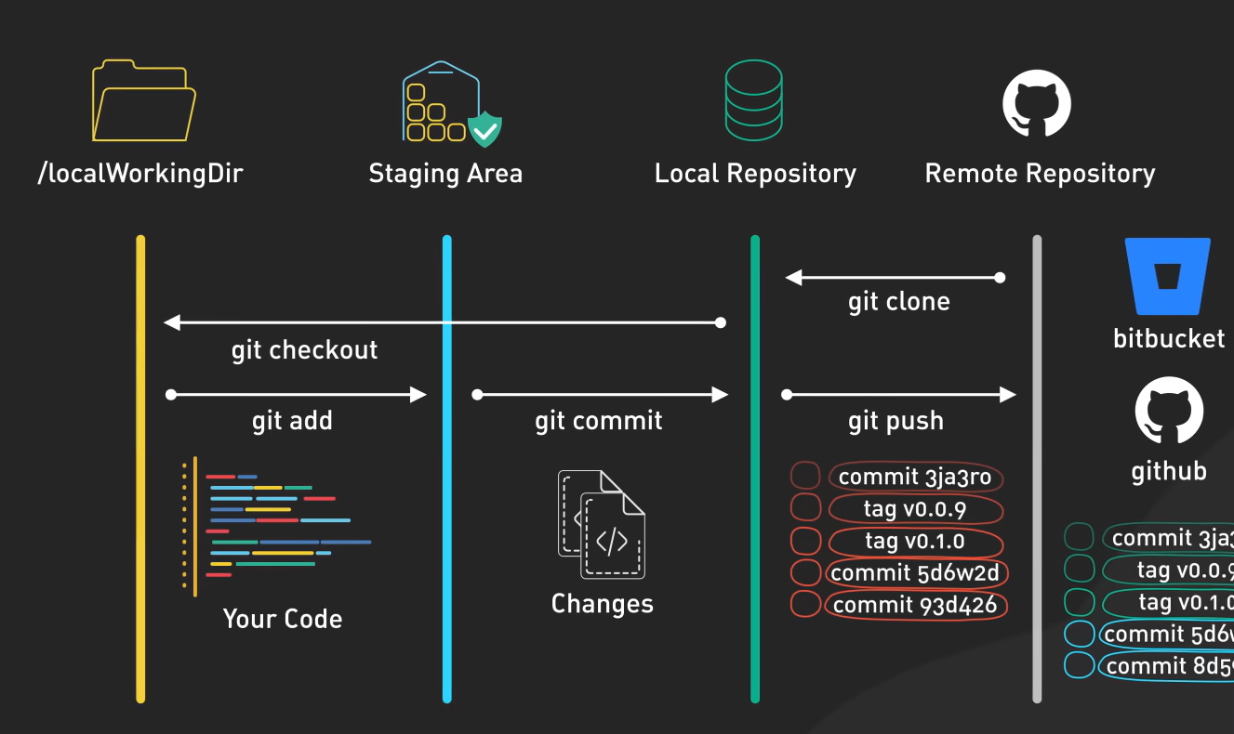

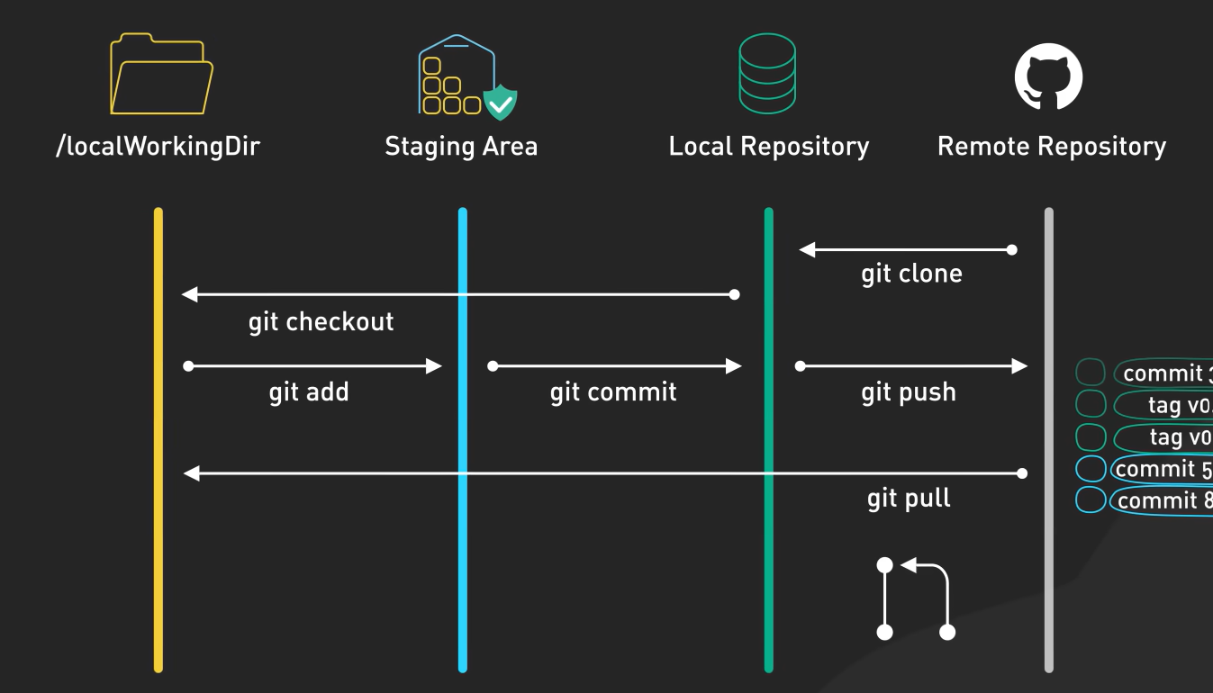

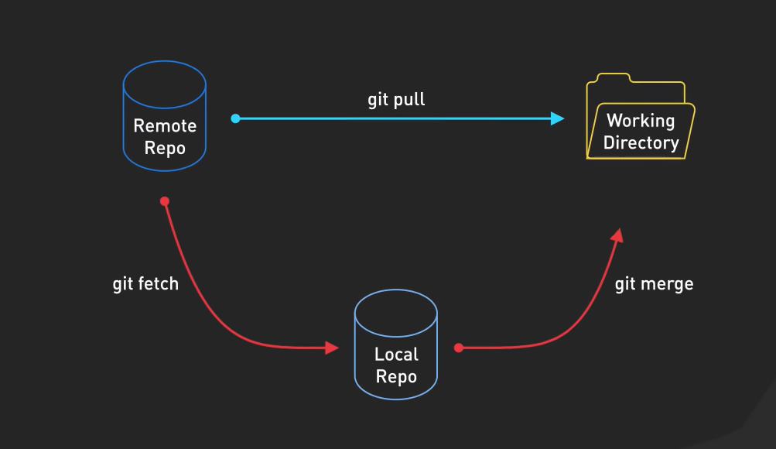
Branching strategy

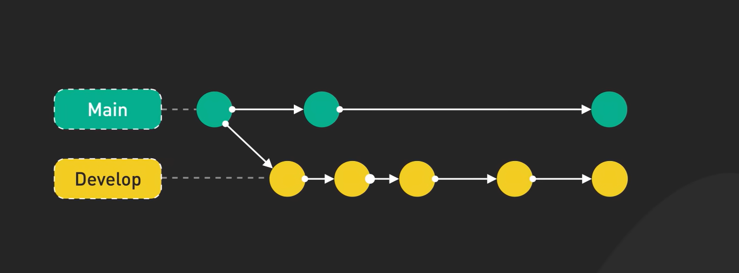
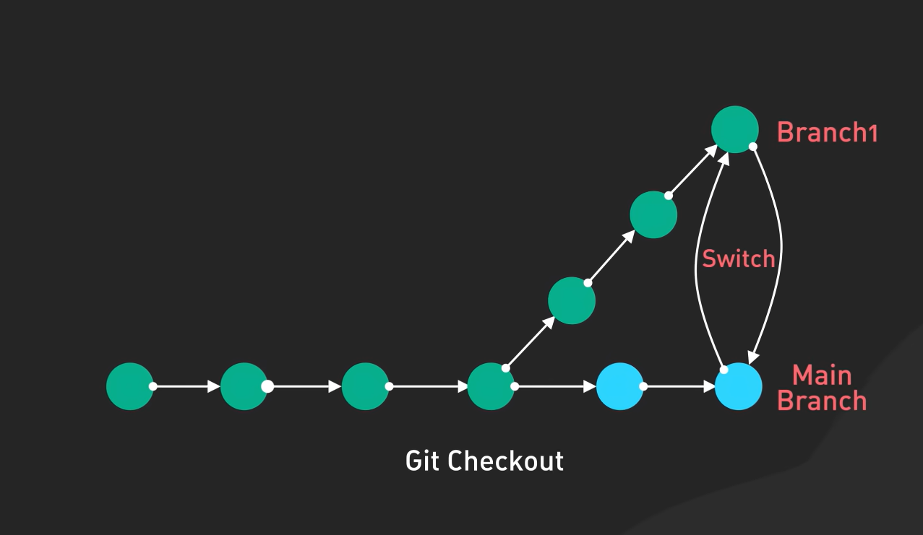

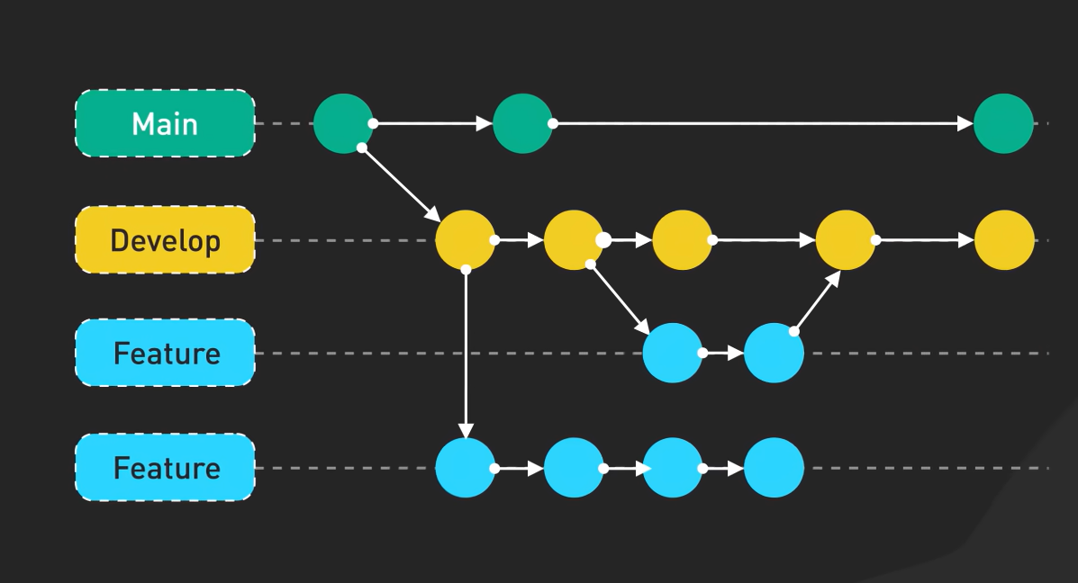

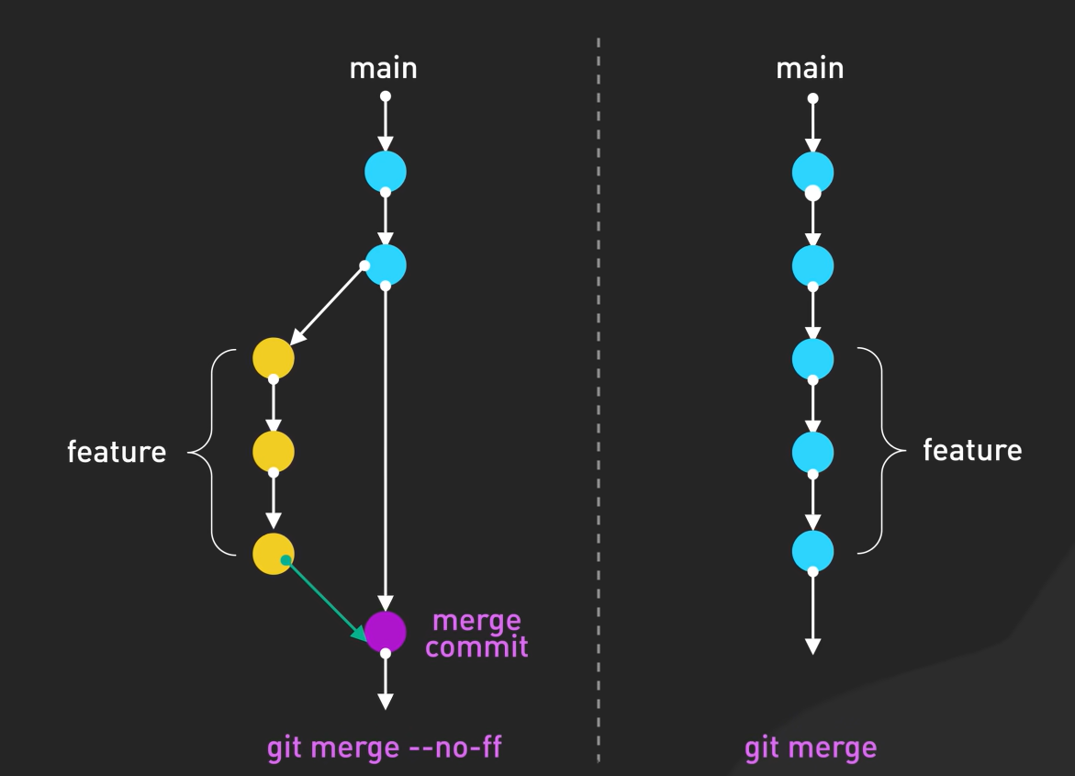

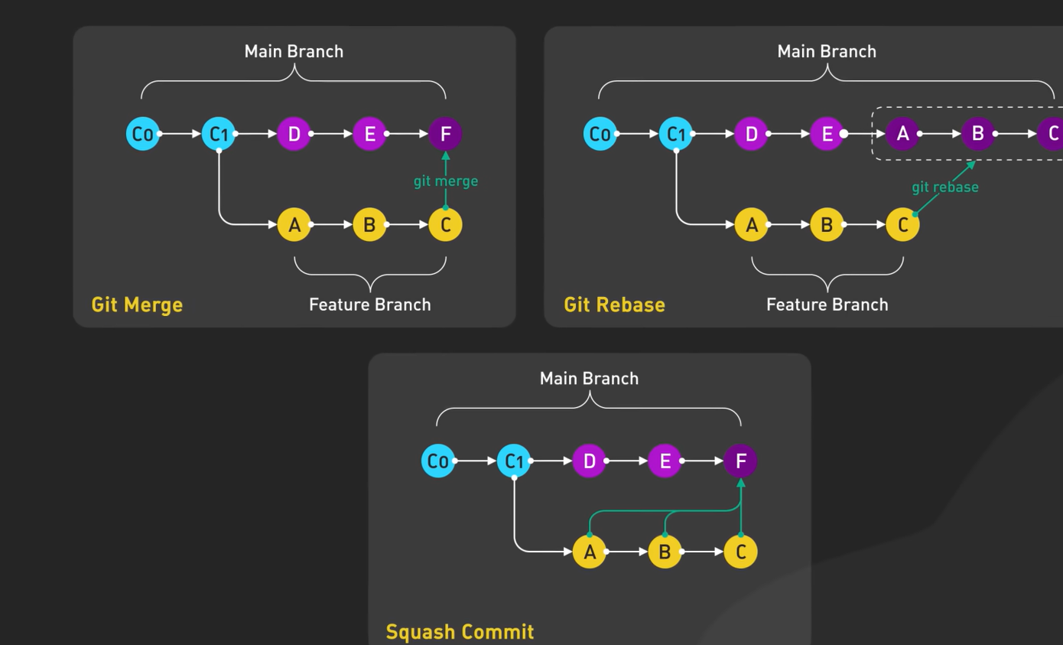

Personal token”
