Fake News Detection Project Report

1. Introduction
This project is an end-to-end Machine Learning pipeline that classifies news articles as either Real or Fake. It includes data preprocessing, exploratory data analysis, classification models, and a deployed Flask web interface.

2. Role of Files
- app.py
The main Flask application script that serves the web interface and handles model predictions.
- train_model.py
The script responsible for data preprocessing, exploratory data analysis (EDA), and training the machine learning models. It exports the best performing model.
- best_model.joblib
The serialized trained model (Logistic Regression) used for inference in the web app.
- templates/home.html
The frontend HTML template for the home page where users input news text.
- templates/result.html
The frontend HTML template for displaying the prediction results.
- Data/
Directory containing the datasets (Fake.csv and True.csv).
- *.png (Images)
Various screenshots and generated EDA plots (e.g., common words, article lengths, UI screens).

3. How to Run the Program
1. Ensure all dependencies are installed: pip install pandas numpy nltk scikit-learn matplotlib seaborn flask joblib
2. Download the dataset and place it in the Data/ folder.
3. (Optional) Train the model by running: python train_model.py
4. Start the web application by running: python app.py
5. Open a web browser and navigate to http://127.0.0.1:5000

4. Flowchart & Architecture
The pipeline involves text preprocessing (lowercasing, punctuation removal, stop-words removal), vectorization using CountVectorizer, and classification using Logistic Regression.
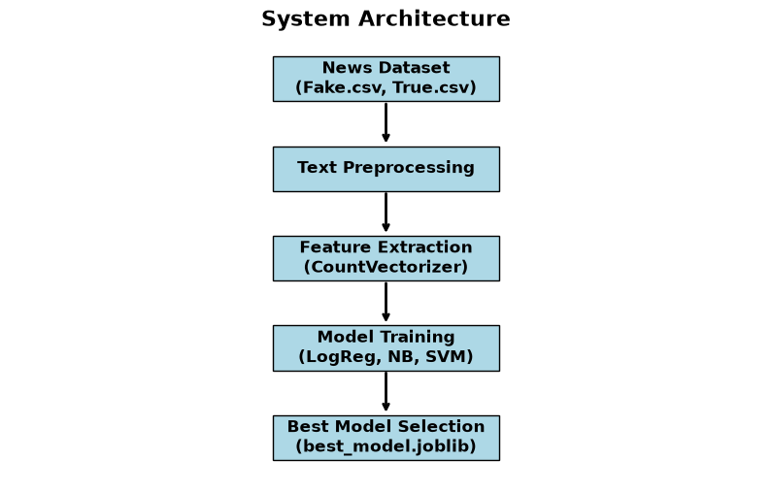
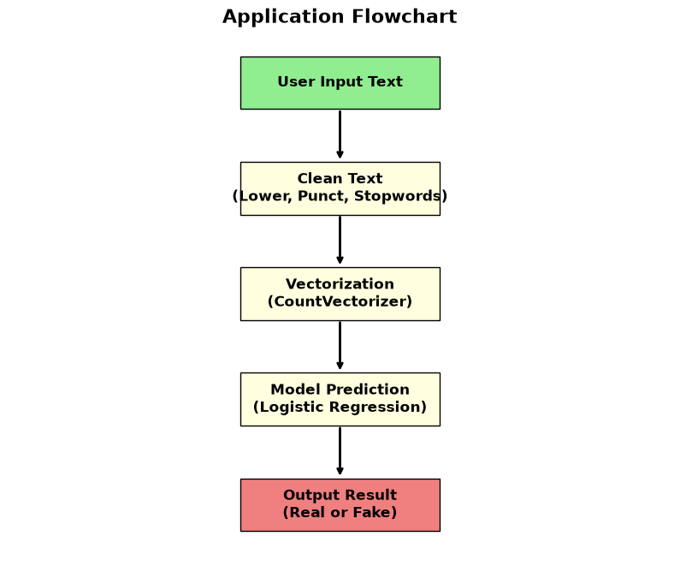

5. UI Screenshots
Home Screen:
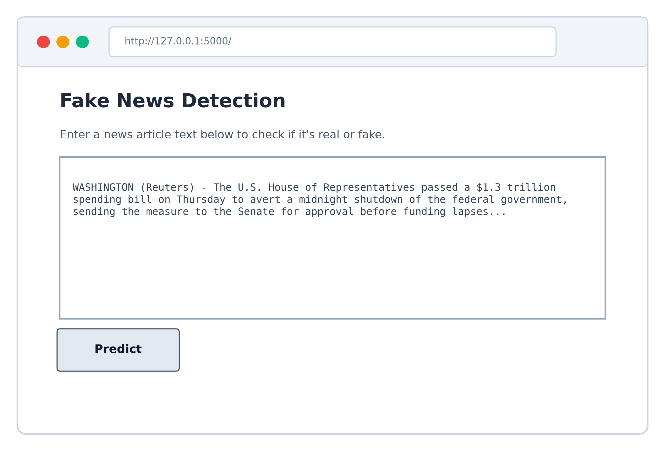
Result Screen (Fake News):
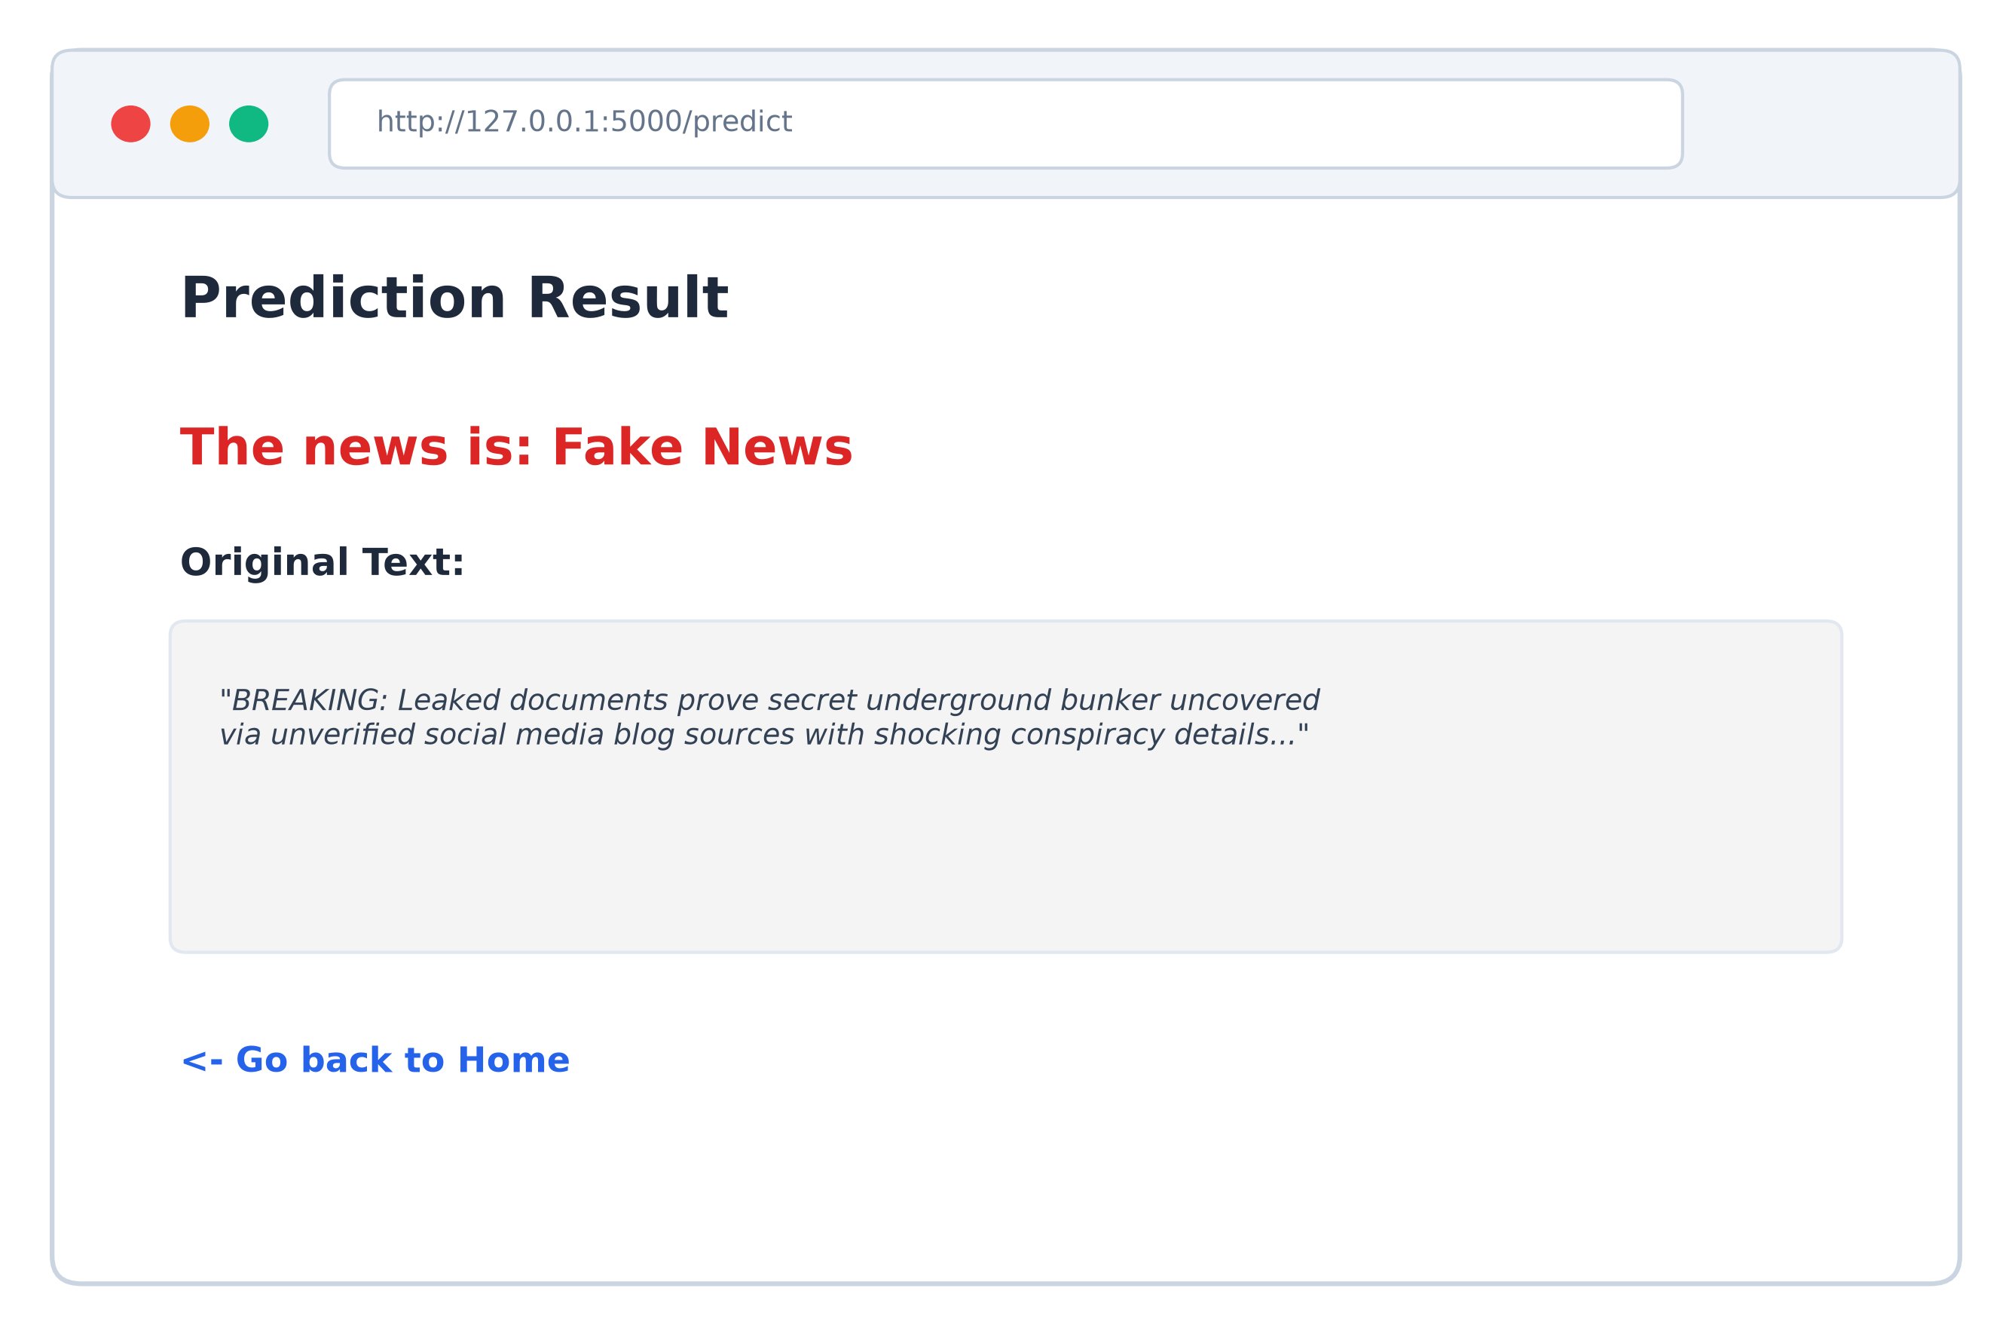
Result Screen (Real News):
