CISSP PRACTICAL PROJECT REPORT
Hands-On Security Workbook — Complete Submission
Prepared as a practical working report

Document Item | Details
Project basis | CISSP Practical Assignment Workbook
Case organization | SecurePay Solutions Pvt. Ltd. — fictional mid-size payment-services company
Scope | Eight practical CISSP security domains specified in the workbook
Evidence approach | Reference architecture, lab evidence references, control tables and practical templates
Evidence disclaimer | Screenshots marked as reference evidence are documentation examples and are not claims of production execution.

Executive Summary
This report converts the supplied CISSP Practical Assignment Workbook into a structured, practical project report. The workbook requires practical work across Security and Risk Management, Asset Security, Security Architecture and Engineering, Communication and Network Security, Identity and Access Management, Security Assessment and Testing, Security Operations, and Software Development Security. It also emphasizes clarity, practical understanding, accurate risk/control identification, diagrams/configurations, and professional presentation.
A fictional mid-size payment-services organization, SecurePay Solutions Pvt. Ltd., is used as the working case so that the activities can be demonstrated consistently. The company scenario is a constructed lab example for the assignment and is not represented as a real organization.

Contents
- 1. Security and Risk Management
- 2. Asset Security
- 3. Security Architecture and Engineering
- 4. Communication and Network Security
- 5. Identity and Access Management
- 6. Security Assessment and Testing
- 7. Security Operations
- 8. Software Development Security
- 9. Evidence & Submission Notes
- 10. Conclusion

1. Security and Risk Management
Assignment requirement: select a mid-size company, perform a basic risk assessment with at least ten risks, propose treatment, and write a 1–2 page Information Security Policy.

1.1 Organization Profile
Attribute | Working Scenario
Organization | SecurePay Solutions Pvt. Ltd. (fictional)
Industry | Payment services / fintech
Size | Approximately 250 employees
Technology | Cloud workloads, corporate endpoints, APIs, databases, SaaS platforms
Critical information | Customer PII, payment tokens, transaction records, source code, credentials
Security objective | Protect confidentiality, integrity and availability while supporting business operations and compliance

1.2 Risk Assessment
ID | Risk | Impact | Treatment | Key Controls | Owner
R01 | Ransomware affecting critical servers | High | Reduce | EDR, immutable backups, segmentation, IR testing | Security / IT
R02 | Credential compromise / phishing | High | Reduce | MFA, awareness, conditional access, phishing lab exercises | IAM / Security
R03 | Cloud misconfiguration exposing data | High | Reduce | CSPM, secure baselines, reviews, least privilege | Cloud / Security
R04 | Third-party security failure | High | Transfer / Reduce | Due diligence, contracts, security clauses, monitoring | GRC / Procurement
R05 | Unpatched critical vulnerability | High | Reduce | Vulnerability scanning, patch SLAs, exception process | IT / Security
R06 | Data leakage from endpoints | Medium | Reduce | DLP, encryption, removable-media controls | Security / IT
R07 | DDoS affecting public APIs | Medium | Transfer / Reduce | CDN/WAF, rate limiting, provider protection | Network / Cloud
R08 | Unauthorized privileged access | High | Reduce | PAM, MFA, access reviews, session logging | IAM / Security
R09 | Backup failure or unusable recovery point | High | Reduce | 3-2-1 strategy, restore tests, monitoring | IT / DR
R10 | Insider misuse of sensitive data | Medium | Reduce | Least privilege, logging, DLP, SoD | HR / Security
R11 | Loss/theft of company laptop | Medium | Reduce | Full-disk encryption, MDM, remote wipe | IT
R12 | Security control non-compliance | Medium | Reduce | Internal audit, CAPA tracking, management review | GRC

1.3 Risk Treatment Principles
- Avoid: discontinue an activity when its risk exceeds organizational tolerance and cannot be reasonably controlled.
- Reduce: implement preventive, detective, corrective or compensating controls to lower likelihood and/or impact.
- Transfer: contractually or financially share risk with a third party, while retaining appropriate oversight.
- Accept: formally acknowledge residual risk when it falls within approved risk appetite/tolerance.

1.4 Information Security Policy
Policy Area | Requirement
Purpose | Protect organizational information and technology assets through risk-based security governance and consistent control implementation.
Scope | Employees, contractors, systems, applications, cloud services, endpoints, networks, data and third parties handling company information.
Access Control | Access shall be based on business need, least privilege and role. Privileged access shall use MFA and be periodically reviewed.
Data Protection | Information shall be classified and protected according to sensitivity. Restricted and Confidential information shall use approved encryption mechanisms where appropriate.
Endpoint & Network Security | Managed endpoints shall use approved security controls. Network segmentation, secure protocols, firewalls and monitoring shall be implemented based on risk.
Vulnerability Management | Security vulnerabilities shall be identified, prioritized and remediated according to documented risk-based timelines.
Incident Management | Suspected security incidents shall be reported immediately through approved channels and handled through documented incident-response procedures.
Business Continuity | Critical services shall maintain recovery strategies, backups and periodic restoration/testing appropriate to business requirements.
Third Parties | Security requirements shall be incorporated into applicable contracts and supplier reviews.
Awareness | Personnel shall receive security awareness training appropriate to their role.
Compliance | Applicable legal, contractual and regulatory requirements shall be identified, monitored and addressed.
Enforcement | Violations may result in corrective action under applicable organizational procedures.
Review | This policy shall be reviewed at least annually and after significant changes to business, technology, threat landscape or regulatory requirements.

2. Asset Security
The workbook requires an asset inventory, classification into Public/Internal/Confidential/Restricted, handling rules, and an encryption exercise.

2.1 Asset Inventory
ID | Asset | Type | Classification | Reason | Owner
AST-001 | Customer database | Data | Restricted | Customer PII / transactions | Database Team
AST-002 | Payment-token repository | Data | Restricted | Payment-related tokens | Application Team
AST-003 | Source-code repository | Application | Confidential | Proprietary code | DevOps
AST-004 | Production API | Application | Restricted | Business-critical service | Application Team
AST-005 | Employee HR records | Data | Confidential | Personnel information | HR
AST-006 | Corporate laptops | Endpoint | Internal | Managed devices | IT
AST-007 | Security logs / SIEM | Data | Confidential | Security telemetry | SOC
AST-008 | Public website | Application | Public | Public information | Marketing / IT
AST-009 | Backup repository | Data | Restricted | Recovery copies | IT
AST-010 | Firewall configuration | Configuration | Confidential | Security configuration | Network Team
AST-011 | IAM directory | System | Restricted | Identity and access data | IAM
AST-012 | Vendor security records | Data | Confidential | Contracts / assessments | GRC

2.2 Classification Handling Rules
Classification | Handling Rules
Public | May be shared externally after approval; integrity should be maintained; no sensitive information.
Internal | Business use only; access limited to personnel/authorized third parties; use approved corporate storage.
Confidential | Need-to-know access; encryption in transit and at rest where appropriate; controlled sharing and retention.
Restricted | Strongest controls; least privilege; MFA/privileged controls where applicable; encryption; logging; restricted transfer and approved disposal.

2.3 CEH_Test_File.txt Encryption Procedure
- Create a non-sensitive CEH_Test_File.txt for the exercise; do not use real customer or production data.
- Open an approved encryption/archive tool such as 7-Zip and select the CEH_Test_File.txt.
- Create a 7z archive and enable AES-256 encryption with a strong password.
- Enable filename encryption where supported.
- Store the CEH_Encrypted_Archive.7z only in an approved location and manage the password separately.
- Attempt a controlled extraction to verify that the archive cannot be opened without the correct password.
- Record the evidence, date, CEH_Test_File.txt and verification result.
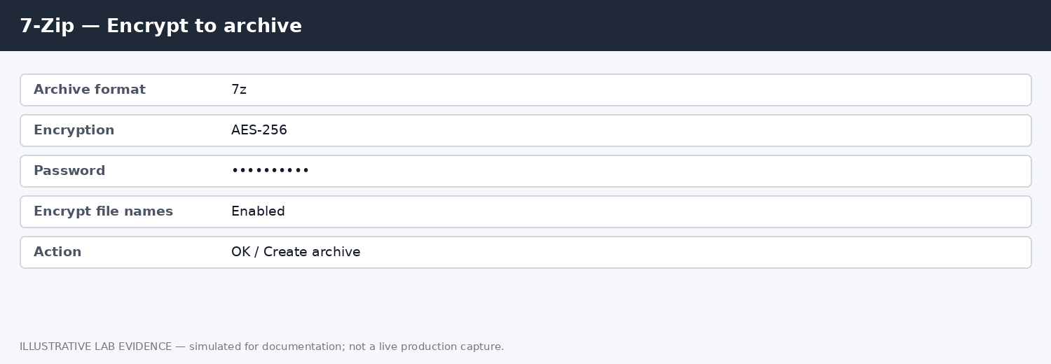
Figure 1 — 7-Zip encryption evidence reference for CEH_Test_File.txt. Insert the actual lab capture if execution evidence is required.

3. Security Architecture and Engineering
The workbook requires a basic architecture diagram, placement of controls, at least two hardware security options, and an explanation of layered security.
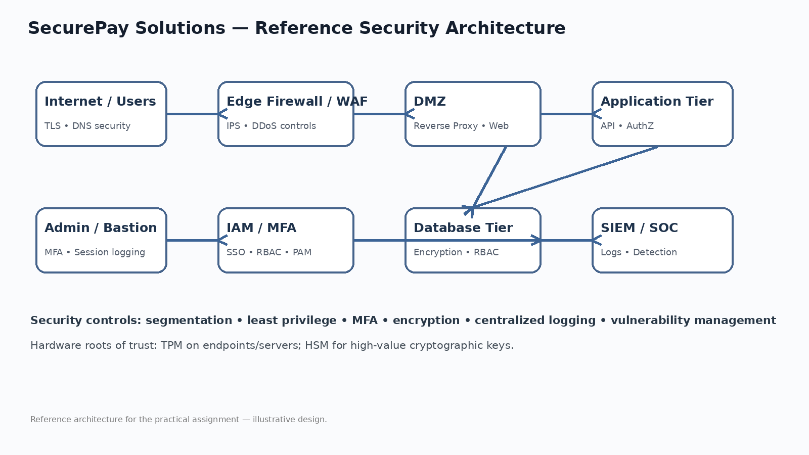
Figure 2 — SecurePay Solutions Pvt. Ltd. reference architecture with security-control placement.

3.1 Hardware-Based Security Options
Technology | Use
TPM (Trusted Platform Module) | Hardware-backed key storage, device identity/attestation and support for secure boot/disk-encryption workflows.
HSM (Hardware Security Module) | Dedicated hardware for generating, storing and using high-value cryptographic keys with strong administrative and audit controls.

3.2 Layered Security
Layered security (defense in depth) places multiple complementary controls across identity, endpoint, network, application, data and monitoring layers. For lab example, MFA can reduce account-compromise risk; segmentation can limit lateral movement; WAF controls can protect internet-facing applications; encryption can reduce the impact of data exposure; and centralized logging/SIEM can provide detection and investigation capability. The objective is not to rely on one control but to ensure that failure of one layer does not automatically result in complete compromise.

4. Communication and Network Security
The workbook requires firewall rule lab examples, secure protocol descriptions, packet capture evidence, and VLAN/DMZ segmentation.

4.1 Firewall Rule Examples
Rule | Source | Destination | Service | Action | Reason
FW-01 | Internet | WAF-01 (10.20.60.10) | TCP/443 | ALLOW | Public HTTPS service
FW-02 | Internet | WEB-01 (10.20.60.20) | Any | DENY | Prevent direct access to protected tiers
FW-03 | WEB-01 (10.20.60.20) | DB-01 (10.20.30.10) | TCP/5432 | ALLOW | Only required application-to-database traffic
FW-04 | User VLAN | ADMIN-01 (10.20.40.10) | Any | DENY | Limit lateral/admin access
FW-05 | ADMIN-01 (10.20.40.10) | APP-01 (10.20.20.20) | TCP/22,443 | ALLOW | Controlled administration
FW-06 | Any | Any | Known malicious indicators | DENY | Threat-based blocking where validated

4.2 Secure Protocols
Protocol | Purpose
HTTPS | HTTP protected by TLS for confidentiality and integrity of web traffic.
TLS | Cryptographic protocol providing secure communication and server/client authentication where configured.
SSH | Encrypted remote administration and secure command execution.
SFTP | Secure file transfer over SSH.
IPsec | Network-layer protection commonly used for VPNs and secure site-to-site connectivity.

4.3 Packet Capture Evidence
The workbook allows Wireshark capture or tutorial screenshots when tools are unavailable. The following evidence is therefore provided as a CISSP-CEH-LAB capture. It demonstrates the expected TCP three-way handshake: SYN, SYN/ACK, ACK, followed by TLS traffic.
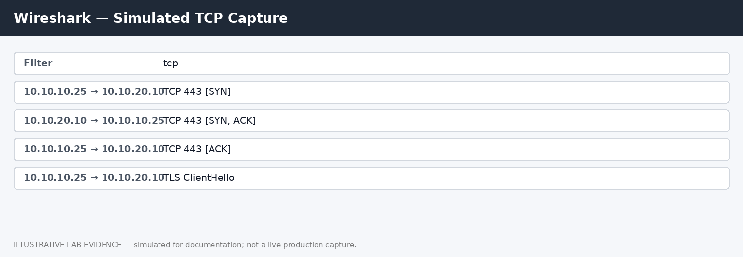
Figure 3 — Wireshark lab evidence reference showing a TCP handshake and TLS ClientHello. Insert the actual lab capture if required.

4.4 Network Segmentation
Segment | Example Contents | Control Objective
VLAN 10 — Users | Employee endpoints | Limit user-to-user and user-to-server exposure
VLAN 20 — Servers | Internal application services | Restrict access to approved service flows
VLAN 30 — Database | Sensitive databases | Allow only required application connections
VLAN 40 — Admin | Bastion/PAM/admin systems | Highly restricted privileged access
DMZ | WAF, reverse proxy, public-facing services | Separate internet-facing services from internal systems
VLAN 50 — Guest | GUEST-01 (10.20.50.10) | Internet-only; no corporate network access

5. Identity and Access Management
The workbook requires an RBAC chart, joiner/mover/leaver process, MFA demonstration/research, and an access-review checklist.
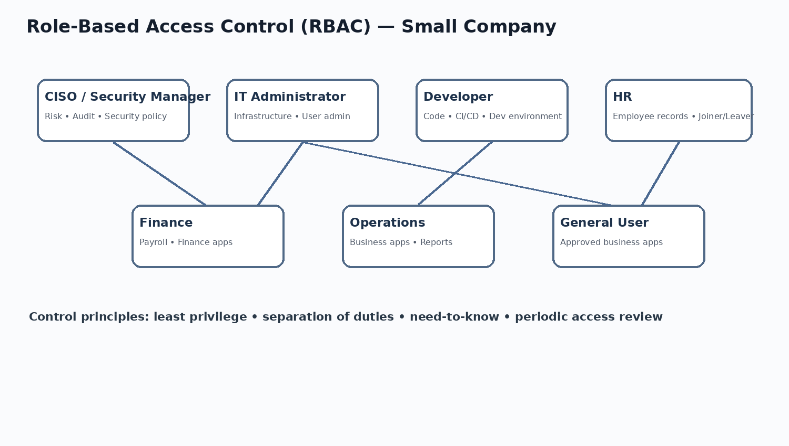
Figure 4 — RBAC model for the SecurePay Solutions Pvt. Ltd..

5.1 Joiner / Mover / Leaver Process
Stage | Activities | Control
Joiner | HR creates approved request; manager confirms role; IAM provisions minimum required access. | Approval + RBAC + MFA
Mover | Role change triggers access review; old privileges removed before new privileges are granted where practical. | Least privilege + SoD
Leaver | HR triggers termination workflow; IAM disables account; sessions/tokens revoked; assets recovered. | Timely deprovisioning
Privileged access | Separate privileged identity; MFA; PAM where available; logging and periodic review. | PAM + MFA + monitoring

5.2 MFA Demonstration
MFA combines two or more different authentication factors, such as something the user knows, has, or is. The following lab evidence illustrates a typical password-plus-authenticator flow.
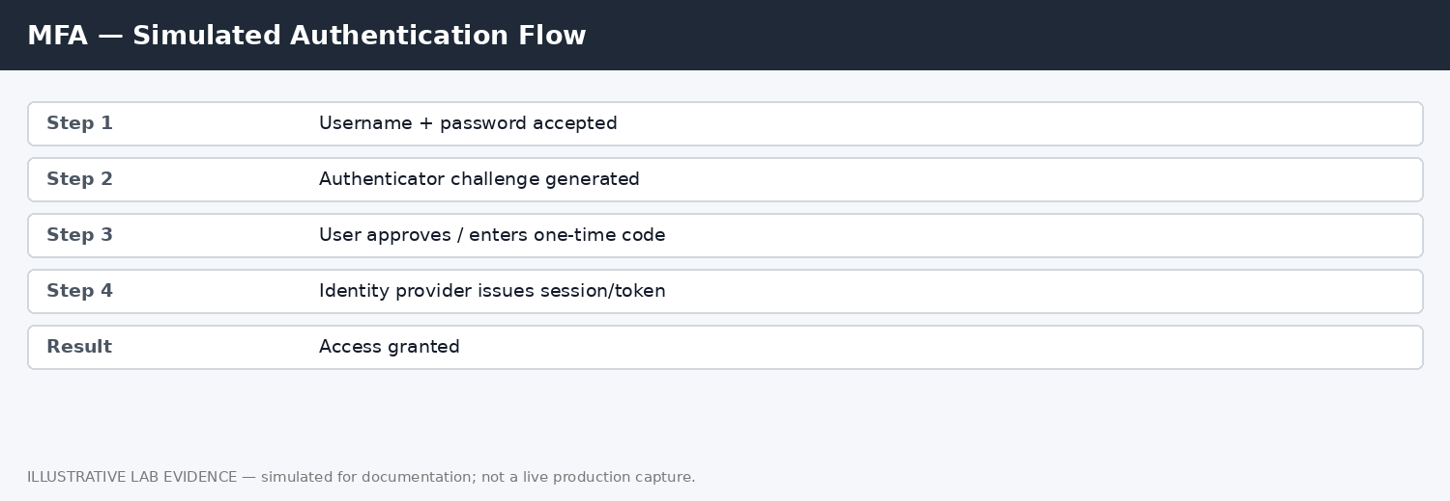
Figure 5 — MFA lab authentication flow.

5.3 Access Review Checklist
- Confirm user account ownership and employment status.
- Confirm access is still required for the current role.
- Review privileged and administrative access separately.
- Identify dormant, shared, orphaned and generic accounts.
- Validate MFA enrollment for required users.
- Check segregation-of-duties conflicts.
- Review recent joiner/mover/leaver tickets.
- Document exceptions with owner and expiry date.
- Obtain business/application-owner sign-off.
- Track remediation and retain evidence.

6. Security Assessment and Testing
The workbook requires a vulnerability scan or lab exercise, a penetration-test report template, OWASP Top 10 mitigations, and a quarterly audit checklist.

6.1 OpenVAS/Greenbone Vulnerability Scan
Because the source workbook permits a CISSP-CEH-LAB scan or screenshots where a tool is unavailable, the following is a controlled lab reference. It should be replaced with the actual scan output from WEB-01 (10.20.60.20) when execution evidence is required.
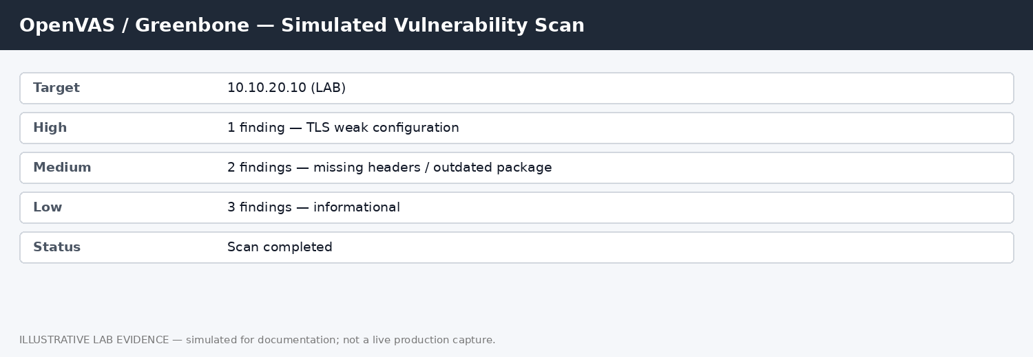
Figure 6 — OpenVAS/Greenbone lab scan vulnerability-scan evidence.

6.2 Penetration Testing Report Template
Section | Required Content
Executive Summary | Scope, objective, overall risk themes
Scope | Systems, IP ranges, applications, exclusions
Rules of Engagement | Dates, authorization, constraints, contacts
Methodology | Reconnaissance, validation, exploitation where authorized, reporting
Findings | ID, title, severity, affected asset, evidence, impact
Remediation | Recommended fix, owner, target date
Retest | Validation of remediation and residual findings
Evidence | Screenshots/logs/requests/responses with sensitive data redacted
Conclusion | Overall observations and next actions

6.3 OWASP Top 10 — One-Line Mitigations
OWASP Category | One-Line Mitigation
A01 Broken Access Control | Enforce server-side authorization, deny by default and validate object-level permissions.
A02 Cryptographic Failures | Use strong modern cryptography, protect keys, and avoid exposing sensitive data unnecessarily.
A03 Injection | Use parameterized queries, safe APIs, input validation and contextual output handling.
A04 Insecure Design | Threat-model critical workflows and design security requirements before implementation.
A05 Security Misconfiguration | Harden defaults, disable unnecessary features and continuously validate secure configuration.
A06 Vulnerable and Outdated Components | Maintain an inventory, monitor vulnerabilities and patch/upgrade within defined SLAs.
A07 Identification and Authentication Failures | Use MFA, secure session management, strong credential controls and rate limiting.
A08 Software and Data Integrity Failures | Protect build/update pipelines, verify integrity and control dependencies.
A09 Security Logging and Monitoring Failures | Centralize relevant logs, protect them from tampering and alert on meaningful events.
A10 SSRF | Restrict outbound destinations, validate URLs and isolate application network privileges.

6.4 Quarterly Security Audit Checklist
- Review policy and standard changes.
- Verify asset inventory and owners.
- Review access and privileged accounts.
- Validate vulnerability/patch metrics.
- Sample security logs and alerts.
- Review backup and restoration evidence.
- Check incident tickets and CAPA closure.
- Review third-party security assessments.
- Verify endpoint encryption/MDM coverage.
- Review network firewall rule changes.
- Check security-awareness completion.
- Report exceptions to management.

7. Security Operations
The workbook requires a ransomware Incident Response Plan, Business Continuity Plan, unusual log review, and a one-page Disaster Recovery approach.

7.1 Ransomware Incident Response Plan
Phase | Key Activities | Primary Responsibility
Preparation | IR plan, contacts, backups, EDR, tabletop exercises | Security / IT / GRC
Detection | Validate alert, identify affected host/user, preserve initial evidence | SOC
Containment | Isolate affected endpoints/servers, disable compromised accounts, block indicators | SOC / IT
Eradication | Remove persistence, remediate vulnerabilities, reset credentials as required | IT / Security
Recovery | Restore from verified clean backups, validate controls, monitor closely | IT / Application
Post-Incident | Root cause, lessons learned, CAPA, evidence retention and management report | Security / GRC

7.2 Business Continuity Plan — Outline
Component | Content
Business Impact Analysis | Identify critical processes, dependencies and recovery priorities.
RTO / RPO | Define recovery time and recovery-point requirements per critical service.
Continuity Strategies | Redundancy, alternate processing, backups, manual workarounds and supplier alternatives.
Roles | Incident/continuity leadership, technical recovery, business validation and communications.
Communications | Approved internal/external communication paths and escalation contacts.
Testing | Tabletops, failover/recovery tests and documented lessons learned.

7.3 Unusual Log Review — Sample
Timestamp | Event | Assessment | Action
10:14:03 | 18 failed logins for one privileged account | Suspicious brute-force pattern | Investigate source; verify user; consider temporary containment
10:18:44 | Successful privileged login after failures | Potential compromise | Validate MFA/session and source; correlate endpoint/network logs
10:21:12 | New admin account created outside change window | High-risk change | Validate authorization; disable if unauthorized; preserve evidence
10:25:39 | Large outbound transfer from database host | Potential data exfiltration | Investigate destination, process and user context

7.4 Disaster Recovery Approach
A practical DR approach begins with a business impact analysis and identification of recovery priorities. Critical applications should have documented RTO/RPO targets, dependency maps and recovery procedures. Backups should follow an appropriate resilient strategy, include offline/immutable protection where justified, and be periodically restored to prove usability. Recovery should be performed in a controlled sequence: infrastructure, identity/network dependencies, databases, applications, integrations, and business validation. After recovery, heightened monitoring should remain in place until service stability is confirmed. Test results, gaps and corrective actions should feed back into the continuity and security programs.

8. Software Development Security
The workbook requires code-risk review, 10–15 secure coding guidelines, a STRIDE threat model, and a secure DevSecOps pipeline.

8.1 Example Code-Risk Review
For the practical exercise, a small illustrative API pattern is reviewed. The following risks are representative review findings, not findings from a real application.
Finding | Risk | Recommended Control
Hard-coded credential | Credential exposure through source repository | Use secret manager/environment injection; rotate exposed secrets
String-built SQL query | SQL injection risk | Parameterized queries / safe ORM APIs
Missing authorization check | Horizontal/vertical privilege escalation | Enforce server-side authorization on every sensitive operation
Verbose error response | Information disclosure | Return generic client errors; log details securely server-side
Unvalidated redirect/URL | Abuse of redirect or SSRF-like behavior | Allowlist destinations and validate URLs

8.2 Secure Coding Guidelines
- Validate input at trust boundaries and apply allowlist validation where practical.
- Use parameterized queries and safe database APIs.
- Enforce authorization on the server for every protected function and object.
- Never hard-code passwords, API keys or private keys in source code.
- Use approved cryptographic libraries and protect encryption keys.
- Use secure session management with appropriate expiration and invalidation.
- Return generic errors to users and avoid exposing stack traces.
- Encode output according to the destination context to reduce injection risks.
- Keep dependencies inventoried and patched; monitor for known vulnerabilities.
- Apply secure defaults and disable unnecessary features.
- Protect secrets through an approved secret-management mechanism.
- Log security-relevant events without recording unnecessary sensitive data.
- Require peer review and security testing before production deployment.
- Protect CI/CD credentials and restrict build/deployment permissions.
- Use dependency, SAST, DAST and/or IaC scanning according to application risk.

8.3 STRIDE Threat Model
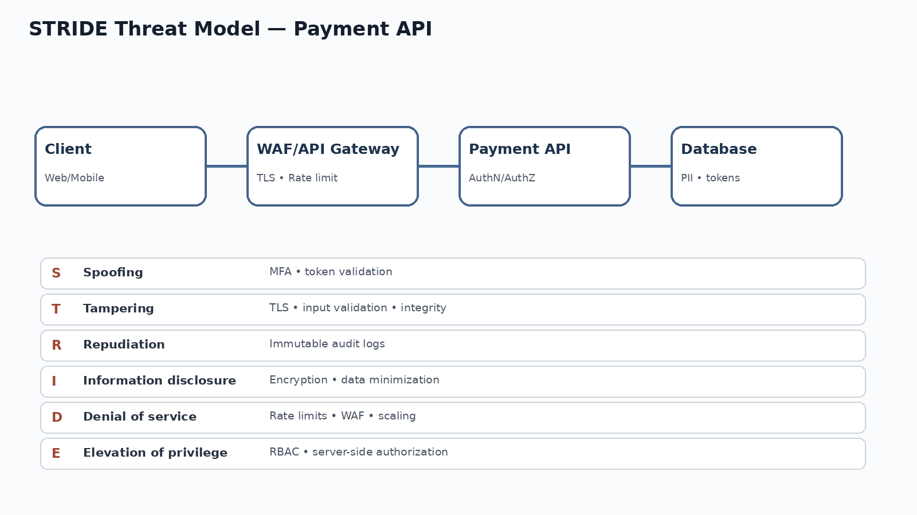
Figure 7 — STRIDE threat model for a payment API.

8.4 Secure DevSecOps Pipeline
Stage | Security Activities
Plan | Security requirements, data classification, abuse cases and threat modeling
Code | Secure coding standards, peer review, secret scanning
Build | SAST, dependency/SCA checks, artifact integrity
Test | DAST/API testing, unit/security tests, negative testing
Package | Sign/version artifacts; controlled repository
Deploy | IaC validation, approvals, least-privilege deployment identity
Operate | Runtime monitoring, vulnerability management, logging and alerting
Improve | Incident lessons, metrics, defect trends and control tuning

9. Evidence & Submission Notes

9.1 Evidence Register
ID | Evidence | Domain | Location | Status
EV-01 | Risk register | Risk management | Table 1 in report | Prepared
EV-02 | Information Security Policy | Governance | Policy section | Prepared
EV-03 | Asset inventory | Asset Security | Asset table | Prepared
EV-04 | Encryption procedure | Asset Security | Figure 1 | Lab evidence
EV-05 | Security architecture | Architecture | Figure 2 | Prepared diagram
EV-06 | Firewall rules | Network Security | Firewall table | Prepared lab example
EV-07 | Wireshark packet capture | Network Security | Figure 3 | Lab evidence
EV-08 | RBAC chart | IAM | Figure 4 | Prepared diagram
EV-09 | MFA flow | IAM | Figure 5 | Lab evidence
EV-10 | Vulnerability scan | Assessment | Figure 6 | Lab evidence
EV-11 | Penetration test template | Assessment | Template table | Prepared
EV-12 | Ransomware IR plan | Operations | IR table | Prepared
EV-13 | Business Continuity Plan | Operations | BCP table | Prepared
EV-14 | Threat model | Software Security | Figure 7 | Prepared diagram
EV-15 | DevSecOps pipeline | Software Security | Pipeline table | Prepared

9.2 Screenshot Integrity Note
The workbook specifically permits tutorial screenshots when tools are unavailable. To avoid representing fabricated evidence as real execution, all reference figures in this report are labeled as lab evidence references and are not presented as production scan results. For final submission, attach the screenshots captured during the CISSP lab work where the evaluator requires execution evidence (for example, Wireshark, 7-Zip, OpenVAS/Greenbone, or the MFA test account mfa.test@securepay.local).

9.3 Recommended Genuine Evidence to Capture
- A real 7-Zip encryption screen showing a non-sensitive CEH_Test_File.txt and AES-256 selection.
- A real Wireshark capture with the tcp filter and visible SYN/SYN-ACK/ACK packets from a CISSP-CEH-LAB.
- A real vulnerability scanner report against an intentionally authorized WEB-01 (10.20.60.20).
- A real MFA enrollment/login screen using a mfa.test@securepay.local.
- A screenshot of firewall rules from a lab firewall or network simulator.
- A screenshot of the completed asset inventory spreadsheet.

10. Conclusion
The completed practical project demonstrates the eight areas requested in the supplied workbook through a consistent fictional mid-size organization scenario. It combines risk assessment, information classification, security architecture, network controls, identity management, assessment/testing, incident response and secure development practices. The deliverable is structured to demonstrate practical understanding and professional documentation rather than only theoretical definitions.
Before final academic submission, any lab evidence should be replaced with genuine screenshots from an authorized lab where the assignment evaluator expects proof of execution. All production or personal information should be removed or redacted from evidence.

Alignment with Workbook Evaluation Guidelines
Evaluation Area | How This Report Addresses It
Clarity and structure | Eight workbook sections, tables, diagrams and evidence register.
Practical understanding | Risk register, policy, asset classification, controls, procedures and operational plans.
Accuracy of risk/control identification | Risks are linked to treatment and representative controls.
Diagrams/configurations | Architecture, RBAC and STRIDE diagrams plus firewall lab examples.
Presentation/professionalism | Consistent headings, tables, figure captions and evidence-status labeling.

Source Basis
The supplied CISSP Practical Assignment Workbook is the basis for the structure and required activities in this report. It states that the workbook is intended to apply CISSP concepts through practical scenarios and lists the eight activity areas and evaluation guidelines.

