TEAM NAME:PROJ_216160_TEAM_1

KARTHIK M(TEAM MEMBER)

TEAM NAME:PROJ_216160_TEAM_1

KARTHIK M(TEAM MEMBER)



Problem Statement:

Implement data science techniques to segment customers based on their behaviour , preferences, and demographic attributes, enabling businesses to personalize marketing strategies and enhance customer satisfaction.

Design Thinking Process:

1. Data Collection:

Collect customer data ,including attributes like purchase history, demographic information, and interaction behavior.

2. Data Preprocessing:

Clean and preprocess the data, handle missing values, and convert categorical features into numerical representations.

3. Feature Engineering:

Create additional features that capture customer behavior and preferences, such as total spending ,frequency of purchases, etc.

4. Clustering Algorithms:

Apply clustering algorithms like K-Means, DBSCAN, or hierarchical clustering to segment customers.

5. Visualization:

Visualize the customer segments using techniques like scatter plots,bar charts, and heatmaps.

6. Interpretation: Analyze and interpret the characteristics of each customer segment to derive actionable insights for marketing strategies

# Importing the required libraries and loading the dataset

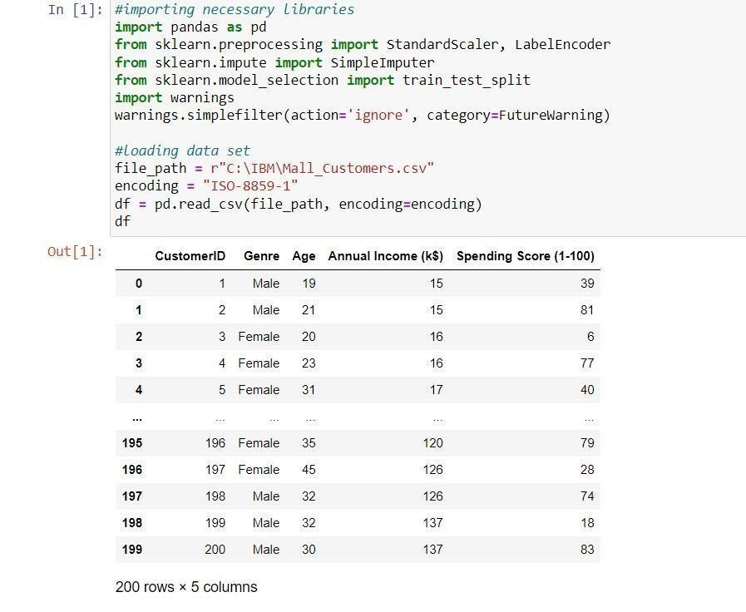

# Handling Missing Data

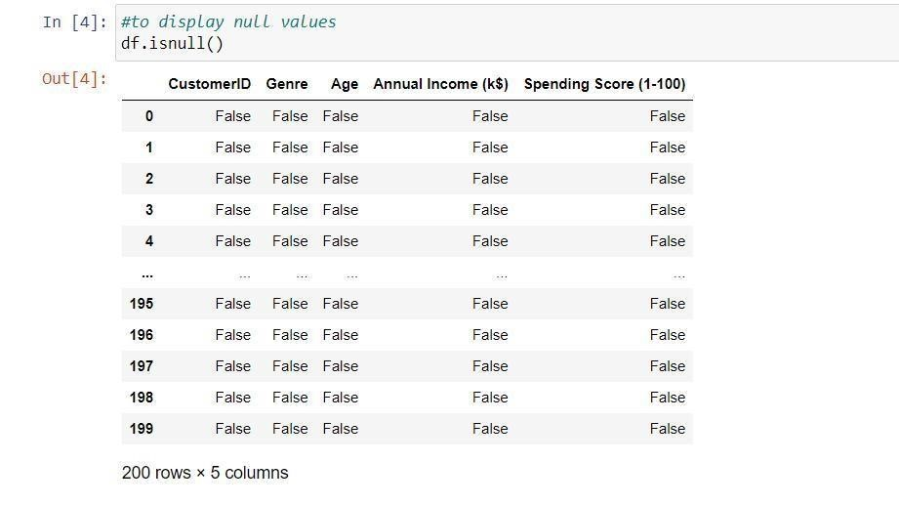

# Handling the missing data

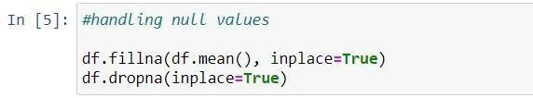

# Label encoder for Genre column

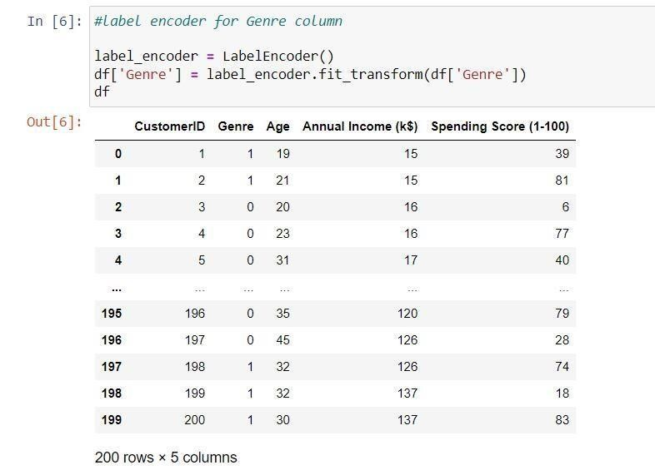

# Feature Scaling using StandardScaler

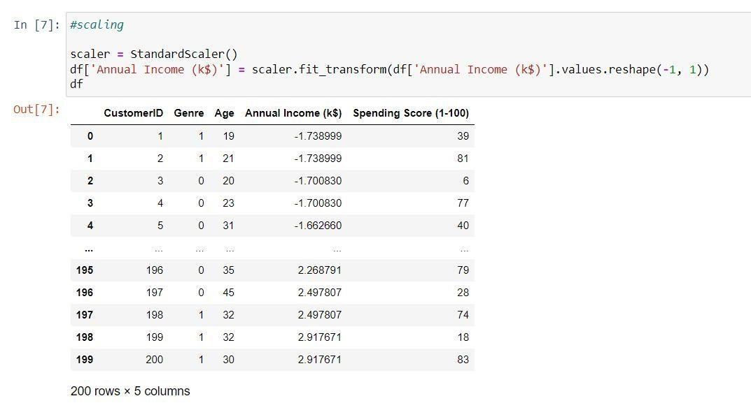

# Splitting the data into a training set and a test

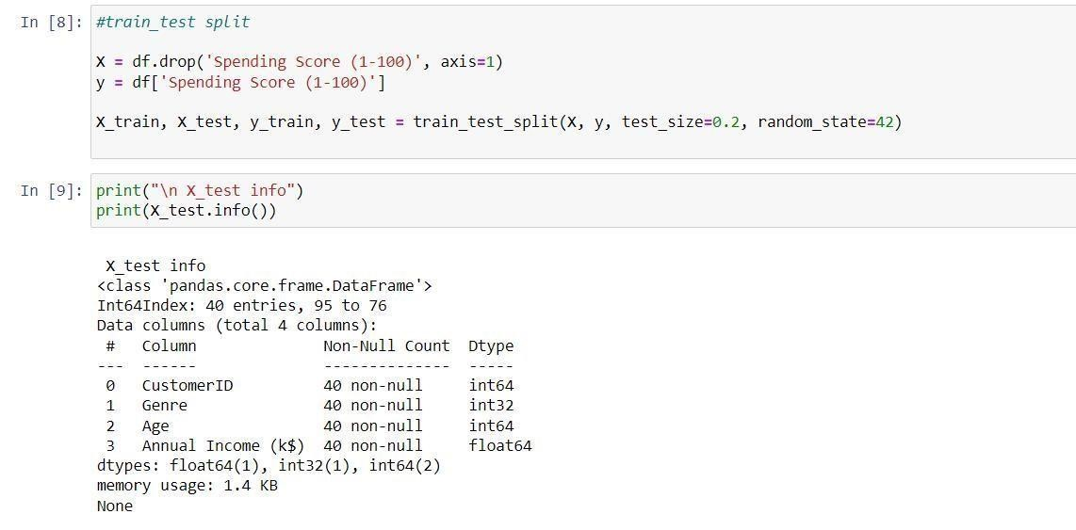

Importing the necessary libraries:

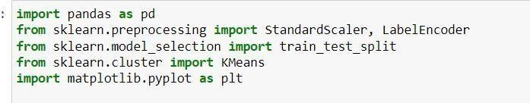

Train test split: 

K-Means Clustering: 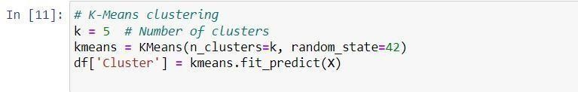

Visualization of the result:

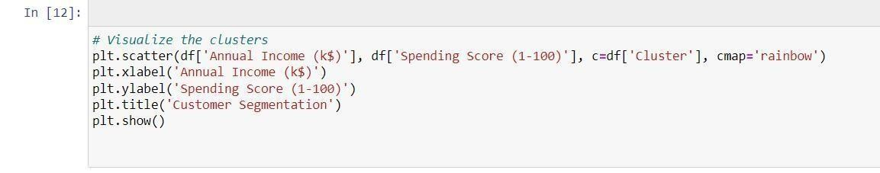

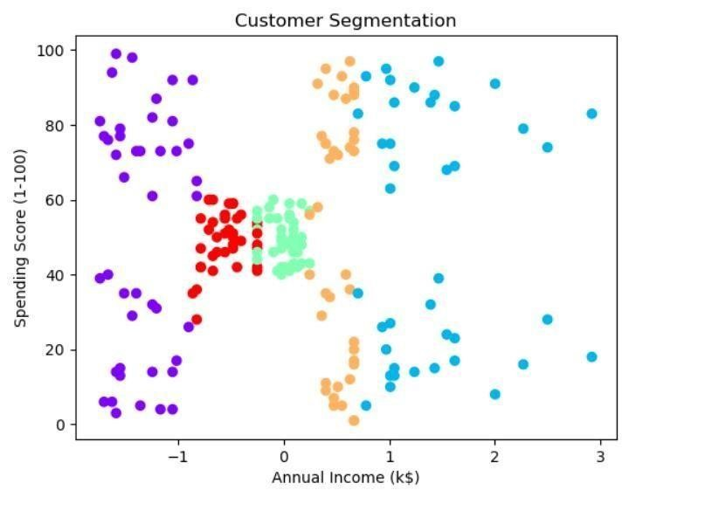

Explore the clusters:

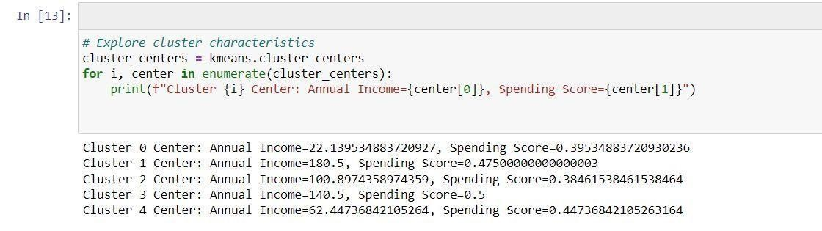

Analyze each cluster for insights:

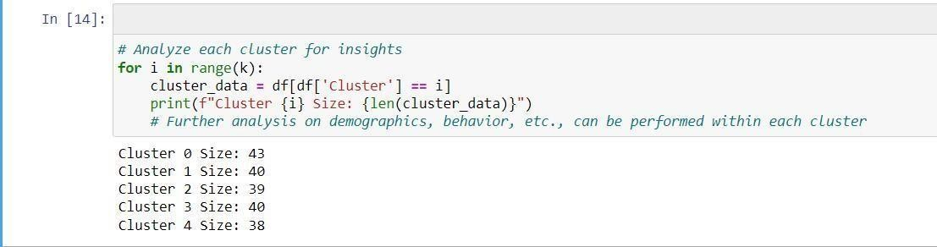

Interpretation:

The code provided offers a complete workflow for customer segmentation using K-Means clustering. It begins with data preprocessing, including handling missing values, label encoding, and feature scaling. It then performs clustering to segment customers into distinct clusters based on their 'Annual Income' and 'Spending Score.' The clusters are visualized, and cluster characteristics are analyzed. The code sets the foundation for understanding customer behavior and tailoring marketing strategies to specific customer segments. Additionally, it highlights the potential for further analysis within each cluster to gain deeper insights and make data-driven decisions.

Conclusion:

In conclusion, a customer segmentation project is a valuable endeavor for businesses looking to enhance their marketing strategies and customer relationships. By effectively dividing the customer base into distinct groups, it enables personalized marketing efforts, product recommendations, and customer service, ultimately leading to improved customer satisfaction and increased revenue. However, the success of such a project depends on data quality, appropriate algorithm selection, and continuous evaluation and refinement to adapt to changing customer behaviors and preferences. When executed well, customer segmentation can be a powerful tool for businesses seeking to better understand and serve their diverse customer base.