Applying Probability and Statistics to Evaluate a Machine Learning Model
Empirical Evaluation of a Farmer Subsidy Recommendation System in Karnataka
Project Repository: | ML-Based Personalized Government Scheme and Subsidy Recommendation System (`farmer-benefit-ml`)
Milestone / Scope: | Benchmark v1.2 Scenario-Isolated Supervised Classification Experiment
Statistical Protocol: | Paired Resampling (B=10,000), 95% Confidence Interval, Exact McNemar Test (alpha=0.05)
Date & Status: | October 2026 | Comprehensive Academic Evaluation Report

Executive Summary & Scientific Verdict
- Core Research Question: Does an improved candidate machine learning model (Random Forest Classifier) demonstrate genuine superior classification accuracy over a transparent baseline model (Logistic Regression Classifier), or is the measured difference attributable to sampling variability in the test data?
- Empirical Findings: On a held-out, scenario-isolated test set (N = 18 scenarios, n = 72 candidate pairs across 10 Karnataka agro-climatic zones), the candidate Random Forest achieved 76.39% accuracy (55/72 correct), outperforming the baseline Logistic Regression at 73.61% accuracy (53/72 correct) by an observed difference of +2.78 percentage points (Delta = +0.0278, exactly 2 additional correct predictions).
- Statistical Inference: The 95% cluster-aware paired bootstrap confidence interval spans [-0.0649, +0.1250], clearly encompassing zero. McNemar's exact paired binomial test on discordant pairs (b = 7, c = 9, n = 16) yields p = 0.8036 (>> 0.05). At the pre-registered 5% significance level, we FAIL TO REJECT the null hypothesis of equal error probabilities.
- Scientific Verdict: PASS WITH WARNINGS. The observed gain is not statistically significant and is fully consistent with test-sample variation. Furthermore, because labels are derived from expert policy assessments rather than empirical subsidy disbursements, these results evaluate rule/policy agreement, not real-world farmer welfare outcomes.

1. Problem Statement & Research Objective
Machine learning models deployed in high-stakes public welfare domains must be held to rigorous statistical standards. In the Karnataka Farmer Benefit Recommendation System, agricultural support schemes—ranging from income transfers (PM-KISAN) and micro-irrigation capital grants (PMKSY-PDMC) to farm mechanization (SMAM) and targeted parastatal dryland borewells (Ganga Kalyana)—operate under strict statutory rules and multi-dimensional farmer context.
A common pitfall in applied data science is observing a nominal percentage improvement on a single test partition and declaring the candidate model 'superior'. In reality, when test sets are finite, point estimates of accuracy are random variables subject to sampling variability. The objective of this assignment is to construct a rigorous, reproducible statistical experiment to answer: "Does an improved machine learning model perform better than a baseline model, or could the observed difference be due to variation in the test sample?"
Importantly, we establish a clean demarcation between legal statutory eligibility and machine learning prediction:
- Deterministic Statutory Eligibility Engine (src/eligibility/engine.py): Codifies formal government notifications and acts as a deterministic legal filter. It categorizes candidate schemes into Section A (Actionable), Section B (Provisional / Documentary verification required), and Ineligible. Machine learning models are strictly downstream and never override legal disqualifications.
- Machine Learning Priority Classification: Within the legally verified Section A candidates, models classify whether a scheme represents an acute, high-priority match (label_bin = 1) versus a marginal/secondary option (label_bin = 0) based on the farmer's immediate crisis and agrarian profile.
Pre-Registered Primary Metric: Classification Accuracy on the held-out test split, evaluated at significance level alpha = 0.05.

2. Dataset Description & Provenance
The experimental dataset is derived from Benchmark v1.2 within the repository (data/benchmarks/v1.2/):
- Number of Scenarios: 90 comprehensive farmer profiles (S131–S220) balanced across Karnataka's 10 agro-climatic zones (9 scenarios per zone).
- Total Candidate Pairs: 369 Section A candidate pairs (mean 4.10 candidate schemes per farmer, range 2 to 6).
- Feature Representation: 30 structured features spanning demographics, landholding size, annual income, tenure status (pure tenant vs. owner), operational water source, electrical status, primary crisis, immediate need, scheme statutory limits, and compatibility interactions.
- Target Variable: An agricultural policy expert (human reviewer 2) evaluated all 369 pairs on a 4-point relevance scale (0: Irrelevant, 1: Marginal, 2: Relevant, 3: Highly Relevant). For supervised classification, the label is binarized into label_bin: Class 1 (relevance >= 2, Actionable Priority, n = 151, 40.92%) and Class 0 (relevance < 2, Marginal/Irrelevant, n = 218, 59.08%).
Critical Data Integrity Disclosure: The project repository contains no historical database of actual government subsidy disbursement or bank transfer records (data/raw contains only .gitkeep). Consequently, this experiment evaluates rule-concordance and policy relevance agreement. It does NOT establish real-world scheme delivery or successful financial receipt.

3. Sampling Methodology & Experimental Controls
Because each farmer scenario contains multiple candidate schemes, standard row-level random splitting results in fatal data leakage: the same farmer profile would appear simultaneously in training and test partitions, allowing the model to memorize farmer-level attributes. To enforce strict isolation, we implemented the following controls:
- Scenario-Level Grouped Splitting: 90 scenario IDs were partitioned using train_test_split(scenarios, test_size=0.20, random_state=42), allocating 72 scenarios (297 candidate pairs) to training and 18 scenarios (72 candidate pairs) to testing. Scenario overlap is exactly 0.0%.
- Strict Preprocessing Isolation: Encoders (OneHotEncoder) and scalers (StandardScaler) were fit strictly on the 72 training scenarios and applied out-of-fold to the test split.
- Pre-Registered Leakage Exclusions: The features immediate_need_matches_heuristic_primary and archetype_id were permanently excluded to prevent circular heuristic leakage.

4. Model Architecture: Baseline vs. Candidate
- Baseline Model (Logistic Regression): A standard L2-regularized logistic regression classifier (C=1.0, max_iter=1000, random_state=42). Chosen for transparency, log-odds interpretability, and established role as the standard benchmark in tabular classification.
- Candidate Model (Random Forest): An ensemble of 100 de-correlated decision trees (random_state=42). Chosen for its ability to capture non-linear feature interactions between multi-attribute farmer constraints (e.g., tenant without title + rainfed dryland + credit need) and statutory scheme prerequisites without manual feature interaction engineering.
Both models were trained on the identical 297 training observations and evaluated on the exact same 72 held-out test observations.

5. Empirical Evaluation Results
Table 1 summarizes the performance of both models across all standard classification metrics on the held-out test split (N = 72 pairs, 18 scenarios).
Table 1: Classification metrics on the held-out test split (N = 72 pairs, 18 scenarios).
Evaluation Metric | Baseline (Logistic Regression) | Candidate (Random Forest) | Observed Gain (Delta)
Accuracy (Primary) | 0.7361 (73.61%) | 0.7639 (76.39%) | +0.0278 (+2.78%)
Precision | 0.7407 | 0.8000 | +0.0593
Recall (Sensitivity) | 0.6250 | 0.6250 | +0.0000
Specificity | 0.8250 | 0.8750 | +0.0500
F1-Score | 0.6780 | 0.7018 | +0.0238
ROC-AUC | 0.8070 | 0.8156 | +0.0086

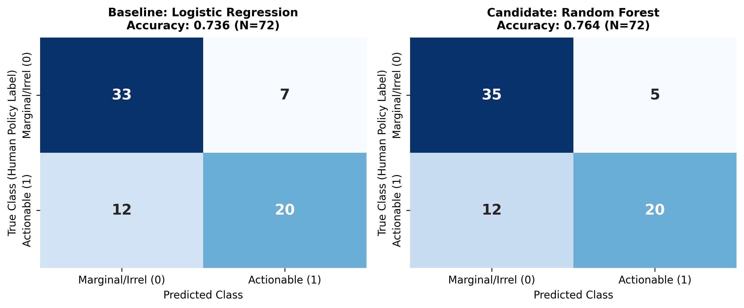
Figure 1: Side-by-side Confusion Matrices on Held-Out Test Split (N = 72 pairs, 18 scenarios).
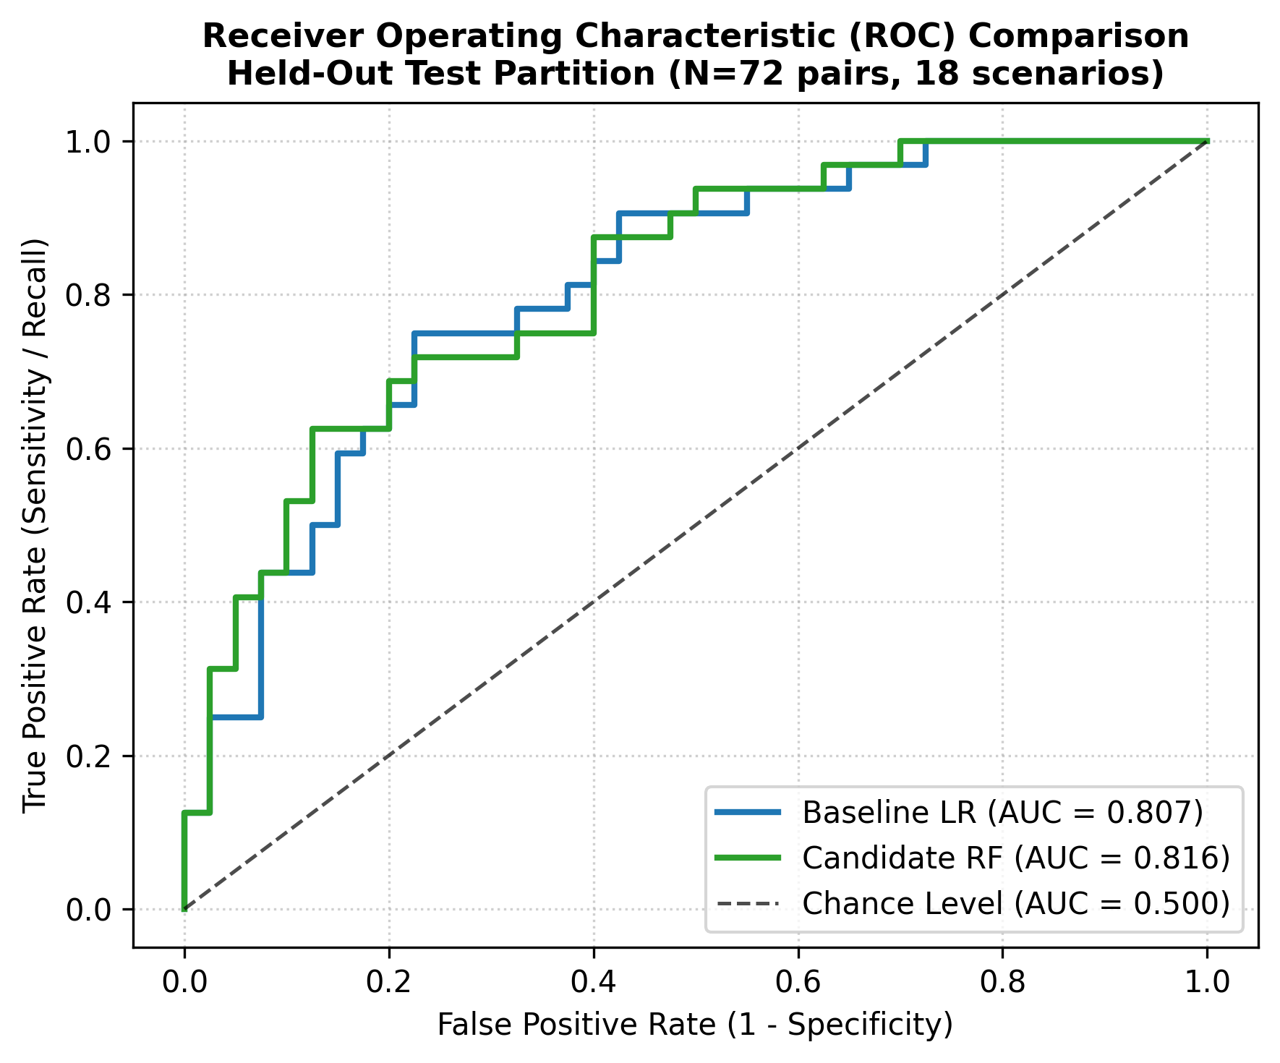
Figure 2: Receiver Operating Characteristic (ROC) Curves for Baseline LR vs Candidate RF.

6. Where Probability & Statistics Were Applied
Probability and statistical inference were explicitly integrated across four key stages of this experiment:
- Probability Theory & Finite Sampling Uncertainty: An observed test accuracy is an empirical estimator of true population error. Because test samples are finite, sample estimators fluctuate around the true parameter with variance inversely proportional to sample size. Evaluating models on identical paired units eliminates between-scenario variance, enhancing comparative precision.
- Non-Parametric Bootstrap Resampling (B = 10,000 Replicates): To construct a 95% confidence interval for Delta = Acc_RF - Acc_LR without distributional normality assumptions, we performed paired bootstrap resampling. Furthermore, because candidate schemes are clustered within farmers, we implemented both standard row-level bootstrap and cluster-aware (scenario-level) bootstrap:
  - Row-Level 95% Bootstrap CI: [-0.0833, +0.1389]
  - Cluster-Aware 95% Bootstrap CI: [-0.0649, +0.1250]
Interpretation: Both confidence intervals encompass zero. The observed gain of +2.78% cannot be statistically distinguished from zero at the 95% level.
- McNemar's Hypothesis Test on Paired Predictions: Testing the pre-registered null hypothesis H0: P(Error_RF) = P(Error_LR) vs H1: P(Error_RF) != P(Error_LR) at significance level alpha = 0.05. The paired outcomes produce a 2x2 contingency matrix:
  - a (Both Correct): 46 pairs
  - b (LR Correct, RF Wrong): 7 pairs
  - c (RF Correct, LR Wrong): 9 pairs
  - d (Both Wrong): 10 pairs
  - Total Discordant Pairs: b + c = 16
Under H0, discordant outcomes follow a Binomial(16, 0.5) distribution. The exact two-sided binomial p-value is p = 0.8036. The continuity-corrected Chi-Square statistic is stat = 0.0625 (p = 0.8026). At alpha = 0.05, we FAIL TO REJECT H0.
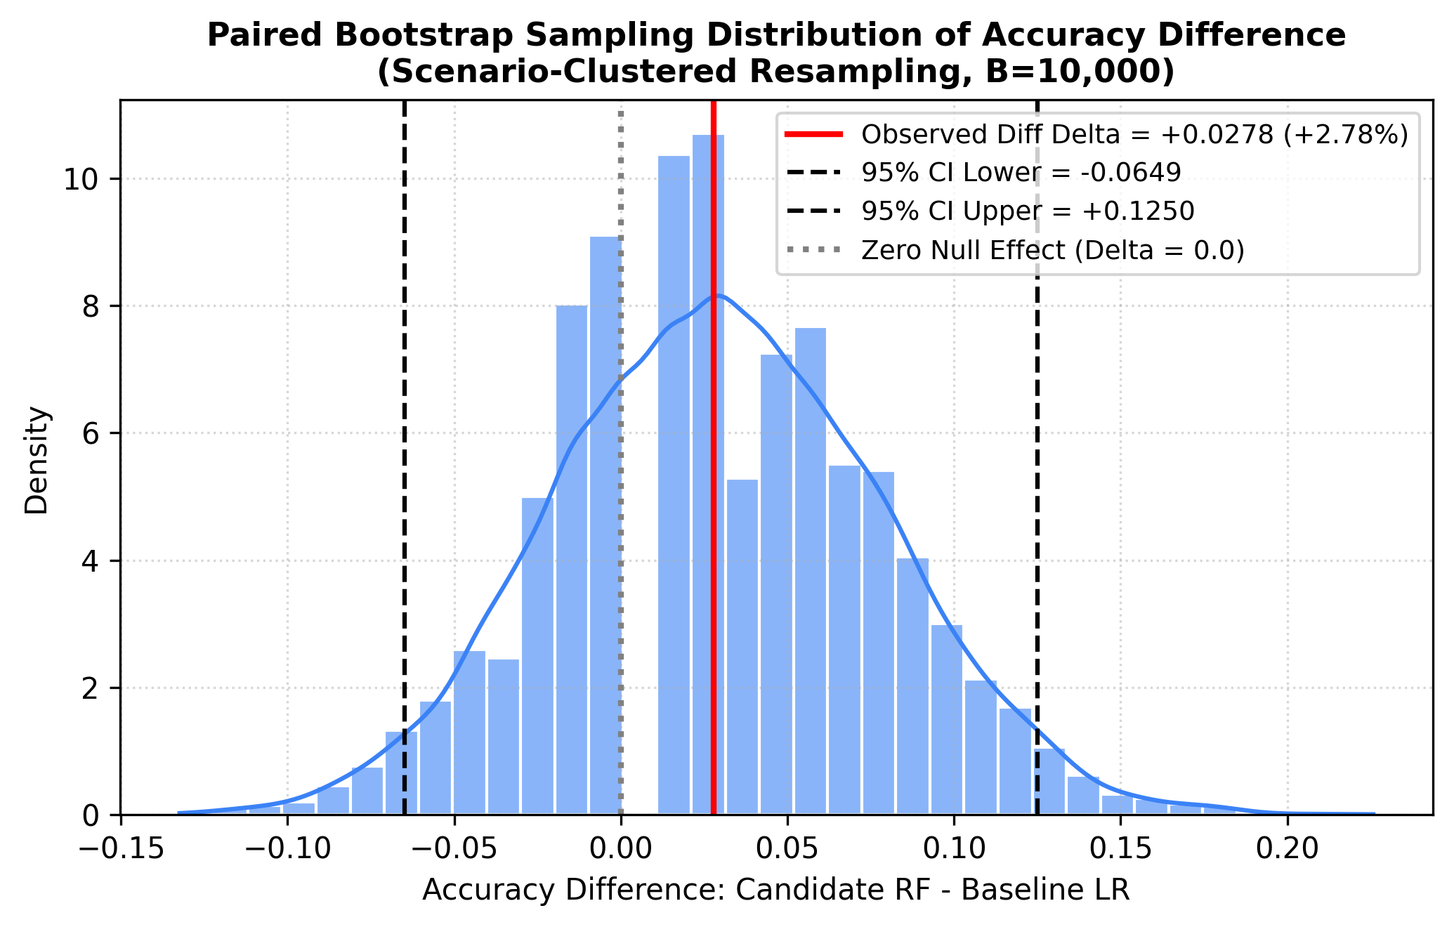
Figure 3: Paired Bootstrap Sampling Distribution of Accuracy Difference (Scenario-Clustered, B=10,000).
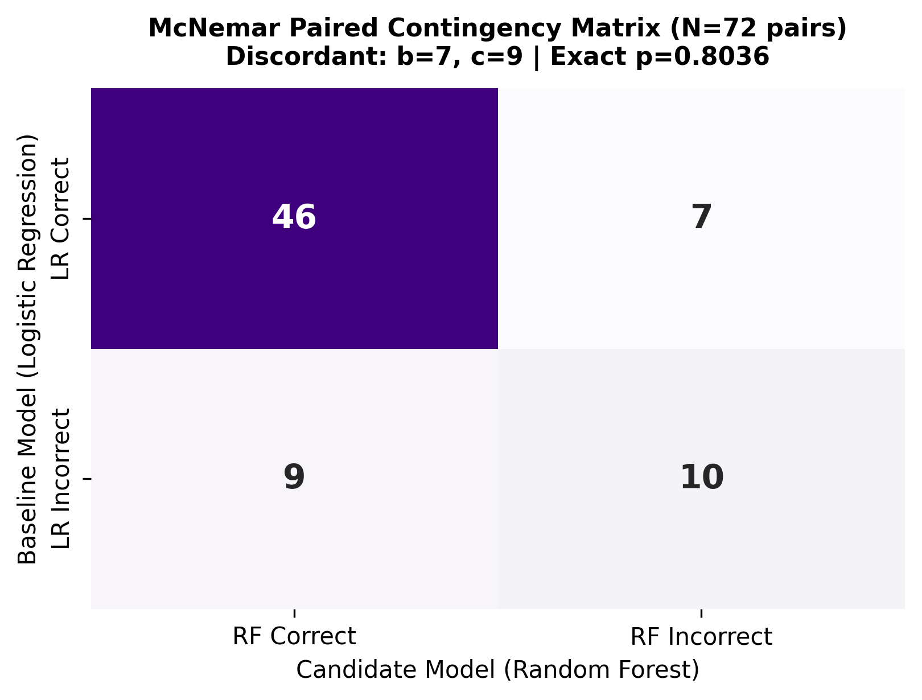
Figure 4: McNemar Paired Contingency Heatmap displaying concordant and discordant predictions.

7. Final Decision & Answers to Core Questions
- Did the candidate model achieve a higher observed primary metric? Yes. The candidate Random Forest achieved 76.39% accuracy versus 73.61% for Logistic Regression (+2.78 percentage points).
- What was the measured difference? Delta = +0.0278. This corresponds to exactly 2 additional correctly classified candidate pairs out of 72 test observations.
- What does its 95% confidence interval indicate? The cluster-aware 95% CI is [-0.0649, +0.1250]. Because it encompasses zero (-6.5% to +12.5%), we cannot rule out that the true population difference is zero or even slightly negative.
- What did the hypothesis test conclude? McNemar's exact paired test yielded p = 0.8036. At alpha = 0.05, we fail to reject the null hypothesis of equal error probabilities.
- Is there statistically significant evidence of improvement at the 5% level? No. p = 0.8036 >> 0.05 indicates no statistically significant difference.
- Is the measured improvement practically meaningful? No. A net gain of 2 scheme classifications across 18 farmers does not warrant deploying a complex non-linear ensemble in place of an interpretable linear model in a public welfare application.
- What limitations remain? Small sample size (N=18 test scenarios, 16 discordant pairs) gives low statistical power (<15% to detect a 3% difference). Furthermore, single-annotator labels lack inter-rater reliability.
- Does the result establish real-world scheme eligibility or successful access? No. The experiment measures agreement with human policy judgments within statutorily filtered candidates, not guaranteed administrative sanction or bank fund disbursement.

8. Limitations & Recommendations for Future Research
- Absence of Ground-Truth Disbursement Data: In real-world agricultural subsidy programs, eligibility does not equate to absorption. Administrative friction, documentation rejections, and quota exhaustion govern disbursement. Future research should integrate anonymized administrative data from Karnataka's FRUITS (Farmer Registration and Unified Beneficiary Information System) portal.
- Single-Annotator Bias: Benchmark v1.2 relies on a single human annotator (human reviewer 2). Dual independent raters are required to compute Cohen's quadratic-weighted kappa or Krippendorff's alpha to verify that the classification target reflects consensus policy logic rather than individual subjective preferences.
- Statistical Power & Sample Size: A post-hoc power analysis indicates that detecting a true 3% difference at alpha = 0.05 with 80% power requires approximately 800 independent farmer scenarios. Expanding the benchmark is essential for conclusive model selection.

