Halvorsen Robotics Employee Handbook

Time off
Vacation days depend on how long you have worked at the company.
Years of service | Vacation days per year
0-4 years | 20
5-9 years | 25
10 or more years | 30

Travel
Daily allowances and hotel limits for business travel:
Role | Daily allowance | Hotel limit per night
Engineer | $60 | $180
Manager | $85 | $250
Director | $110 | $320

Oslo office layout
The plan below shows the 3rd floor of the Oslo office.
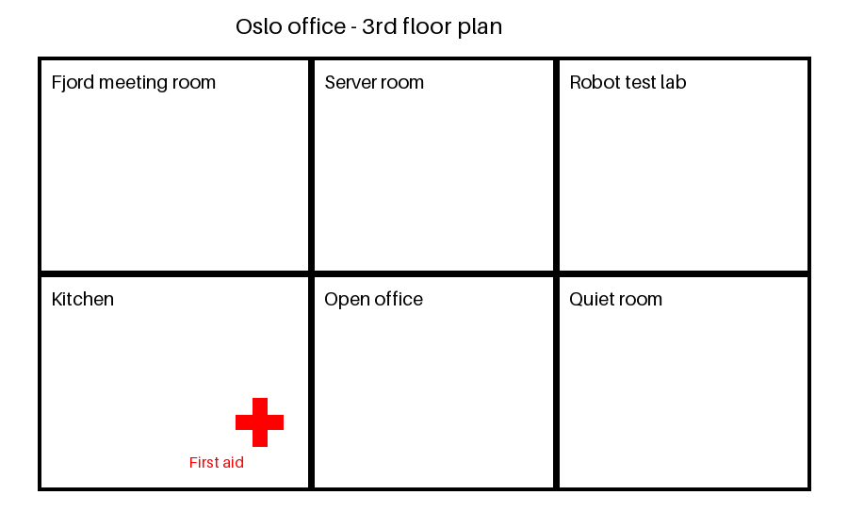

Equipment
Company laptops are replaced every 3 years.

