**High Level Design:**

API Controller

(Attribute Routing, CORS)

Database

DAL

DI (Ninject)

EF (Code first)

I

Class implemented IBLL

Interface

IBLL

BLL: IBLL

CustomerApp Module

Customer List Component

Customer Details Component

Customer Service

Routing

Angular

Web API

**Technical Stack**

Front End

* Angular 6.0
* Bootstrap 4.0
* SASS

Back End

* Web API 2.0
* Ninject 3.3
* Entity Framework 6.0

**Customer Details Screen:**

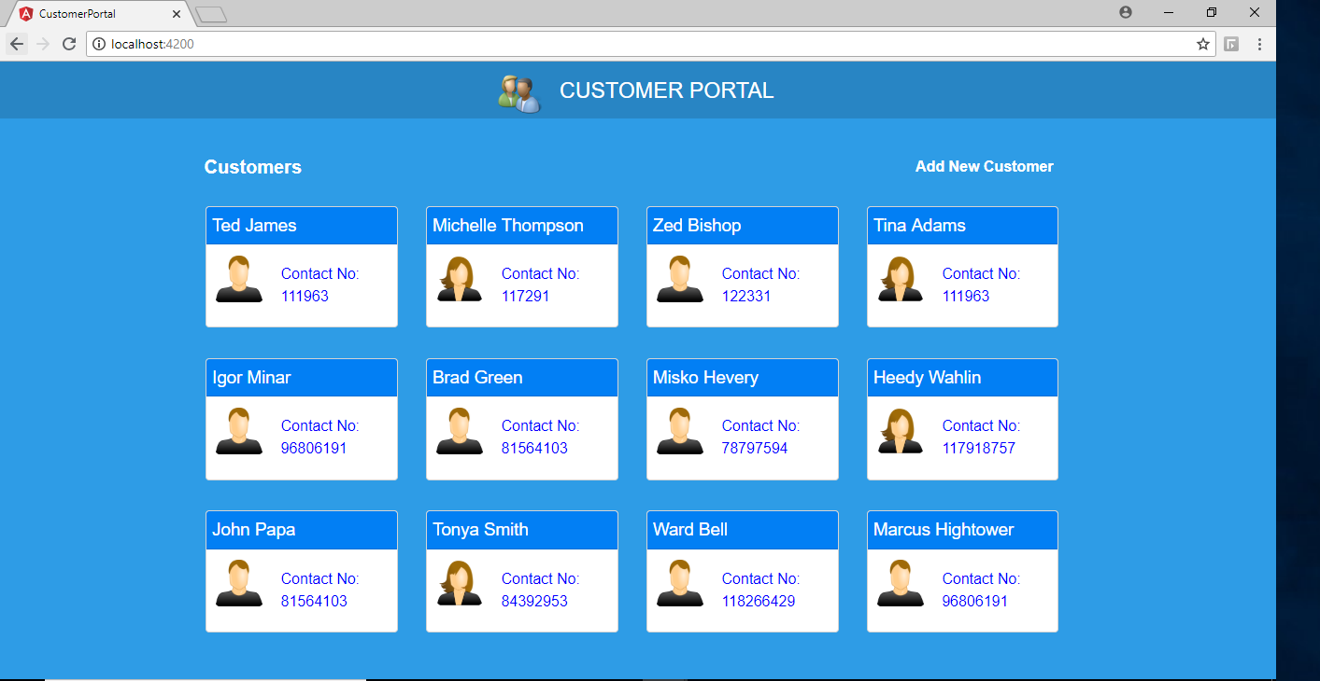

**Add Customer Form Screen:**

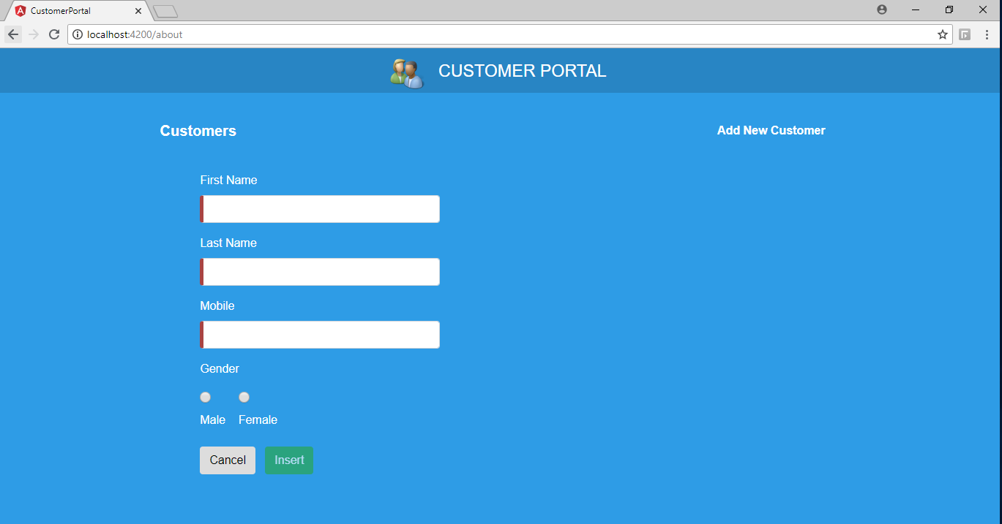

**Must do to execute:**

* Launch/Host Web API - CustomerService.sln
* Copy the hosted URL and update customerBaseUrl in customer.service.ts file in Angular App