Question 1: Banking Account Management System
#include <iostream>
#include <string>
using namespace std;

class Account
{
int accountNumber;
string customerName;
double balance;

public:
Account()
{
accountNumber = 0;
customerName = "Unknown";
balance = 0.0;
cout << "Default constructor called" << endl;
}

Account(int no, string name, double bal)
{
accountNumber = no;
customerName = name;
balance = bal;
cout << "Parameterized constructor called" << endl;
}

Account(const Account &a)
{
accountNumber = a.accountNumber;
customerName = a.customerName;
balance = a.balance;
cout << "Copy constructor called" << endl;
}

void display()
{
cout << "Account Number: " << accountNumber << endl;
cout << "Customer Name: " << customerName << endl;
cout << "Balance: " << balance << endl;
}
};

int main()
{
Account a1;

int no;
string name;
double balance;

cout << "\nEnter account number: ";
cin >> no;

cout << "Enter customer name: ";
cin.ignore();
getline(cin, name);

cout << "Enter balance: ";
cin >> balance;

Account a2(no, name, balance);
Account a3(a2);

cout << "\nAccount 1 Details:" << endl;
a1.display();

cout << "\nAccount 2 Details:" << endl;
a2.display();

cout << "\nAccount 3 Details:" << endl;
a3.display();

return 0;
}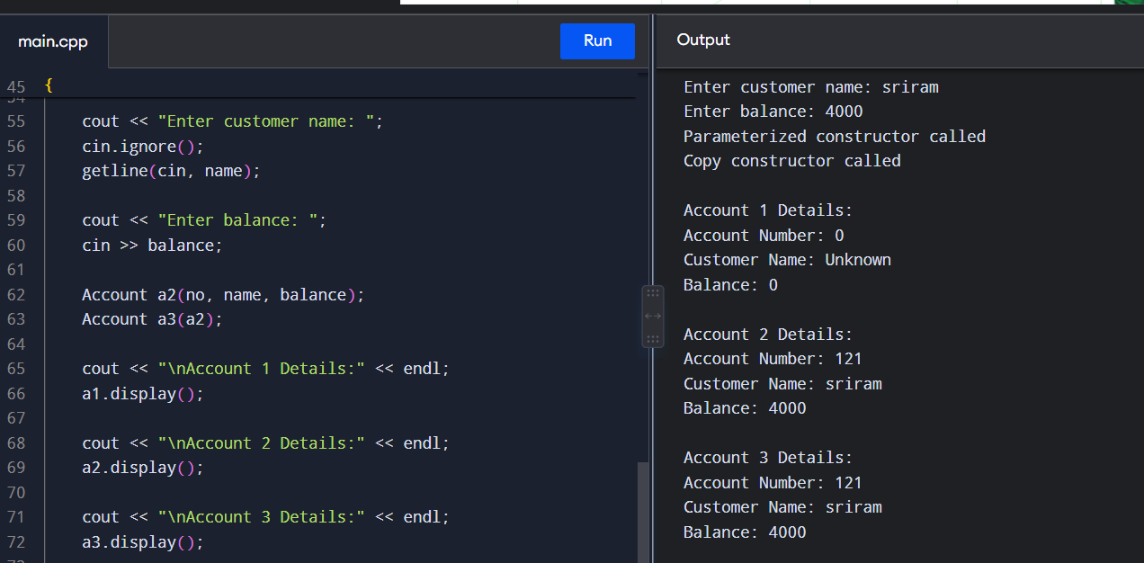
Question 2: Inventory Product Management System
#include <iostream>
#include <string>
using namespace std;

class Product
{
string name;
int stock;

public:
Product(string n, int s)
{
name = n;
stock = s;
cout << "Parameterized constructor called for " << name << endl;
}

Product(const Product &p)
{
name = p.name;
stock = p.stock;
cout << "Copy constructor called for " << name << endl;
}

Product operator+(const Product &p)
{
Product temp(name + " + " + p.name, stock + p.stock);
return temp;
}

void display()
{
cout << "Product Name: " << name << endl;
cout << "Stock Quantity: " << stock << endl;
}

~Product()
{
cout << "Destructor called for " << name << endl;
}
};

int main()
{
string name1, name2;
int stock1, stock2;

cout << "Enter first product name: ";
getline(cin, name1);

cout << "Enter first product stock: ";
cin >> stock1;
cin.ignore();

cout << "Enter second product name: ";
getline(cin, name2);

cout << "Enter second product stock: ";
cin >> stock2;

Product p1(name1, stock1);
Product p2(name2, stock2);

Product p3(p1);
Product p4 = p1 + p2;

cout << "\nProduct 1:" << endl;
p1.display();

cout << "\nProduct 2:" << endl;
p2.display();

cout << "\nCopied Product:" << endl;
p3.display();

cout << "\nCombined Product:" << endl;
p4.display();

return 0;
}

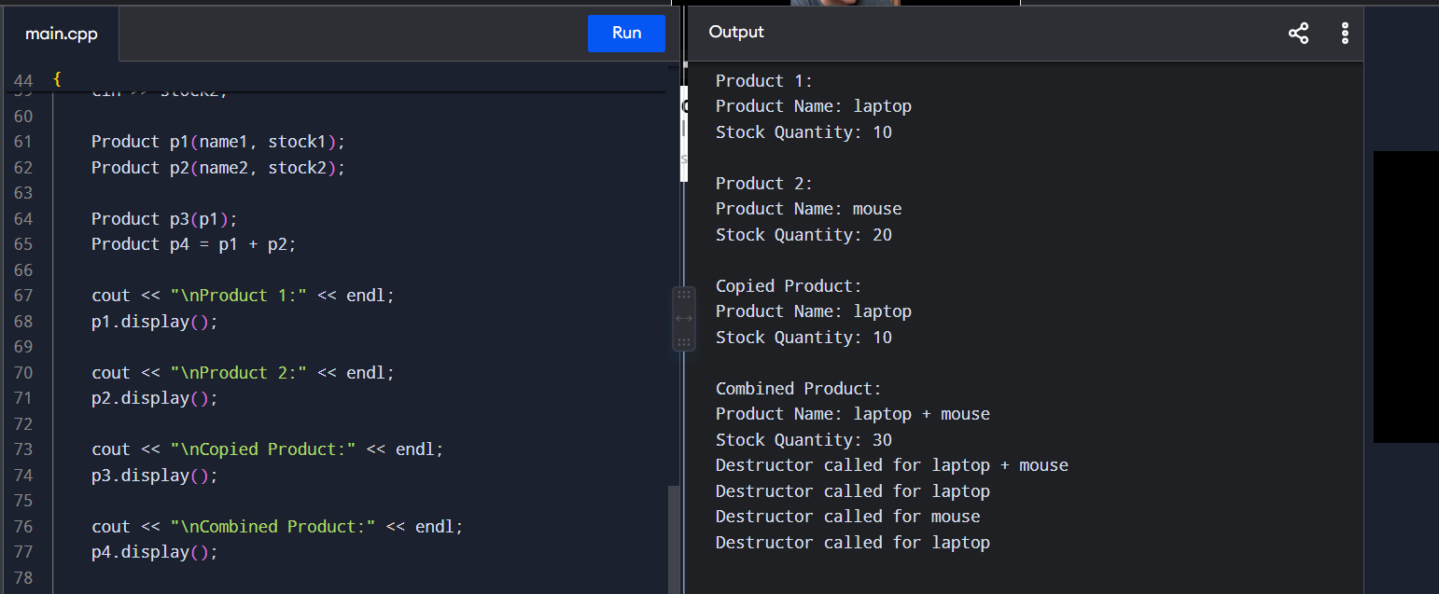
Question 3: Shopping Cart Management System
#include <iostream>
#include <string>
using namespace std;

class Product
{
string name;
int quantity;

public:
Product(string n, int q)
{
name = n;
quantity = q;
cout << "Parameterized constructor called for " << name << endl;
}

Product(const Product &p)
{
name = p.name;
quantity = p.quantity;
cout << "Copy constructor called for " << name << endl;
}

Product operator+(const Product &p)
{
Product temp(name + " + " + p.name, quantity + p.quantity);
return temp;
}

void display()
{
cout << "Product Name: " << name << endl;
cout << "Quantity: " << quantity << endl;
}

~Product()
{
cout << "Destructor called for " << name << endl;
}
};

int main()
{
string name1, name2;
int quantity1, quantity2;

cout << "Enter first product name: ";
getline(cin, name1);

cout << "Enter first product quantity: ";
cin >> quantity1;
cin.ignore();

cout << "Enter second product name: ";
getline(cin, name2);

cout << "Enter second product quantity: ";
cin >> quantity2;

Product p1(name1, quantity1);
Product p2(name2, quantity2);

Product p3(p1);
Product merged = p1 + p2;

cout << "\nFirst Product:" << endl;
p1.display();

cout << "\nSecond Product:" << endl;
p2.display();

cout << "\nCopied Product:" << endl;
p3.display();

cout << "\nMerged Product:" << endl;
merged.display();

return 0;
}
