IND64
Artist Booking Marketplace
Business Requirements Document
Role-Based Analysis: Client · Artist · Agency
Prepared: 16 August 2026
Version 1.0 — Draft for review

Table of Contents
1. Document Control
2. Executive Summary
3. Purpose & Scope
4. Business Objectives
5. User Roles & Personas
6. Screen Inventory (Observed)
7. User Flows
7.1 Shared: Sign-in / Sign-up Flow
7.2 Client (Customer) Flow
7.3 Artist Flow
7.4 Agency Flow
8. Functional Requirements
9. Non-Functional Requirements
10. Assumptions, Dependencies & Open Questions
11. Appendix — Glossary

1. Document Control
Field | Detail
Product | IND64 (ind64.com) — marketplace connecting event organisers with performing artists across India.
Document type | Business Requirements Document (BRD) with role-based user flows, functional and non-functional requirements.
Roles analysed | Client (Customer), Artist, Agency
Evidence base | 9 screenshots of authenticated sessions + a 47-second screen recording, supplied by the requester for three distinct accounts, plus the public marketing site.
Status | Draft — sections marked "assumed" require confirmation from the product/engineering team (see Section 9).
This BRD was produced by analysing screenshots and a screen recording the user captured from live sign-ins on three accounts (Client, Artist, Agency), rather than by an automated login — the assistant does not have credentialed browser access to ind64.com. Every requirement below is tagged as either directly observed or reasonably assumed.

2. Executive Summary
IND64 is a two-sided (in practice three-sided) marketplace positioned as “Where India's artists and event organisers meet.” It lets event organisers (Clients) discover verified performing artists — musicians, dancers, live painters, Koothu troupes, magicians, MCs, photographers and more — filter them by category, city and name, and send booking requests directly from an artist's profile. Artists (individuals) and Agencies (organisations managing multiple artists) are the supply side, publishing bookable profiles and responding to incoming requests through a shared, badge-based account model.
A single login can carry more than one capability: every account is a Client by default, and additionally becomes an Artist and/or Agency once the corresponding profile work has begun. This was confirmed directly across the three supplied accounts — the Client account showed only a “Client” badge, the Artist account showed “Client + Artist” with a “Pending” profile status and an extra “Artist inbox” tab, and the Agency account showed “Client + Agency” badges.
This document translates that observed behaviour into a structured BRD: role definitions, screen inventory, user flows, and functional/non-functional requirements, clearly separating what was directly observed in the supplied screens from what is reasonably inferred and should be validated with the IND64 product team before being treated as a build spec.

3. Purpose & Scope

3.1 Purpose
To document the business and functional requirements of the IND64 platform as currently implemented, organised by user role, so that the requirements can be used for QA test planning, stakeholder sign-off, or as a baseline for a rebuild/enhancement backlog.

3.2 In Scope
- Public marketing site: homepage, “How it Works,” footer/legal navigation.
- Authentication: sign-in, sign-up, Google OAuth.
- Client journey: browse, filter, view artist detail, request booking, track requests.
- Artist journey: create/submit profile, profile approval status, respond to incoming requests.
- Agency journey: shared Client capabilities plus (assumed) multi-artist management.

3.3 Out of Scope
- Payment gateway and invoicing flows (not present in the supplied screens).
- Admin/back-office moderation console used to approve artist profiles (referenced only indirectly via the “Pending” status).
- Native mobile app (only the responsive web app was reviewed).
- Post-event review/rating submission screen (existence inferred from the rating shown on artist cards, but the entry screen itself was not captured).

4. Business Objectives
- Reduce the friction of booking performing artists for weddings and events in India by centralising discovery, comparison and inquiry in one product (“Verified profiles. Transparent pricing. Beautiful experiences.”).
- Grow a two-sided marketplace: acquire Clients (event organisers) on one side and Artists/Agencies (supply) on the other, using homepage CTAs (“Find your artist” / “List your talent”) to route each audience appropriately.
- Build trust through visible signals — star ratings, completed-bookings counts and an explicit “Verified profiles” promise — shown consistently on artist cards and detail pages.
- Support both independent artists and agencies that manage several artists, widening the addressable supply side without requiring separate products.

5. User Roles & Personas
IND64 uses a single account model with additive role badges rather than separate account types. The table below summarises the three roles observed.
Role | Who they are | Primary goals on the platform
Client / Customer | Any registered end-user booking artists for personal or corporate events (weddings, corporate shows, private parties). | Discover verified artists, compare profiles, send booking requests, track requests through to confirmation.
Artist | An individual performer (musician, dancer, painter, MC, magician, etc.) offering services on the platform. | Publish a bookable profile, receive and respond to booking requests, get discovered by clients, build a rating/booking history.
Agency | An organisation or manager representing multiple artists (e.g. a talent agency or production house). | Everything a Client can do, plus manage a roster of artists on their behalf and (assumed) triage requests across that roster.
A fourth role — platform Admin/moderator, responsible for approving “Pending” artist profiles — is implied by the workflow but was not part of the supplied credentials and is therefore out of scope for the flows below (see Section 3.3).

6. Screen Inventory (Observed)
The following screens were directly captured across the three sessions and the public site recording.
Screen | Visible to | What it contains | Evidence
Sign in / Create account | Public | Email + password sign-in, "Continue with Google" OAuth, and a "Create one" link to sign-up. | Screenshot 1
Homepage | Public | Hero ("Book India's most extraordinary artists for any occasion"), "Find your artist" / "List your talent" CTAs, Explore-by-category grid, Featured artists, footer. | Video (0:00–0:11)
How IND64 Works | Public | 3-step explainer: Discover → Book → Perform, plus an "Are you an artist?" conversion banner. | Video (0:12–0:18)
Client Dashboard | Client | "Welcome back, [Name]" with a Client badge; stat cards for My Bookings, Artist Profile, Incoming Requests; My bookings / Profile tabs; empty state prompting "Browse artists." | Screenshot 2
Browse Artists | All roles | Grid of artist cards with name-search, category filter and city filter; shows result count, rating and starting price per card. | Screenshot 3
Artist Detail | All roles | Cover image, price ('starting'), "Request booking" CTA, bookings count, rating, category tag, name/description. | Screenshots 4–5
Agency Dashboard | Agency | Same stat-card layout as the Client dashboard but the name badge shows both "Client" and "Agency." | Screenshot 6
Create/Edit Artist Profile | Artist (and Agency, assumed) | Form: Stage name*, Tagline, Category, City*, Starting price (₹), Experience (years), Cover image URL, Bio — with save-draft-or-submit messaging. | Screenshot 7
Artist Dashboard | Artist | Same stat cards, badge shows "Client" + "Artist"; Artist Profile stat reads "Pending"; an extra "Artist inbox" tab appears alongside My bookings / Profile. | Screenshot 8

7. User Flows

7.1 Shared: Sign-in / Sign-up Flow
Applies identically to all three roles — the platform does not ask “which kind of account” at login; the dashboard simply renders whatever badges the account already holds.
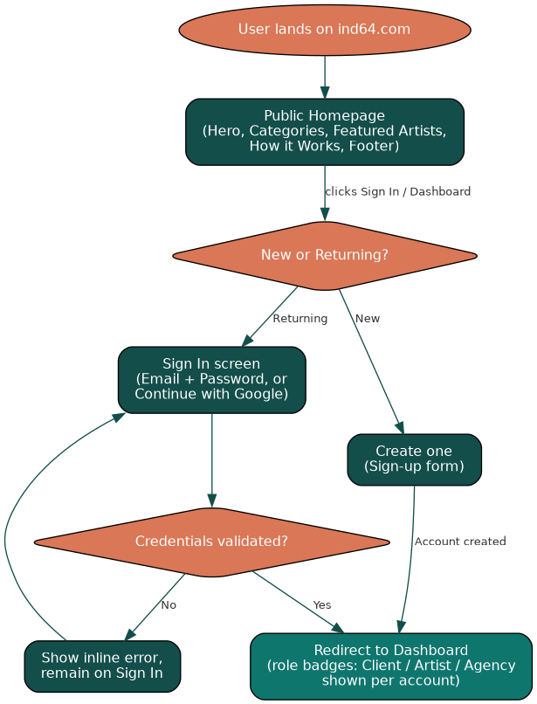
Figure 1 — Shared authentication flow

7.2 Client (Customer) Flow
Observed via the makeshjanaki@gmail.com account: lands on a Client-badged dashboard with My Bookings / Artist Profile / Incoming Requests cards all at zero, and an empty “Bookings I've requested” state prompting “Browse artists.”
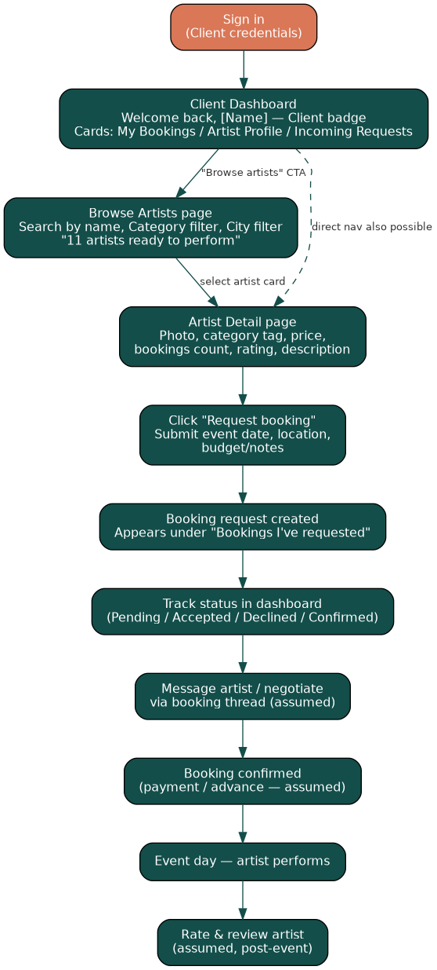
Figure 2 — Client booking-request flow

Step-by-step
- 1. Sign in → arrive on Client Dashboard (“Welcome back, Janaki Makesh,” Client badge).
- 2. Click “Browse artists” (from the empty state or top nav) → Browse Artists page.
- 3. Search by name and/or filter by category and city — 11 artists shown by default.
- 4. Select an artist card → Artist Detail page (photo, category tag, starting price, bookings count, rating).
- 5. Click “Request booking” → submit event details (assumed: date, location, budget/notes — the request form itself was not captured).
- 6. Request appears under “Bookings I've requested” and increments the My Bookings counter.
- 7. Track status and (assumed) message the artist to negotiate; once confirmed, the booking is fulfilled on the event date.

7.3 Artist Flow
Observed via the suparnamakesh@gmail.com account (displayed as “Makesh Janako”): dashboard shows Client + Artist badges, an Artist Profile status of “Pending,” and a third tab — “Artist inbox” — not present on the plain Client dashboard.
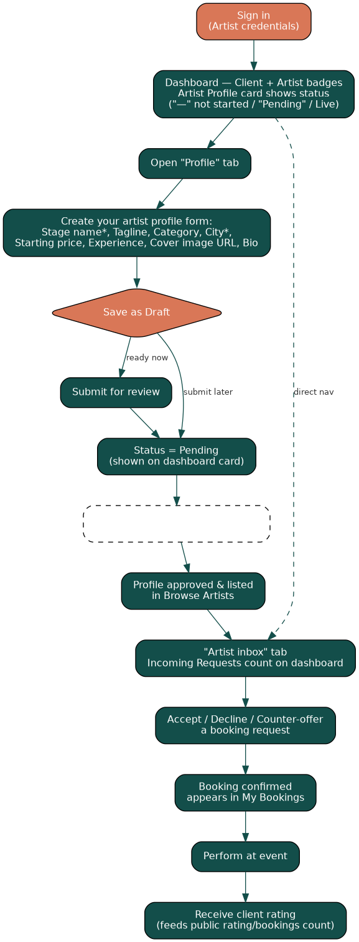
Figure 3 — Artist profile & booking-response flow

Step-by-step
- 1. Sign in → Dashboard shows Client + Artist badges; Artist Profile card reads “Pending.”
- 2. Open the “Profile” tab → “Create your artist profile” form: Stage name*, Tagline, Category, City*, Starting price (₹), Experience (years), Cover image URL, Bio.
- 3. Save as draft, or submit for review — the form copy explicitly supports both (“You can save a draft and submit when ready”).
- 4. Profile enters “Pending” status, visible on the dashboard card, until (assumed) a platform review step approves it.
- 5. Once approved, the profile becomes publicly listed on Browse Artists, and the Incoming Requests counter and Artist inbox tab begin receiving client requests.
- 6. Artist accepts, declines or negotiates each request from the Artist inbox; accepted requests move to My Bookings.
- 7. After the event, the completed-bookings count and rating shown publicly on the artist's card/detail page are updated.

7.4 Agency Flow
Observed via the janaki@aganitha.ai account (displayed as “Aganitha Janaki”): dashboard shows Client + Agency badges, with the same card layout and the same two tabs (My bookings / Profile) as a plain Client — no distinct “Artist inbox” or roster-management screen was captured for this account in its current state.
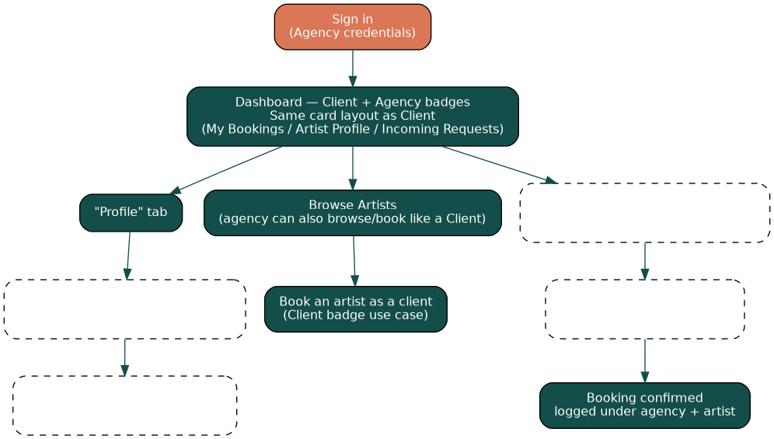
Figure 4 — Agency flow (grey/dashed boxes = inferred, not directly observed)

Step-by-step
- 1. Sign in → Dashboard shows Client + Agency badges; stat cards and tabs currently mirror the Client dashboard exactly.
- 2. (Assumed) Roster management — adding or linking multiple managed-artist profiles — is expected to live under the “Profile” tab, reusing the same “Create your artist profile” form seen on the Artist account, but this specific screen state was not captured for the Agency login.
- 3. (Assumed) Incoming requests across all managed artists would need to aggregate into the Incoming Requests counter, with a way to assign a request to a specific roster artist.
- 4. The Agency account can also act purely as a Client — browsing and requesting bookings directly — since the Client badge and My Bookings flow are identical to Section 7.2.
Recommendation: re-capture the Agency account after it has at least one managed artist linked, to confirm whether roster management is a distinct tab, a sub-section of “Profile,” or a separate screen not yet reached in the supplied recording.

8. Functional Requirements

4.1 Authentication & Account Management
ID | Requirement | Applicable role(s) | Priority
FR-AUTH-01 | The system shall allow a user to sign in with a registered email address and password. | All | Must
FR-AUTH-02 | The system shall allow a user to sign in or register via "Continue with Google" OAuth. | All | Must
FR-AUTH-03 | The system shall allow a new user to create an account via a "Create one" sign-up flow from the sign-in screen. | All | Must
FR-AUTH-04 | The system shall display an inline error and keep the user on the sign-in screen if credentials are invalid. | All | Must
FR-AUTH-05 | The system shall provide a "Sign out" action from the persistent top navigation on every authenticated screen. | All | Must
FR-AUTH-06 | The system shall support password reset / account recovery. | All | Should (assumed — not seen in captured screens)

4.2 Role & Profile Model
ID | Requirement | Applicable role(s) | Priority
FR-ROLE-01 | Every account shall carry a "Client" capability by default, shown as a persistent badge on the dashboard. | All | Must
FR-ROLE-02 | An account shall be able to additionally hold an "Artist" badge once an artist profile has been started, unlocking an "Artist inbox" tab and an Artist Profile status indicator (— / Pending / Live). | Artist | Must
FR-ROLE-03 | An account shall be able to additionally hold an "Agency" badge, identifying it as representing multiple artists. | Agency | Must
FR-ROLE-04 | The dashboard shall render role-specific tabs and cards based on the badge(s) present on the account, without requiring separate logins per role. | All | Must
FR-ROLE-05 | The system shall support an approval workflow that moves a newly submitted artist profile from "Pending" to a publicly listed state. | Artist, Agency | Must (assumed owner: platform admin — not directly observed)

4.3 Artist Discovery & Search
ID | Requirement | Applicable role(s) | Priority
FR-DISC-01 | The system shall list all live artist profiles on a "Browse Artists" page with a running total (e.g. "11 artists ready to perform"). | All | Must
FR-DISC-02 | The system shall allow filtering/search of artists by name (text search box). | All | Must
FR-DISC-03 | The system shall allow filtering of artists by category (dropdown, e.g. Music & Dance, Live Painting, Traditional & Folk, Anchors & Hosts, Magicians, Comedians, Photographers). | All | Must
FR-DISC-04 | The system shall allow filtering of artists by city. | All | Must
FR-DISC-05 | Each artist card shall display a representative photo, name, one-line description, star rating, city and starting price. | All | Must
FR-DISC-06 | The homepage shall surface a curated "Featured artists" section and an "Explore by category" grid to aid discovery without an active search. | All | Must

4.4 Artist Profile Management
ID | Requirement | Applicable role(s) | Priority
FR-PROF-01 | The system shall provide a "Create your artist profile" form capturing: stage name (required), tagline, category, city (required), starting price (₹), years of experience, cover image URL and bio. | Artist, Agency | Must
FR-PROF-02 | The system shall allow a profile to be saved as a draft and completed/submitted later. | Artist, Agency | Must
FR-PROF-03 | The artist detail page shall display the starting price, an explicit note that "final price depends on event details," total bookings completed and average rating. | All | Must
FR-PROF-04 | The system shall let an artist/agency edit an existing profile after initial submission. | Artist, Agency | Should (assumed)
FR-PROF-05 | The system shall support multiple media/portfolio images per artist beyond the single cover image. | Artist, Agency | Could (not observed in captured screens)

4.5 Booking Request Lifecycle
ID | Requirement | Applicable role(s) | Priority
FR-BOOK-01 | The system shall let a signed-in user submit a "Request booking" from an artist's detail page. | Client, Agency | Must
FR-BOOK-02 | Every submitted request shall appear under "Bookings I've requested" on the requester's dashboard. | Client, Agency | Must
FR-BOOK-03 | The dashboard "My Bookings" counter shall reflect the number of active booking threads for the account. | All | Must
FR-BOOK-04 | The dashboard "Incoming Requests" counter shall reflect booking requests received by an artist/agency profile. | Artist, Agency | Must
FR-BOOK-05 | An artist shall be able to view, accept, decline or respond to incoming booking requests from an "Artist inbox." | Artist | Must
FR-BOOK-06 | The system shall support messaging/negotiation between client and artist within a booking thread (event date, location, budget). | All | Should (assumed — request form fields not directly captured)
FR-BOOK-07 | The system shall track a booking's status (e.g. Pending → Accepted → Confirmed → Completed / Declined) and reflect it in both parties' dashboards. | All | Must
FR-BOOK-08 | The system shall increment an artist's public "Bookings" count once an engagement is completed. | Artist, Agency | Should (inferred from the 38-Bookings stat on the artist detail page)

4.6 Agency / Roster Management
ID | Requirement | Applicable role(s) | Priority
FR-AGY-01 | The system shall let an Agency account create/link multiple artist profiles under its management. | Agency | Must (assumed — not directly observed; recommend UX validation, see Section 6)
FR-AGY-02 | The system shall let an Agency view and triage booking requests aggregated across all managed artists. | Agency | Should (assumed)
FR-AGY-03 | The system shall let an Agency assign an incoming request to a specific managed artist. | Agency | Should (assumed)
FR-AGY-04 | The Agency dashboard shall additionally allow the account to act as a Client (browse and book artists directly), consistent with the persistent "Client" badge. | Agency | Must

4.7 Content & Navigation
ID | Requirement | Applicable role(s) | Priority
FR-CMS-01 | The system shall provide a public, unauthenticated "How it Works" page explaining the Discover → Book → Perform journey. | All / Public | Must
FR-CMS-02 | The system shall provide a persistent top navigation (Browse Artists, How it Works, Search, Dashboard, Sign out) on every authenticated page. | All | Must
FR-CMS-03 | The system shall provide a footer with Company, Support, For Artists and Legal link groups (About IND64, Contact Us, FAQs, Careers, Terms, Privacy, Cookie Policy, Refund & Cancellation, etc.). | All / Public | Must
FR-CMS-04 | The homepage shall provide role-conversion CTAs — "Find your artist" / "List your talent" and an "Are you an artist? Create artist profile / Browse first" banner. | Public | Must
FR-CMS-05 | The system shall provide a global site search accessible from the top navigation. | All | Should (icon observed; behaviour not captured)

9. Non-Functional Requirements
ID | Category | Requirement
NFR-PERF-01 | Performance | Artist listing, search/filter results and artist detail pages should load within 2 seconds on a standard broadband/4G connection.
NFR-PERF-02 | Performance | The homepage (hero, category grid, featured artists) should achieve a Largest Contentful Paint under 2.5 seconds.
NFR-SCAL-01 | Scalability | The platform shall support growth from an initial small catalogue (observed: 11 artists) to several thousand artist profiles and concurrent client sessions without redesign.
NFR-SCAL-02 | Scalability | Search/filter (name, category, city) shall remain responsive as the artist catalogue and booking-request volume grow.
NFR-SEC-01 | Security | Passwords shall never be stored or transmitted in plain text; the system shall use salted hashing (e.g. bcrypt/argon2) and TLS 1.2+ for all traffic.
NFR-SEC-02 | Security | OAuth ("Continue with Google") shall follow standard OAuth 2.0 / OIDC flows; no third-party credentials shall be stored by IND64.
NFR-SEC-03 | Security | Role/badge elevation (gaining an Artist or Agency badge) shall be governed by server-side authorization checks, not client-side flags alone.
NFR-SEC-04 | Security | All booking requests, messages and payment-related data (if introduced) shall be encrypted at rest.
NFR-PRIV-01 | Privacy & Compliance | Collection and processing of personal data (names, contact details, location) shall comply with India's Digital Personal Data Protection Act (DPDP) 2023.
NFR-PRIV-02 | Privacy & Compliance | Users shall be able to request access to, correction of, or deletion of their personal data, consistent with the published Privacy Policy.
NFR-USAB-01 | Usability | Core flows (sign in, browse, request booking, respond to a request) shall be completable by a first-time user without external help, consistent with the platform's minimal, editorial visual style.
NFR-USAB-02 | Usability | The interface shall meet WCAG 2.1 AA accessibility guidelines (colour contrast, keyboard navigation, screen-reader labelling).
NFR-REL-01 | Reliability & Availability | The platform shall target 99.5%+ monthly uptime for authentication, browse and booking-request functions.
NFR-REL-02 | Reliability & Availability | Booking-request data shall not be lost on submission failure; the client shall receive explicit confirmation or a retry-safe error.
NFR-COMP-01 | Compatibility | The web application shall render correctly on current versions of Chrome, Safari, Edge and Firefox, and on iOS/Android mobile browsers (the layout is responsive down to a single-column mobile view).
NFR-LOC-01 | Localization | Pricing shall be displayed in Indian Rupees (₹) with Indian numbering conventions; city fields shall support Indian city names and common transliterations.
NFR-LOC-02 | Localization | The system should support regional language content for artist bios/categories in future phases (assumed, not observed).
NFR-MAINT-01 | Maintainability | The system shall be built on a modular architecture that allows the role/badge model (Client, Artist, Agency, future Admin) to be extended without a full rewrite.
NFR-AUDIT-01 | Auditability | All state changes to a booking (request, accept, decline, confirm, cancel) shall be timestamped and attributable to the acting account for dispute resolution.
NFR-DATA-01 | Data Integrity | An artist's public rating and bookings-completed count shall be derived from verified, system-recorded events rather than free-text/manual entry.

10. Assumptions, Dependencies & Open Questions

10.1 Assumptions made in this document
- An admin/moderation capability exists to move an artist profile from “Pending” to publicly listed, since a profile-status field was observed but no approval screen was supplied.
- A booking request captures event date, location and budget/notes, and supports back-and-forth messaging, since the request form itself (post “Request booking” click) was not captured in the supplied screens.
- Agencies can add/manage multiple artist profiles; only the entry points (Client + Agency badge, shared Profile tab) were observed, not the roster screen itself.
- A payment/settlement step exists somewhere in the confirmed-booking flow, consistent with an events marketplace, but no payment screen was supplied.
- Clients can rate/review an artist after an event, inferred from the star ratings and booking counts shown on artist cards.

10.2 Open questions for the IND64 product team
- What does the Agency roster-management screen actually look like, and how are requests routed to a specific managed artist?
- What fields does the “Request booking” form capture, and is there in-app messaging or does negotiation happen off-platform?
- Who approves a “Pending” artist profile, and what criteria/SLA governs that review?
- Is there a cancellation/refund flow, given “Refund & Cancellation” appears as a footer link?
- Is pricing always “starting from” with a manual quote, or can some artists offer fixed, instantly bookable pricing?

11. Appendix — Glossary
Term | Meaning
Badge | A role indicator (Client / Artist / Agency) shown next to the account name on the dashboard; an account can hold more than one.
Starting price | The minimum price shown on an artist's card/detail page; final pricing is quote-based per the platform's own copy (“Final price depends on event details”).
Artist inbox | The tab, visible only to accounts with the Artist badge, that lists incoming booking requests.
Pending | The status of an artist profile after creation/submission and before it is approved and publicly listed.

