**Employee Name: Karthikraja Venkatesh**

**Employee Id: 662056**

**Step1: Cloud Formation**

Creating VPC with one public subnet and one private subnet, routing table and internet gateways

Creation of stack with template:

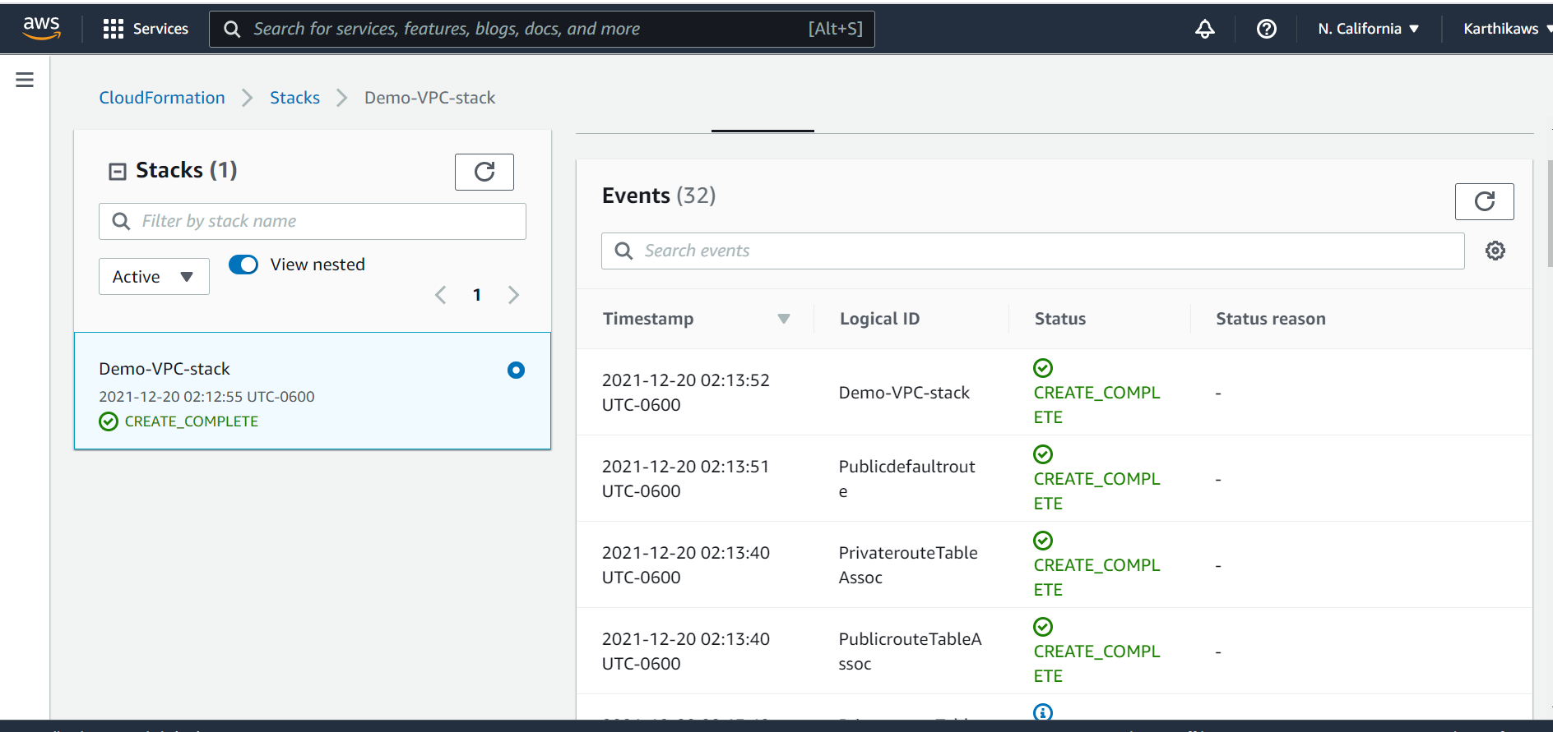

VPC:

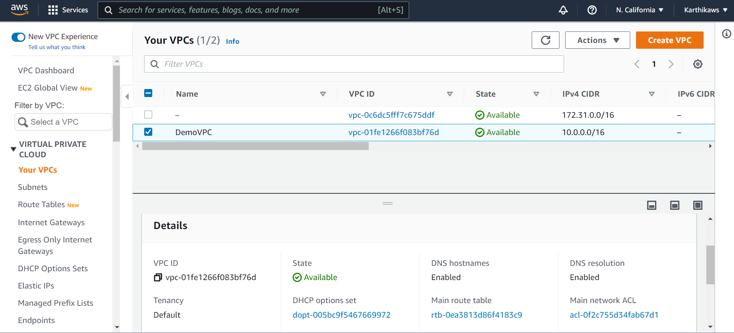

Public Subnet:

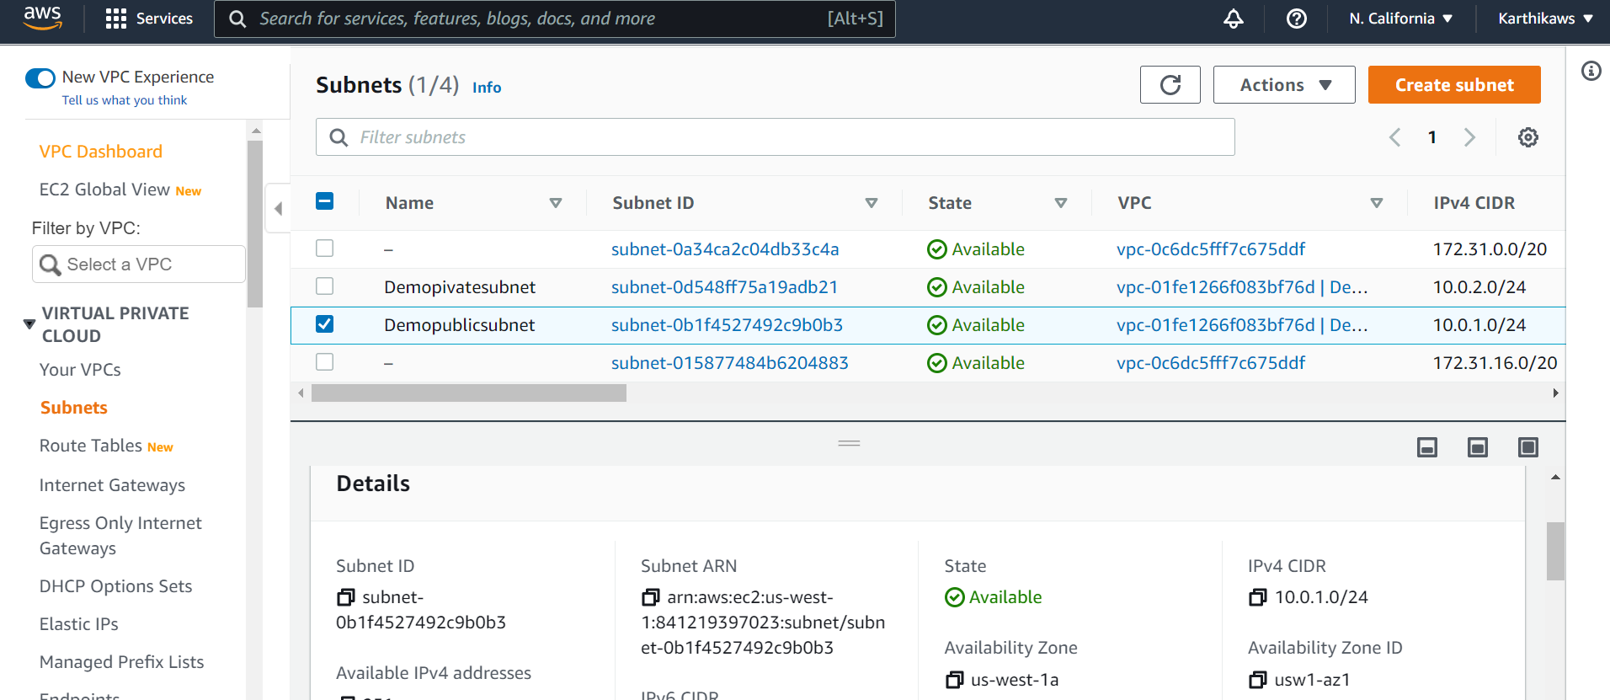

Private Subnet:

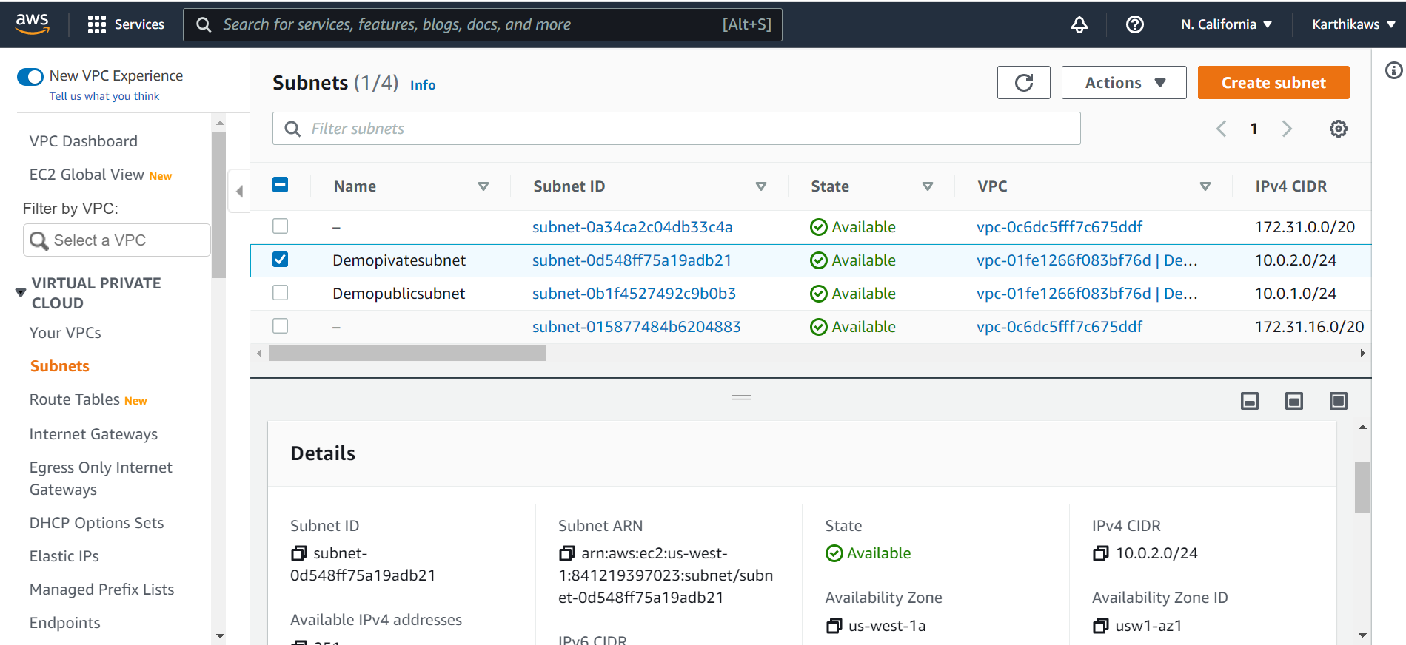

Routing Table:

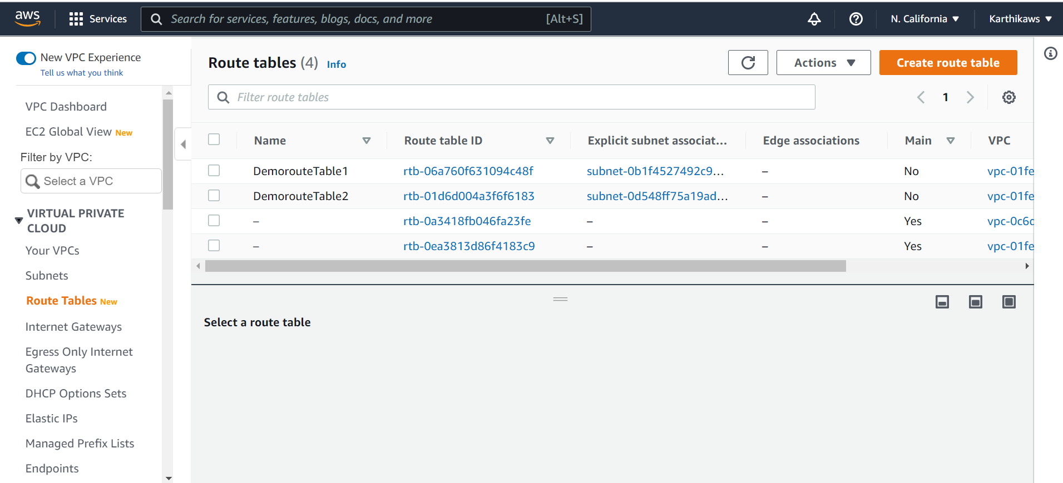

Internet Gateway:

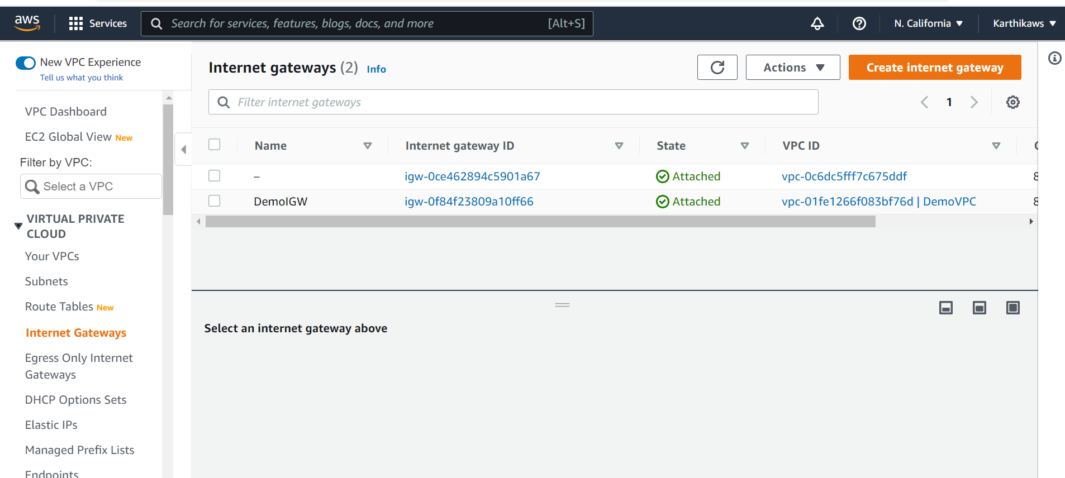

**Step2: Terraform**

Create application infrastructure using auto scaling group along with Layer 4 load balancer

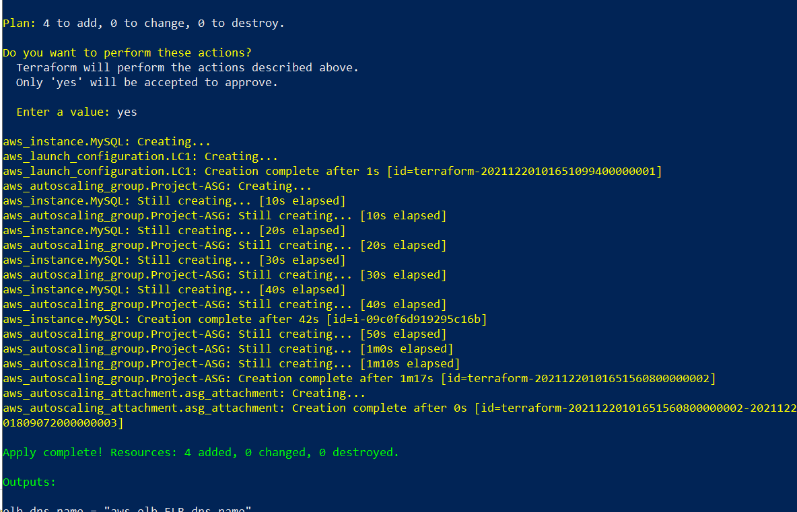

Security Groups:

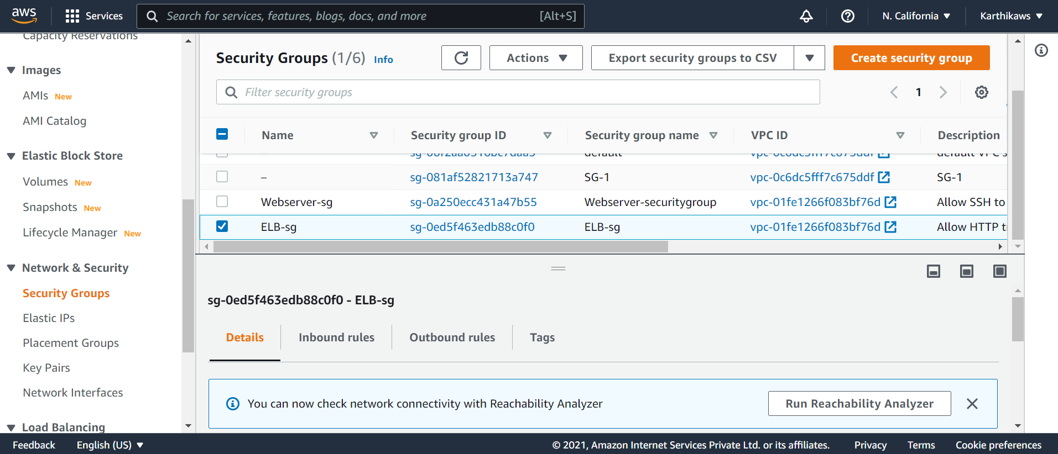

Load Balancer:

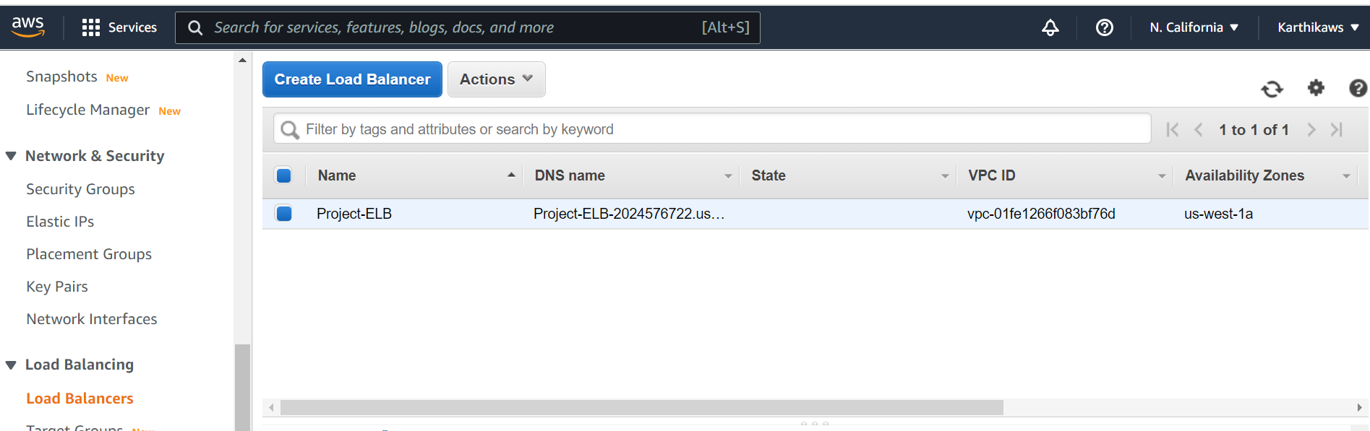

Launch Configuration:

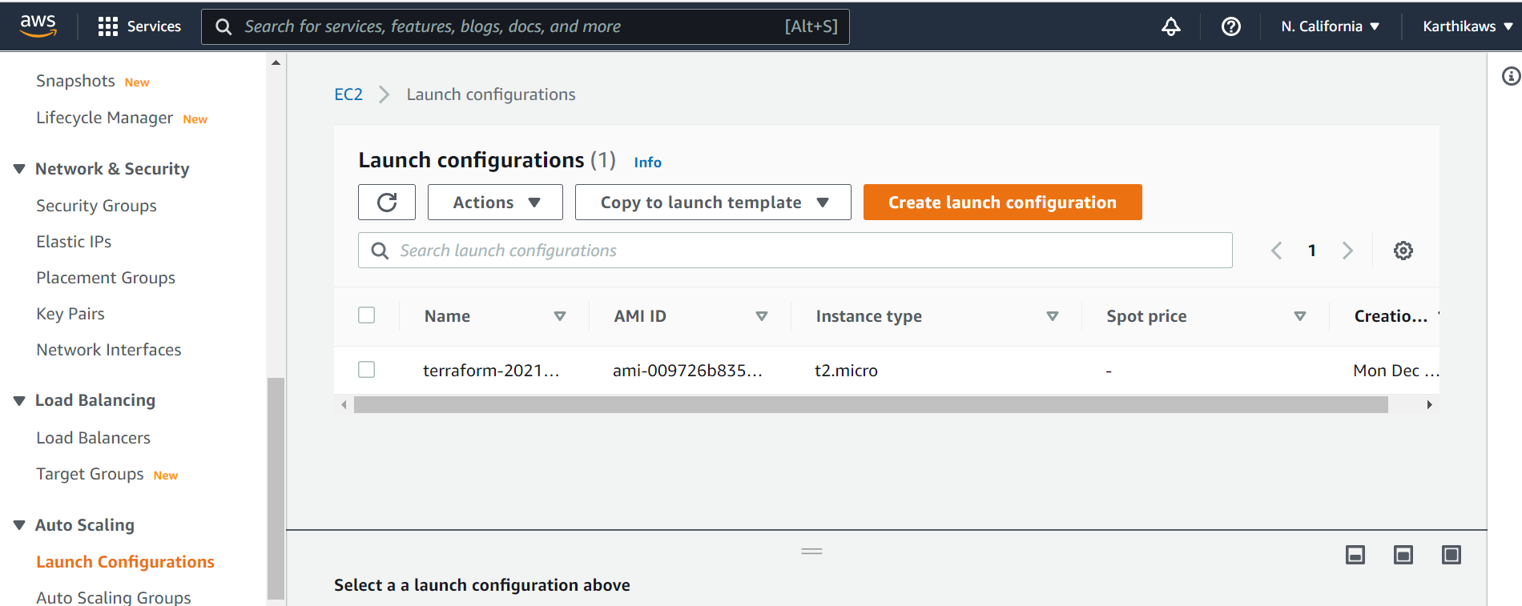

Auto scaling group:

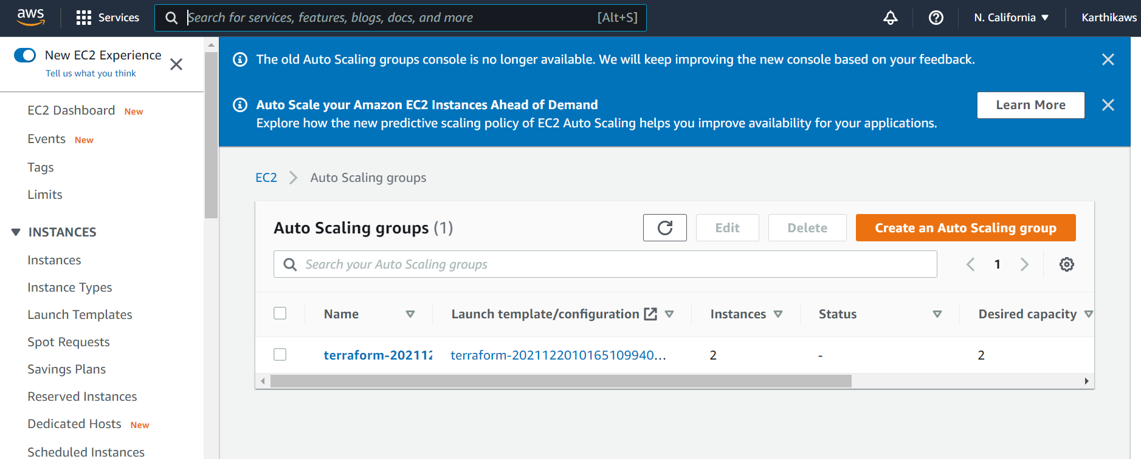

Webcluster instances

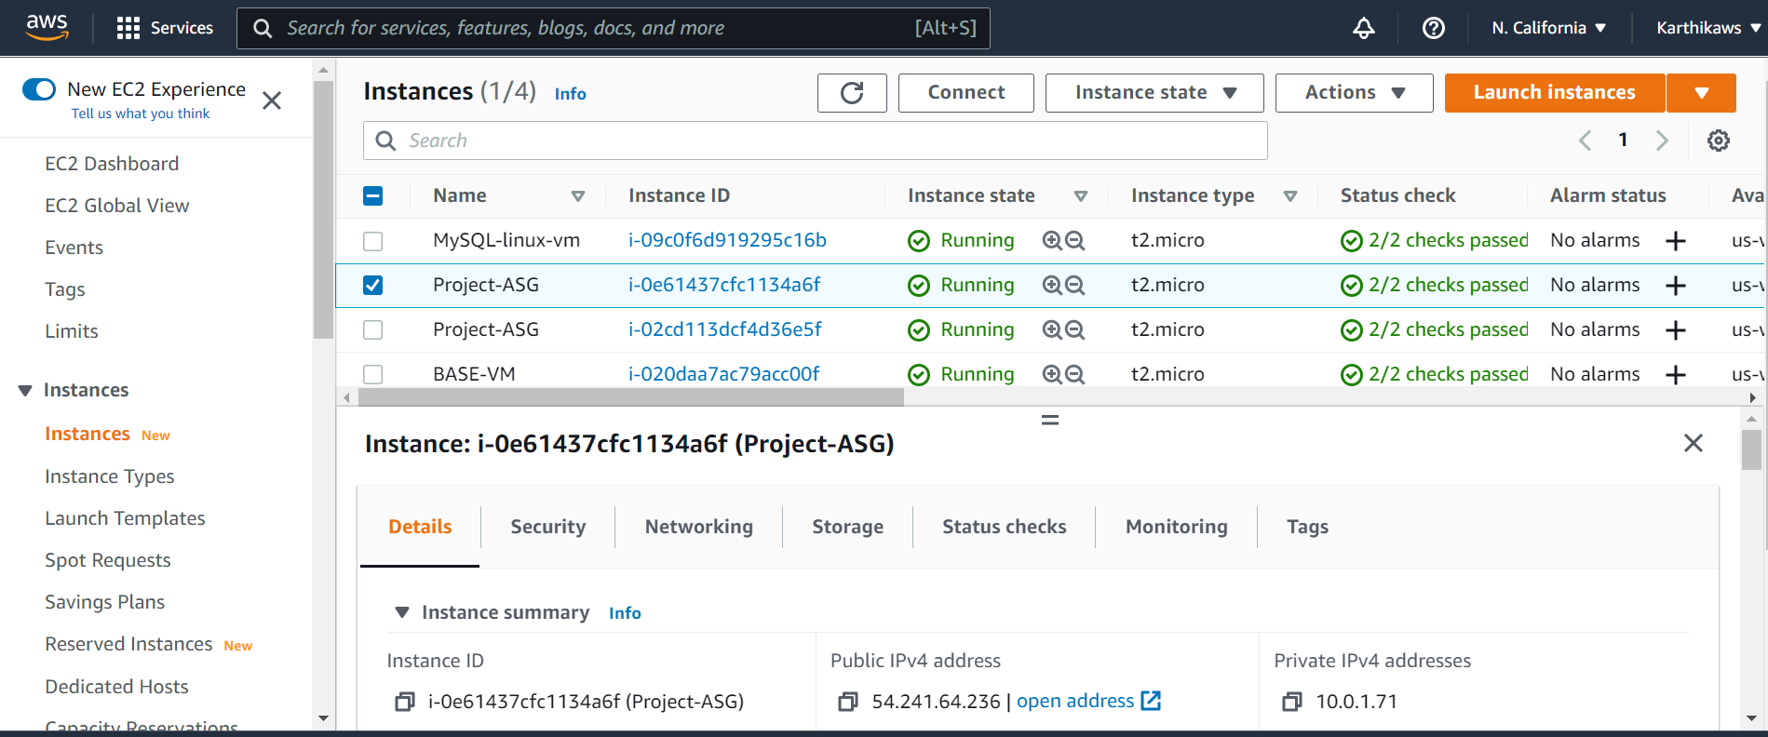

MYSQL instances

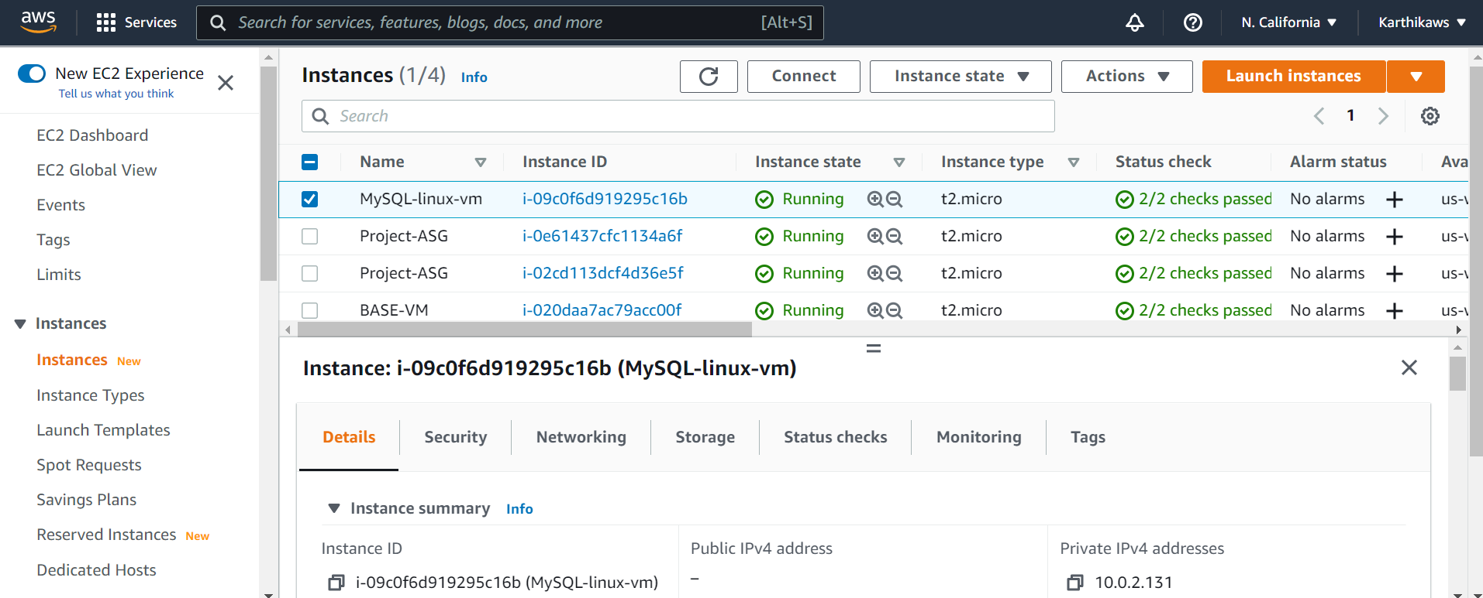

**Step3: Ansible**

ASG EC2 instance and private instance set as remote nodes in ansible server

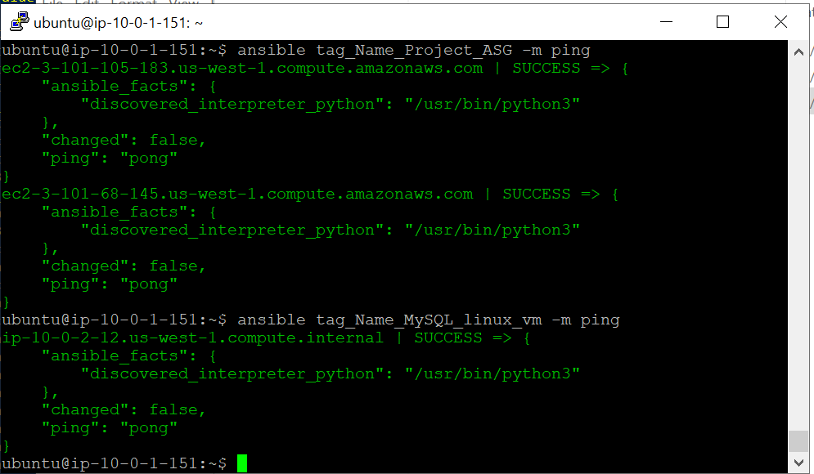

Apache server installed

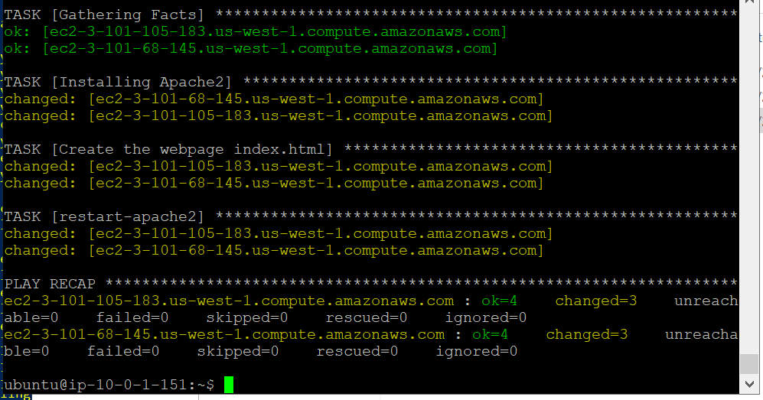

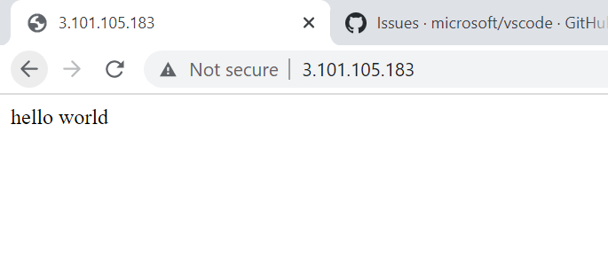

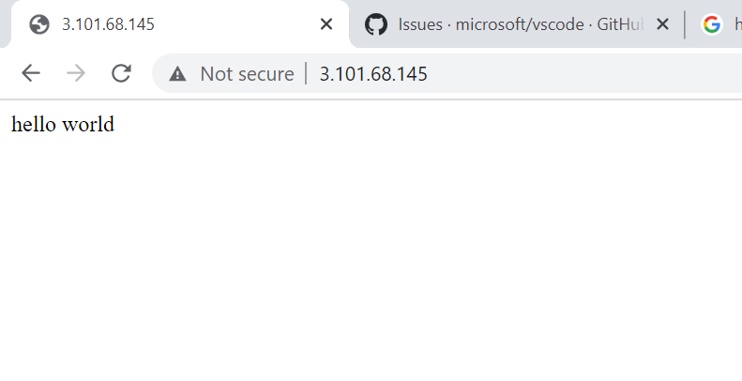

Installed MySQL

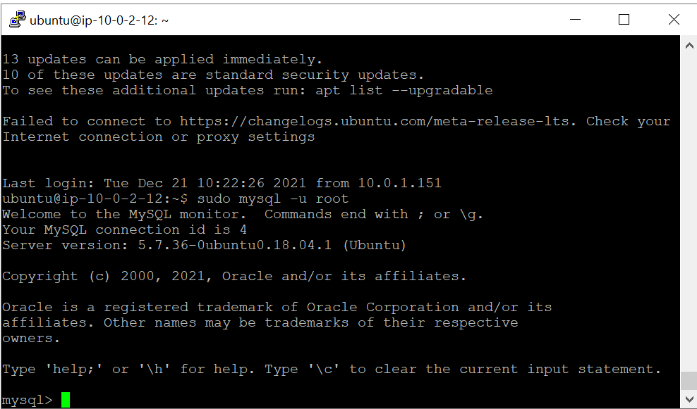

**PART-2 Secure Communication and Security Management for Application (Manual Configuration)**

Route53 Configuration for VPC internal communication:

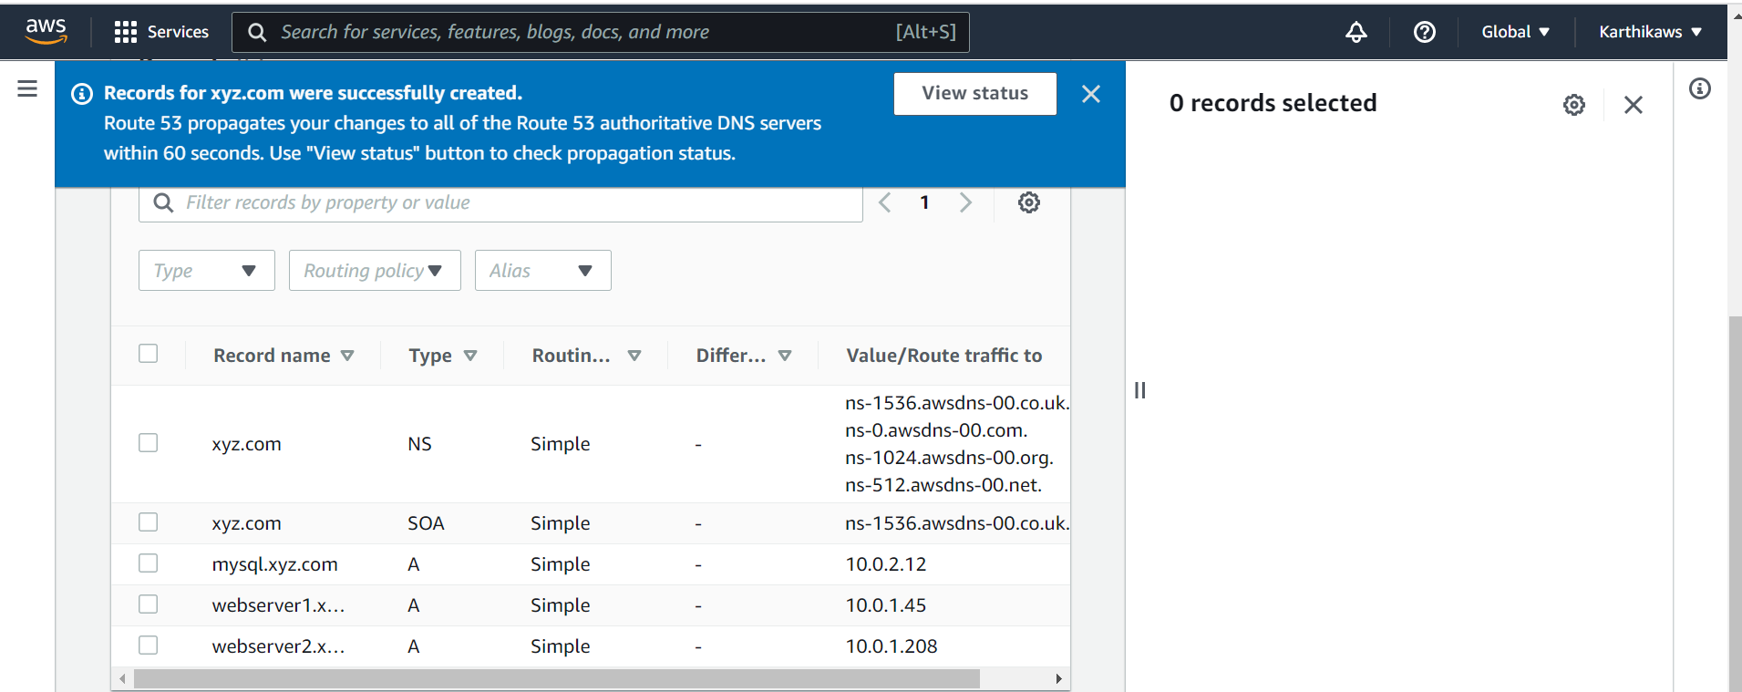

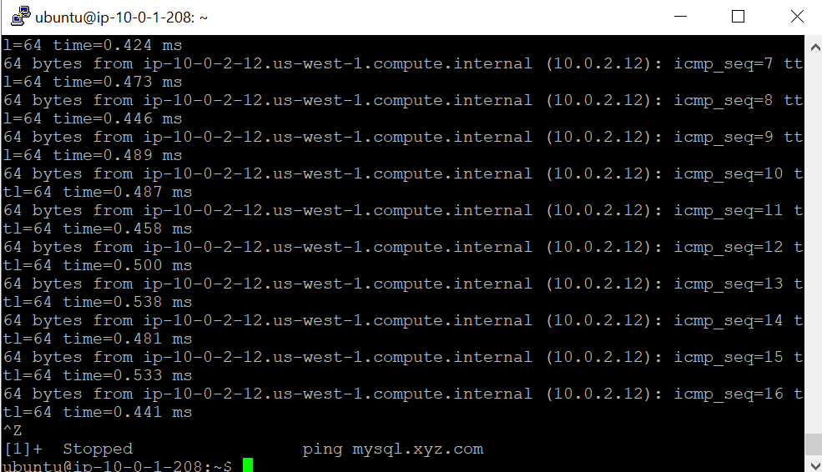

MySQL DB (EC2) should be accessible only from ASG (Webserver Cluster) Hint: Security Groups

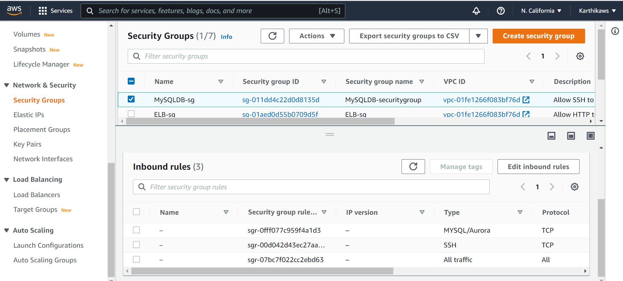

Create user to manage application infrastructure (VPC, Route53, EC2) Hint: IAM Policies

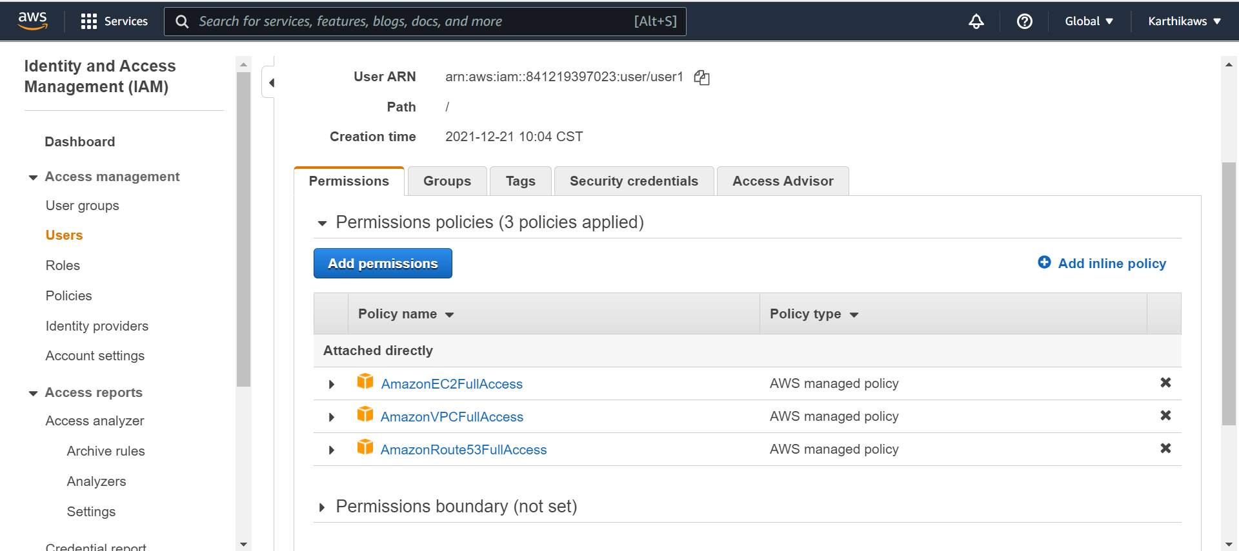

S3 Bucket to store log files:

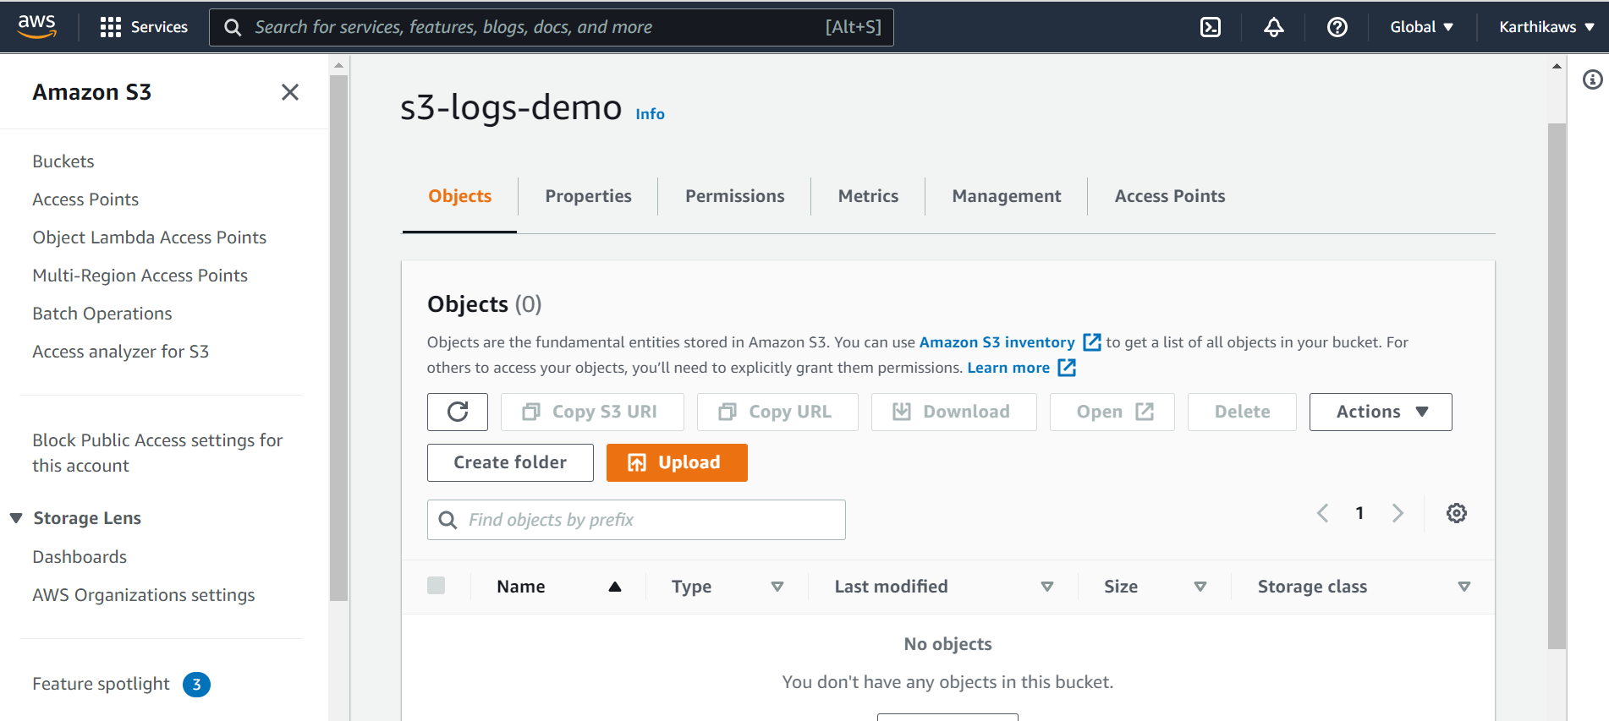

All EC2 instances should have permission to access S3 Hints: IAM Roles

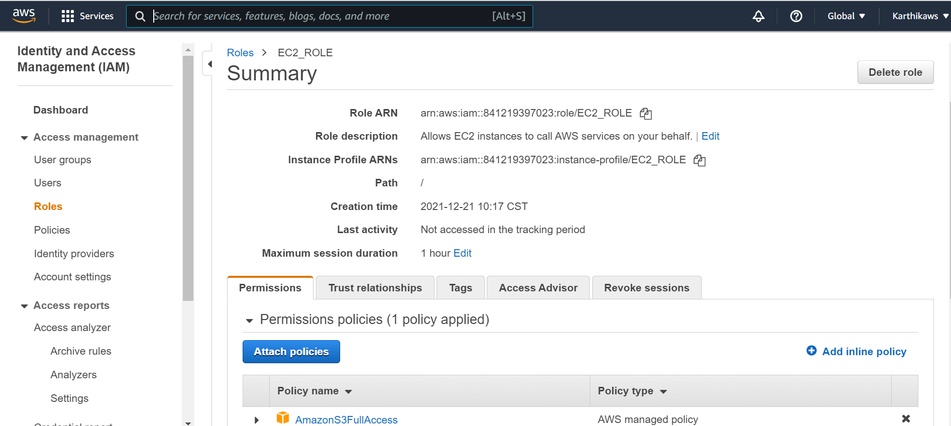

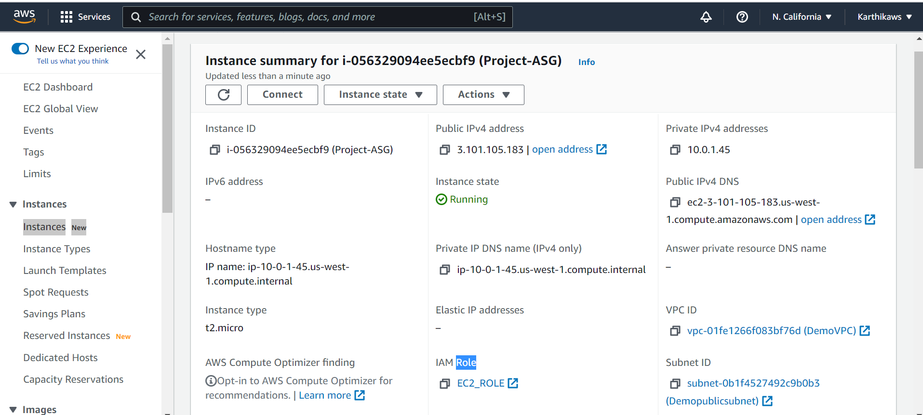

**PART-3 Monitoring App and App Infrastructure (Manual Configuration)**

**Create a CloudWatch Dashboard to monitor:**

