Assign 3
Search Remix IDE -> contracts -> Create new file Bank.sol in contracts
In Bank.sol first line will be licencse aggrement

SPDX : UNLICENSED

For Compile write Compiler version which you want to use
For Defining Soldity Compiler version write it’s version

Pragma solidity ^0.8.0;
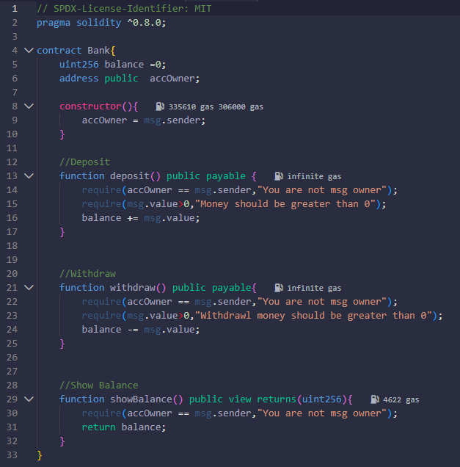
Now create Contract

Keywords :-
payable -> this given function will accept ether

After Writing code Compile and Deploy and then give input to it and see results

Assign 4.
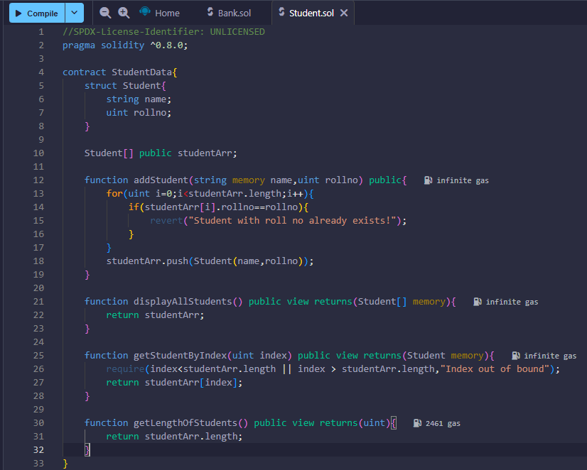

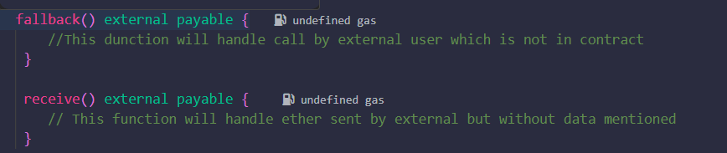
What is Ethereum?
Ans. Blockchain platform, Ethereum contains EVM (Ethereum Vrtual machine)
Any user who comes in Eth env gets EVM

What is cryptocurrency?
Ans.

What is Gas Value , Gas Limit and Gas Price?
Ans.
Gas Limit :- Price to reduce time
Gas Price :- Amount per work done

Fallback:-it is special function which handles if external user which is not contract try to perform any operation

Let’s break this down clearly 👇

🪙 1. Ethereum (ETHEREUM ≠ ETHER)
🔹 Definition
Ethereum is a blockchain-based decentralized computing platform.
It allows developers to build and deploy smart contracts — self-executing programs that run exactly as written, without downtime, censorship, or interference.
Think of Ethereum as a global computer that anyone can use — where programs (called dApps, or decentralized applications) run on thousands of distributed nodes worldwide.

🔹 Key Features
Feature | Description
Blockchain platform | Like Bitcoin, Ethereum maintains a public ledger of all transactions.
Smart Contracts | Small pieces of code that automatically execute when certain conditions are met.
dApps (Decentralized Apps) | Apps built on Ethereum that don’t rely on a central authority.
Decentralization | No single owner; maintained by thousands of computers (nodes).
Consensus Mechanism | Uses Proof of Stake (PoS) since The Merge (2022) — energy-efficient and secure.

💰 2. Ether (ETH)
🔹 Definition
Ether (ETH) is the cryptocurrency (native coin) of the Ethereum network.
It’s used to:
- Pay for computation (gas fees),
- Incentivize validators,
- Facilitate transactions between users.
You can think of Ether as the fuel that powers the Ethereum network.

🔹 Use Cases of Ether
Purpose | Description
Transaction fees (Gas) | Every time you perform an operation (like running a smart contract), you pay gas in ETH.
Store of value | Like Bitcoin, ETH can be held as an investment.
Staking | Validators lock ETH to secure the network and earn rewards.
Medium of exchange | You can buy/sell goods, NFTs, or use it within dApps.

🔹 Gas and Gas Fees
- Every operation on Ethereum consumes “gas” — a measure of computational effort.
- Users pay gas fees in Ether (ETH) to execute transactions or smart contracts.
- High demand → higher gas price (similar to surge pricing).

⚙️ 3. Example
Let’s say you deploy a smart contract that sends 1 ETH when a condition is met.
- You write and upload the smart contract on the Ethereum blockchain.
- The network charges you gas fees in ETH.
- When someone triggers the contract, the program runs automatically — no banks or intermediaries.

🧠 4. Ethereum vs Ether — Summary Table
Concept | Ethereum | Ether (ETH)
Type | Platform / Network | Cryptocurrency
Purpose | To run decentralized applications and smart contracts | To pay for transactions and computation
Analogy | Like a computer | Like the fuel that runs the computer
Launched | 2015 (by Vitalik Buterin) | 2015
Consensus | Proof of Stake (PoS) | —
Symbol | — | ETH

🧩 5. Quick Analogy
- Ethereum = the Internet
- Smart contracts = Websites/Apps
- Ether = Data or bandwidth charges you pay to use it

Would you like me to explain how Ethereum executes smart contracts (step-by-step, including gas calculation and blockchain confirmation)?

