**Project Design Phase-1SolutionArchitecture**

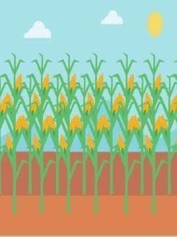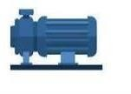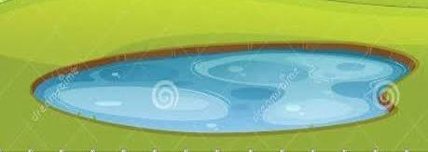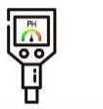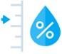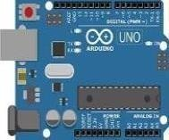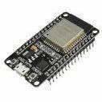

# **Date:** 16October2022

**Team ID:** PNT2022TMID43101

# **ProjectName:** IOTBASEDCROPPROTECTIONSYSTEMFORAGRICULTURE

Cameramodule

Temperaturesensor

Flamesensor

ArduinoMicro Gate way

PHlevelsensor controller module

Cellulartower

InternetCloud

Router

Waterand NowI can monitormy

moisturelevel farmfromanywhere at

sensor anytime

MotorPump