If we have an array start with 0index bydefault array contains 7 values we want check whether 27 present inside the array ore not

Our Array is :

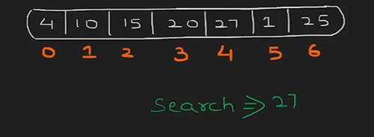

We want to find two cases :

1. Whether Element exist or not
2. If it Exist which index it might be Exist

There are two kind of Technique To Solve this Problem :

1. Linear Search (Step by Step Checking)
2. Binary Search

In Most of the Case we Use Binary Search Algorithm instead Linear

And Another Technique is Interpolation Search

Here we See About Linear Search

Code for Linear Search :

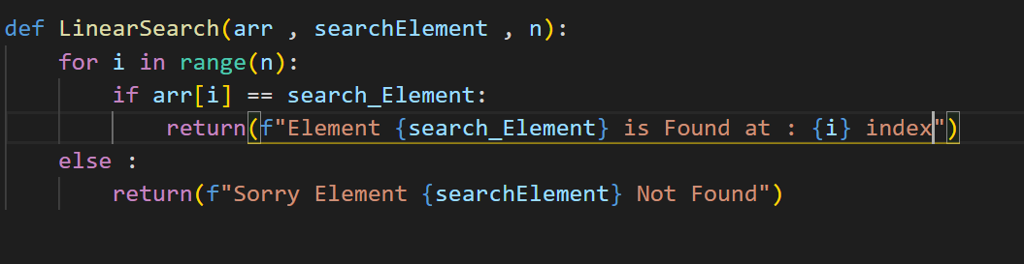

Here we go with one by one So we call it as a Linear Search

Time Complexity Of Linear Search



If this was our data , which is the best case

* Best case 🡪 4

Becozz when it search one by one it search at the first time itself

If best case the time complexity is 🡺 O(1) [Constant]

Best Case means no of Iteration(Scenario) is low

* Worst Case 🡪 25

Becozz when it search last time only this come

Worst Case Means number of Iteration is High (close to End of an Array

Worst Case Time Complexity is 🡪 O(n)

Average Case 🡪 4 , 10 , 15 , ….. , 25

It might we anything

Time complexity is : 1 + 2 + 3 …..+n /n

* N(n+1)/2/n
* N+1/2 is the time complexity

