Arrays-Overview

It is Most frequent and widely used Data Structure in Programming

What is an Array ?

It is a collection of data in a same type in a contiguous Memory

The Main Terms are : 1.) Same Type 2.) Contiguous Memory

1. Same Type :

It means we will store only Same data types in the array like we create a string array we only store collection of string in that store we can’t store int , float , or Boolean

Problem : If we want to store the marks of 1000 students , without array \* we create 1000 variable and store the thousand records.

If is bad approach here we waste our time and memory

* Instead of this we create a int array and store 1000 records in a single array , it is effective and time –memory consumption is low

Array will store by index , index start with 0 , if we want to see the 100th student record we use mark[99] 🡪 It will the 100th student record

2.)Contiguous Memory :

If we store the float array of 5 records ,how it stores in the memory

It will store in 1000th Memory address , so first record is for 1000 and 2nd record is for 1004 and third record is for 1008 becozz float holds 4 bytes in the memory

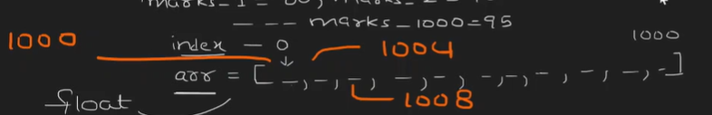

Here the Base Address is 1000 , it means which record store the first record it will be Base Address (Address of First Element inside an Array).

The Time Complexity of getting random record in the Array is Constant O(1)

It means if we need 145th record we directly use mark[144] it gives the 145 the value we don’t need to go all the element

If the Array is Int :

Integer will hold 2 bytes

