Memory Management



How we want To Allocate the memory using which Data-type like int , str , array , hash(dictionary) or user-defined dtype(class )

Saving a Memory Not only Save Your Memory also an Time Complexity

Hard Disk Vs Memory (ROM vs RAM) :

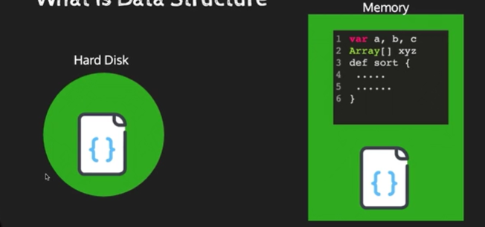

So if our Code is not in the Optimized way it will slow down Your Process (Memory).

Memory :

For Programming Aspects Memory is Divided into Three Blocks :

1. Code Loader
2. Stack
3. Heap

For ex when we use to edit Photo From Photoshop

Once we open the Photoshop it goes to the code loader then we open image it alloacate some blocl in our memory we called it as stack once we close the image it Free up the stack

but Heap doesn’t access directly

We use Heap using Pointer , In Python Pointer is Not There but some abstract datatype like sets are used heap (internal Pointer).

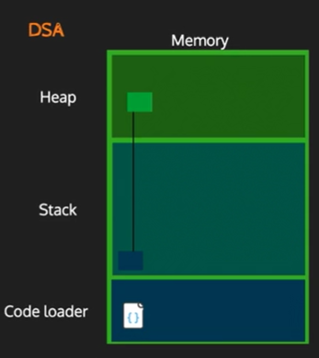

There are Two Types Of Data Structure(dtype) :

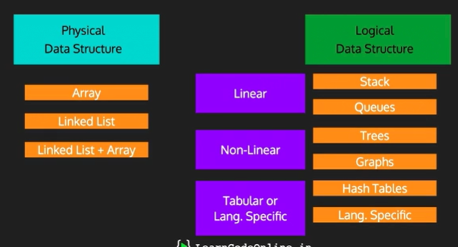

Language specific means Some special only on the language ex : DataFrame(in Python Pandas) DataTabel (in C#).

Abstract Data Type(ADT) :

If u add 2 + 2 🡺 4 ; then it normal datatype

If we add str 2 + str2 🡺 22 ; some one will written this this is Abstract data type

Some of ADT Datatype :

