1.using sll insert at end using random function and store it in a file
Code:
#include <stdio.h>
#include <stdlib.h>

struct Node {
int data;
struct Node* next;
};

void insertAtEnd(struct Node** head_ref, int newData) {
struct Node* newNode = (struct Node*)malloc(sizeof(struct Node));
struct Node* last = *head_ref;
newNode->data = newData;
newNode->next = NULL;
if (*head_ref == NULL) {
*head_ref = newNode;
return;
}
while (last->next != NULL) {
last = last->next;
}
last->next = newNode;
}

void displayList(struct Node* node) {
while (node != NULL) {
printf("%d\n", node->data);
node = node->next;
}
}

void writeToFile(struct Node* head) {
FILE* fp = fopen("linked_list.txt", "w");
while (head != NULL) {
fprintf(fp, "%d ", head->data);
head = head->next;
}
fclose(fp);
}

void readFromFile(struct Node** head_ref) {
FILE* fp = fopen("linked_list.txt", "r");
int data;
while (fscanf(fp, "%d", &data) != EOF) {
insertAtEnd(head_ref, data);
}
fclose(fp);
}

int main() {
struct Node* head = NULL;
int i;
for (i = 0; i < 5; i++) {
insertAtEnd(&head, rand() % 100); // Insert random numbers
}
printf("Initial linked list:\n ");
displayList(head);
writeToFile(head);
printf("Data written to file.\n");
printf("Reading from file...\n");
struct Node* new_head = NULL;
readFromFile(&new_head);
printf("Linked list after reading from file:\n ");
displayList(new_head);
return 0;
}

Output:
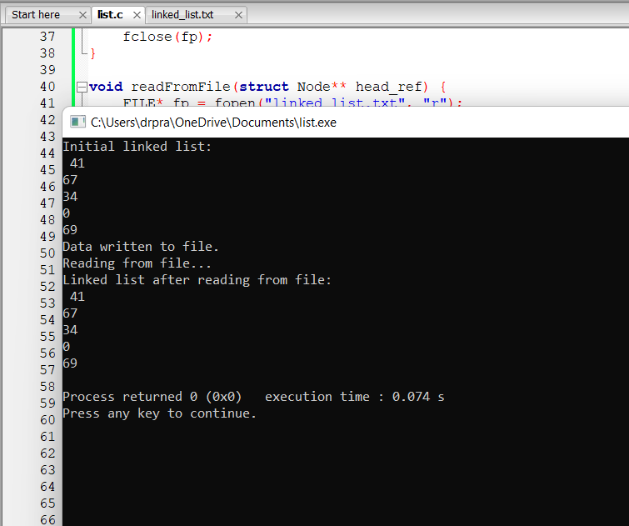
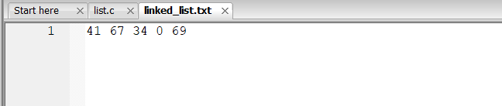
2.using sll insert at end using random function and insert elements in the front and store it in a file
Code: #include <stdio.h>
#include <stdlib.h>

struct Node {
int data;
struct Node* next;
};

void insertAtEnd(struct Node** head_ref, int newData) {
struct Node* newNode = (struct Node*)malloc(sizeof(struct Node));
struct Node* last = *head_ref;
newNode->data = newData;
newNode->next = NULL;
if (*head_ref == NULL) {
*head_ref = newNode;
return;
}
while (last->next != NULL) {
last = last->next;
}
last->next = newNode;
}

void insertAtFront(struct Node** head_ref, int newData) {
struct Node* newNode = (struct Node*)malloc(sizeof(struct Node));
newNode->data = newData;
newNode->next = *head_ref;
*head_ref = newNode;
}

void displayList(struct Node* node) {
while (node != NULL) {
printf("%d ", node->data);
node = node->next;
}
printf("\n");
}

void writeToFile(struct Node* head, const char* filename) {
FILE* fp = fopen(filename, "w");
if (fp == NULL) {
printf("Error opening file for writing.\n");
return;
}
while (head != NULL) {
fprintf(fp, "%d ", head->data);
head = head->next;
}
fclose(fp);
}

void readFromFile(struct Node** head_ref, const char* filename) {
FILE* fp = fopen(filename, "r");
if (fp == NULL) {
printf("Error opening file for reading.\n");
return;
}
int data;
while (fscanf(fp, "%d", &data) != EOF) {
insertAtEnd(head_ref, data);
}
fclose(fp);
}

int main() {
struct Node* head = NULL;
const char* filename = "linked_list.txt";
int i;

// Insert elements at the end and store in a file
for ( i = 0; i < 5; i++) {
insertAtEnd(&head, rand() % 100); // Insert random numbers
}
printf("Initial linked list:\n");
displayList(head);
writeToFile(head, filename);
printf("Data written to file '%s'.\n", filename);

// Read from file, insert elements at the front, and store in another file
struct Node* new_head = NULL;
const char* new_filename = "updated_list.txt";
readFromFile(&new_head, filename);
printf("Linked list after reading from file:\n");
displayList(new_head);

// Insert two elements at the front generated randomly
for ( i = 0; i <2; i++) {
insertAtFront(&new_head, rand() % 100);
}
printf("Linked list after inserting elements at the front:\n");
displayList(new_head);

// Write the updated list to another file
writeToFile(new_head, new_filename);
printf("Updated data written to file '%s'.\n", new_filename);

return 0;
}
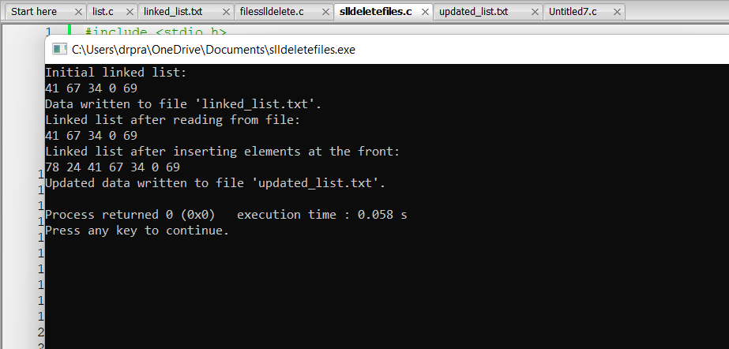
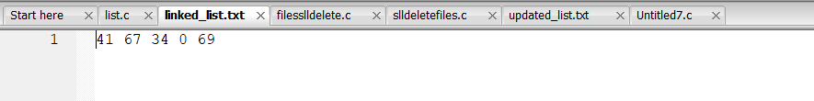
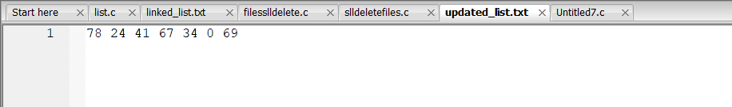
3.using sll insert at end using random function and delete elements in the front and store it in a file
Code:
#include <stdio.h>
#include <stdlib.h>

struct Node {
int data;
struct Node* next;
};

void insertAtEnd(struct Node** head_ref, int newData) {
struct Node* newNode = (struct Node*)malloc(sizeof(struct Node));
struct Node* last = *head_ref;
newNode->data = newData;
newNode->next = NULL;
if (*head_ref == NULL) {
*head_ref = newNode;
return;
}
while (last->next != NULL) {
last = last->next;
}
last->next = newNode;
}

void insertAtFront(struct Node** head_ref, int newData) {
struct Node* newNode = (struct Node*)malloc(sizeof(struct Node));
newNode->data = newData;
newNode->next = *head_ref;
*head_ref = newNode;
}

void displayList(struct Node* node) {
while (node != NULL) {
printf("%d ", node->data);
node = node->next;
}
printf("\n");
}

void writeToFile(struct Node* head, const char* filename) {
FILE* fp = fopen(filename, "w");
if (fp == NULL) {
printf("Error opening file for writing.\n");
return;
}
while (head != NULL) {
fprintf(fp, "%d ", head->data);
head = head->next;
}
fclose(fp);
}

void readFromFile(struct Node** head_ref, const char* filename) {
FILE* fp = fopen(filename, "r");
if (fp == NULL) {
printf("Error opening file for reading.\n");
return;
}
int data;
while (fscanf(fp, "%d", &data) != EOF) {
insertAtEnd(head_ref, data);
}
fclose(fp);
}

void deleteFront(struct Node** head_ref) {
if (*head_ref == NULL) {
printf("List is empty. Cannot delete.\n");
return;
}
struct Node* temp = *head_ref;
*head_ref = (*head_ref)->next;
free(temp);
}

int main() {
struct Node* head = NULL;
const char* filename = "linked_list.txt";
int i;

// Insert elements at the end and store in a file
for ( i = 0; i < 5; i++) {
insertAtEnd(&head, rand() % 100); // Insert random numbers
}
printf("Initial linked list:\n");
displayList(head);
writeToFile(head, filename);
printf("Data written to file '%s'.\n", filename);

// Read from file, insert elements at the front, and store in another file
struct Node* new_head = NULL;
const char* new_filename = "updated_list.txt";
readFromFile(&new_head, filename);
printf("Linked list after reading from file:\n");
displayList(new_head);

// Delete first two elements from the front
deleteFront(&new_head);
deleteFront(&new_head);
printf("Linked list after deleting first two elements from the front:\n");
displayList(new_head);

// Write the updated list to another file
writeToFile(new_head, new_filename);
printf("Updated data written to file '%s'.\n", new_filename);

return 0;
}
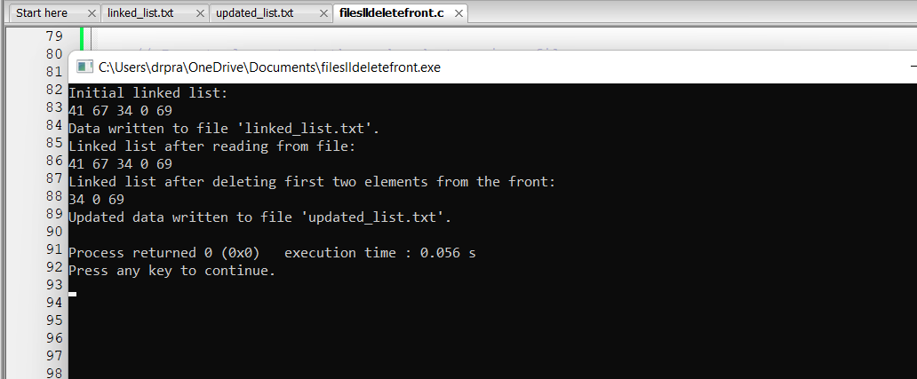
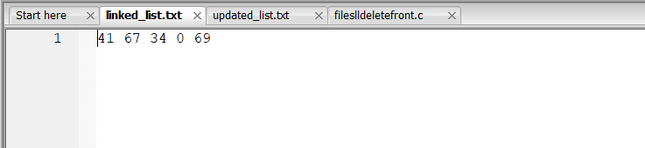
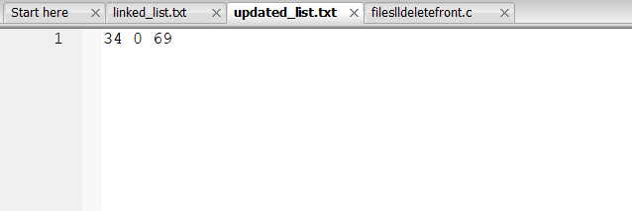
4.using sll insert at end using random function and delete elements in the front and store it in a file
#include <stdio.h>
#include <stdlib.h>

// Define the structure for the linked list node
struct Node {
int data;
struct Node* next;
};

// Function to insert a new node with data at the end of the linked list
void insertAtEnd(struct Node** head_ref, int newData) {
struct Node* newNode = (struct Node*)malloc(sizeof(struct Node));
struct Node* last = *head_ref;
newNode->data = newData;
newNode->next = NULL;
if (*head_ref == NULL) {
*head_ref = newNode;
return;
}
while (last->next != NULL) {
last = last->next;
}
last->next = newNode;
}

// Function to insert a new node with data at the front of the linked list
void insertAtFront(struct Node** head_ref, int newData) {
struct Node* newNode = (struct Node*)malloc(sizeof(struct Node));
newNode->data = newData;
newNode->next = *head_ref;
*head_ref = newNode;
}

// Function to display the contents of the linked list
void displayList(struct Node* node) {
while (node != NULL) {
printf("%d ", node->data);
node = node->next;
}
printf("\n");
}

// Function to write the contents of the linked list to a file
void writeToFile(struct Node* head, const char* filename) {
FILE* fp = fopen(filename, "w");
if (fp == NULL) {
printf("Error opening file for writing.\n");
return;
}
while (head != NULL) {
fprintf(fp, "%d ", head->data);
head = head->next;
}
fclose(fp);
}

// Function to read the contents of the linked list from a file
void readFromFile(struct Node** head_ref, const char* filename) {
FILE* fp = fopen(filename, "r");
if (fp == NULL) {
printf("Error opening file for reading.\n");
return;
}
int data;
while (fscanf(fp, "%d", &data) != EOF) {
insertAtEnd(head_ref, data);
}
fclose(fp);
}

// Function to insert a new node with data at a specified position in the linked list
void insertAtPosition(struct Node** head_ref, int newData, int position) {
int i;
if (position <= 0) {
printf("Invalid position.\n");
return;
}
if (position == 1) {
insertAtFront(head_ref, newData);
return;
}
struct Node* current = *head_ref;
for ( i = 1; i < position - 1 && current != NULL; i++) {
current = current->next;
}
if (current == NULL) {
printf("Position exceeds the length of the list.\n");
return;
}
struct Node* newNode = (struct Node*)malloc(sizeof(struct Node));
newNode->data = newData;
newNode->next = current->next;
current->next = newNode;
}

int main() {
struct Node* head = NULL;
const char* filename = "linked_list.txt";
int position,i;

// Insert elements at the end and store in a file
for ( i = 0; i < 5; i++) {
insertAtEnd(&head, rand() % 100); // Insert random numbers
}
printf("Initial linked list:\n");
displayList(head);
writeToFile(head, filename);
printf("Data written to file '%s'.\n", filename);

// Read from file, insert elements at the specified position, and store in another file
struct Node* new_head = NULL;
const char* new_filename = "updated_list.txt";
readFromFile(&new_head, filename);
printf("Linked list after reading from file:\n");
displayList(new_head);

printf("Enter the position to insert elements at the front: ");
scanf("%d", &position);
insertAtPosition(&new_head, rand() % 100, position);
printf("Linked list after inserting elements at position %d:\n", position);
displayList(new_head);

// Write the updated list to another file
writeToFile(new_head, new_filename);
printf("Updated data written to file '%s'.\n", new_filename);

return 0;
}
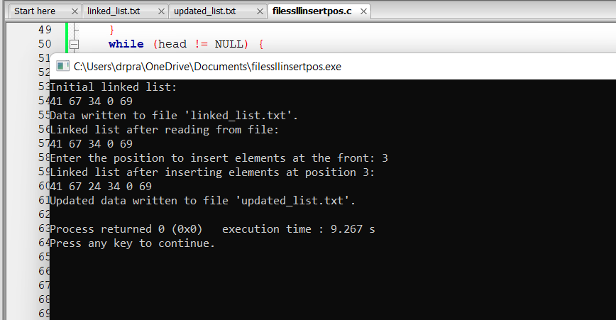
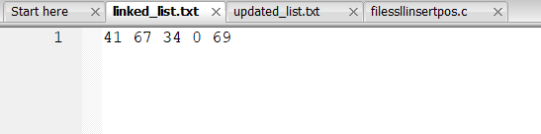
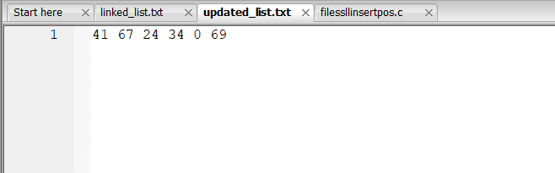
5.using cll insert at end using random function and store it in a file
Code:
#include <stdio.h>
#include <stdlib.h>
#include <time.h>

struct Node {
int data;
struct Node* next;
};

void insertAtEnd(struct Node** head_ref, int newData) {
struct Node* newNode = (struct Node*)malloc(sizeof(struct Node));
struct Node* last = *head_ref;
newNode->data = newData;
newNode->next = newNode; // Circular singly linked list

if (*head_ref == NULL) {
*head_ref = newNode;
return;
}

while (last->next != *head_ref) {
last = last->next;
}

last->next = newNode;
newNode->next = *head_ref;
}

void displayList(struct Node* head) {
struct Node* temp = head;

if (head != NULL) {
do {
printf("%d\n", temp->data);
temp = temp->next;
} while (temp != head);
}
}

void writeToFile(struct Node* head, const char* filename) {
FILE* fp = fopen(filename, "w");
struct Node* temp = head;

if (head != NULL) {
do {
fprintf(fp, "%d ", temp->data);
temp = temp->next;
} while (temp != head);
}
fclose(fp);
}

void readFromFile(struct Node** head_ref, const char* filename) {
FILE* fp = fopen(filename, "r");
int data;

while (fscanf(fp, "%d", &data) != EOF) {
insertAtEnd(head_ref, data);
}
fclose(fp);
}

int main() {
int i;
struct Node* head = NULL;

// Seed the random number generator
srand(time(NULL));

// Generate and insert random numbers
for ( i = 0; i < 5; ++i) {
insertAtEnd(&head, rand() % 100);
}

printf("Initial circular linked list:\n");
displayList(head);

writeToFile(head, "circular_linked_list.txt");
printf("Data written to file.\n");

struct Node* new_head = NULL;
readFromFile(&new_head, "circular_linked_list.txt");
printf("Linked list after reading from file:\n");
displayList(new_head);

writeToFile(new_head, "updated_circular_linked_list.txt");
printf("Updated list with two elements inserted at front written to file.\n");

return 0;
}
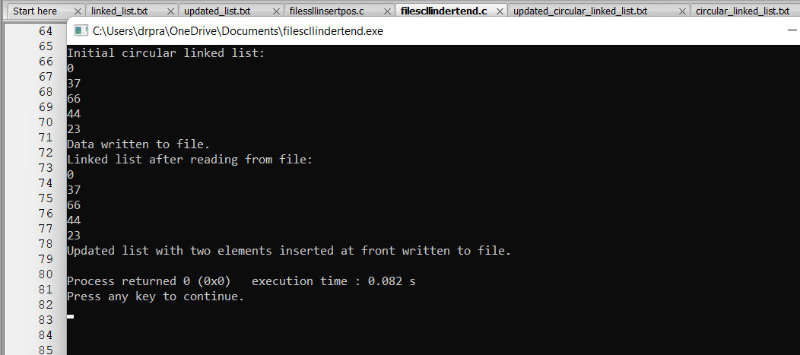
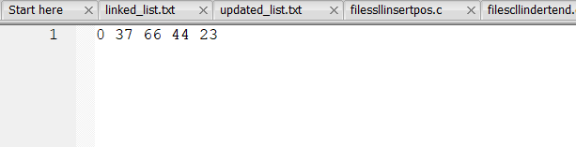
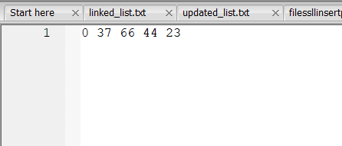
6.using cll insert at end using random function and search a given element
#include <stdlib.h>
#include <time.h>

struct Node {
int data;
struct Node* next;
};

void insertAtEnd(struct Node** head_ref, int newData) {
struct Node* newNode = (struct Node*)malloc(sizeof(struct Node));
struct Node* last = *head_ref;
newNode->data = newData;
newNode->next = newNode; // Circular singly linked list

if (*head_ref == NULL) {
*head_ref = newNode;
return;
}

while (last->next != *head_ref) {
last = last->next;
}

last->next = newNode;
newNode->next = *head_ref;
}

void displayList(struct Node* head) {
struct Node* temp = head;

if (head != NULL) {
do {
printf("%d\n", temp->data);
temp = temp->next;
} while (temp != head);
}
}

void writeToFile(struct Node* head, const char* filename) {
FILE* fp = fopen(filename, "w");
struct Node* temp = head;

if (head != NULL) {
do {
fprintf(fp, "%d ", temp->data);
temp = temp->next;
} while (temp != head);
}
fclose(fp);
}

void readFromFile(struct Node** head_ref, const char* filename) {
FILE* fp = fopen(filename, "r");
int data;

while (fscanf(fp, "%d", &data) != EOF) {
insertAtEnd(head_ref, data);
}
fclose(fp);
}

struct Node* search(struct Node* head, int key) {
struct Node* temp = head;
if (head == NULL)
return NULL;
do {
if (temp->data == key)
return temp;
temp = temp->next;
} while (temp != head);
return NULL;
}

int main() {
int i;
struct Node* head = NULL;

// Seed the random number generator
srand(time(NULL));

// Generate random numbers and insert into the list

for ( i = 0; i < 5; ++i) {
int newData = rand() % 100; // Generate random number between 0 and 99
insertAtEnd(&head, newData);
}

printf("Initial circular linked list:\n");
displayList(head);

writeToFile(head, "circular_linked_list.txt");
printf("Data written to file.\n");

struct Node* new_head = NULL;
readFromFile(&new_head, "circular_linked_list.txt");
printf("Linked list after reading from file:\n");
displayList(new_head);

// Ask the user for the element to search
int searchKey;
printf("Enter the element to search: ");
scanf("%d", &searchKey);

// Search for the element in the list
struct Node* foundNode = search(new_head, searchKey);

if (foundNode != NULL)
printf("Element %d found in the list.\n", searchKey);
else
printf("Element %d not found in the list.\n", searchKey);

FILE* searchResultFile = fopen("search_result.txt", "w");
if (foundNode != NULL)
fprintf(searchResultFile, "Element %d found in the list.\n", searchKey);
else
fprintf(searchResultFile, "Element %d not found in the list.\n", searchKey);
fclose(searchResultFile);

return 0;
}
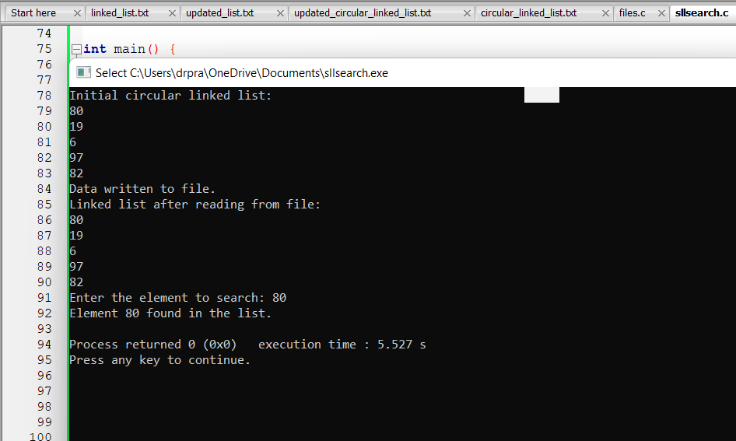
- Find the nth node in a linked list
#include <stdio.h>
#include <stdlib.h>

struct Node {
int data;
struct Node* next;
};

void insertAtEnd(struct Node** head_ref, int newData) {
struct Node* newNode = (struct Node*)malloc(sizeof(struct Node));
if (newNode == NULL) {
printf("Memory allocation failed\n");
return;
}
newNode->data = newData;
newNode->next = NULL;
if (*head_ref == NULL) {
*head_ref = newNode;
return;
}
struct Node* last = *head_ref;
while (last->next != NULL) {
last = last->next;
}
last->next = newNode;
}

int getNth(struct Node* head, int index) {
struct Node* current = head;
int count = 0;
while (current != NULL) {
if (count == index) {
return current->data;
}
count++;
current = current->next;
}
printf("Index out of bounds.\n");
return -1;
}

void writeToFile(struct Node* head, int index) {
FILE* fp = fopen("linked_list.txt", "w");
if (fp == NULL) {
printf("Failed to open file\n");
return;
}
int count = 0;
while (head != NULL) {
if (count == index) {
fprintf(fp, "%d ", head->data);
fclose(fp);
return;
}
count++;
head = head->next;
}
printf("Index out of bounds.\n");
}

void readFromFile(struct Node** head_ref) {
FILE* fp = fopen("linked_list.txt", "r");
if (fp == NULL) {
printf("Failed to open file\n");
return;
}
int data;
while (fscanf(fp, "%d", &data) != EOF) {
insertAtEnd(head_ref, data);
}
fclose(fp);
}

void displayList(struct Node* head) {
while (head != NULL) {
printf("%d ", head->data);
head = head->next;
}
printf("\n");
}

int main() {
struct Node* head = NULL;
int i;
for (i = 0; i < 5; i++) {
insertAtEnd(&head, rand() % 100); // Insert random numbers
}
printf("Linked list: ");
displayList(head);
int index = 2; // Get the element at index 2
printf("Element at index %d is: %d\n", index, getNth(head, index));
writeToFile(head, index);
printf("Element at index %d written to file.\n", index);
printf("Reading from file...\n");
struct Node* new_head = NULL;
readFromFile(&new_head);
printf("Linked list after reading from file: ");
displayList(new_head);
return 0;
}
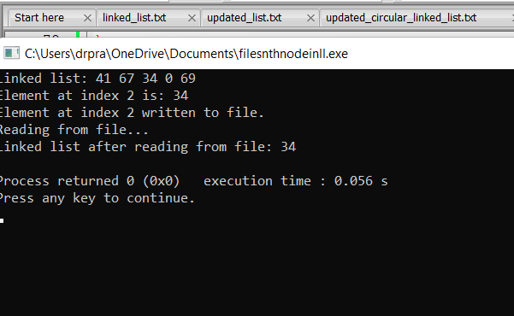
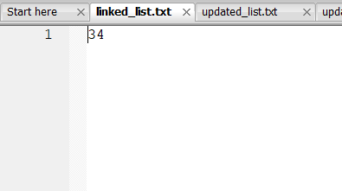
8.reverse a list using doubly linked list
Code:
#include <stdio.h>
#include <stdlib.h>
#include <time.h>

// Structure for a node in doubly linked list
struct Node {
int data;
struct Node* prev;
struct Node* next;
};

// Function to create a new node
struct Node* createNode(int data) {
struct Node* newNode = (struct Node*)malloc(sizeof(struct Node));
if (newNode == NULL) {
printf("Memory allocation failed\n");
exit(1);
}
newNode->data = data;
newNode->prev = NULL;
newNode->next = NULL;
return newNode;
}

// Function to insert a new node at the end of the list
void insertAtEnd(struct Node** head_ref, int data) {
struct Node* newNode = createNode(data);
if (*head_ref == NULL) {
*head_ref = newNode;
return;
}
struct Node* current = *head_ref;
while (current->next != NULL) {
current = current->next;
}
current->next = newNode;
newNode->prev = current;
}

// Function to display the doubly linked list
void displayList(struct Node* head) {
while (head != NULL) {
printf("%d \n", head->data);
head = head->next;
}
}

// Function to write the doubly linked list to a file
void writeToFile(struct Node* head, const char* filename) {
FILE* fp = fopen(filename, "w");
if (fp == NULL) {
printf("Error opening file for writing\n");
return;
}
while (head != NULL) {
fprintf(fp, "%d ", head->data);
head = head->next;
}
fclose(fp);
}

// Function to read the doubly linked list from a file
struct Node* readFromFile(const char* filename) {
struct Node* head = NULL;
FILE* fp = fopen(filename, "r");
if (fp == NULL) {
printf("Error opening file for reading\n");
return NULL;
}
int data;
while (fscanf(fp, "%d", &data) != EOF) {
insertAtEnd(&head, data);
}
fclose(fp);
return head;
}

// Function to reverse the doubly linked list
void reverseList(struct Node** head_ref) {
struct Node* current = *head_ref;
struct Node* temp = NULL;
while (current != NULL) {
temp = current->prev;
current->prev = current->next;
current->next = temp;
current = current->prev;
}
if (temp != NULL) {
*head_ref = temp->prev;
}
}

int main() {
struct Node* head = NULL;
int i;

// Seed random number generator
srand(time(NULL));

// Generate random numbers and insert into doubly linked list
for ( i = 0; i < 5; i++) {
insertAtEnd(&head, rand() % 100);
}

// Display the doubly linked list
printf("Doubly linked list:\n");
displayList(head);

// Write the doubly linked list to a file
writeToFile(head, "linked_list.txt");
printf("Doubly linked list written to file.\n");

// Reverse the doubly linked list
reverseList(&head);
printf("Reversed doubly linked list:\n");
displayList(head);

// Write the reversed doubly linked list to another file
writeToFile(head, "updated_list.txt");
printf("Reversed doubly linked list written to file.\n");

// Free memory allocated for current list
struct Node* temp = head;
while (head != NULL) {
temp = head;
head = head->next;
free(temp);
}

// Read the doubly linked list from the file
head = readFromFile("reversed_doubly_linked_list.txt");

// Display the doubly linked list read from file
printf("Doubly linked list read from file:\n");
displayList(head);

// Free memory allocated for the list read from file
while (head != NULL) {
temp = head;
head = head->next;
free(temp);
}

return 0;
}
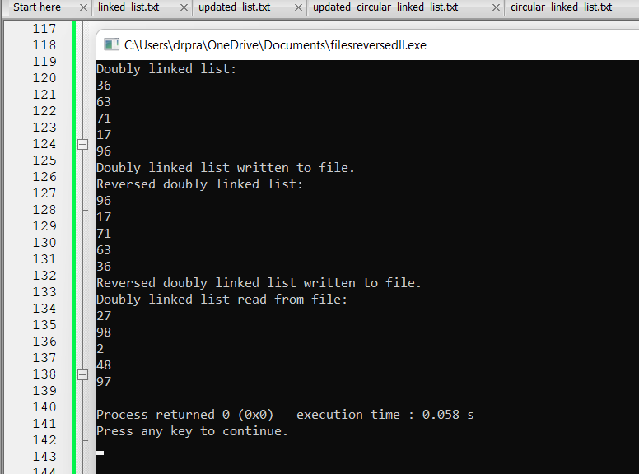
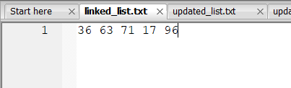
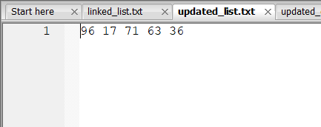
- Find the middle node in circular doubly linked list
Code:
#include <stdio.h>
#include <stdlib.h>
#include <time.h>

// Structure for a node in circular doubly linked list
struct Node {
int data;
struct Node* prev;
struct Node* next;
};

// Function to create a new node
struct Node* createNode(int data) {
struct Node* newNode = (struct Node*)malloc(sizeof(struct Node));
if (newNode == NULL) {
printf("Memory allocation failed\n");
exit(1);
}
newNode->data = data;
newNode->prev = NULL;
newNode->next = NULL;
return newNode;
}

// Function to insert a new node at the end of the list
void insertAtEnd(struct Node** head_ref, int data) {
struct Node* newNode = createNode(data);
if (*head_ref == NULL) {
*head_ref = newNode;
(*head_ref)->next = newNode;
(*head_ref)->prev = newNode;
return;
}
struct Node* last = (*head_ref)->prev;
last->next = newNode;
newNode->prev = last;
newNode->next = *head_ref;
(*head_ref)->prev = newNode;
}

// Function to display the circular doubly linked list
void displayList(struct Node* head) {
if (head == NULL) {
printf("Empty List\n");
return;
}
struct Node* current = head;
do {
printf("%d\n ", current->data);
current = current->next;
} while (current != head);
}

// Function to generate a circular doubly linked list with random data
struct Node* generateRandomList(int size) {
int i;
struct Node* head = NULL;
srand(time(NULL)); // Seed the random number generator
for ( i = 0; i < size; i++) {
int randomData = rand() % 100; // Generate random data (0 to 99)
insertAtEnd(&head, randomData);
}
return head;
}

// Function to find the middle node of the circular doubly linked list
struct Node* findMiddle(struct Node* head) {
if (head == NULL) {
printf("Empty List\n");
return NULL;
}
struct Node* slow = head;
struct Node* fast = head;
while (fast->next != head && fast->next->next != head) {
slow = slow->next;
fast = fast->next->next;
}
return slow;
}

// Function to store the middle node's data in a file
void storeMiddleToFile(struct Node* middleNode, const char* filename) {
FILE* fp = fopen(filename, "w");
if (fp == NULL) {
printf("Error opening file\n");
exit(1);
}
fprintf(fp, "%d", middleNode->data);
fclose(fp);
}

int main() {
// Generate a circular doubly linked list with random data
struct Node* head = generateRandomList(5); // Generate 5 random elements

// Display the circular doubly linked list
printf("Circular Doubly linked list with random data:\n");
displayList(head);

// Find the middle node of the list
struct Node* middleNode = findMiddle(head);
if (middleNode != NULL) {
printf("Middle node has data: %d\n", middleNode->data);

// Store the middle node's data in a file
storeMiddleToFile(middleNode, "updated_list.txt");
printf("Middle node's data stored in updated_list.txt\n");
}

return 0;
}
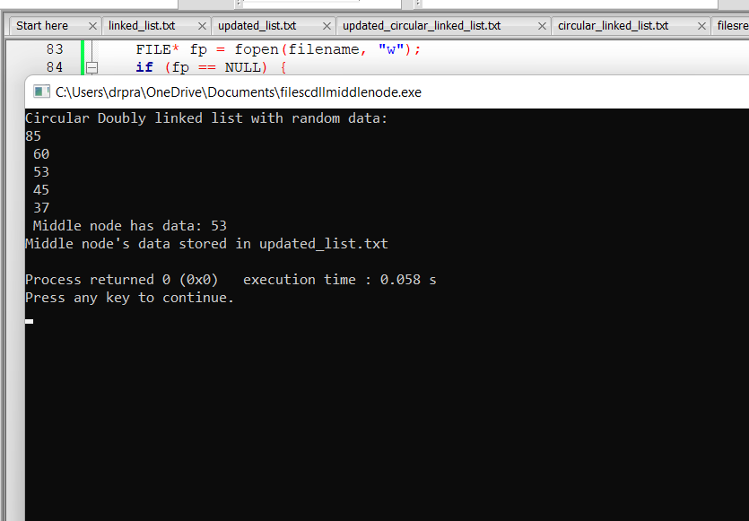
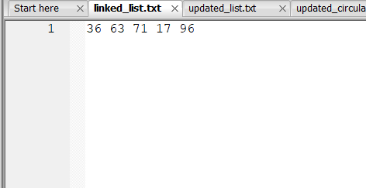
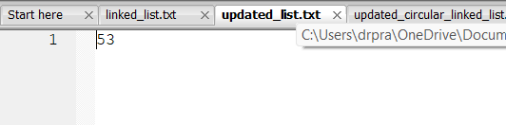
10.find the largest number in the list
#include <stdio.h>
#include <stdlib.h>
#include <time.h>

// Structure for a node in the circular doubly linked list
struct Node {
int data;
struct Node* prev;
struct Node* next;
};

// Function to create a new node
struct Node* createNode(int data) {
struct Node* newNode = (struct Node*)malloc(sizeof(struct Node));
if (newNode == NULL) {
printf("Memory allocation failed\n");
exit(1);
}
newNode->data = data;
newNode->prev = NULL;
newNode->next = NULL;
return newNode;
}

// Function to insert a new node at the end of the list
void insertAtEnd(struct Node** head_ref, int data) {
struct Node* newNode = createNode(data);
if (*head_ref == NULL) {
*head_ref = newNode;
(*head_ref)->next = newNode;
(*head_ref)->prev = newNode;
} else {
struct Node* last = (*head_ref)->prev;
last->next = newNode;
newNode->prev = last;
newNode->next = *head_ref;
(*head_ref)->prev = newNode;
}
}

// Function to display the circular doubly linked list
void displayList(struct Node* head) {
if (head == NULL) {
printf("List is empty\n");
return;
}
struct Node* current = head;
do {
printf("%d ", current->data);
current = current->next;
} while (current != head);
printf("\n");
}

// Function to find the largest number in the circular doubly linked list
int findLargest(struct Node* head) {
if (head == NULL)
return -1; // Assuming -1 represents an error or invalid value
int max = head->data;
struct Node* current = head->next;
while (current != head) {
if (current->data > max) {
max = current->data;
}
current = current->next;
}
return max;
}

// Function to write the largest number in the list to a file
void writeLargestToFile(int largest, const char* filename) {
FILE* fp = fopen(filename, "w");
if (fp == NULL) {
printf("Error opening file\n");
exit(1);
}
fprintf(fp, "%d\n", largest); // Write the largest number followed by a newline
fclose(fp);
}

// Function to generate a random number between min and max
int getRandom(int min, int max) {
return rand() % (max - min + 1) + min;
}

int main() {
int i;
struct Node* head = NULL;

// Seed the random number generator
srand(time(NULL));

// Generate a circular doubly linked list with random numbers
for ( i = 0; i < 5; i++) {
int randomNum = getRandom(1, 100); // Generate random number between 1 and 100
insertAtEnd(&head, randomNum);
}

// Display the circular doubly linked list
printf("Circular Doubly Linked List: ");
displayList(head);

// Find the largest number in the list
int largest = findLargest(head);
if (largest != -1) {
printf("Largest number in the list: %d\n", largest);
// Write the largest number to a file
writeLargestToFile(largest, "largest_number.txt");
printf("Largest number written to file\n");
} else {
printf("List is empty\n");
}

return 0;
}
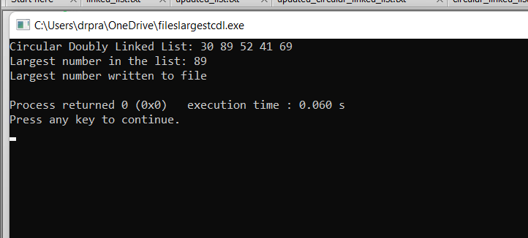
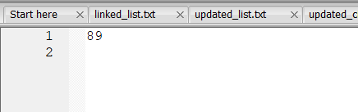
11.To push the elements into stack
#include <stdio.h>
#include <stdlib.h>
#include <time.h>

#define MAX_SIZE 100 // Maximum size of the stack
#define FILENAME "stack_elements.txt" // Name of the file to store stack elements

// Structure to represent a stack
struct Stack {
int items[MAX_SIZE];
int top;
};

// Function to initialize the stack
void initializeStack(struct Stack* stack) {
stack->top = -1; // Initialize top to -1 to indicate an empty stack
}

// Function to check if the stack is empty
int isEmpty(struct Stack* stack) {
return stack->top == -1; // Returns 1 if the stack is empty, otherwise 0
}

// Function to check if the stack is full
int isFull(struct Stack* stack) {
return stack->top == MAX_SIZE - 1; // Returns 1 if the stack is full, otherwise 0
}

// Function to push an element onto the stack
void push(struct Stack* stack, int value) {
if (isFull(stack)) {
printf("Stack Overflow: Cannot push element, stack is full\n");
} else {
stack->top++; // Increment top
stack->items[stack->top] = value; // Store the value at the top of the stack
printf("%d pushed to stack\n", value);
}
}

// Function to generate a random number between min and max
int getRandom(int min, int max) {
return rand() % (max - min + 1) + min;
}

// Function to display the elements in the stack
void display(struct Stack* stack) {
int i;
if (isEmpty(stack)) {
printf("Stack is empty\n");
} else {
printf("Stack elements: ");
for ( i = 0; i <= stack->top; i++) {
printf("%d ", stack->items[i]);
}
printf("\n");
}
}

// Function to save stack elements to a file
void saveToFile(struct Stack* stack) {
int i;
FILE* file = fopen(FILENAME, "w");
if (file == NULL) {
printf("Error opening file for writing\n");
return;
}

for ( i = 0; i <= stack->top; i++) {
fprintf(file, "%d\n", stack->items[i]);
}

fclose(file);
}

int main() {
int i;
struct Stack stack;
initializeStack(&stack);

// Seed the random number generator
srand(time(NULL));

// Generate a stack with random elements
for ( i = 0; i < 5; i++) {
int randomNum = getRandom(1, 100); // Generate random number between 1 and 100
push(&stack, randomNum);
}

// Save stack elements to file
saveToFile(&stack);

// Display the stack
display(&stack);

return 0;
}
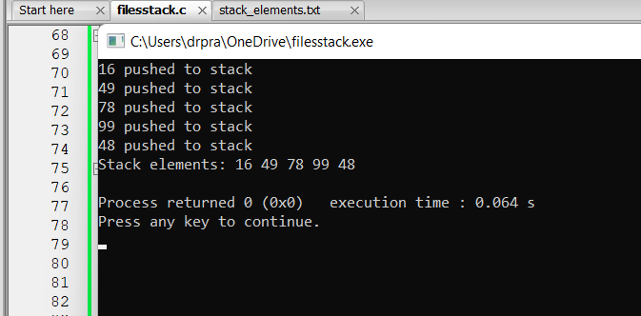
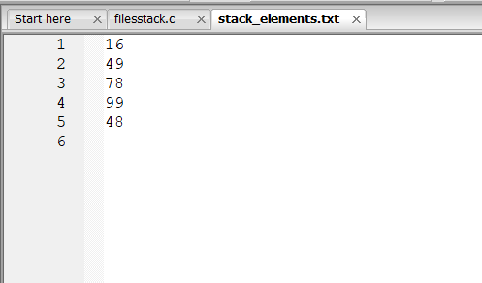
12.store the alternate stack elements in a file
Code:
#include <stdio.h>
#include <stdlib.h>
#include <time.h>

#define MAX_SIZE 100 // Maximum size of the stack
#define FILENAME "stack_elements.txt" // Name of the file to store stack elements
#define ALTERNATE_FILENAME "alternate_elements.txt" // Name of the file to store alternate elements

// Structure to represent a stack
struct Stack {
int items[MAX_SIZE];
int top;
};

// Function to initialize the stack
void initializeStack(struct Stack* stack) {
stack->top = -1; // Initialize top to -1 to indicate an empty stack
}

// Function to check if the stack is empty
int isEmpty(struct Stack* stack) {
return stack->top == -1; // Returns 1 if the stack is empty, otherwise 0
}

// Function to check if the stack is full
int isFull(struct Stack* stack) {
return stack->top == MAX_SIZE - 1; // Returns 1 if the stack is full, otherwise 0
}

// Function to push an element onto the stack
void push(struct Stack* stack, int value) {
if (isFull(stack)) {
printf("Stack Overflow: Cannot push element, stack is full\n");
} else {
stack->top++; // Increment top
stack->items[stack->top] = value; // Store the value at the top of the stack
printf("%d pushed to stack\n", value);
}
}

// Function to pop an element from the stack
int pop(struct Stack* stack) {
if (isEmpty(stack)) {
printf("Stack Underflow: Cannot pop element, stack is empty\n");
return -1; // Return -1 indicating failure
} else {
int popped = stack->items[stack->top]; // Get the top element
stack->top--; // Decrement top
return popped; // Return the popped element
}
}

// Function to save stack elements to a file
void saveToFile(struct Stack* stack, const char* filename) {
int i;
FILE* file = fopen(filename, "w");
if (file == NULL) {
printf("Error opening file for writing\n");
return;
}

for ( i = 0; i <= stack->top; i++) {
fprintf(file, "%d\n", stack->items[i]);
}

fclose(file);
}

// Function to pop alternate elements from the stack and store them in a file
void popAndStoreAlternateToFile(struct Stack* stack, const char* filename) {
FILE* file = fopen(filename, "w");
if (file == NULL) {
printf("Error opening file for writing\n");
return;
}

// Flag to toggle between popping and skipping elements
int popFlag = 1;

while (!isEmpty(stack)) {
if (popFlag) {
int element = pop(stack); // Pop an element from the stack
fprintf(file, "%d\n", element); // Write the popped element to the file
} else {
pop(stack); // Skip the element
}
popFlag = !popFlag; // Toggle the flag
}

fclose(file);
}

int main() {
int i;
struct Stack stack;
initializeStack(&stack);

// Seed the random number generator
srand(time(NULL));

// Generate a stack with random elements
for ( i = 0; i < 10; i++) { // Generating more elements for demonstration purposes
int randomNum = rand() % 100 + 1; // Generate random number between 1 and 100
push(&stack, randomNum);
}

// Store alternate elements in a separate file
popAndStoreAlternateToFile(&stack, ALTERNATE_FILENAME);

printf("Alternate elements popped from the stack and stored in the file: %s\n", ALTERNATE_FILENAME);

return 0;
}
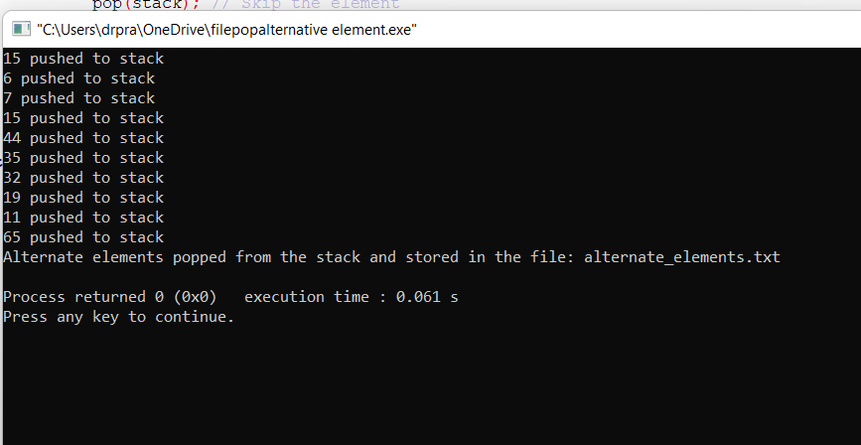
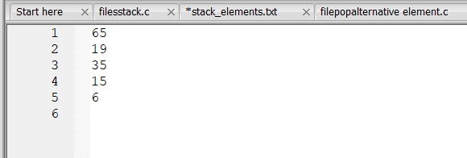
13.file the maximum element in the stack
#include <stdio.h>
#include <stdlib.h>
#include <time.h>

#define MAX_SIZE 100 // Maximum size of the stack
#define FILENAME "stack_elements.txt" // Name of the file to store stack elements
#define MAX_ELEMENT_FILE "alternate_elements.txt" // Name of the file to store the maximum element

// Structure to represent a stack
struct Stack {
int items[MAX_SIZE];
int top;
};

// Function to initialize the stack
void initializeStack(struct Stack* stack) {
stack->top = -1; // Initialize top to -1 to indicate an empty stack
}

// Function to check if the stack is empty
int isEmpty(struct Stack* stack) {
return stack->top == -1; // Returns 1 if the stack is empty, otherwise 0
}

// Function to check if the stack is full
int isFull(struct Stack* stack) {
return stack->top == MAX_SIZE - 1; // Returns 1 if the stack is full, otherwise 0
}

// Function to push an element onto the stack
void push(struct Stack* stack, int value) {
if (isFull(stack)) {
printf("Stack Overflow: Cannot push element, stack is full\n");
} else {
stack->top++; // Increment top
stack->items[stack->top] = value; // Store the value at the top of the stack
printf("%d pushed to stack\n", value);
}
}

// Function to pop an element from the stack
int pop(struct Stack* stack) {
if (isEmpty(stack)) {
printf("Stack Underflow: Cannot pop element, stack is empty\n");
return -1; // Return -1 indicating failure
} else {
int popped = stack->items[stack->top]; // Get the top element
stack->top--; // Decrement top
return popped; // Return the popped element
}
}

// Function to save stack elements to a file
void saveToFile(struct Stack* stack, const char* filename) {
int i;
FILE* file = fopen(filename, "w");
if (file == NULL) {
printf("Error opening file for writing\n");
return;
}

for ( i = 0; i <= stack->top; i++) {
fprintf(file, "%d\n", stack->items[i]);
}

fclose(file);
}

// Function to find the maximum element in the stack
int findMaxElement(struct Stack* stack) {
int i;
int maxElement = stack->items[0]; // Assume first element as maximum

for ( i = 1; i <= stack->top; i++) {
if (stack->items[i] > maxElement) {
maxElement = stack->items[i]; // Update maxElement if current element is greater
}
}

return maxElement;
}

// Function to store the maximum element in a file
void storeMaxElementToFile(struct Stack* stack, const char* filename) {
int maxElement = findMaxElement(stack); // Find the maximum element

FILE* file = fopen(filename, "w");
if (file == NULL) {
printf("Error opening file for writing\n");
return;
}

fprintf(file, "%d\n", maxElement); // Write the maximum element to the file
fclose(file);
}

int main() {
int i;
struct Stack stack;
initializeStack(&stack);

// Seed the random number generator
srand(time(NULL));

// Generate a stack with random elements
for ( i = 0; i < 10; i++) { // Generating more elements for demonstration purposes
int randomNum = rand() % 100 + 1; // Generate random number between 1 and 100
push(&stack, randomNum);
}

// Store stack elements in a file
saveToFile(&stack, FILENAME);
printf("Stack elements stored in the file: %s\n", FILENAME);

// Store maximum element in a separate file
storeMaxElementToFile(&stack, MAX_ELEMENT_FILE);
printf("Maximum element in the stack stored in the file: %s\n", MAX_ELEMENT_FILE);

return 0;
}
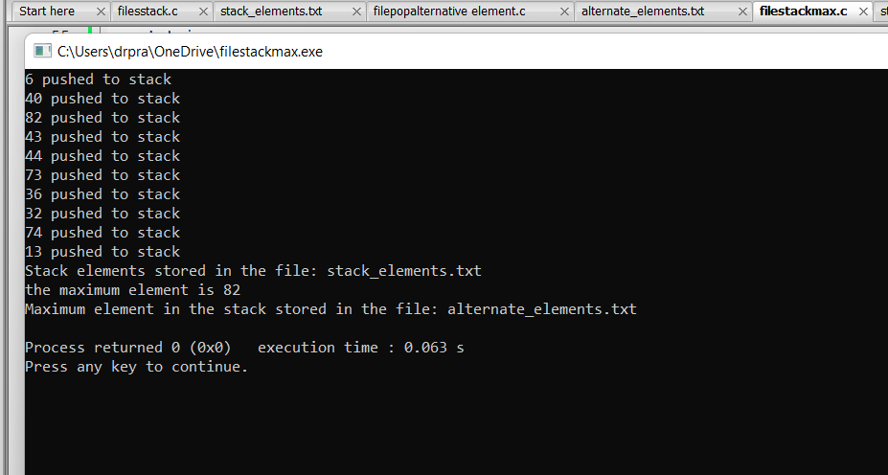
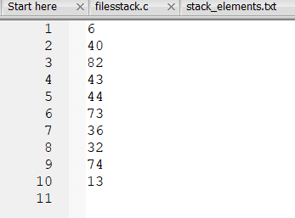
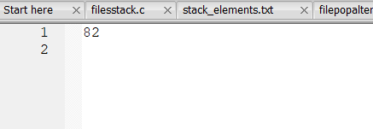
14.find the minimum element in the stack
#include <stdio.h>
#include <stdlib.h>
#include <time.h>

#define MAX_SIZE 100 // Maximum size of the stack
#define FILENAME "stack_elements.txt" // Name of the file to store stack elements
#define MIN_ELEMENT_FILE "alternate_elements.txt" // Name of the file to store the minimum element

// Structure to represent a stack
struct Stack {
int items[MAX_SIZE];
int top;
};

// Function to initialize the stack
void initializeStack(struct Stack* stack) {
stack->top = -1; // Initialize top to -1 to indicate an empty stack
}

// Function to check if the stack is empty
int isEmpty(struct Stack* stack) {
return stack->top == -1; // Returns 1 if the stack is empty, otherwise 0
}

// Function to check if the stack is full
int isFull(struct Stack* stack) {
return stack->top == MAX_SIZE - 1; // Returns 1 if the stack is full, otherwise 0
}

// Function to push an element onto the stack
void push(struct Stack* stack, int value) {
if (isFull(stack)) {
printf("Stack Overflow: Cannot push element, stack is full\n");
} else {
stack->top++; // Increment top
stack->items[stack->top] = value; // Store the value at the top of the stack
printf("%d pushed to stack\n", value);
}
}

// Function to pop an element from the stack
int pop(struct Stack* stack) {
if (isEmpty(stack)) {
printf("Stack Underflow: Cannot pop element, stack is empty\n");
return -1; // Return -1 indicating failure
} else {
int popped = stack->items[stack->top]; // Get the top element
stack->top--; // Decrement top
return popped; // Return the popped element
}
}

// Function to save stack elements to a file
void saveToFile(struct Stack* stack, const char* filename) {
int i;
FILE* file = fopen(filename, "w");
if (file == NULL) {
printf("Error opening file for writing\n");
return;
}

for ( i = 0; i <= stack->top; i++) {
fprintf(file, "%d\n", stack->items[i]);
}

fclose(file);
}

// Function to find the minimum element in the stack
int findMinElement(struct Stack* stack) {
int i;
int minElement = stack->items[0]; // Assume first element as minimum

for ( i = 1; i <= stack->top; i++) {
if (stack->items[i] < minElement) {
minElement = stack->items[i]; // Update minElement if current element is smaller
}
}
printf("the minimum element is %d\n",minElement);
return minElement;
}

// Function to store the minimum element in a file
void storeMinElementToFile(struct Stack* stack, const char* filename) {
int minElement = findMinElement(stack); // Find the minimum element

FILE* file = fopen(filename, "w");
if (file == NULL) {
printf("Error opening file for writing\n");
return;
}

fprintf(file, "%d\n", minElement); // Write the minimum element to the file
fclose(file);
}

int main() {
int i;
struct Stack stack;
initializeStack(&stack);

// Seed the random number generator
srand(time(NULL));

// Generate a stack with random elements
for ( i = 0; i < 10; i++) { // Generating more elements for demonstration purposes
int randomNum = rand() % 100 + 1; // Generate random number between 1 and 100
push(&stack, randomNum);
}

// Store stack elements in a file
saveToFile(&stack, FILENAME);
printf("Stack elements stored in the file: %s\n", FILENAME);

// Store minimum element in a separate file
storeMinElementToFile(&stack, MIN_ELEMENT_FILE);
printf("Minimum element in the stack stored in the file: %s\n", MIN_ELEMENT_FILE);

return 0;
}
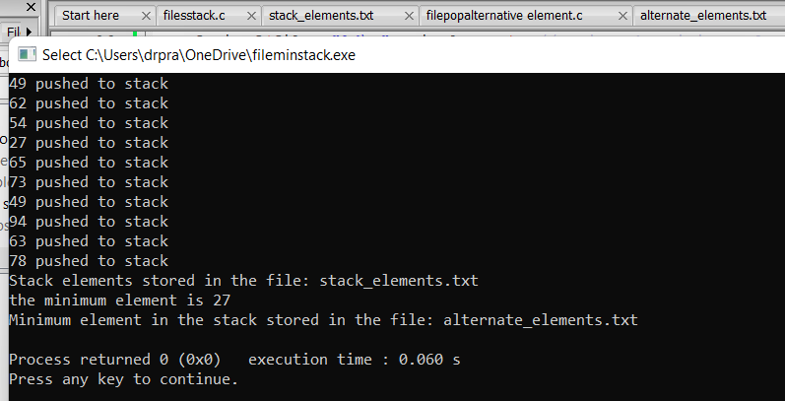
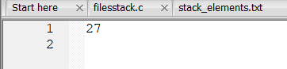
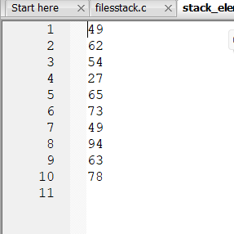
15.reverse a stack
Code:
#include <stdio.h>
#include <stdlib.h>
#include <time.h>

#define MAX_SIZE 100 // Maximum size of the stack
#define FILENAME "stack_elements.txt" // Name of the file to store stack elements
#define REVERSED_FILE "reversed_stack.txt" // Name of the file to store the reversed stack elements

// Structure to represent a stack
struct Stack {
int items[MAX_SIZE];
int top;
};

// Function to initialize the stack
void initializeStack(struct Stack* stack) {
stack->top = -1; // Initialize top to -1 to indicate an empty stack
}

// Function to check if the stack is empty
int isEmpty(struct Stack* stack) {
return stack->top == -1; // Returns 1 if the stack is empty, otherwise 0
}

// Function to check if the stack is full
int isFull(struct Stack* stack) {
return stack->top == MAX_SIZE - 1; // Returns 1 if the stack is full, otherwise 0
}

// Function to push an element onto the stack
void push(struct Stack* stack, int value) {
if (isFull(stack)) {
printf("Stack Overflow: Cannot push element, stack is full\n");
} else {
stack->top++; // Increment top
stack->items[stack->top] = value; // Store the value at the top of the stack
printf("%d pushed to stack\n", value);
}
}

// Function to pop an element from the stack
int pop(struct Stack* stack) {
if (isEmpty(stack)) {
printf("Stack Underflow: Cannot pop element, stack is empty\n");
return -1; // Return -1 indicating failure
} else {
int popped = stack->items[stack->top]; // Get the top element
stack->top--; // Decrement top
return popped; // Return the popped element
}
}

// Function to save stack elements to a file
void saveToFile(struct Stack* stack, const char* filename) {
int i;
FILE* file = fopen(filename, "w");
if (file == NULL) {
printf("Error opening file for writing\n");
return;
}

for ( i = 0; i <= stack->top; i++) {
fprintf(file, "%d\n", stack->items[i]);
}

fclose(file);
}

// Function to reverse the elements of the stack
void reverseStack(struct Stack* stack) {
struct Stack tempStack;
initializeStack(&tempStack);

// Pop all elements from the original stack and push them onto the temporary stack
while (!isEmpty(stack)) {
push(&tempStack, pop(stack));
}

// Pop all elements from the temporary stack and push them back onto the original stack
while (!isEmpty(&tempStack)) {
push(stack, pop(&tempStack));
}
}

int main() {
int i;
struct Stack stack;
initializeStack(&stack);

// Seed the random number generator
srand(time(NULL));

// Generate a stack with random elements
for ( i = 0; i < 10; i++) { // Generating more elements for demonstration purposes
int randomNum = rand() % 100 + 1; // Generate random number between 1 and 100
push(&stack, randomNum);
}

// Store stack elements in a file
saveToFile(&stack, FILENAME);
printf("Stack elements stored in the file: %s\n", FILENAME);

// Reverse the elements of the stack
reverseStack(&stack);
printf("Stack elements reversed\n");

// Store the reversed stack elements in a file
saveToFile(&stack, REVERSED_FILE);
printf("Reversed stack elements stored in the file: %s\n", REVERSED_FILE);

return 0;
}
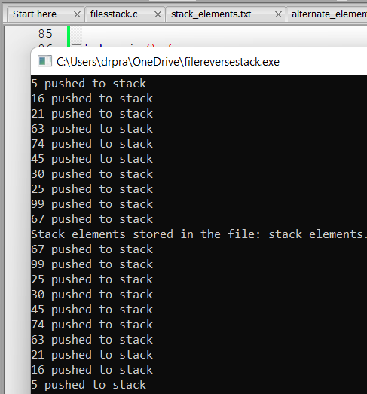
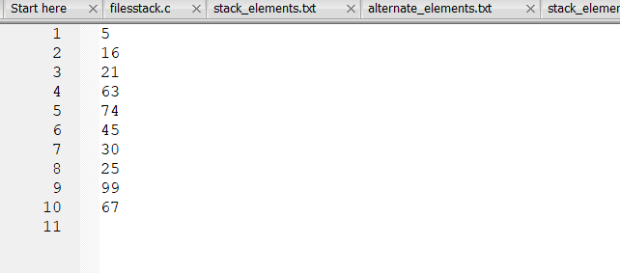
16.pop even elements from the stack
#include <stdio.h>
#include <stdlib.h>
#include <time.h>

#define MAX_SIZE 100 // Maximum size of the stack
#define FILENAME "stack_elements.txt" // Name of the file to store stack elements
#define EVEN_ELEMENTS_FILE "alternate_elements.txt" // Name of the file to store even elements

// Structure to represent a stack
struct Stack {
int items[MAX_SIZE];
int top;
};

// Function to initialize the stack
void initializeStack(struct Stack* stack) {
stack->top = -1; // Initialize top to -1 to indicate an empty stack
}

// Function to check if the stack is empty
int isEmpty(struct Stack* stack) {
return stack->top == -1; // Returns 1 if the stack is empty, otherwise 0
}

// Function to check if the stack is full
int isFull(struct Stack* stack) {
return stack->top == MAX_SIZE - 1; // Returns 1 if the stack is full, otherwise 0
}

// Function to push an element onto the stack
void push(struct Stack* stack, int value) {
if (isFull(stack)) {
printf("Stack Overflow: Cannot push element, stack is full\n");
} else {
stack->top++; // Increment top
stack->items[stack->top] = value; // Store the value at the top of the stack
printf("%d pushed to stack\n", value);
}
}

// Function to pop an element from the stack
int pop(struct Stack* stack) {
if (isEmpty(stack)) {
printf("Stack Underflow: Cannot pop element, stack is empty\n");
return -1; // Return -1 indicating failure
} else {
int popped = stack->items[stack->top]; // Get the top element
stack->top--; // Decrement top
return popped; // Return the popped element
}
}

// Function to save stack elements to a file
void saveToFile(struct Stack* stack, const char* filename) {
int i;
FILE* file = fopen(filename, "w");
if (file == NULL) {
printf("Error opening file for writing\n");
return;
}

for ( i = 0; i <= stack->top; i++) {
fprintf(file, "%d\n", stack->items[i]);
}

fclose(file);
}

// Function to store even elements of the stack in a file
void popEvenElementsToFile(struct Stack* stack, const char* filename) {
FILE* file = fopen(filename, "w");
printf("even elements are\n");
if (file == NULL) {
printf("Error opening file for writing\n");
return;
}

while (!isEmpty(stack)) {
int element = pop(stack);
if (element % 2 == 0) {
fprintf(file, "%d\n", element);
}
printf("%d\n",element);
}

fclose(file);
}

int main() {
int i;
struct Stack stack;
initializeStack(&stack);

// Seed the random number generator
srand(time(NULL));

// Generate a stack with random elements
for ( i = 0; i < 10; i++) { // Generating more elements for demonstration purposes
int randomNum = rand() % 100 + 1; // Generate random number between 1 and 100
push(&stack, randomNum);
}

// Store stack elements in a file
saveToFile(&stack, FILENAME);
printf("Stack elements stored in the file: %s\n", FILENAME);

// Pop even elements from the stack and store them in a file
popEvenElementsToFile(&stack, EVEN_ELEMENTS_FILE);
printf("Even elements from the stack stored in the file: %s\n", EVEN_ELEMENTS_FILE);

return 0;
}
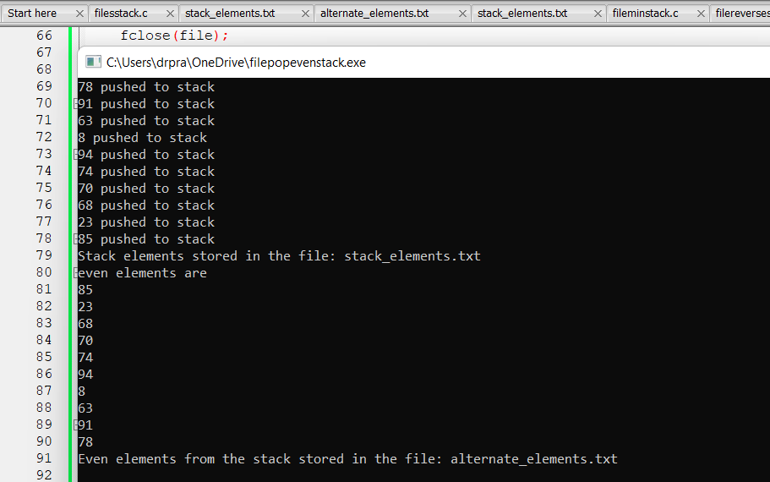
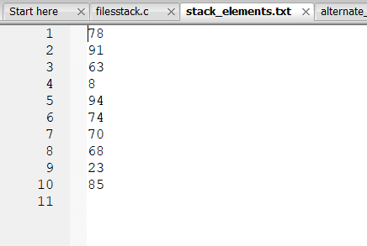
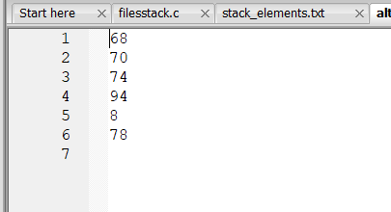
17.find odd element in the stack
#include <stdio.h>
#include <stdlib.h>
#include <time.h>

#define MAX_SIZE 100 // Maximum size of the stack
#define FILENAME "stack_elements.txt" // Name of the file to store stack elements
#define ODD_ELEMENTS_FILE "alternate_elements.txt" // Name of the file to store odd elements

// Structure to represent a stack
struct Stack {
int items[MAX_SIZE];
int top;
};

// Function to initialize the stack
void initializeStack(struct Stack* stack) {
stack->top = -1; // Initialize top to -1 to indicate an empty stack
}

// Function to check if the stack is empty
int isEmpty(struct Stack* stack) {
return stack->top == -1; // Returns 1 if the stack is empty, otherwise 0
}

// Function to check if the stack is full
int isFull(struct Stack* stack) {
return stack->top == MAX_SIZE - 1; // Returns 1 if the stack is full, otherwise 0
}

// Function to push an element onto the stack
void push(struct Stack* stack, int value) {
if (isFull(stack)) {
printf("Stack Overflow: Cannot push element, stack is full\n");
} else {
stack->top++; // Increment top
stack->items[stack->top] = value; // Store the value at the top of the stack
printf("%d pushed to stack\n", value);
}
}

// Function to pop an element from the stack
int pop(struct Stack* stack) {
if (isEmpty(stack)) {
printf("Stack Underflow: Cannot pop element, stack is empty\n");
return -1; // Return -1 indicating failure
} else {
int popped = stack->items[stack->top]; // Get the top element
stack->top--; // Decrement top
return popped; // Return the popped element
}
}

// Function to save stack elements to a file
void saveToFile(struct Stack* stack, const char* filename) {
int i;
FILE* file = fopen(filename, "w");
if (file == NULL) {
printf("Error opening file for writing\n");
return;
}

for ( i = 0; i <= stack->top; i++) {
fprintf(file, "%d\n", stack->items[i]);
}

fclose(file);
}

// Function to store odd elements of the stack in a file
void popOddElementsToFile(struct Stack* stack, const char* filename) {
FILE* file = fopen(filename, "w");
printf("the odd elements are\n");
if (file == NULL) {
printf("Error opening file for writing\n");
return;
}

while (!isEmpty(stack)) {
int element = pop(stack);
if (element % 2 != 0) {
fprintf(file, "%d\n", element);
printf("%d\n",element);
}
}

fclose(file);
}

int main() {
int i;
struct Stack stack;
initializeStack(&stack);

// Seed the random number generator
srand(time(NULL));

// Generate a stack with random elements
for ( i = 0; i < 10; i++) { // Generating more elements for demonstration purposes
int randomNum = rand() % 100 + 1; // Generate random number between 1 and 100
push(&stack, randomNum);
}

// Store stack elements in a file
saveToFile(&stack, FILENAME);
printf("Stack elements stored in the file: %s\n", FILENAME);

// Pop odd elements from the stack and store them in a file
popOddElementsToFile(&stack, ODD_ELEMENTS_FILE);
printf("Odd elements from the stack stored in the file: %s\n", ODD_ELEMENTS_FILE);

return 0;
}
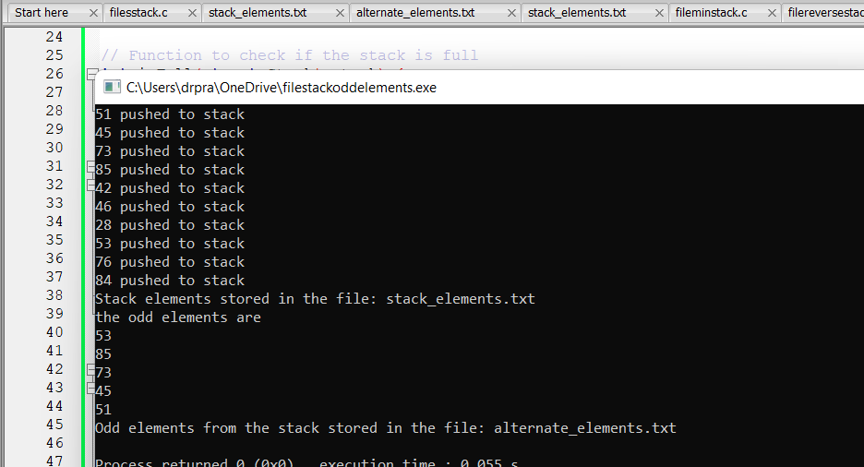
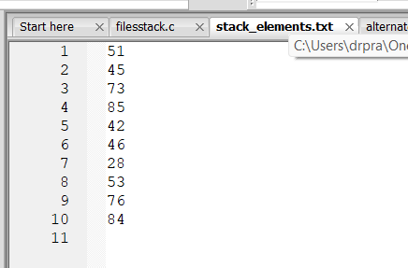

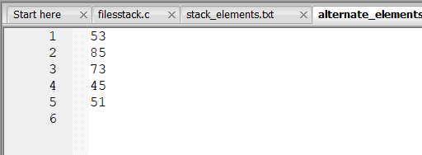
18. find the prime elements in the stack
#include <stdio.h>
#include <stdlib.h>
#include <time.h>
#include <math.h>

#define MAX_SIZE 100 // Maximum size of the stack
#define FILENAME "stack_elements.txt" // Name of the file to store stack elements
#define PRIME_ELEMENTS_FILE "alternate_elements.txt" // Name of the file to store prime elements

// Structure to represent a stack
struct Stack {
int items[MAX_SIZE];
int top;
};

// Function to initialize the stack
void initializeStack(struct Stack* stack) {
stack->top = -1; // Initialize top to -1 to indicate an empty stack
}

// Function to check if the stack is empty
int isEmpty(struct Stack* stack) {
return stack->top == -1; // Returns 1 if the stack is empty, otherwise 0
}

// Function to check if the stack is full
int isFull(struct Stack* stack) {
return stack->top == MAX_SIZE - 1; // Returns 1 if the stack is full, otherwise 0
}

// Function to push an element onto the stack
void push(struct Stack* stack, int value) {
if (isFull(stack)) {
printf("Stack Overflow: Cannot push element, stack is full\n");
} else {
stack->top++; // Increment top
stack->items[stack->top] = value; // Store the value at the top of the stack
printf("%d pushed to stack\n", value);
}
}

// Function to pop an element from the stack
int pop(struct Stack* stack) {
if (isEmpty(stack)) {
printf("Stack Underflow: Cannot pop element, stack is empty\n");
return -1; // Return -1 indicating failure
} else {
int popped = stack->items[stack->top]; // Get the top element
stack->top--; // Decrement top
return popped; // Return the popped element
}
}

// Function to save stack elements to a file
void saveToFile(struct Stack* stack, const char* filename) {
int i;
FILE* file = fopen(filename, "w");
if (file == NULL) {
printf("Error opening file for writing\n");
return;
}

for ( i = 0; i <= stack->top; i++) {
fprintf(file, "%d\n", stack->items[i]);
}

fclose(file);
}

// Function to check if a number is prime
int isPrime(int num) {
int i;
if (num <= 1) {
return 0;
}
for ( i = 2; i <= sqrt(num); i++) {
if (num % i == 0) {
return 0;
}
}
return 1;
}

// Function to store prime elements of the stack in a file
void popPrimeElementsToFile(struct Stack* stack, const char* filename) {
FILE* file = fopen(filename, "w");
if (file == NULL) {
printf("Error opening file for writing\n");
return;
}
printf("the prime elements in the stack are\n");
while (!isEmpty(stack)) {
int element = pop(stack);
if (isPrime(element)) {
fprintf(file, "%d\n", element);
printf("%d\n",element);
}
}

fclose(file);
}

int main() {
int i;
struct Stack stack;
initializeStack(&stack);

// Seed the random number generator
srand(time(NULL));

// Generate a stack with random elements
for ( i = 0; i < 10; i++) { // Generating more elements for demonstration purposes
int randomNum = rand() % 100 + 1; // Generate random number between 1 and 100
push(&stack, randomNum);
}

// Store stack elements in a file
saveToFile(&stack, FILENAME);
printf("Stack elements stored in the file: %s\n", FILENAME);

// Pop prime elements from the stack and store them in a file
popPrimeElementsToFile(&stack, PRIME_ELEMENTS_FILE);
printf("Prime elements from the stack stored in the file: %s\n", PRIME_ELEMENTS_FILE);

return 0;
}
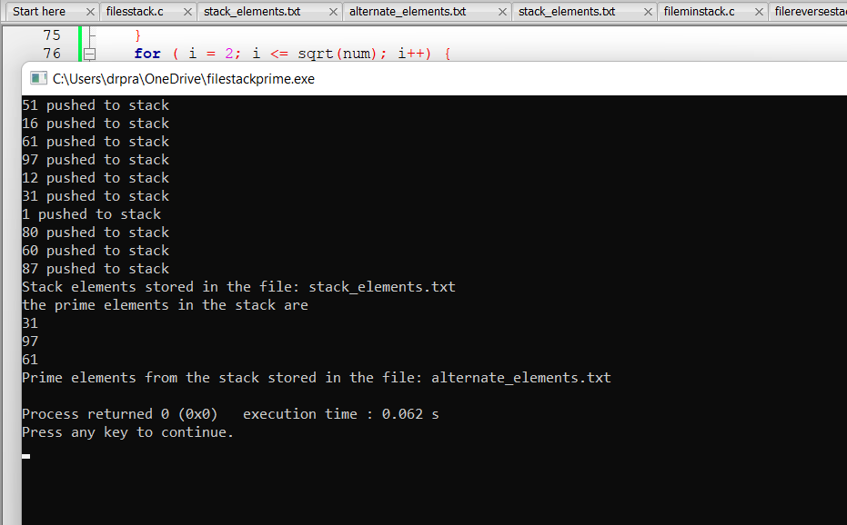
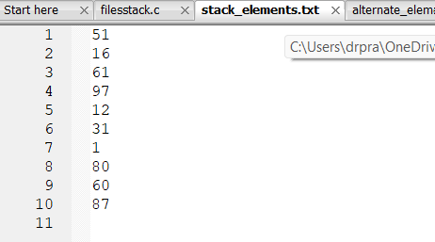
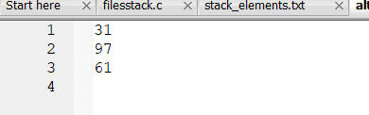
19.search an element I the file
#includeude <stdio.h>
#include <stdlib.h>
#include <time.h>
#include <math.h>

#define MAX_SIZE 100 // Maximum size of the stack
#define FILENAME "stack_elements.txt" // Name of the file to store stack elements
#define search_element_FILE "alternate_elements.txt" // Name of the file to store prime elements

// Structure to represent a stack
struct Stack {
int items[MAX_SIZE];
int top;
};

// Function to initialize the stack
void initializeStack(struct Stack* stack) {
stack->top = -1; // Initialize top to -1 to indicate an empty stack
}

// Function to check if the stack is empty
int isEmpty(struct Stack* stack) {
return stack->top == -1; // Returns 1 if the stack is empty, otherwise 0
}

// Function to check if the stack is full
int isFull(struct Stack* stack) {
return stack->top == MAX_SIZE - 1; // Returns 1 if the stack is full, otherwise 0
}

// Function to push an element onto the stack
void push(struct Stack* stack, int value) {
if (isFull(stack)) {
printf("Stack Overflow: Cannot push element, stack is full\n");
} else {
stack->top++; // Increment top
stack->items[stack->top] = value; // Store the value at the top of the stack
printf("%d pushed to stack\n", value);
}
}

// Function to pop an element from the stack
int pop(struct Stack* stack) {
if (isEmpty(stack)) {
printf("Stack Underflow: Cannot pop element, stack is empty\n");
return -1; // Return -1 indicating failure
} else {
int popped = stack->items[stack->top]; // Get the top element
stack->top--; // Decrement top
return popped; // Return the popped element
}
}

// Function to save stack elements to a file
void saveToFile(struct Stack* stack, const char* filename) {
int i;
FILE* file = fopen(filename, "w");
if (file == NULL) {
printf("Error opening file for writing\n");
return;
}

for ( i = 0; i <= stack->top; i++) {
fprintf(file, "%d\n", stack->items[i]);
}

fclose(file);
}

// Function to search for an element in the stack
int searchElement(struct Stack* stack, int key) {
int i;
for ( i = stack->top; i >= 0; i--) {
if (stack->items[i] == key) {
return i; // Return index of the element if found
}
}
return -1; // Return -1 if element not found
}

int main() {
int i;
struct Stack stack;
initializeStack(&stack);

// Seed the random number generator
srand(time(NULL));

// Generate a stack with random elements
for ( i = 0; i < 10; i++) { // Generating more elements for demonstration purposes
int randomNum = rand() % 100 + 1; // Generate random number between 1 and 100
push(&stack, randomNum);
}

// Store stack elements in a file
saveToFile(&stack, FILENAME);
printf("Stack elements stored in the file: %s\n", FILENAME);

// Search for an element in the stack
int key = 42; // Element to search for
int index = searchElement(&stack, key);
if (index != -1) {
printf("Element %d found at index %d in the stack\n", key, index);
} else {
printf("Element %d not found in the stack\n", key);
}

return 0;
}
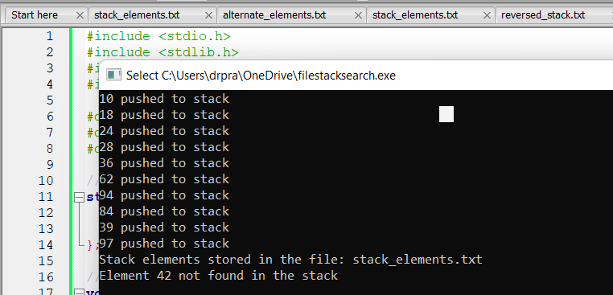
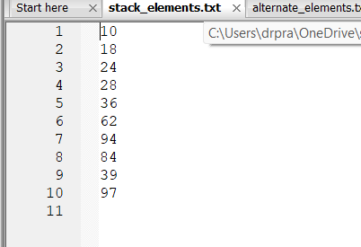
20.find the element with the staring digit 1 and store the index
Code:
#include <stdio.h>
#include <stdlib.h>
#include <time.h>

#define MAX_SIZE 100 // Maximum size of the stack
#define FILENAME "stack_elements.txt" // Name of the file to store stack elements
#define FIRST_DIGIT_ONE_FILE "alternate_elements.txt" // Name of the file to store elements with first digit 1

// Structure to represent a stack
struct Stack {
int items[MAX_SIZE];
int top;
};

// Function to initialize the stack
void initializeStack(struct Stack* stack) {
stack->top = -1; // Initialize top to -1 to indicate an empty stack
}

// Function to check if the stack is empty
int isEmpty(struct Stack* stack) {
return stack->top == -1; // Returns 1 if the stack is empty, otherwise 0
}

// Function to check if the stack is full
int isFull(struct Stack* stack) {
return stack->top == MAX_SIZE - 1; // Returns 1 if the stack is full, otherwise 0
}

// Function to push an element onto the stack
void push(struct Stack* stack, int value) {
if (isFull(stack)) {
printf("Stack Overflow: Cannot push element, stack is full\n");
} else {
stack->top++; // Increment top
stack->items[stack->top] = value; // Store the value at the top of the stack
printf("%d pushed to stack\n", value);
}
}

// Function to save stack elements to a file
void saveToFile(struct Stack* stack, const char* filename) {
int i;
FILE* file = fopen(filename, "w");
if (file == NULL) {
printf("Error opening file for writing\n");
return;
}

for ( i = 0; i <= stack->top; i++) {
fprintf(file, "%d\n", stack->items[i]);
}

fclose(file);
}

// Function to check if the first digit of a number is 1
int isFirstDigitOne(int num) {
int firstDigit;
while (num >= 10) {
num /= 10;
}
firstDigit = num;
return firstDigit == 1;
}

// Function to search for elements where the first digit is 1 in the stack and store their indices and values in a file
void searchAndStoreFirstDigitOne(struct Stack* stack, const char* filename) {
int i;
FILE* file = fopen(filename, "w");
if (file == NULL) {
printf("Error opening file for writing\n");
return;
}
printf("the elements with digit 1 are at the following position\n");

for ( i = 0; i <= stack->top; i++) {
if (isFirstDigitOne(stack->items[i])) {
fprintf(file, "Index: %d, Value: %d\n", i, stack->items[i]);
printf("%d\n",i+1);
}
}

fclose(file);
}

int main() {
int i;
struct Stack stack;
initializeStack(&stack);

// Seed the random number generator
srand(time(NULL));

// Generate a stack with random elements
for ( i = 0; i < 10; i++) { // Generating more elements for demonstration purposes
int randomNum = rand() % 100 + 1; // Generate random number between 1 and 100
push(&stack, randomNum);
}

// Store stack elements in a file
saveToFile(&stack, FILENAME);
printf("Stack elements stored in the file: %s\n", FILENAME);

// Search for elements where the first digit is 1 and store their indices and values in a file
searchAndStoreFirstDigitOne(&stack, FIRST_DIGIT_ONE_FILE);
printf("Elements where the first digit is 1 stored in the file: %s\n", FIRST_DIGIT_ONE_FILE);

return 0;
}
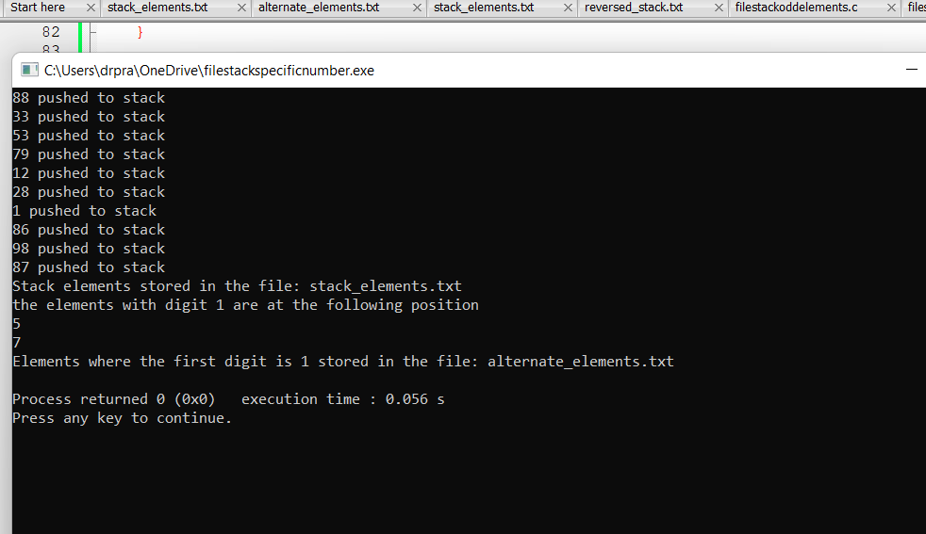
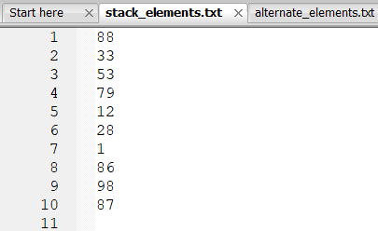
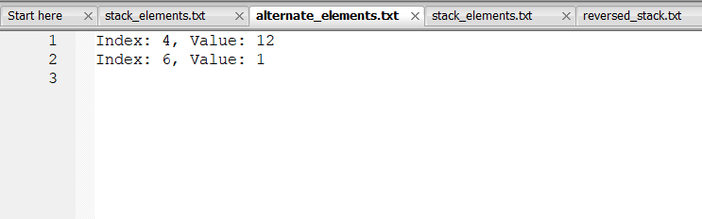
21. generate queues and store it in a file
Code:
#include <stdio.h>
#include <stdlib.h>
#include <time.h>

#define MAX_SIZE 100
#define FILENAME "queue_elements.txt"

// Structure for a queue
struct Queue {
int items[MAX_SIZE];
int front;
int rear;
};

// Function to initialize the queue
void initializeQueue(struct Queue* queue) {
queue->front = -1;
queue->rear = -1;
}

// Function to check if the queue is empty
int isEmpty(struct Queue* queue) {
return queue->front == -1;
}

// Function to check if the queue is full
int isFull(struct Queue* queue) {
return (queue->rear + 1) % MAX_SIZE == queue->front;
}

// Function to add an element to the rear of the queue
void enqueue(struct Queue* queue, int value) {
if (isFull(queue)) {
printf("Queue is full\n");
return;
}
if (isEmpty(queue)) {
queue->front = 0;
}
queue->rear = (queue->rear + 1) % MAX_SIZE;
queue->items[queue->rear] = value;
}

// Function to display the elements of the queue
void display(struct Queue* queue) {
if (isEmpty(queue)) {
printf("Queue is empty\n");
return;
}
int i = queue->front;
printf("Queue elements: ");
do {
printf("%d ", queue->items[i]);
i = (i + 1) % MAX_SIZE;
} while (i != (queue->rear + 1) % MAX_SIZE);
printf("\n");
}

// Function to write queue elements to a file
void writeToFile(struct Queue* queue, const char* filename) {
int i;
FILE* file = fopen(filename, "w");
if (file == NULL) {
printf("Error opening file for writing\n");
return;
}
for ( i = queue->front; i != (queue->rear + 1) % MAX_SIZE; i = (i + 1) % MAX_SIZE) {
fprintf(file, "%d\n", queue->items[i]);
}
fclose(file);
}

// Function to generate random elements and enqueue them into the queue
void generateAndEnqueueRandomElements(struct Queue* queue, int count) {
int i;
srand(time(NULL)); // Seed the random number generator
for ( i = 0; i < count; i++) {
int randomNumber = rand() % 100; // Generate a random number between 0 and 99
enqueue(queue, randomNumber);
}
}

int main() {
struct Queue queue;
initializeQueue(&queue);

// Generate 10 random elements and enqueue them into the queue
generateAndEnqueueRandomElements(&queue, 10);

// Write queue elements to a file
writeToFile(&queue, FILENAME);
printf("Queue elements stored in the file: %s\n", FILENAME);

// Display elements
printf("Initial queue:\n");
display(&queue);

return 0;
}
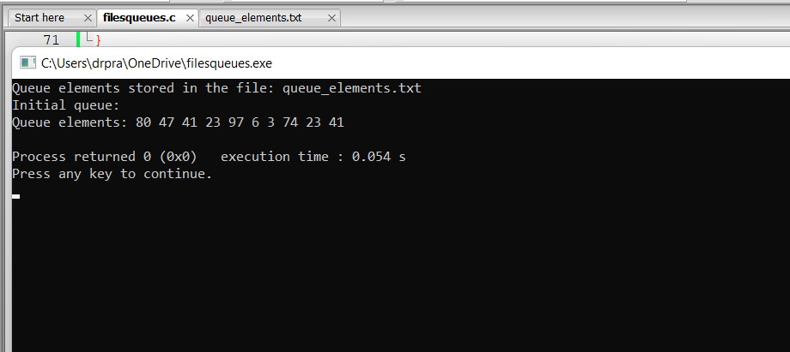
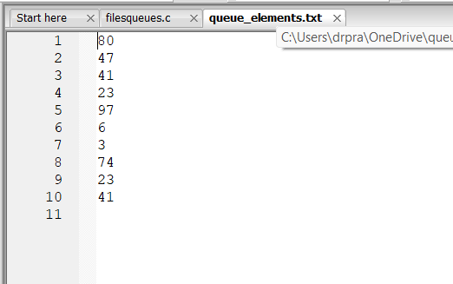
21.reverse a queue
Code:
#include <stdio.h>
#include <stdlib.h>
#include <time.h>

#define MAX_SIZE 100

// Structure for a queue
struct Queue {
int items[MAX_SIZE];
int front;
int rear;
};

// Function to initialize the queue
void initializeQueue(struct Queue* queue) {
queue->front = -1;
queue->rear = -1;
}

// Function to check if the queue is empty
int isEmpty(struct Queue* queue) {
return queue->front == -1;
}

// Function to check if the queue is full
int isFull(struct Queue* queue) {
return (queue->rear + 1) % MAX_SIZE == queue->front;
}

// Function to add an element to the rear of the queue
void enqueue(struct Queue* queue, int value) {
if (isFull(queue)) {
printf("Queue is full\n");
return;
}
if (isEmpty(queue)) {
queue->front = 0;
}
queue->rear = (queue->rear + 1) % MAX_SIZE;
queue->items[queue->rear] = value;
}

// Function to reverse an array
void reverseArray(int arr[], int size) {
int left = 0;
int right = size - 1;
while (left < right) {
// Swap elements at left and right indices
int temp = arr[left];
arr[left] = arr[right];
arr[right] = temp;
// Move to the next pair of elements
left++;
right--;
}
}

// Function to reverse the elements of a queue
void reverseQueue(struct Queue* queue) {
int size = (queue->rear - queue->front + MAX_SIZE + 1) % MAX_SIZE;
int arr[MAX_SIZE];
int i = 0, j = queue->front;
while (i < size) {
arr[i++] = queue->items[j];
j = (j + 1) % MAX_SIZE;
}
reverseArray(arr, size);
i = 0, j = queue->front;
while (i < size) {
queue->items[j] = arr[i++];
j = (j + 1) % MAX_SIZE;
}
}

// Function to display the elements of the queue
void display(struct Queue* queue) {
if (isEmpty(queue)) {
printf("Queue is empty\n");
return;
}
printf("Queue elements: ");
int i = queue->front;
while (i != queue->rear) {
printf("%d ", queue->items[i]);
i = (i + 1) % MAX_SIZE;
}
printf("%d\n", queue->items[queue->rear]);
}

int main() {
struct Queue queue;
initializeQueue(&queue);

// Seed the random number generator
srand(time(NULL));

// Enqueue random elements into the queue and store them in a file
const char* inputFilename = "queue_elements.txt";
FILE* inputFile = fopen(inputFilename, "w");
if (inputFile == NULL) {
printf("Error opening file for writing\n");
return 1;
}
int i;
for ( i = 0; i < 10; i++) {
int randomNumber = rand() % 100;
fprintf(inputFile, "%d ", randomNumber);
enqueue(&queue, randomNumber);
}
fclose(inputFile);

printf("Queue elements stored in the file: %s\n", inputFilename);

// Display the original queue
printf("Original queue:\n");
display(&queue);

// Store the reversed queue in another file
reverseQueue(&queue);
const char* outputFilename = "output.txt";
FILE* outputFile = fopen(outputFilename, "w");
if (outputFile == NULL) {
printf("Error opening file for writing\n");
return 1;
}
i = queue.front;
while (i != queue.rear) {
fprintf(outputFile, "%d ", queue.items[i]);
i = (i + 1) % MAX_SIZE;
}
fprintf(outputFile, "%d", queue.items[queue.rear]);
fclose(outputFile);

printf("Reversed queue elements stored in the file: %s\n", outputFilename);

return 0;
}
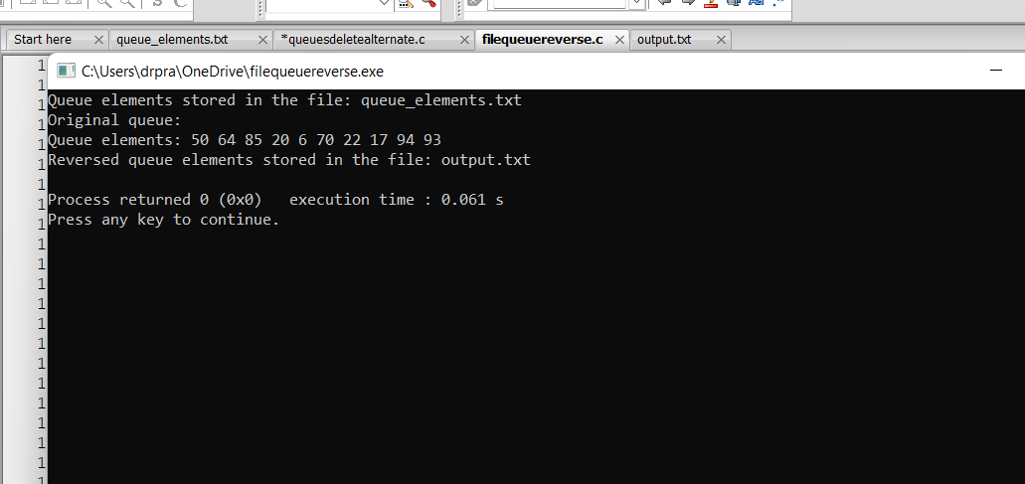
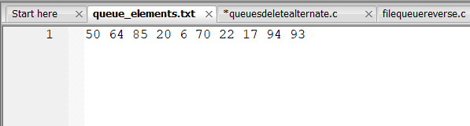
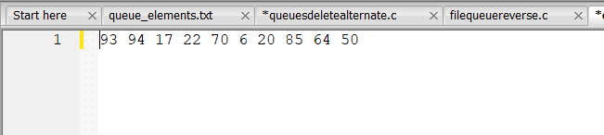
22. find the odd number sin the stack
Code:
#include <stdio.h>
#include <stdlib.h>

#define MAX_SIZE 100

// Structure for a queue
struct Queue {
int items[MAX_SIZE];
int front;
int rear;
FILE* file; // File to store the queue elements
FILE* oddFile; // File to store odd elements
};

// Function to initialize the queue
void initializeQueue(struct Queue* queue) {
queue->front = -1;
queue->rear = -1;
queue->file = fopen("queue_elements.txt", "w"); // Open file for writing
if (queue->file == NULL) {
printf("Error opening file for writing\n");
exit(1);
}
queue->oddFile = fopen("odd_elements.txt", "w"); // Open file for writing odd elements
if (queue->oddFile == NULL) {
printf("Error opening file for writing\n");
exit(1);
}
}

// Function to check if the queue is empty
int isEmpty(struct Queue* queue) {
return queue->front == -1;
}

// Function to check if the queue is full
int isFull(struct Queue* queue) {
return (queue->rear + 1) % MAX_SIZE == queue->front;
}

// Function to add an element to the rear of the queue
void enqueue(struct Queue* queue, int value) {
if (isFull(queue)) {
printf("Queue is full\n");
return;
}
if (isEmpty(queue)) {
queue->front = 0;
}
queue->rear = (queue->rear + 1) % MAX_SIZE;
queue->items[queue->rear] = value;
// Print the value to the console
printf("queue: %d\n", value);
// Write the value to the file
fprintf(queue->file, "%d\n", value);
// Check if the value is odd and write to odd elements file
if (value % 2 != 0) {
fprintf(queue->oddFile, "%d\n", value);
}
}

int main() {
int i;
struct Queue queue;
initializeQueue(&queue);

// Generate random elements and enqueue them into the queue
srand(time(NULL));
for ( i = 0; i < 10; i++) { // Generate 10 random elements for demonstration
int randomNum = rand() % 100; // Generate random number between 0 and 99
enqueue(&queue, randomNum);
}

// Close the files after enqueueing
fclose(queue.file);
fclose(queue.oddFile);
printf("Queue elements stored in file: queue_elements.txt\n");
printf("Odd elements stored in file: odd_elements.txt\n");

return 0;
}
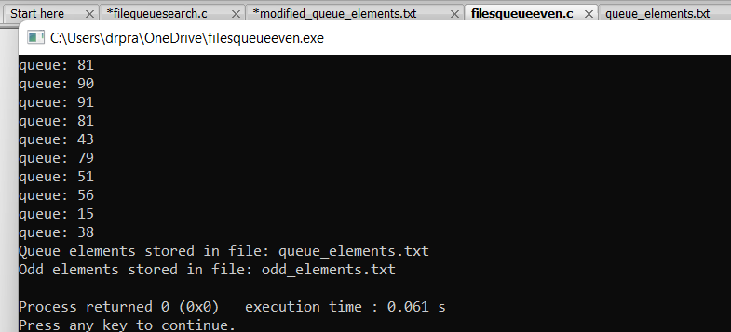
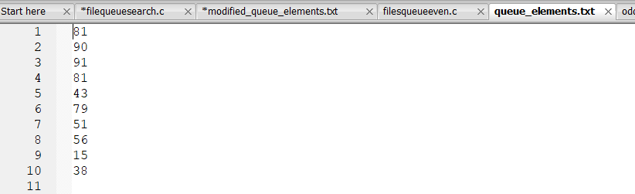
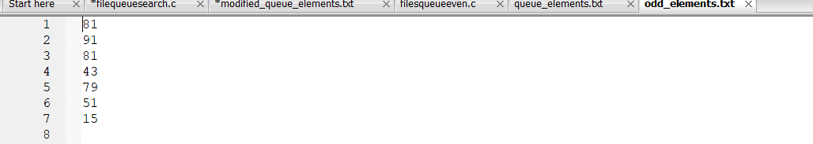
23.find even number in the queue
Code:
#include <stdio.h>
#include <stdlib.h>

#define MAX_SIZE 100

// Structure for a queue
struct Queue {
int items[MAX_SIZE];
int front;
int rear;
FILE* file; // File to store the queue elements
FILE* evenFile; // File to store even elements
};

// Function to initialize the queue
void initializeQueue(struct Queue* queue) {
queue->front = -1;
queue->rear = -1;
queue->file = fopen("queue_elements.txt", "w"); // Open file for writing
if (queue->file == NULL) {
printf("Error opening file for writing\n");
exit(1);
}
queue->evenFile = fopen("even_elements.txt", "w"); // Open file for writing even elements
if (queue->evenFile == NULL) {
printf("Error opening file for writing\n");
exit(1);
}
}

// Function to check if the queue is empty
int isEmpty(struct Queue* queue) {
return queue->front == -1;
}

// Function to check if the queue is full
int isFull(struct Queue* queue) {
return (queue->rear + 1) % MAX_SIZE == queue->front;
}

// Function to add an element to the rear of the queue
void enqueue(struct Queue* queue, int value) {
if (isFull(queue)) {
printf("Queue is full\n");
return;
}
if (isEmpty(queue)) {
queue->front = 0;
}
queue->rear = (queue->rear + 1) % MAX_SIZE;
queue->items[queue->rear] = value;
// Print the value to the console if even
if (value % 2 == 0) {
printf("Enqueued even number: %d\n", value);
// Write the even value to the file
fprintf(queue->evenFile, "%d\n", value);
}
// Write all values to the file
fprintf(queue->file, "%d\n", value);
}

int main() {
int i;

struct Queue queue;
initializeQueue(&queue);

// Generate random elements and enqueue them into the queue
srand(time(NULL));
for ( i = 0; i < 10; i++) { // Generate 10 random elements for demonstration
int randomNum = rand() % 100; // Generate random number between 0 and 99
enqueue(&queue, randomNum);
}

// Close the files after enqueueing
fclose(queue.file);
fclose(queue.evenFile);
printf("Queue elements stored in file: queue_elements.txt\n");
printf("Even elements stored in file: even_elements.txt\n");

return 0;
}
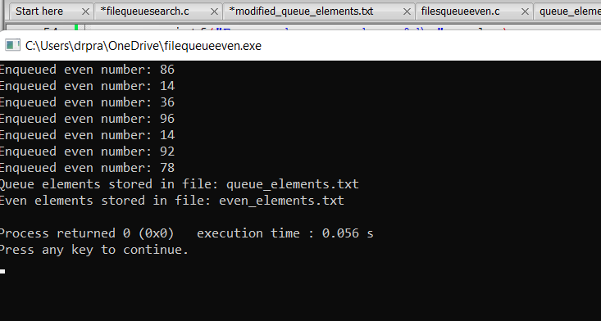
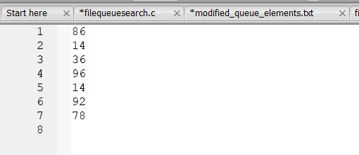
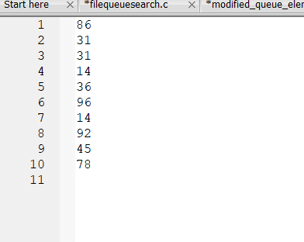
24.find the prime number in the queue
Code:
#include <stdio.h>
#include <stdlib.h>
#include <stdbool.h>

#define MAX_SIZE 100

// Structure for a queue
struct Queue {
int items[MAX_SIZE];
int front;
int rear;
FILE* file; // File to store the queue elements
FILE* primeFile; // File to store prime elements
};

// Function to initialize the queue
void initializeQueue(struct Queue* queue) {
queue->front = -1;
queue->rear = -1;
queue->file = fopen("queue_elements.txt", "w"); // Open file for writing
if (queue->file == NULL) {
printf("Error opening file for writing\n");
exit(1);
}
queue->primeFile = fopen("prime_elements.txt", "w"); // Open file for writing prime elements
if (queue->primeFile == NULL) {
printf("Error opening file for writing\n");
exit(1);
}
}

// Function to check if the queue is empty
int isEmpty(struct Queue* queue) {
return queue->front == -1;
}

// Function to check if the queue is full
int isFull(struct Queue* queue) {
return (queue->rear + 1) % MAX_SIZE == queue->front;
}

// Function to add an element to the rear of the queue
void enqueue(struct Queue* queue, int value) {
if (isFull(queue)) {
printf("Queue is full\n");
return;
}
if (isEmpty(queue)) {
queue->front = 0;
}
queue->rear = (queue->rear + 1) % MAX_SIZE;
queue->items[queue->rear] = value;
// Print the value to the console if prime
if (isPrime(value)) {
printf("Enqueued prime number: %d\n", value);
// Write the prime value to the file
fprintf(queue->primeFile, "%d\n", value);
}
// Write all values to the file
fprintf(queue->file, "%d\n", value);
}

// Function to check if a number is prime
isPrime(int num) {
int i;
if (num <= 1) {
return false;
}
for ( i = 2; i * i <= num; i++) {
if (num % i == 0) {
return false;
}
}
return true;
}

int main() {
int i;
struct Queue queue;
initializeQueue(&queue);

// Generate random elements and enqueue them into the queue
srand(time(NULL));
for ( i = 0; i < 10; i++) { // Generate 10 random elements for demonstration
int randomNum = rand() % 100; // Generate random number between 0 and 99
enqueue(&queue, randomNum);
}

// Close the files after enqueueing
fclose(queue.file);
fclose(queue.primeFile);
printf("Queue elements stored in file: queue_elements.txt\n");
printf("Prime elements stored in file: prime_elements.txt\n");

return 0;
}
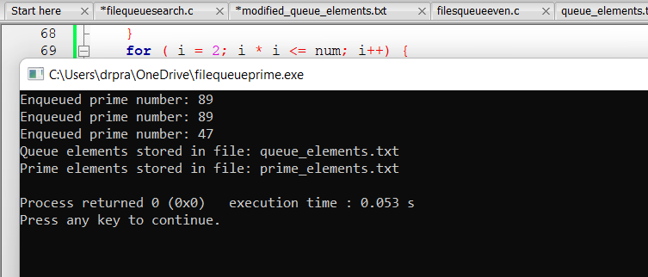
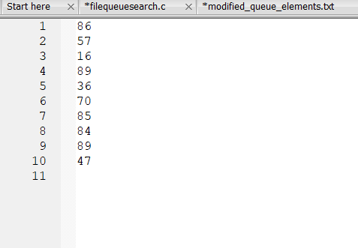
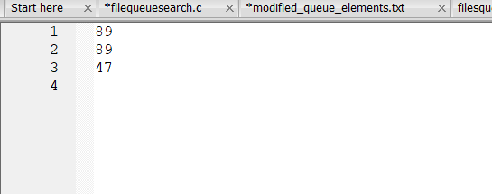
25.search an element in a queue
Code:
#include <stdio.h>
#include <stdlib.h>
#include <time.h>

#define MAX_SIZE 100

// Structure for a queue
struct Queue {
int items[MAX_SIZE];
int front;
int rear;
FILE* file; // File to store the queue elements
FILE* evenFile; // File to store even elements
};

// Function to initialize the queue
void initializeQueue(struct Queue* queue) {
queue->front = -1;
queue->rear = -1;
queue->file = fopen("queue_elements.txt", "w"); // Open file for writing
if (queue->file == NULL) {
printf("Error opening file for writing\n");
exit(1);
}
queue->evenFile = fopen("even_elements.txt", "w"); // Open file for writing even elements
if (queue->evenFile == NULL) {
printf("Error opening file for writing\n");
exit(1);
}
}

// Function to check if the queue is empty
int isEmpty(struct Queue* queue) {
return queue->front == -1;
}

// Function to check if the queue is full
int isFull(struct Queue* queue) {
return (queue->rear + 1) % MAX_SIZE == queue->front;
}

// Function to add an element to the rear of the queue
void enqueue(struct Queue* queue, int value) {
if (isFull(queue)) {
printf("Queue is full\n");
return;
}
if (isEmpty(queue)) {
queue->front = 0;
}
queue->rear = (queue->rear + 1) % MAX_SIZE;
queue->items[queue->rear] = value;

// Write all values to the file
fprintf(queue->file, "%d\n", value);
}

// Function to search for an element in the queue
int searchElement(struct Queue* queue, int element) {
if (isEmpty(queue)) {
printf("Queue is empty\n");
return 0;
}
int i = queue->front;
while (i != queue->rear) {
if (queue->items[i] == element) {
printf("Element %d found at index %d\n", element, i);
return 1;
}
i = (i + 1) % MAX_SIZE;
}
if (queue->items[queue->rear] == element) {
printf("Element %d found at index %d\n", element, queue->rear);
return 1;
}
printf("Element %d not found in the queue\n", element);
return 0;
}

int main() {
int i;
struct Queue queue;
initializeQueue(&queue);

// Generate random elements and enqueue them into the queue
srand(time(NULL));
for ( i = 0; i < 10; i++) { // Generate 10 random elements for demonstration
int randomNum = rand() % 100; // Generate random number between 0 and 99
enqueue(&queue, randomNum);
printf("%d\n",randomNum);
}

// Search for an element in the queue
int searchValue = 50; // Element to search
searchElement(&queue, searchValue);

// Close the files after enqueueing
fclose(queue.file);
fclose(queue.evenFile);
printf("Queue elements stored in file: queue_elements.txt\n");
printf("Even elements stored in file: even_elements.txt\n");

return 0;
}
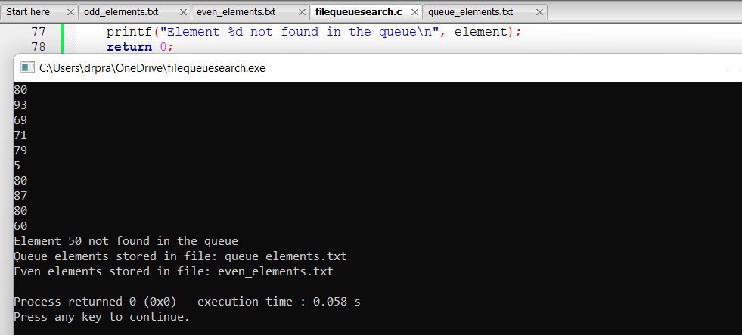
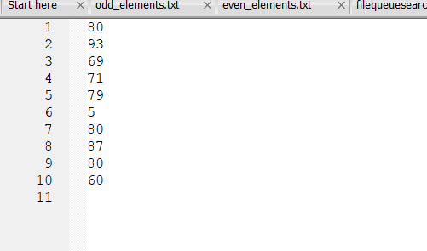
26.apply dequeue operation in queues
Code:
#include <stdio.h>
#include <stdlib.h>
#include <time.h>

#define MAX_SIZE 100

// Structure for a queue
struct Queue {
int items[MAX_SIZE];
int front;
int rear;
FILE* file; // File to store the queue elements
};

// Function to initialize the queue
void initializeQueue(struct Queue* queue) {
queue->front = -1;
queue->rear = -1;
queue->file = fopen("queue_elements.txt", "w"); // Open file for writing
if (queue->file == NULL) {
printf("Error opening file for writing\n");
exit(1);
}
}

// Function to check if the queue is empty
int isEmpty(struct Queue* queue) {
return queue->front == -1;
}

// Function to check if the queue is full
int isFull(struct Queue* queue) {
return (queue->rear + 1) % MAX_SIZE == queue->front;
}

// Function to add an element to the rear of the queue
void enqueue(struct Queue* queue, int value) {
if (isFull(queue)) {
printf("Queue is full\n");
return;
}
if (isEmpty(queue)) {
queue->front = 0;
}
queue->rear = (queue->rear + 1) % MAX_SIZE;
queue->items[queue->rear] = value;

// Write all values to the file
fprintf(queue->file, "%d\n", value);
}

// Function to remove an element from the front of the queue
int dequeue(struct Queue* queue) {
if (isEmpty(queue)) {
printf("Queue is empty\n");
return -1;
}
int frontItem = queue->items[queue->front];
if (queue->front == queue->rear) {
queue->front = -1;
queue->rear = -1;
} else {
queue->front = (queue->front + 1) % MAX_SIZE;
}
return frontItem;
}

// Function to delete a specific element from the queue
void delete(struct Queue* queue, int value) {
if (isEmpty(queue)) {
printf("Queue is empty\n");
return;
}
int found = 0;
int i = queue->front;
while (i != queue->rear) {
if (queue->items[i] == value) {
found = 1;
break;
}
i = (i + 1) % MAX_SIZE;
}
if (queue->items[queue->rear] == value) {
found = 1;
}
if (found) {
printf("Element %d deleted from the queue\n", value);
// Shift elements to remove the found element
while (i != queue->rear) {
queue->items[i] = queue->items[(i + 1) % MAX_SIZE];
i = (i + 1) % MAX_SIZE;
}
queue->rear = (queue->rear - 1 + MAX_SIZE) % MAX_SIZE; // Update rear
} else {
printf("Element %d not found in the queue\n", value);
}
}

int main() {
int i;
struct Queue queue;
initializeQueue(&queue);

// Generate random elements and enqueue them into the queue
srand(time(NULL));
for ( i = 0; i < 10; i++) { // Generate 10 random elements for demonstration
int randomNum = rand() % 100; // Generate random number between 0 and 99
enqueue(&queue, randomNum);
}

// Dequeue elements from the queue
printf("Dequeued elements: ");
while (!isEmpty(&queue)) {
int dequeuedItem = dequeue(&queue);
printf("%d ", dequeuedItem);
}
printf("\n");

// Close the file after enqueueing
fclose(queue.file);
printf("Queue elements stored in file: queue_elements.txt\n");

// Delete an element from the queue
delete(&queue, 50);

return 0;
}
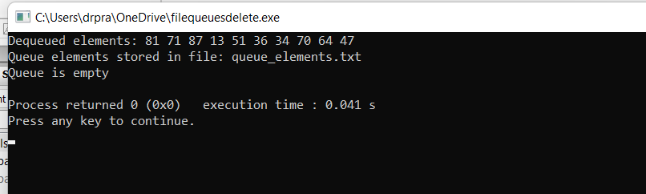
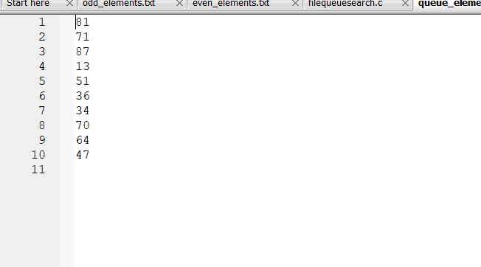
27.delete alternate member of the queue
Code:
#include <stdio.h>
#include <stdlib.h>
#include <time.h>

#define MAX_SIZE 100

// Structure for a queue
struct Queue {
int items[MAX_SIZE];
int front;
int rear;
FILE* originalFile; // File to store the original queue elements
FILE* finalFile; // File to store the final queue elements
};

// Function to initialize the queue
void initializeQueue(struct Queue* queue) {
queue->front = -1;
queue->rear = -1;
queue->originalFile = fopen("original_queue_elements.txt", "w"); // Open file for writing original elements
if (queue->originalFile == NULL) {
printf("Error opening file for writing\n");
exit(1);
}
queue->finalFile = fopen("final_queue_elements.txt", "w"); // Open file for writing final elements
if (queue->finalFile == NULL) {
printf("Error opening file for writing\n");
exit(1);
}
}

// Function to check if the queue is empty
int isEmpty(struct Queue* queue) {
return queue->front == -1;
}

// Function to check if the queue is full
int isFull(struct Queue* queue) {
return (queue->rear + 1) % MAX_SIZE == queue->front;
}

// Function to add an element to the rear of the queue
void enqueue(struct Queue* queue, int value) {
if (isFull(queue)) {
printf("Queue is full\n");
return;
}
if (isEmpty(queue)) {
queue->front = 0;
}
queue->rear = (queue->rear + 1) % MAX_SIZE;
queue->items[queue->rear] = value;

// Write the value to the original queue file
fprintf(queue->originalFile, "%d\n", value);
}

// Function to remove an element from the front of the queue
int dequeue(struct Queue* queue) {
if (isEmpty(queue)) {
printf("Queue is empty\n");
return -1;
}
int frontItem = queue->items[queue->front];
if (queue->front == queue->rear) {
queue->front = -1;
queue->rear = -1;
} else {
queue->front = (queue->front + 1) % MAX_SIZE;
}
return frontItem;
}

// Function to delete alternate elements from the queue
void deleteAlternate(struct Queue* queue) {
if (isEmpty(queue)) {
printf("Queue is empty\n");
return;
}
int count = 1; // Start count from 1 to delete alternate elements
int i = queue->front;
while (i != queue->rear) {
if (count % 2 == 0) {
// Skip deletion for alternate elements
printf("Element %d skipped\n", queue->items[i]);
} else {
// Delete current element
printf("Element %d deleted\n", queue->items[i]);
queue->front = (queue->front + 1) % MAX_SIZE;
}
count++;
i = (i + 1) % MAX_SIZE;
}
// Delete last element if queue size is odd
if ((count % 2) == 0) {
printf("Element %d deleted\n", queue->items[i]);
queue->front = (queue->front + 1) % MAX_SIZE;
}
queue->rear = (queue->rear - count + MAX_SIZE) % MAX_SIZE; // Update rear
}

// Function to store the final queue elements in a file
void storeFinalQueueToFile(struct Queue* queue) {
int i = queue->front;
while (i != queue->rear) {
fprintf(queue->finalFile, "%d\n", queue->items[i]);
i = (i + 1) % MAX_SIZE;
}
fprintf(queue->finalFile, "%d\n", queue->items[queue->rear]);
fclose(queue->finalFile);
}

int main() {
int i;
struct Queue queue;
initializeQueue(&queue);

// Generate random elements and enqueue them into the queue
srand(time(NULL));
for ( i = 0; i < 10; i++) { // Generate 10 random elements for demonstration
int randomNum = rand() % 100; // Generate random number between 0 and 99
enqueue(&queue, randomNum);
}

// Display original queue
printf("Original queue:\n");
i = queue.front;
while (i != queue.rear) {
printf("%d ", queue.items[i]);
i = (i + 1) % MAX_SIZE;
}
printf("%d\n", queue.items[queue.rear]);

// Store the original queue elements in a file
storeFinalQueueToFile(&queue);
printf("Original queue elements stored in file: original_queue_elements.txt\n");

// Delete alternate elements from the queue
deleteAlternate(&queue);

// Display modified queue
printf("Modified queue:\n");
i = queue.front;
while (i != queue.rear) {
printf("%d ", queue.items[i]);
i = (i + 1) % MAX_SIZE;
}
printf("%d\n", queue.items[queue.rear]);

// Store the final queue elements in a file
storeFinalQueueToFile(&queue);
printf("Final queue elements stored in file: final_queue_elements.txt\n");

// Close the file after enqueueing
fclose(queue.originalFile);

return 0;
}
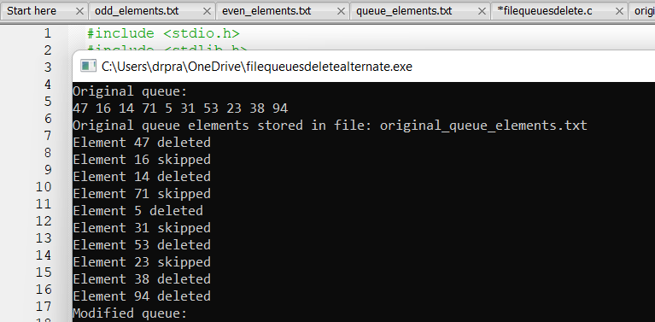
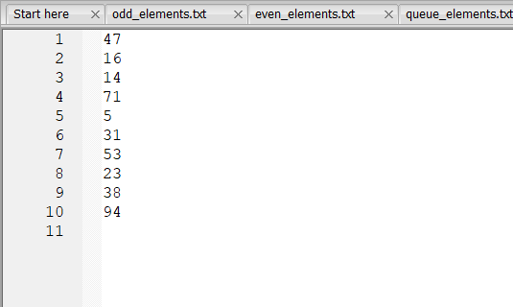
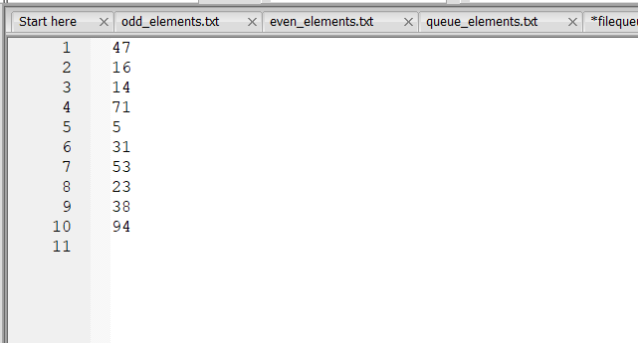
28.find the max number in the queue
#include <stdio.h>
#include <stdlib.h>
#include <time.h>

#define MAX_SIZE 100

// Structure for a queue
struct Queue {
int items[MAX_SIZE];
int front;
int rear;
int max; // Maximum term in the queue
FILE* originalFile; // File to store the original queue elements
FILE* finalFile; // File to store the final queue elements
FILE* maxFile; // File to store the maximum term
};

// Function to initialize the queue
void initializeQueue(struct Queue* queue) {
queue->front = -1;
queue->rear = -1;
queue->max = -1;
queue->originalFile = fopen("original_queue_elements.txt", "w"); // Open file for writing original elements
if (queue->originalFile == NULL) {
printf("Error opening file for writing\n");
exit(1);
}
queue->finalFile = fopen("final_queue_elements.txt", "w"); // Open file for writing final elements
if (queue->finalFile == NULL) {
printf("Error opening file for writing\n");
exit(1);
}
queue->maxFile = fopen("max_queue_element.txt", "w"); // Open file for writing maximum element
if (queue->maxFile == NULL) {
printf("Error opening file for writing\n");
exit(1);
}
}

// Function to check if the queue is empty
int isEmpty(struct Queue* queue) {
return queue->front == -1;
}

// Function to check if the queue is full
int isFull(struct Queue* queue) {
return (queue->rear + 1) % MAX_SIZE == queue->front;
}

// Function to add an element to the rear of the queue
void enqueue(struct Queue* queue, int value) {
if (isFull(queue)) {
printf("Queue is full\n");
return;
}
if (isEmpty(queue)) {
queue->front = 0;
}
queue->rear = (queue->rear + 1) % MAX_SIZE;
queue->items[queue->rear] = value;

// Write the value to the original queue file
fprintf(queue->originalFile, "%d\n", value);

// Update maximum term if needed
if (value > queue->max) {
queue->max = value;
}
}

// Function to store the final queue elements in a file
void storeFinalQueueToFile(struct Queue* queue) {
int i = queue->front;
while (i != queue->rear) {
fprintf(queue->finalFile, "%d\n", queue->items[i]);
i = (i + 1) % MAX_SIZE;
}
fprintf(queue->finalFile, "%d\n", queue->items[queue->rear]);
fclose(queue->finalFile);
}

int main() {
int i;
struct Queue queue;
initializeQueue(&queue);

// Generate random elements and enqueue them into the queue
srand(time(NULL));
for ( i = 0; i < 10; i++) { // Generate 10 random elements for demonstration
int randomNum = rand() % 100; // Generate random number between 0 and 99
enqueue(&queue, randomNum);
printf("%d\n",randomNum);
}

// Print the maximum term
printf("Maximum term in the queue: %d\n", queue.max);

// Store the original queue elements in a file
storeFinalQueueToFile(&queue);
printf("Original queue elements stored in file: original_queue_elements.txt\n");

// Store the maximum term in a file
fprintf(queue.maxFile, "%d\n", queue.max);
fclose(queue.maxFile);
printf("Maximum term stored in file: max_queue_element.txt\n");

return 0;
}
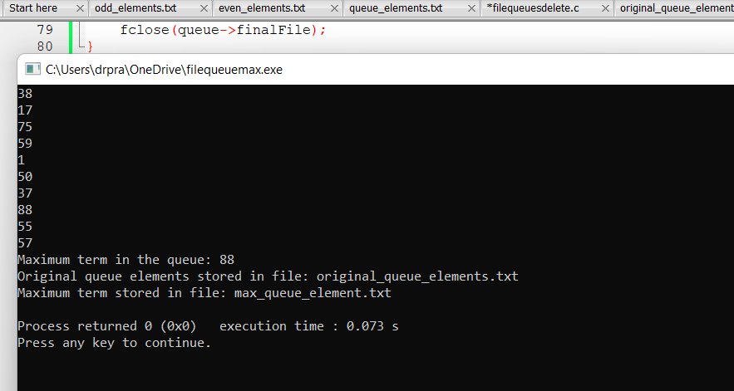
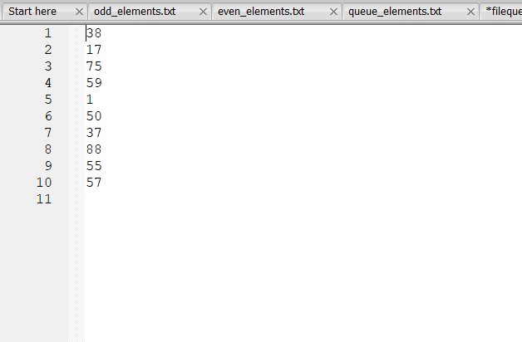
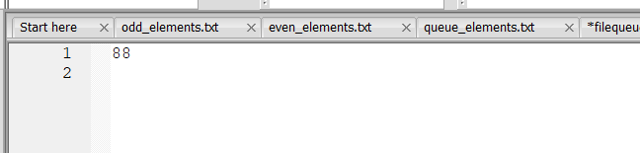
29.find the maximum element in the queue
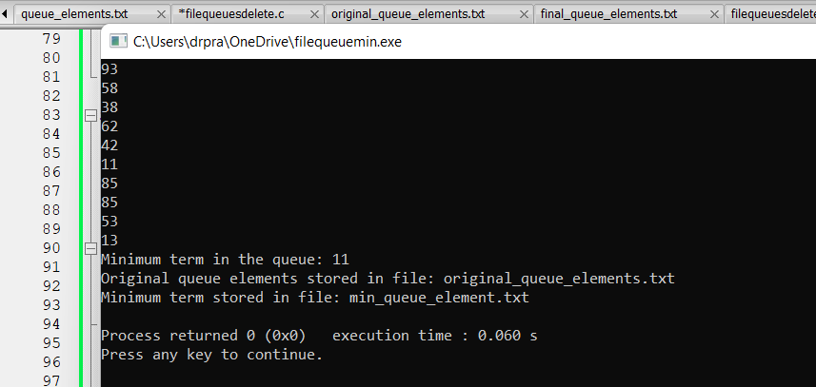
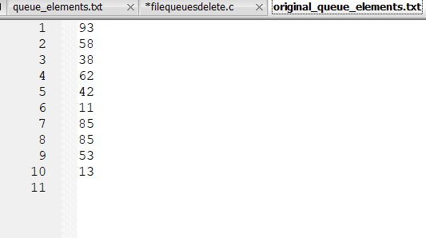
30.to sort the queue in assending order
Code:
#include <stdio.h>
#include <stdlib.h>
#include <time.h>
#include <limits.h> // Include limits.h for INT_MAX
#include <stdbool.h> // Include stdbool.h for boolean data type
#include <string.h> // Include string.h for strcpy function

#define MAX_SIZE 100

// Structure for a queue
struct Queue {
int items[MAX_SIZE];
int front;
int rear;
int min; // Minimum term in the queue
FILE* originalFile; // File to store the original queue elements
FILE* finalFile; // File to store the final queue elements
FILE* minFile; // File to store the minimum term
};

// Function to initialize the queue
void initializeQueue(struct Queue* queue) {
queue->front = -1;
queue->rear = -1;
queue->min = INT_MAX; // Initialize min to maximum possible integer value
queue->originalFile = fopen("original_queue_elements.txt", "w"); // Open file for writing original elements
if (queue->originalFile == NULL) {
printf("Error opening file for writing\n");
exit(1);
}
queue->finalFile = fopen("final_queue_elements.txt", "w"); // Open file for writing final elements
if (queue->finalFile == NULL) {
printf("Error opening file for writing\n");
exit(1);
}
queue->minFile = fopen("min_queue_element.txt", "w"); // Open file for writing minimum element
if (queue->minFile == NULL) {
printf("Error opening file for writing\n");
exit(1);
}
}

// Function to check if the queue is empty
int isEmpty(struct Queue* queue) {
return queue->front == -1;
}

// Function to check if the queue is full
int isFull(struct Queue* queue) {
return (queue->rear + 1) % MAX_SIZE == queue->front;
}

// Function to add an element to the rear of the queue
void enqueue(struct Queue* queue, int value) {
if (isFull(queue)) {
printf("Queue is full\n");
return;
}
if (isEmpty(queue)) {
queue->front = 0;
}
queue->rear = (queue->rear + 1) % MAX_SIZE;
queue->items[queue->rear] = value;

// Write the value to the original queue file
fprintf(queue->originalFile, "%d\n", value);

// Update minimum term if needed
if (value < queue->min) {
queue->min = value;
}
}

// Function to dequeue an element from the front of the queue
int dequeue(struct Queue* queue) {
if (isEmpty(queue)) {
printf("Queue is empty\n");
return -1;
}
int frontItem = queue->items[queue->front];
if (queue->front == queue->rear) {
queue->front = -1;
queue->rear = -1;
} else {
queue->front = (queue->front + 1) % MAX_SIZE;
}
return frontItem;
}

// Function to sort an array in ascending order
void sortArray(int arr[], int size) {
int i,j;
for ( i = 0; i < size - 1; i++) {
for ( j = i + 1; j < size; j++) {
if (arr[i] > arr[j]) {
int temp = arr[i];
arr[i] = arr[j];
arr[j] = temp;
}
}
}
}

// Function to sort the queue in ascending order
void sortQueue(struct Queue* queue) {
int i;
// Dequeue all elements from the queue and store them in an array
int temp[MAX_SIZE];
int count = 0;
while (!isEmpty(queue)) {
temp[count++] = dequeue(queue);
}

// Sort the array
sortArray(temp, count);

// Enqueue the sorted elements back into the queue
for ( i = 0; i < count; i++) {
enqueue(queue, temp[i]);
}
}

// Function to store the final queue elements in a file
void storeFinalQueueToFile(struct Queue* queue) {
int i = queue->front;
while (i != queue->rear) {
fprintf(queue->finalFile, "%d\n", queue->items[i]);
i = (i + 1) % MAX_SIZE;
}
fprintf(queue->finalFile, "%d\n", queue->items[queue->rear]);
fclose(queue->finalFile);
}

int main() {
int i;
struct Queue queue;
initializeQueue(&queue);

// Generate random elements and enqueue them into the queue
srand(time(NULL));
for ( i = 0; i < 10; i++) { // Generate 10 random elements for demonstration
int randomNum = rand() % 100; // Generate random number between 0 and 99
enqueue(&queue, randomNum);

}

// Print the original queue
printf("Original queue:\n");
for ( i = queue.front; i != queue.rear; i = (i + 1) % MAX_SIZE) {
printf("%d ", queue.items[i]);
}
printf("%d\n", queue.items[queue.rear]);

// Sort the queue in ascending order
sortQueue(&queue);

// Print the sorted queue
printf("Sorted queue in ascending order:\n");
for ( i = queue.front; i != queue.rear; i = (i + 1) % MAX_SIZE) {
printf("%d ", queue.items[i]);
}
printf("%d\n", queue.items[queue.rear]);

// Store the original and final queue elements in files
storeFinalQueueToFile(&queue);
printf("Original queue elements stored in file: original_queue_elements.txt\n");
printf("Final queue elements stored in file: final_queue_elements.txt\n");

return 0;
}
