
Lovely Professional University
Phagwara, Punjab

Dockerized Online Quiz System Microservices Application with CI/CD Pipeline using Node.js

Student Name: Thota Mohan Karthik Tej
Registration Number: 12300587
Course / Program: B.Tech
Department: Computer Science and Engineering
Institution Name: Lovely Professional University
Guide / Supervisor: Manpreet Kaur
Submission Date: 01/05/2026
Section: 20M59
RollNo: 07
TABLE OF CONTENTS
- Project Title and Problem Statement
- Tools and Technologies Used
- Architecture / Workflow Diagram (CI/CD Pipeline)
- Expected Results and Conclusion

1. PROJECT TITLE AND PROBLEM STATEMENT
Project Title
Dockerized Online Quiz System Microservices Application with CI/CD Pipeline using Node.js
Problem Statement
Online quiz platforms are widely used for education and assessments. Traditional monolithic applications face challenges such as poor scalability, difficult maintenance, and inefficient deployment processes.
In a monolithic system, all components such as user management, quiz handling, and result evaluation are tightly coupled into a single application. This leads to several issues.
One major problem is scalability. When many users attempt quizzes simultaneously, the entire application must be scaled, even if only one module is under heavy load.
Another issue is maintainability. Updating a single feature requires redeploying the entire application, increasing downtime.
Environment inconsistency is also a concern, where applications behave differently across development and production environments.
Manual deployment further increases complexity and chances of human error.
To overcome these issues, this project proposes a microservices-based Online Quiz System that:
- Splits the application into independent services
- Uses Docker for consistent execution environments
- Automates build and deployment using GitHub Actions
- Enables independent scaling of services
- Improves system reliability through service isolation
This solution follows modern DevOps practices and ensures efficiency and scalability.

2. TOOLS AND TECHNOLOGIES USED
- Docker – Containerizes each microservice
- Docker Compose – Runs multiple services together
- GitHub Actions – Automates CI/CD pipeline
- Node.js (Express.js) – Backend development
- MongoDB – Database for storing quiz data
- NGINX – API Gateway for routing requests
- Git – Version control

3. ARCHITECTURE / WORKFLOW DIAGRAM (CI/CD PIPELINE)
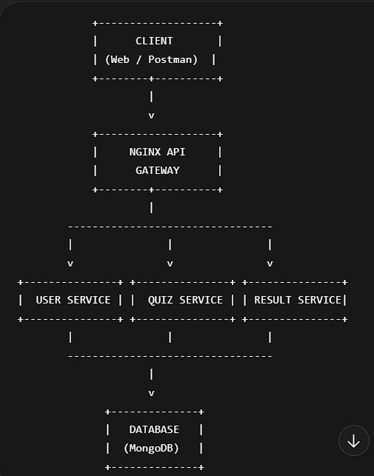
System Architecture Flowchart
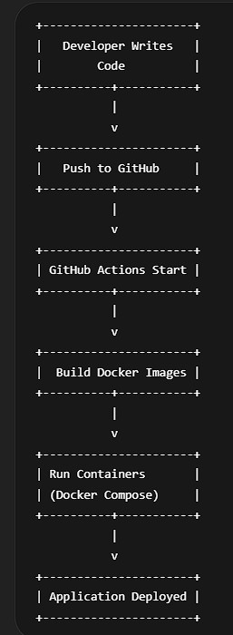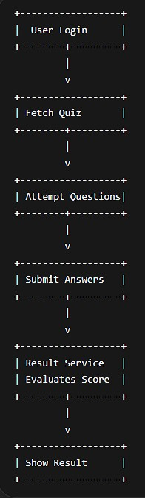

CI/CD Pipeline Flowchart User Takes Quiz Flow
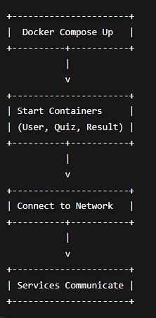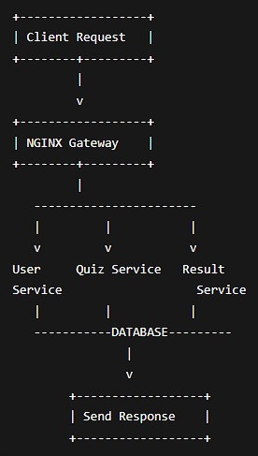

Request Flow Docker Execution Flow

Workflow Explanation
- Developer writes code and pushes it to GitHub
- GitHub Actions automatically triggers the pipeline
- Docker images are built for each microservice
- Containers are started using Docker Compose
- NGINX acts as an API Gateway
- Requests are routed to appropriate services
- Services interact with MongoDB
- Results are processed and returned to the user

4. EXPECTED RESULTS AND CONCLUSION
Expected Results
- Successful deployment using Docker containers
- Automated CI/CD pipeline using GitHub Actions
- Reduced manual effort
- Improved scalability and flexibility
- Faster response and processing

