



KARNATAKA STATE COUNCIL FOR SCIENCE AND TECHNOLOGY
Indian Institute of Science campus, Bengaluru
Telephone: 080 -23600978, 23341652 || Email: spp@kscst.org.in
Website: www.kscst.org.in/spp.html or https://kscst.karnataka.gov.in/en
FORMAT FOR STUDENT PROJECT PROPOSAL FOR THE
48th SERIES OF STUDENT PROJECT PROGRAMME
(Handwritten proposals will not be accepted, please fill all the details in this MS word file, insert images / diagrams wherever necessary. Convert to pdf file, get it approved from the project guide / head of the department and principal of your institution. Keep ready the scanned pdf file of 1) Declaration and Endorsement 2) details of processing fees made and fill-up the Google Form.
https://forms.gle/ks2WxWB4ei1hgv9D9
Name of the College: MANGALORE INSTITUTE OF TECHNOLOGY AND ENGINEERING, Moodabidri

Project Title: ONCOGUIDERX: A DEEP LEARNING-BASED PLATFORM FOR PREDICTING PERSONALIZED CANCER DRUG SENSITIVITY
Branch: COMPUTER SCIENCE & ENGINEERING

Theme:
Healthcare management, Information Technology, Resources and
Environmental Management

Name of project guide:

Name: Mrs. Suma K
Email id: suma@mite.ac.in
Contact No.: 7899671674

Name of Team Members:


Name: K SAHANA RAO
USN No.: 4MT21CS062
Email id: sahana2003.rao@gmail.com
Mobile No: 9482297663


Name: KARTHIK U SHETTIGAR
USN No.: 4MT21CS064
Email id: karthikushettigar11@gmail.com
Mobile No.: 9448127175

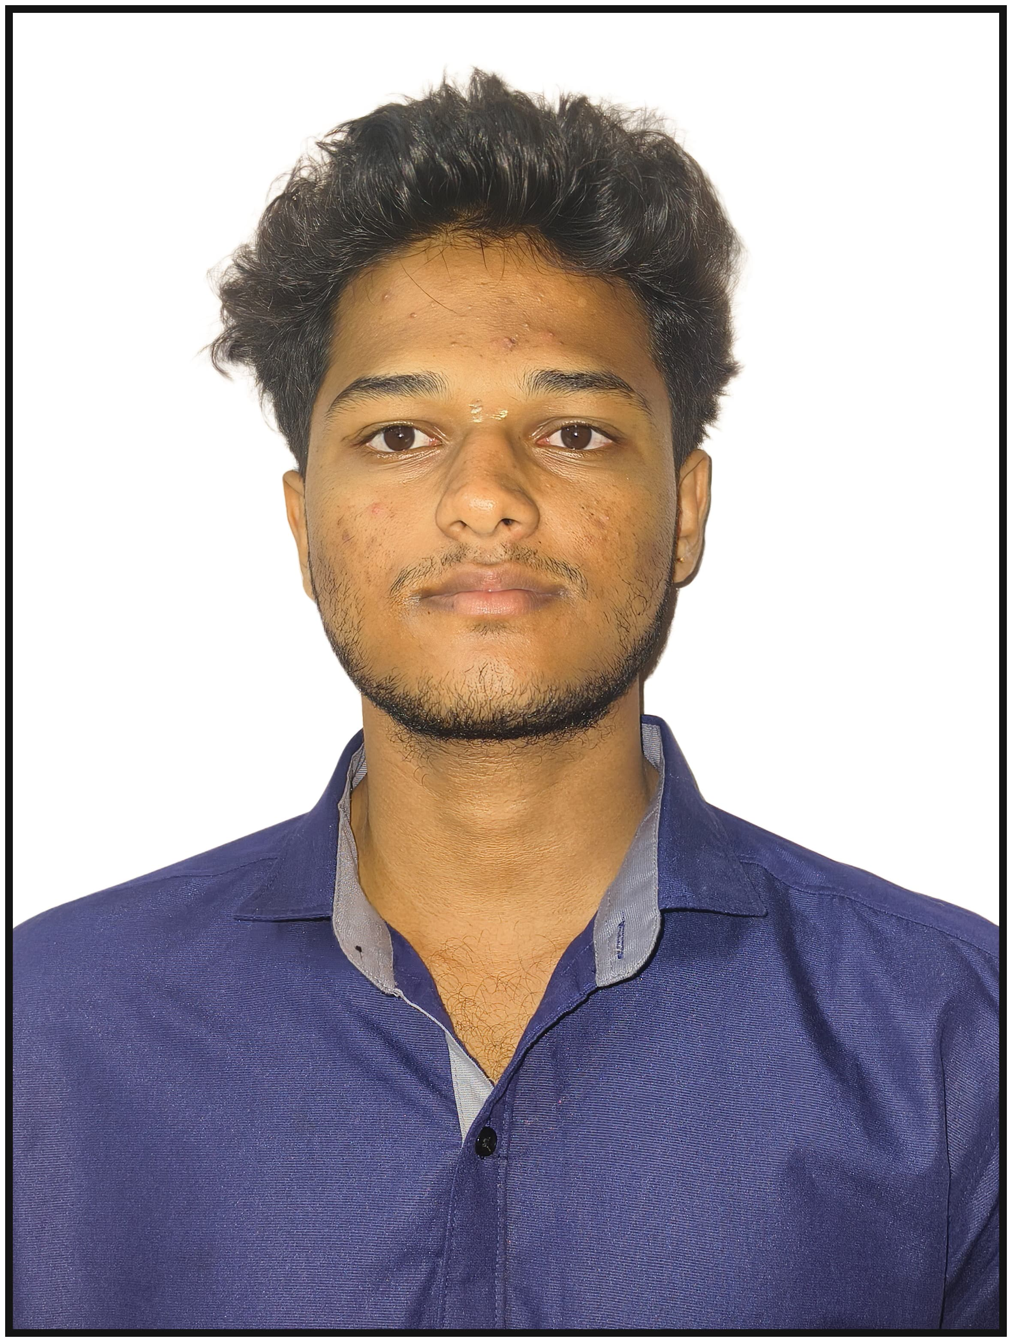
Name: DHANUSH A
USN No.: 4MT21CS046
Email id: dhanushbhat510@gmail.com
Mobile No.: 6363540669


Name: DHANUSH S SHETTY
USN No.: 4MT21CS047
Email id: dhanush14atcoc@gmail.com
Mobile No.: 6360881098

Team Leader of the Project:
Name: K SAHANA RAO
USN No.: 4MT21CS062
Email id: sahana2003.rao@gmail.com
Mobile No: 9482297663

Processing Fee Details (Through Online Payment only):
(processing fee of Rs. 1180/-)
Payment details furnished in the last page.
Transaction ID: 433027124906
Date of commencement of the Project: 28/08/2024

Probable date of completion of the project: 14/12/2024

Scope / Objectives of the project:
- Preprocess genomic datasets to prepare them for training the predictive model.
- Develop and train an Artificial Neural Network (ANN) model using the processed dataset to predict IC50 values for cancer drugs.
- Test the ANN model’s performance to ensure accuracy and reliability in drug response predictions.
- Implement a web-based system to provide IC50 predictions and visualizations for selected cancer drugs.

Methodology:
- Input Genomic Data: Input genomic and drug-related features, including gene expression, mutations, and copy number alterations (CNAs), for IC50 prediction.
- Data Preprocessing: Normalize continuous features and apply feature selection to reduce noise and improve model accuracy.
- Data Integration: Merge datasets from the Genomics of Drug Sensitivity in Cancer (GDSC) project, creating a unified dataset with relevant genomic markers.
- Data Splitting: Split the dataset into 80% training and 20% testing subsets to evaluate model performance effectively.
- Model Training: Train an Artificial Neural Network (ANN) model using PyTorch to predict IC50 values based on input genomic features.
- Input Test Data: Evaluate the trained model on the testing dataset to ensure generalization and accuracy.
- IC50 Prediction: Predict IC50 values for specific drugs and cancer cell lines using the trained ANN model.
- Visualizations: Generate comparative graphs and visualizations for selected drugs to support decision-making.
- Deployment: Deploy the trained model via a Flask-based web interface, allowing users to input data and receive predictions in real-time.

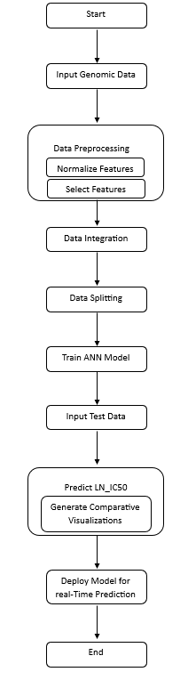

Expected Outcome of the project:
The project aims to predict drug sensitivity in cancer treatment by determining IC50 values for various drugs based on genomic data. The model will provide highly accurate IC50 predictions, enabling personalized drug recommendations for specific cancer cell lines. The results will be presented through intuitive visualizations, including comparative graphs of IC50 values for selected drugs. These insights will assist healthcare professionals in selecting the most effective treatment options for individual patients. The deployment of the model via a user-friendly web interface will ensure accessibility for researchers and clinicians, fostering advancements in precision medicine and improving patient outcomes.

Is the project proposed relevant to the Industry / Society or Institution?
Yes / No: Yes
Details of relevance and industry/institution involvement:
The project is highly relevant to the healthcare and pharmaceutical industry, particularly in the domain of oncology and personalized medicine. It aims to address critical challenges in drug sensitivity prediction for cancer treatments by leveraging advanced computational techniques. The Genomics of Drug Sensitivity in Cancer (GDSC) dataset is widely used in research and development, making the project applicable to pharmaceutical companies, cancer research centers, and hospitals.
Potential Industry/Institution Support:
- Technology Support: Hospitals and research institutions can provide real-world genomic and clinical datasets to further validate and enhance the model's accuracy.
- Usage of Final Product: OncoGuideRx can be adopted by oncology departments, pharmaceutical research teams, and academic institutions for drug response analysis and cancer treatment planning.
- Potential Collaborators:
Institution: Local hospitals, cancer research organizations, and genomics labs.

Can the product or process developed in the project be taken up for filing a Patent?
Yes / No: Yes

Prior Art search done?
Yes/No: No
Budget details (break-up details should be given):
Note: KSCST will provide nominal grant support for carrying out the project by students if selected by the project selection committee.
Budget | Amount
a) Materials / Consumables (Datasets and Computing Resources) | 2000.00
b) Labor | 0.00
c) Travel (Doctor Consultations and  Laboratory) | 1000.00
e) Miscellaneous (Domain Name, Web Hosting, Tools) | 2000.00
Total | 5000.00

Any other technical details:
The project, "OncoGuideRx: A Deep Learning-Based Platform for Predicting Personalized Cancer Drug Sensitivity", focuses on predicting drug sensitivity for personalized cancer treatment. The methodology involves preprocessing genomic data from the Genomics of Drug Sensitivity in Cancer (GDSC) dataset, which includes information on gene mutations, gene expression levels, and copy number alterations (CNAs). The data is normalized, features are selected based on relevance, and the processed dataset is used to train an ANN model to predict IC50 values. The trained model is deployed through a Flask-based web interface, enabling real-time predictions and comparative analysis of drug efficacy. The system is designed to assist clinicians and researchers in identifying the most effective cancer treatment options, enhancing precision medicine and improving patient outcomes.

SPP Coordinator (Identified by the college):
Name: Prof. Ajith Kumar
Email id: ajithkumar@mite.ac.in
Contact No.: 9901225235

Name of the Project Guide: Mrs. Suma K | Name of the HOD: Dr. Ravinarayana B
Email id: suma@mite.ac.in | Email id: hodcse@mite.ac.in
Contact No.: 7899671674 | Contact No.: 8971025801

DECLARATION
(From Project Students)
(To scan this page and enclose in the project proposal)

We, the project team hereby declare that the details enclosed in the project proposal (Title of the Project: OncoGuideRx: A Deep Learning-Based Platform for Predicting Personalized Cancer Drug Sensitivity), Branch: Computer Science & Engineering, College: Mangalore Institute of Technology and Engineering are true and correct to the best of our knowledge and belief. We undertake to inform the Karnataka State Council for Science and Technology (KSCST) of any changes to the project title or team members' names immediately through our project guide or the SPP Coordinator of our institution.
Additionally, we declare that the project work is original and not a result of copying or purchasing. We are committed to completing the project independently, with support from our faculty and project guide, while utilizing the facilities provided by the college. We will not engage in plagiarism and pledge to be sincere and dedicated in executing and completing the project as proposed.
We understand that if any of the above information is found to be false, untrue, or misleading, we may be held liable. We authorize the sharing of the project information contained in this proposal with KSCST, Bengaluru.
We acknowledge that the project team must exhibit and demonstrate the project, participate in the mid-term evaluation of sanctioned projects, and engage with experts. Additionally, we must exhibit the project at the Annual State-Level Poster Presentation and Exhibition, if selected. Should our team fail to participate in the mid-term evaluation or the Annual Exhibition (if selected), we understand that the supported project funds will be returned to KSCST.
We also enclose the endorsement form for KSCST, Bengaluru.
Name of the students with USN No. Signature with date
- DHANUSH A -4MT21CS046
- DHANUSH S SHETTY -4MT21CS047
- K SAHANA RAO -4MT21CS062
- KARTHIK U SHETTIGAR -4MT21CS064
(Name & Signature of Project Guide with Seal) | (Name & Signature of HOD with Seal)
Email id: suma@mite.ac.in | Email id: hodcse@mite.ac.in
Contact No.: 7899671674 | Contact No.: 8971025801
ENDORSEMENT
(From College, endorsement to be taken in the institution / Department Letter head)
(To scan this page and enclose in the project proposal)

This is to certify that 1) Mr. Dhanush A, 2) Mr. Dhanush S Shetty, 3) Ms. K Sahana Rao 4) Mr. Karthik U Shettigar are bonafide students of Department of Computer Science & Engineering, in the degree program of our institution. If the project proposal submitted by these students under the 48th series of Student Project Programme is selected by KSCST, we will provide the requisite laboratory / Computer / infrastructure support in our college / Institution. Further we also take necessary steps to see that the project team will exhibit / demonstrate their project in the mid-term evaluation of project and in the Annual State-Level Poster Presentation and Exhibition (if selected). If the student team fails to send the completed project report or fails to attend the evaluation in mid-term evaluation of sanctioned projects or fails to attend the Annual State-Level Poster Presentation and Exhibition (if selected), the supported project amount will be returned to KSCST.

(Name & Signature of  Project Guide with Seal) | (Signature of HOD with Seal) | (Signature of the Principal with Seal)
Email id: suma@mite.ac.in | Email id: hodcse@mite.ac.in | Email id: principal@mite.ac.in
Contact No.: 7899671674 | Contact No.: 8971025801 | Contact No.: 9972099169

DETAILS OF PROCESSING FEES MADE THROUGH
NEFT / UPI PAYMENT
(Note: Include this page in the softcopy of the student project proposal. The student team shall furnish the details in the Google Form. It is informed to the students to 1) keep ready the softcopy of the project proposal and other documents and 2) Furnish the payment made details as processing fees and 3) update the details in the Google Form on the same day of payment made to KSCST by NEFT / UPI payment).

- TITLE OF THE PROJECT | : | OncoGuideRx: A Deep Learning-Based Platform for Predicting Personalized Cancer Drug Sensitivity
- NAME OF THE TEAM LEADER | : | K SAHANA RAO
- EMAIL ID | : | sahana2003.rao@gmail.com
- CONTACT MOBILE NO. | : | 9482297663
PAYMENT MADE DETAILS
- BANK REF. NO. / UTR NO. / UPI No. (12 digits) | : | 433027124906
- TRANSACTION ID | : | 433027124906
- NAME OF THE SENDER / ACCOUNT HOLDER and CONTACT NUMBER | : | KARTHIK U SHETTIGAR  9448127175
- NAME OF THE BANK | : | CANARA BANK
- PROCESSING FEES | : | Rs. 1,180/- (Inclusive of 18% GST)
- DATE OF PAYMENT MADE | : | 25 November 2024
- TIME | : | 3:21 PM
- MODE OF PAYMENT MADE  (NEFT / UPI, PLEASE SPECIFY) | : | UPI

(Name & Signature of  the team leader) | (Name & Signature of  Project Guide or HOD with Seal)

