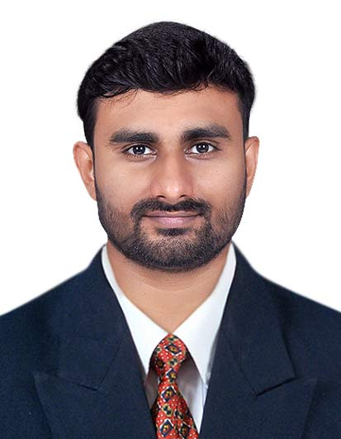 | Karthik Vattekkatt  551Vanier Drive,  Unit 215, Kitchener,  Ontario, Canada  Email : karthikv471@gmail.com  Phone : +1 519 781 4532
Objective
- To work in a competitive and challenging work environment to contribute to the best of my ability towards the growth and development of a progressive organization, and to fully utilize my interpersonal and academic skills to pursue a challenging and rewarding career.

Experience
Currently I am pursuing Certified PG diploma course in Web design and Development in Conestoga College, Canada, Ontario
Sept-2017 - Present
Pooram Fin serve Pvt Ltd  Php Developer  - Development of mobile friendly websites & applications using HTML, CSS, BOOTSTRAP.  - Developing applications in PHP and JavaScript  - Works to Implement JavaScript frameworks like AngularJS.  - Works to implement web services & Social API Integration.  - Developing web application using frameworks like code igniter, Symfony2, Laravel, Drupal.  - Gathering assimilate information regarding website requirements.  - Adapt and prioritize works.  - Testing works that meet quality standards, legislation and best practices.  - Works to integrate live streaming (Live auction) in websites.  Atees Info media Pvt Ltd | Thrissur  Oct -2016 – Sept 2017  Thrissur
Php Developer | March-2015 – Oct-2016
- Development of projects
- Assigning Project tasks to team
- Managing Project Time line
- planning and monitoring the project
- managing project risks
- monitoring overall progress and use of resources, initiating corrective action where necessary
- Determine the organizational structure of the project team

IPSR Solutions Ltd  PHP training Program | Thrissur  Jan-2015 – March-2015

Symphony Teleca Pvt Ltd | Bangalore
Project Trainee | June-2014 – Dec-2014
- Development of GUI
- Development of Business Intelligence
- Finding and fixing bugs
- Modification of existing GUI
Software Expertise
- Programming Languages : Php, Dot Net, Java
- Database : MySQL, Sql Server
- IDE : Php Strome , Visual Studio, Eclipse
- Framework : code igniter

Projects Undertaken (Latest to Old)
- Pooram Finserv (Currently undergoing)
A website for Pooram : Pooram Finserv
Group of Companies.

Technologies Used : PHP
Database : MYSQL

Access link : www.pooramfinserv.com/newsite_demo
- Loan Calculator Online for Pooram Finserv)
An online widget for Pooram : Loan Calculator
Group of Companies.

Technologies Used : PHP
Database : MYSQL

Access link : www.pooramfinserv.com/calculator
- Pooram Nidhi
A website for Pooram : Pooram Nidhi
Group of Companies.
Technologies Used : PHP
Database : MYSQL
Access link : www.pooramnidhi.com

- Pooram Chits
A website for chit division in Pooram : Pooram Chits
Group of Companies.

Technologies Used : PHP
Database : MYSQL

Access link : www.pooramchit.com

- Project for Tripple Point Technologies : UI Framework
A project to control the voyage of ships world wide.
Technologies Used : Dot Net
Database : Sql Server 2008

- Malabar College : Placement Cell
A project to handle placement drives that conducting in college.

Technologies Used : Php
Database : MySQL

- Thejus college : Crime Authority
A project to stop the crimes happening all over the world.

Technologies Used : Php
Database : MySQL

- Milestone Hypermarket, UAE : Milestone
A pure e-commerce website for
Milestone hypermarket where
Customers can buy their daily things.
Technologies Used : Php 5.5.38
Database : MySQL
Access link : www.milestonehypermarket.com/demo1
- Naren Marketing, INDIA : Naren Marketing
An e-commerce website for
Naren marketing, a provider of plumbing materials in India.

Technologies Used : Php 5.5.38
Database : MySQL

Access link : www.narenmarketing.com
Skills
- Highly motivated with ability to work as a team member
- Quick learner and grasp new things quickly.
- Strong interpersonal skills.
- Team management
- Risk management
Education

Qualification | University | Year
MCA - 65% | Bangalore University | 2011 – 2014
BCA – 60% | Bharathiar University | 2008 - 2011
Higher Secondary - 68% | Kerala State Board | 2006 - 2008
SSLC – 70% | Kerala State Board | 2005 - 2006

Personal Profile

- Father's Name : Muralidharan K
- Date of Birth : 25-10-1990
- Sex : Male
- Nationality : Indian
- Marital Status : Single
- Religion : Hindu
- Languages Known : Malayalam, English, Hindi, Tamil

Declaration

I hereby declare that the above given particulars are true to the best of knowledge.
Karthik Vattekkatt

