1. **. Aim:** To Design Deterministic Finite Automata using simulator to accept the input string “a” ,”ac”,and ”bac”.

**Diagram:**

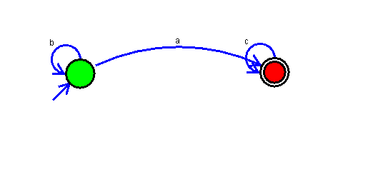

**Result:**

Successfully executed Deterministic Finite Automata using simulator to accept the input string “a” ,”ac”,and ”bac”.

13. Aim: To Design Push Down Automata using simulator to accept the input string aabb.

Diagram:

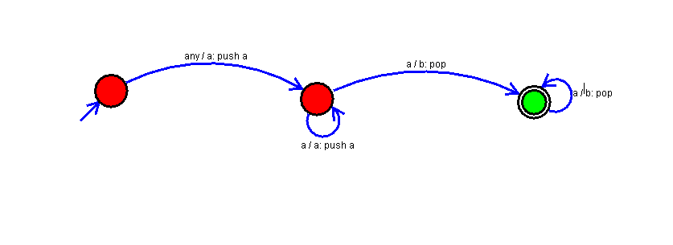

Result:

Successfully executed Push Down Automata using simulator to accept the input string aabb.

14. Aim: To Design Push Down Automata using simulator to accept the input string anb2n .

Diagram:

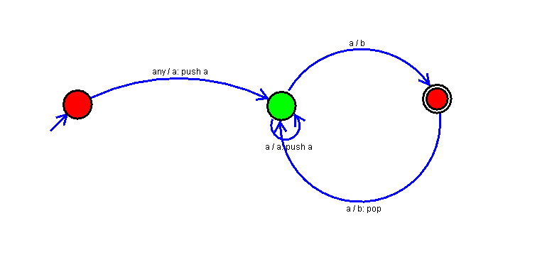

Result:

Successfully executed Push Down Automata using simulator to accept the input string anb2n .

21) Aim: To Design Deterministic Finite Automata using simulator to accept even number of a’s.

Diagram:

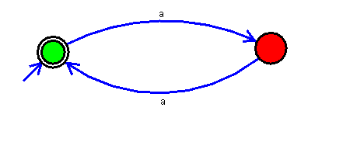

Result:

Successfully executed Deterministic Finite Automata using simulator to accept even number of a’s.

22) Aim: To Design Deterministic Finite Automata using simulator to accept odd number of a’s.

Diagram:

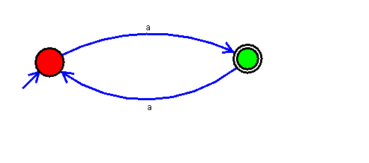

Result:

Successfully executed Deterministic Finite Automata using simulator to accept odd number of a’s.

23) Aim: To Design Deterministic Finite Automata using simulator to accept the string the end with ab over set {a,b) W= aaabab.

Diagram:

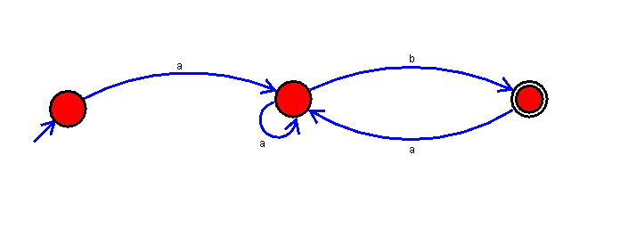

Result:

Successfully executed Deterministic Finite Automata using simulator to accept the string the end with ab over set {a,b) W= aaabab.

24) Aim: To Design Deterministic Finite Automata using simulator to accept the string having ‘ab’ as substring over the set {a,b}.

Diagram:

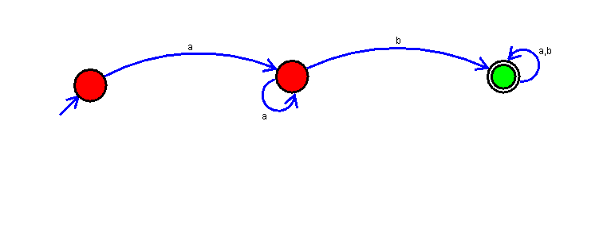

Result:

Successfully executed Deterministic Finite Automata using simulator to accept the string having ‘ab’ as substring over the set {a,b}.

25) Aim: To Draw a Deterministic Finite Automata for the language accepting strings ending with ‘abba’ over input alphabets ∑ = {a, b}.

Diagram:

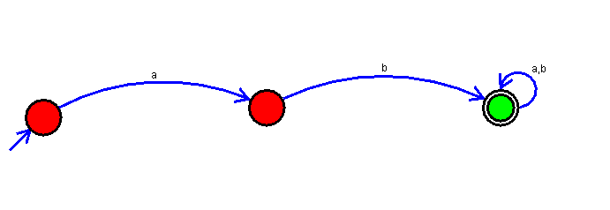

Result:

Successfully executed Deterministic Finite Automata for the language accepting strings ending with ‘abba’ over input alphabets ∑ = {a, b}.

28) Aim: Design DFA using simulator to accept the string the end with ab over set {a,b)

W= abbaabab.

Diagram:

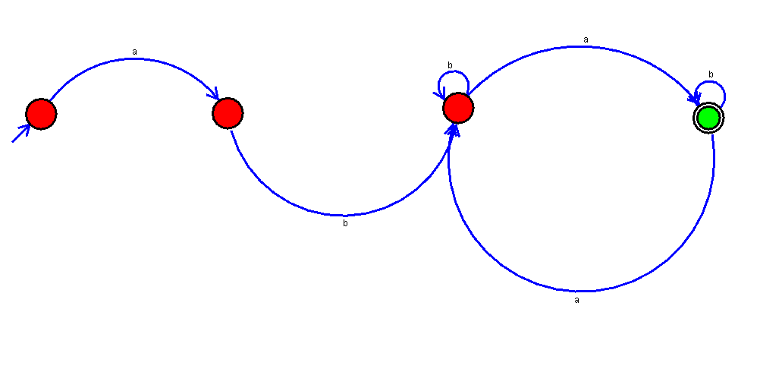

Result:

Successfully executed DFA using simulator to accept the string the end with ab over set {a,b) W= abbaabab.

29) Aim: To Design Deterministic Finite Automata using simulator to accept the input string “bc” ,”c”,and ”bcaaa”.

Diagram:

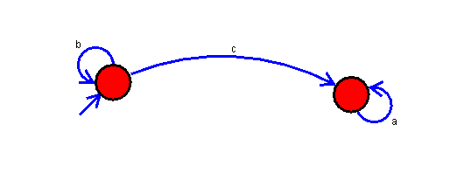

Result:

Successfully Executed Deterministic Finite Automata using simulator to accept the input string “bc” ,”c”,and ”bcaaa”.