BR 1:

SET SQL_MODE = ' ';

WITH contribution_percentage AS (

SELECT city_id,

COUNT(city_id),

ROUND(COUNT(city_id) / (SELECT count(city_id) from fact_trips) * 100, 2) as 'Contribution_Percentage'

FROM fact_trips

GROUP BY city_id

),

Avg_fare as (

SELECT c.city_id,

city_name,

COUNT(ft.trip_id) as 'total_trip',

SUM(ft.fare_amount)/SUM(ft.distance_travelled_km) as 'avg_fare_per_km',

SUM(ft.fare_amount)/COUNT(ft.trip_id) AS 'avg_fare_per_trip'

FROM fact_trips ft

inner join dim_city c ON c.city_id = ft.city_id

group by c.city_id

)

SELECT af.city_name as 'City_Name',

af.total_trip as 'Total_Trips' ,

af.avg_fare_per_km as 'Avg. Fare/Km',

af.avg_fare_per_trip as 'Avg. Fare/Trip',

cp.Contribution_Percentage as '%_Contribution_to_Total_Trips' FROM

Avg_fare af

INNER JOIN contribution_percentage cp ON cp.city_id = af.city_id

ORDER BY af.total_trip DESC  
  
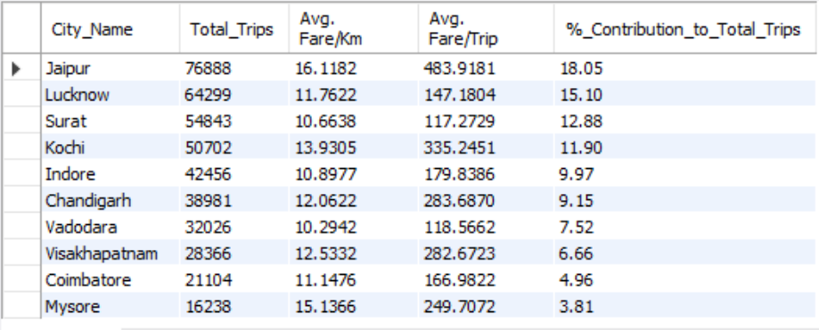

BR 2:

WITH Trips AS (

SELECT ft.city_id,

c.city_name,

monthname(ft.date) AS trip_month,

COUNT(ft.trip_id) as 'actual_trips',

(tt.total_target_trips) as 'Target_trips',

COUNT(ft.trip_id)- (tt.total_target_trips) as 'difference' FROM trips_db.fact_trips ft

INNER JOIN targets_db.monthly_target_trips tt ON tt.city_id = ft.city_id AND MONTH(tt.month) = MONTH(ft.date)

INNER JOIN trips_db.dim_city c ON c.city_id = ft.city_id

INNER JOIN trips_db.dim_date d ON d.date = ft.date

GROUP BY ft.city_id, month(ft.date)

)

SELECT t.city_name AS 'City_Name',

t.trip_month as 'Month_Name',

t.actual_trips,

t.Target_trips,

CASE

WHEN t.actual_trips > t.Target_trips THEN 'Above Target'

WHEN t.actual_trips < t.Target_trips THEN 'Below Target'

END AS 'Performance_Status',

ROUND((t.difference/t.Target_trips) * 100,2) AS '%_difference' FROM Trips t

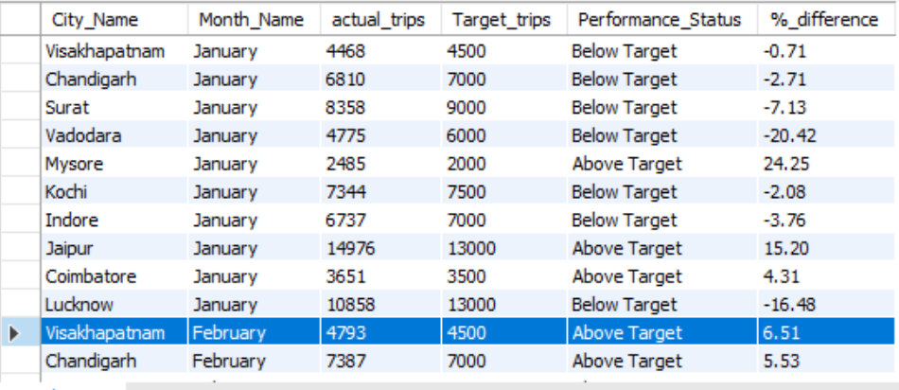

BR 3:

SET SQL_MODE = ' ';

WITH Passenger_Count AS (

SELECT city_id, trip_count, SUM(repeat_passenger_count) AS 'passenger_count_city' ,

(SELECT SUM(repeat_passenger_count) FROM dim_repeat_trip_distribution) as 'Passenger_count'

FROM dim_repeat_trip_distribution

GROUP BY trip_count,city_id )

SELECT

c.city_name,

ROUND((SUM(CASE WHEN pc.trip_count = 2 THEN pc.passenger_count_city ELSE 0 END) / MAX(pc.Passenger_count))*100, 2) AS '2_trips_%',

ROUND((SUM(CASE WHEN pc.trip_count = 3 THEN pc.passenger_count_city ELSE 0 END) / MAX(pc.Passenger_count))*100, 2) AS '3_trips_%',

ROUND((SUM(CASE WHEN pc.trip_count = 4 THEN pc.passenger_count_city ELSE 0 END) / MAX(pc.Passenger_count))*100, 2) AS '4_trips_%',

ROUND((SUM(CASE WHEN pc.trip_count = 5 THEN pc.passenger_count_city ELSE 0 END) / MAX(pc.Passenger_count))*100, 2) AS '5_trips_%',

ROUND((SUM(CASE WHEN pc.trip_count = 6 THEN pc.passenger_count_city ELSE 0 END) / MAX(pc.Passenger_count))*100, 2) AS '6_trips_%',

ROUND((SUM(CASE WHEN pc.trip_count = 7 THEN pc.passenger_count_city ELSE 0 END) / MAX(pc.Passenger_count))*100, 2) AS '7_trips_%',

ROUND((SUM(CASE WHEN pc.trip_count = 8 THEN pc.passenger_count_city ELSE 0 END) / MAX(pc.Passenger_count))*100, 2) AS '8_trips_%',

ROUND((SUM(CASE WHEN pc.trip_count = 9 THEN pc.passenger_count_city ELSE 0 END) / MAX(pc.Passenger_count))*100, 2) AS '9_trips_%',

ROUND((SUM(CASE WHEN pc.trip_count = 10 THEN pc.passenger_count_city ELSE 0 END) / MAX(pc.Passenger_count))*100, 2) AS '10_trips_%'

FROM

Passenger_Count pc

INNER JOIN dim_city c ON c.city_id = pc.city_id

GROUP BY

pc.city_id,c.city_name;

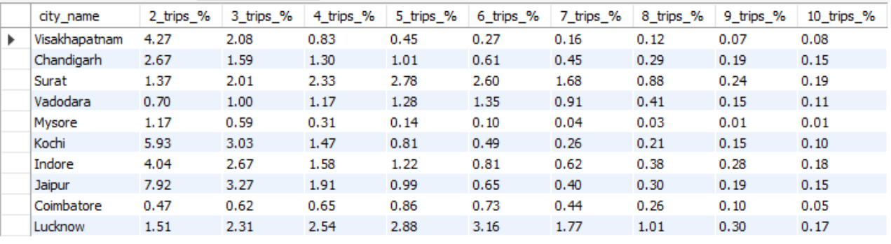

BR 4:

SELECT city_name, Passenger, 'Top City' as City_category

FROM (

SELECT c.city_name, SUM(fps.new_passengers) AS Passenger

FROM fact_passenger_summary fps

INNER JOIN dim_city c ON c.city_id = fps.city_id

GROUP BY c.city_name

ORDER BY SUM(fps.new_passengers) DESC

LIMIT 3

) AS top_cities

UNION ALL

SELECT city_name, Passenger, 'Bottom City' as City_category

FROM (

SELECT c.city_name, SUM(fps.new_passengers) AS Passenger

FROM fact_passenger_summary fps

INNER JOIN dim_city c ON c.city_id = fps.city_id

GROUP BY c.city_name

ORDER BY SUM(fps.new_passengers) ASC

LIMIT 3

) AS bottom_cities;

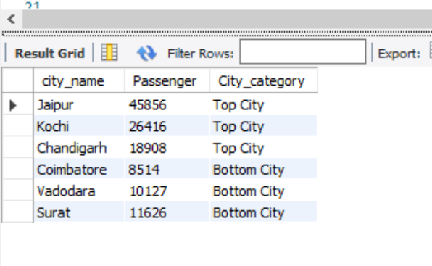

BR 5:

SET SQL_MODE = ' ';

WITH revenue AS (

SELECT c.city_name as 'city_name',

monthname(f.date) as 'Higest_revenue_month' ,

SUM(f.fare_amount) as 'Revenue',

ROUND( (SUM(f.fare_amount) / (SELECT SUM(fare_amount) FROM fact_trips))*100,2) as 'Pecentage_contribution'

FROM fact_trips f

INNER JOIN dim_city c ON c.city_id = f.city_id

group by c.city_name , monthname(f.date)

)

SELECT r.city_name, r.Higest_revenue_month, r.Revenue, r.Pecentage_contribution FROM revenue r

WHERE r.revenue = (SELECT MAX(r1.revenue) FROM revenue r1 WHERE r1.city_name = r.city_name)

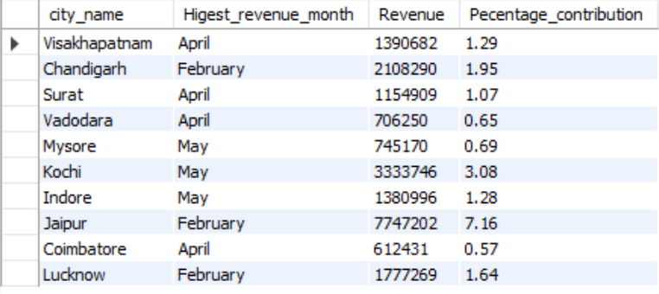

BR 6:

SET SQL_MODE = ' ';

WITH MonthlyRate AS (

SELECT

fp.city_id,

MONTHNAME(fp.month) as 'month_name',

fp.total_passengers,

fp.repeat_passengers,

ROUND((fp.repeat_passengers/fp.total_passengers) *100,2) AS 'monthly_repeat_pax_rate'

FROM fact_passenger_summary fp

),

CityRates AS (

SELECT

fp.city_id,

SUM(fp.total_passengers),

SUM(fp.repeat_passengers),

ROUND((SUM(fp.repeat_passengers)/SUM(fp.total_passengers))*100,2 ) as 'city_repeat_pax_Rate'

FROM fact_passenger_summary fp

GROUP BY fp.city_id

)

SELECT city.city_name, m.month_name, m.total_passengers as 'total_passengers', m.repeat_passengers as 'repeat_passengers', m.monthly_repeat_pax_rate, c.city_repeat_pax_Rate FROM MonthlyRate m

INNER JOIN CityRates c ON c.city_id = m.city_id

INNER JOIN dim_city city ON city.city_id = m.city_id

