Data Warehousing with IBM Cloud Db2 Warehouse

# Problem Definition

Designing and setting up a robust data warehouse using IBM Cloud Db2 Warehouse. This project aims to consolidate data from different sources, execute advanced data integration and transformation, and empower data architects to explore, analyze,

# Data warehouse structure

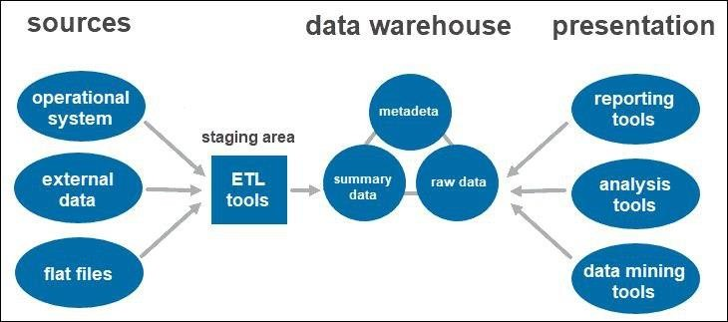

**Designing the schema and structure of a data warehouse to accommodate various data sources involves several key considerations:**

1. **Data Sources:**

**- Identify the diverse data sources you'll be integrating into the data warehouse. These can include databases, spreadsheets, external APIs, log files, and more.**

1. **Data Extraction:**

**- Decide on the methods and tools for extracting data from these sources. This may involve ETL (Extract, Transform, Load) processes, data connectors, or APIs.**

1. **Data Integration:**

**- Determine how you'll integrate and combine data from different sources. Common approaches include star schemas, snowflake schemas, or a hybrid approach, depending on your needs.**

1. **Data Transformation:**

**- Plan for data transformation and cleansing to ensure data quality and consistency. This includes handling missing values, data type conversions, and data enrichment.**

1. **Data Storage:**

**- Choose an appropriate data storage solution, such as a relational database, columnar database, or a NoSQL database, based on your data volume and query requirements.**

1. **Schema Design:**

**- Create a data schema that reflects your business requirements. This schema may include dimensions (e.g., customer, product) and fact tables (e.g., sales, orders) connected by keys.**

1. **Data Governance:**

**- Implement data governance practices to manage metadata, data lineage, and data access controls. This ensures data accuracy, security, and compliance.**

1. **Scalability:**

**- Plan for scalability to accommodate growing data volumes and additional data sources. Consider distributed architectures and cloud-based solutions for flexibility.**

1. **Performance Optimization:**

**- Optimize query performance by creating indexes, aggregations, and using appropriate partitioning strategies.**

1. **Data Access:**

**- Provide user-friendly tools and interfaces for querying and reporting, such as BI (Business Intelligence) tools or SQL interfaces.**

1. **Monitoring and Maintenance:**

**- Implement monitoring and alerting systems to track data quality, performance, and system health. Regularly maintain and update the data warehouse as needed.**

1. **Documentation:**

**- Document the data warehouse schema, transformation processes, and data lineage to facilitate understanding and troubleshooting.**

1. **Data Security:**

**- Implement security measures to protect sensitive data, including encryption, access controls, and auditing.**

1. **Backup and Recovery:**

**- Develop a backup and recovery plan to ensure data availability and disaster recovery.**

1. **Testing:**

**- Thoroughly test the data warehouse to validate data accuracy and performance, especially after making schema or ETL changes.**

**The specific schema and structure will vary depending on your organization's needs and the nature of the data sources. It's essential to involve data architects, engineers, and domain experts to design a data warehouse that effectively supports your analytics and reporting requirements.**

Data integration

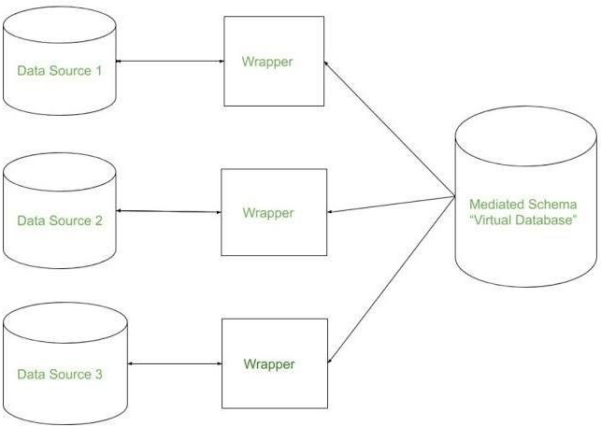

ETL Processes



ETL (Extract, Transform, Load) processes is a critical step in data warehousing. Here's a high-level plan to guide you through the process:

1. **Define Objectives and Scope:**

* **Clearly define what data you need to extract, transform, and load into the data warehouse.**
* **Identify the source systems and data formats.**

1. **Data Extraction:**

* **Select appropriate data extraction methods (e.g., batch processing, real-time streaming, APIs).**
* **Extract data from source systems and ensure data integrity.**
* **Consider incremental extraction for efficiency.**

1. **Data Transformation:**

* **Clean and preprocess data to ensure quality and consistency.**
* **Apply data transformations (e.g., filtering, aggregating, joining) as needed.**
* **Handle data validation and error handling.**

1. **Data Loading:**

* **Choose a loading strategy (e.g., full load, incremental load, CDC - Change Data Capture).**
* **Load transformed data into the data warehouse.**
* **Maintain data lineage and audit trails.**

1. **Data Quality and Validation:**

* **Implement data quality checks and validations.**
* **Monitor and log any data anomalies or errors for debugging.**

1. **Scalability and Performance:**

* **Optimize ETL processes for performance and scalability.**
* **Consider parallel processing and distributed computing where needed.**

1. **Metadata Management:**

* **Maintain metadata about source data, transformations, and target schema.**
* **Document ETL processes and dependencies.**

1. **Error Handling and Logging:**

* **Set up error handling mechanisms to handle data integration failures gracefully.**
* **Implement logging and alerting for monitoring ETL jobs.**

# Data exploration

Certainly, data exploration is a crucial step in the data analysis process. To empower data architects to explore and analyze data effectively, here are some queries and analysis techniques they can use:

1. **Basic Data Profiling Queries:**

* **Count the number of records in the dataset.**
* **Identify unique values in categorical columns.**
* **Calculate summary statistics (mean, median, min, max, standard deviation) for numeric columns.**
* **Detect missing values in the dataset.**

1. **Data Distribution Analysis:**

* **Generate histograms or frequency distributions to visualize the distribution of numeric data.**
* **Create bar charts or pie charts to visualize the distribution of categorical data.**
* **Use box plots to identify outliers and assess data variability.**

1. **Correlation Analysis:**

* **Calculate correlation coefficients (e.g., Pearson, Spearman) between numeric variables to identify relationships.**
* **Visualize correlations using a heatmap.**

1. **Data Visualization:**

* **Create scatter plots to explore relationships between pairs of numeric variables.**
* **Generate line charts or time-series plots to visualize trends over time.**
* **Use box plots or violin plots to compare data distributions across categories.**

1. **Feature Engineering:**

* **Create new features based on domain knowledge or data transformations.**
* **Calculate ratios, percentages, or moving averages.**

1. **Segmentation and Grouping:**

* **Group data by categorical variables and calculate aggregate statistics within each group.**
* **Perform segmentation analysis to identify customer segments or patterns within the data.**

1. **Time-Series Analysis:**

* **Decompose time-series data into trend, seasonality, and residual components.**
* **Use autocorrelation and partial autocorrelation plots to identify lagged relationships.**

1. **Text Analysis:**

* **Tokenize and preprocess text data.**
* **Perform word frequency analysis and identify common terms.**
* **Visualize word clouds to highlight frequently occurring words.**

1. **Geospatial Analysis:**

* **Plot data on maps to explore geospatial patterns.**
* **Calculate distances, areas, or spatial relationships.**

1. **Advanced Statistical Tests:**

* **Perform hypothesis tests (e.g., t-tests, chi-squared tests) to assess statistical significance.**
* **Conduct ANOVA for comparing means across multiple groups.**

1. **Machine Learning Exploration:**

* **Use clustering algorithms (e.g., K-means) to group similar data points.**
* **Try dimensionality reduction techniques (e.g., PCA) for visualization.**

# Actionable Insights

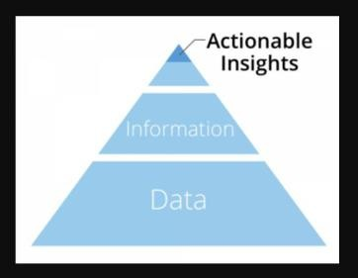

Absolutely, delivering actionable insights is crucial for informed decision-making. To do this effectively, you should:

1. Define clear objectives: Understand what decisions need to be made and what data is relevant.
2. Data quality: Ensure data accuracy, consistency, and reliability.
3. Visualization: Use charts, graphs, and dashboards to make data easily digestible.
4. Contextualize: Explain the significance of the data and its implications.
5. Recommendations: Provide specific recommendations based on the insights.
6. Feedback loop: Continuously refine and update insights as new data becomes available.

By following these steps, you can empower decision-makers to take effective actions based on data-driven insights.