**Verilog Tools Installation Guide**

**Author:** Karthiswaran R  
**Website:** [VLSI Design Hub](https://vlsidesginhub.netlify.app/linux)  
**Date:** 2025

**Copyright © 2025 VLSI Design Hub. All Rights Reserved.**

This document, including all content, text, and images, is the intellectual property of [**vlsidesignhub@gmail.com**](mailto:vlsidesignhub@gmail.com)and is protected by copyright law. Unauthorized reproduction, distribution, or modification of this material, in whole or in part, without prior written permission from the author is strictly prohibited.

You may use this document for personal learning purposes. However, commercial use, redistribution, or incorporation into other materials without explicit consent is not allowed.

For permissions or inquiries, visit [**VLSI Design Hub**](https://vlsidesignhub.netlify.app/tools) or contact [**vlsidesignhub@gmail.com**](mailto:vlsidesignhub@gmail.com?subject=vlsidesignhub@gmail.com)

**Reference**

**For more Verilog tutorials, resources, and hands-on projects, visit our website. Explore comprehensive guides, industry insights, and learning materials to enhance your digital design skills.**

For additional resources and tutorials, visit:

* [**VLSI Design Hub**](https://vlsidesignhub.netlify.app/tools)
* Contact: [**vlsidesignhub@gmail.com**](mailto:vlsidesignhub@gmail.com)

**About**

This document provides a step-by-step guide on installing and using Verilog tools in a Linux environment. It covers essential tools such as **Icarus Verilog (iverilog)** for compilation, **GVim** for code editing, and **GTKWave** for waveform visualization. The instructions help users set up a Verilog development environment, write Verilog programs, compile test benches, and analyze waveforms effectively.

**This guide is designed for students, engineers, and hobbyists interested in digital design, FPGA development, and hardware simulation.**

# **To Install verilog tools in linux**

1. To update Linux distro,
   * Sudo apt-get update
   * Sudo apt-get upgrade
2. To Install iverilog Compiler,
   * Sudo apt install iverilog
3. To Install gvim editor,
   * sudo apt install vim

In this command there is any error,Try the above commands

* + Sudo apt install vim-motif
  + Sudo apt install vim-gtk3

1. To Install gtkwave,
   * Sudo apt install gtkwave

# **To use gvim editor for verilog :**

**1.** First Create the main module file with verilog extension.

* + Ex:

filename.v

**2.** Then Create the test bench module.

* Ex:

tb_filename.v

**3.** Write a program and save using this commands in gvim,

* Press **Esc** ,then **:W!**

**4.** To see number of lines in a program (or) error occur in particular lines,

* Press Esc, then **:se nu**

**5.** Finally save the program and exit from the gvim editor.

# **To Compile the Program use iverilog tool :**

1. Go to terminal, check the present directory is verilog otherwise change the directory by using below command,

* cd → Change directory
* Ex:

cd verilog

1. Then list the available programs by using list command,

* ls → List the files
* Ex:

ls

1. To compile the programs,

* Ex:

iverilog filename.v tb_filename.v -o m1

* m1 is just object you can use any other variable also.
* Refer the figure 1.1

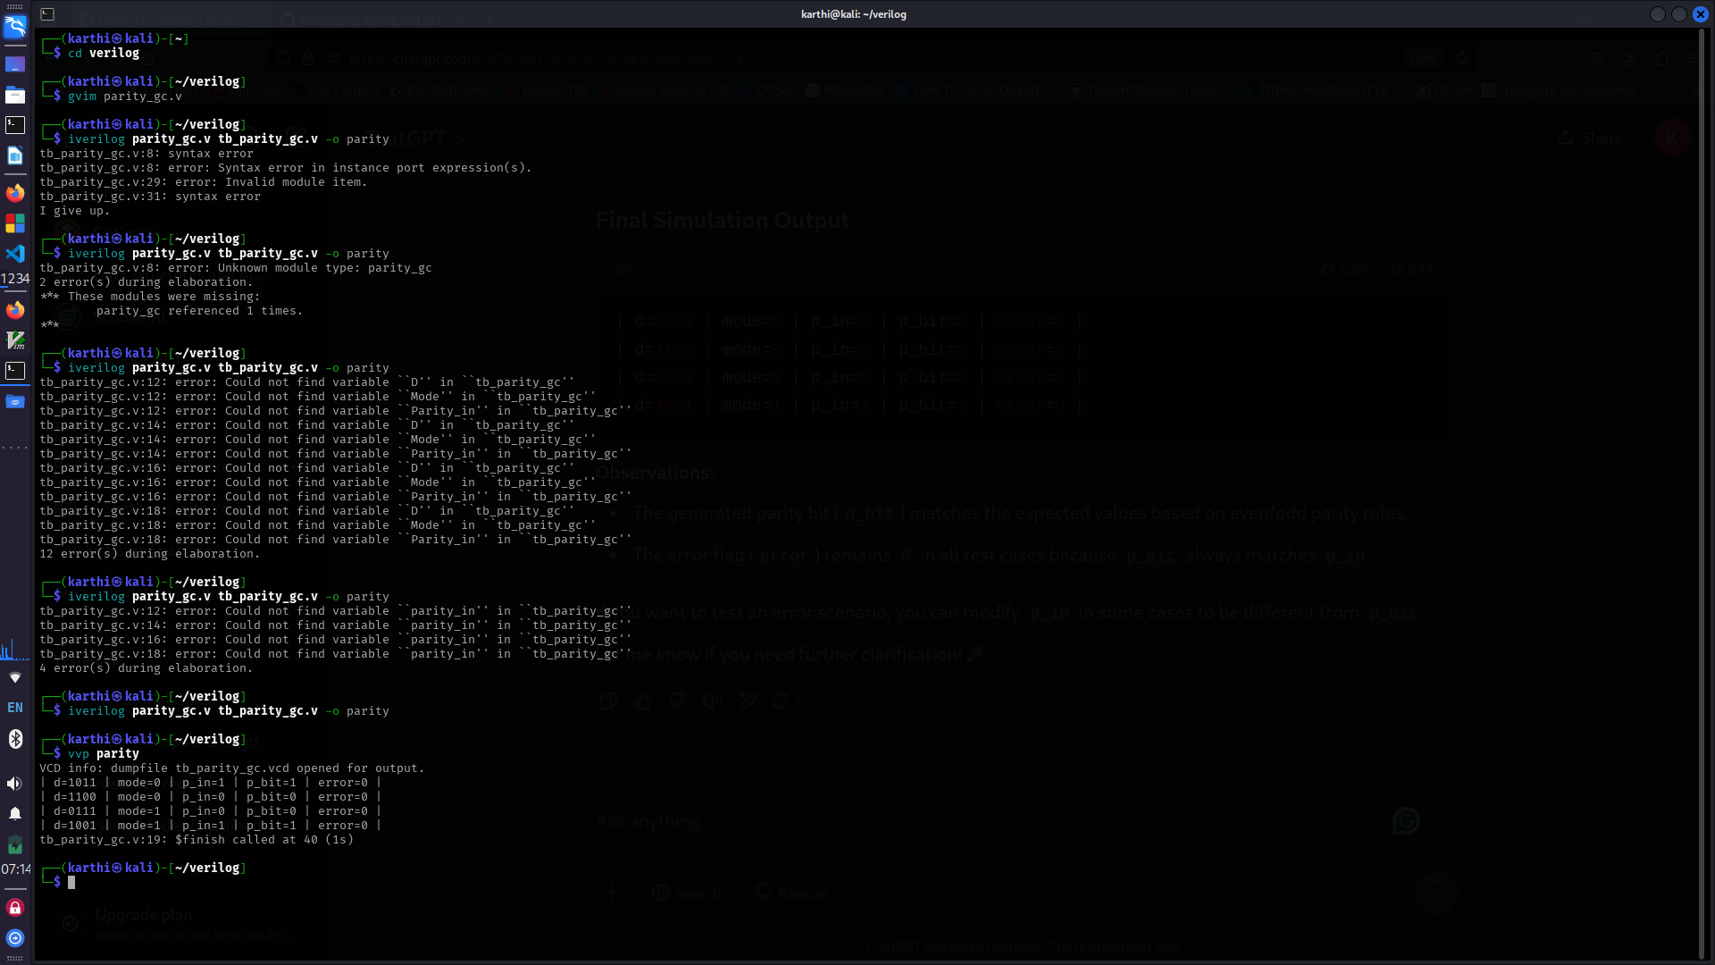

Figure 1.1

4. Execute the programs,

1. Ex:

vvp m1

## **To Generate the waveform using gtkwave,**

1. If the program is executed,then open the generated waveform using below command,

* gtkwave filename.vcd
* Ex:

gtkwave tb_parity_gc.vcd

* Refer the above figure1.2,figure 1.3

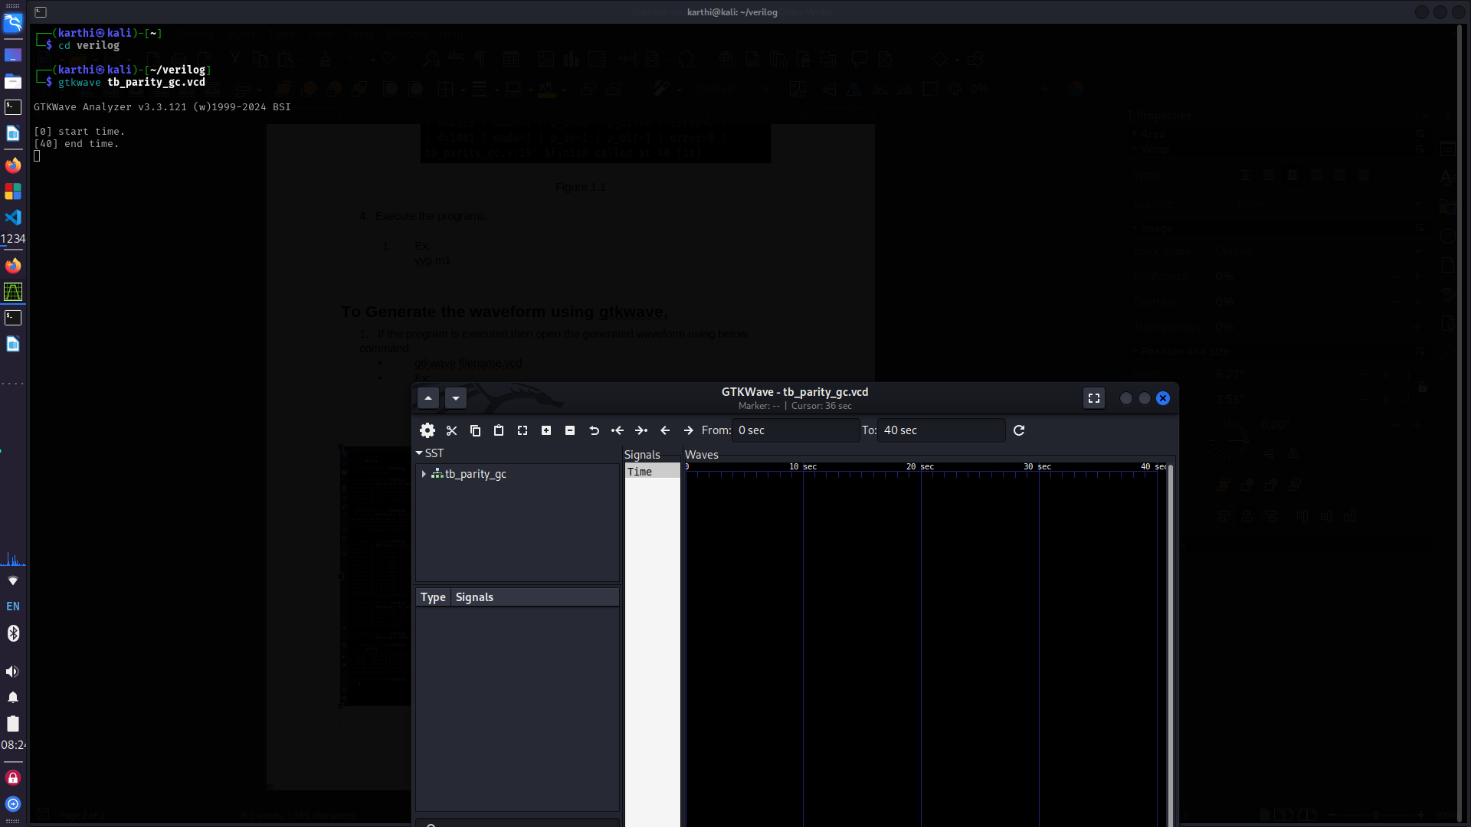Figure 1.2

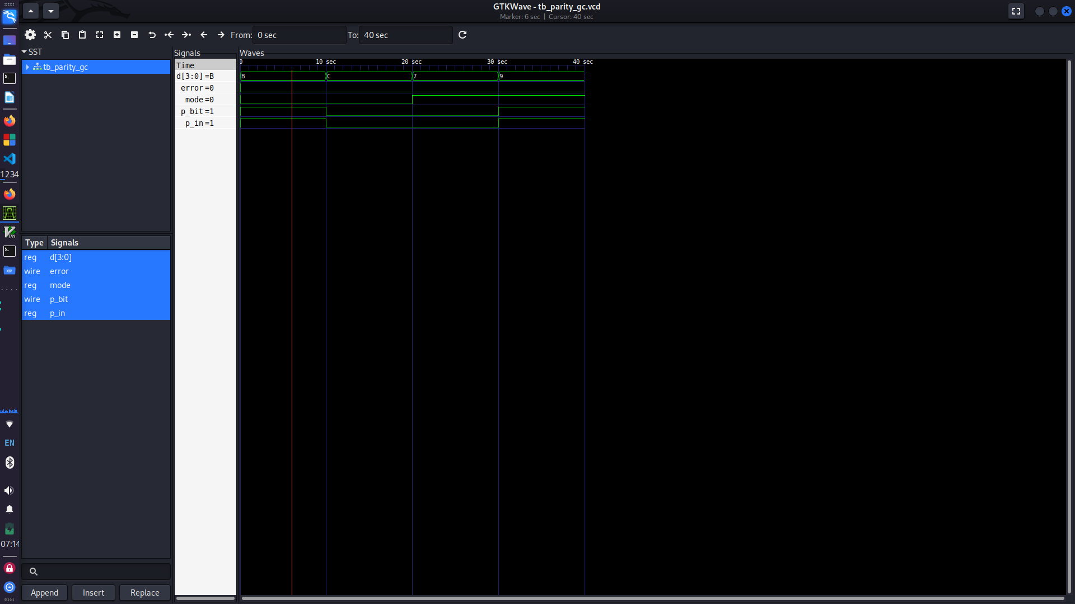Figure 1.3